COMHAIRLE CONTAE ÁTHA CLIATH THEAS
SOUTH DUBLIN COUNTY COUNCIL

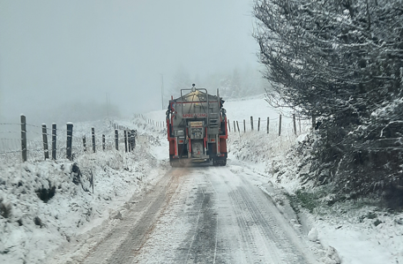

Winter Service Plan 2023- 2024

Table of Contents

1. PURPOSE OF SCOPE 3
2. POLICY 3
3. Community Involvement During Severe Weather Events 5
4. Responsibilities 6
5. Decision Process 8
6. Decision Matrix 9
7. Treatment Matrix 10
8. Plant, Vehicles and Equipment 12
9. Winter Service Depots 12
10. Materials 12
11. Additional Route Requests 13
12. Plan Review 13
Appendix 1 - Gritting Routes and Priority 1 routes 14
Appendix 2 – Salt Bin Locations 16
Appendix 3 – Duty Engineer Roster and Rota 17

PURPOSE OF SCOPE
The purpose of this document is to identify the processes, procedures and key personnel employed by South Dublin County Council to deliver the winter maintenance programme for the 2023/2024 Winter Season.
The percentages of roads gritted within SDCC are summarised below

POLICY

2.1 Road Network
It is the Council’s policy to attempt to maintain the principal roads within the county and to keep them open for traffic and free from ice at all times.

The road network in South Dublin comprises all categories of road from Motorway to Local Tertiary. The responsibility for general and winter maintenance of Motorways has been awarded to private contractors employed directly by Transport Infrastructure Ireland (TII).
South Dublin County Council are responsible for carrying out winter maintenance on National Secondary, Regional and Local roads within the county.

Due to the length of road network in South Dublin it is not possible to treat all roads during a standard treatment run. Winter maintenance is based on a hierarchy of priority;
Category | Road Description | Level of Service
Priority One | All National Routes, major county distributors and access to essential services (emergency services) | Routes will be kept serviceable as far as is reasonably practicable in all weather conditions
Priority Two | Roads that are treated as part of a standard call out but not rated as priority one | Roads will be treated as part of a standard call out but in the event of severe weather they will not be treated until priority one routes are serviceable
Priority Three | All other roads | Not treated as part of the normal  winter service but may receive  intermittent treatment during certain  severe weather events.

Appendix One identifies the normal gritting routes and priority 1 routes

2.2 Pedestrian & Cycle Infrastructure
Footpaths and Cycleways are not included in our standard winter maintenance operating process. During severe weather events such as heavy snow or prolonged icy periods resources may be re-allocated to clearing specific areas such as villages and bridge decks.

2.3 Salt Bins
SDCC have 100 salt bins located around the county. These bins enable members of the public to access salt and treat locations that are not included in the standard treatment routes if they deem it necessary.
Instructions on spread rate will be provided at each bin.

Locations of these can be found on SDCC website and a map is included as Appendix 2.

Community Involvement During Severe Weather Events

3.1 Schools and Community Groups
Schools and Community Groups are advised to plan ahead for severe weather events and to make the necessary arrangements to have sufficient supplies of materials, plant and equipment in storage or available to them to cater for their anticipated needs during such events. Materials and equipment should be acquired in a timely manner in advance of the winter season while stocks are available.

3.2 Business Sector
The Commercial, Retail & Business sectors are requested to assist efforts in periods of severe weather by clearing snow and ice from footpaths in front of their premises. Legal opinion on the matter states that no legal liability exists to those carrying out such works once they are executed in a safe manner. It should be noted that the application of hot water to remove snow and ice from footpaths is not a safe or an acceptable method as more often than not the water refreezes and exacerbates the initial problem.

3.3 Agricultural Sector
The Local Authority will endeavour to work with rural communities & the IFA where possible. The treatment of rural roads by third parties should be carried out in accordance with national policy in this area once published.

Responsibilities

4.1 Winter Services Manager
The Winter Services Manager (WSM) is responsible for co-ordinating the overall delivery of South Dublin County Councils response to cold weather events, in particular the winter salting/gritting response.
The WSM is required to;
- Ensure the Winter Service Plan is updated as required.
- Ensure all personnel listed in the document are briefed on their roles and responsibilities and that contact details are validated.
- Make The Winter Service Plan available to the public.
- Ensure that all plant and equipment used in winter Maintenance activities is properly maintained and fit for purpose.
- Arrange calibration of plant and equipment and maintain up to date records of same.
- Prepare a rota of Duty Engineers for the winter maintenance season.
- Co-ordinate the activities of the Duty Engineers and provide support and training as required.
- Monitor stocks of salt and ensure that adequate supplies of salt are maintained throughout the winter service season.
- Ensure that salt depots are properly maintained and liaise with Municipal District Engineers with regard to the upkeep and maintenance of salt depots.
- Be responsible for the overall management of Health, Safety and Welfare for all Winter Maintenance operations.

4.2 Winter Service Duty Engineers
South Dublin County Council maintains a roster of six Duty Engineers who operate the Transport Infrastructure Ireland (TII) Vaisala DSS Manager Weather Prediction System for the winter service season.
The Duty Engineers work on a weekly rota throughout the season and the handover time is 9am on Monday mornings or as agreed between the Duty Engineers.

Using the Vaisala DSS Manager Weather Prediction System it is the Duty Engineer’s responsibility to determine;
- Whether a call out is required
- What routes are to be treated
- What time to carry out treatment
- What the treatment rate is to be

Once a decision has been determined the Duty Engineer is required to inform the Area Engineers and Inspectors/Assistant Foremen of the decision and to get confirmation that it has been received.

In addition the Duty Engineers will commit to the following duties & procedures:
- To be available outside normal working hours (this means ANY TIME, for the rostered period)
- Keep a log of activities, operations, decision making etc and use the RoadDSS Manager module so that a complete picture of decision making and operations can be inspected.
- Update the National Salt Management System (NSMS) on a weekly (or daily) basis and coordinate salt deliveries/collections for your county as required.

Outside of working hours, from their home the duty engineer will:
- Access the RoadDSS Manager system as required.
- Track the actual conditions over their area.
- Obtain updated or more detailed road weather forecasts by talking to a forecaster using The Telephone Consultancy Service phone number 01 8064219 or 8064255 as a backup number.

The roster and rota for the upcoming season is contained in Appendix 3.

4.3 Area Engineers
South Dublin has two Area Engineers, one in Palmerstown that covers the North of the county and one in Ballymount that covers the South.
Area Engineers have overall responsibility for the delivery of the Winter Service Programme within their area in accordance with the policies and procedures set out in the Winter Service Plan. They are also responsible for the operation, maintenance and upkeep of the Road Maintenance Depots within their Municipal District and shall ensure that they have sufficient manpower, machinery and resources to enable them to provide a satisfactory and safe service.
The Area Engineers shall immediately report any Machinery defects or any Health, Safety and Welfare related issues to the Winter Service Manager/ Machinery Yard Engineer

4.4 Roads Inspectors & Assistant Foremen
The Roads Inspectors and Assistant Foremen are responsible for the co-ordination of the Winter Service Programme on the ground in their respective areas. They shall act on the instruction of the Duty Engineer in relation to issues relating to the delivery of the Winter Service Programme.
Road Inspectors will liaise directly with the Duty Engineer responsible for monitoring salt stocks regarding stock levels and replenishing supplies; the Duty Engineer will then inform the WSM of any need for additional salt supplies that be required. This will generally be on a weekly basis, but may become more frequent during extreme weather events.
Roads Inspectors & Assistant Foremen will also immediately report any Health, Safety and Welfare issues or problems to their Area Engineer.

4.5 Drivers
The Area Engineers shall endeavour to ensure that sufficient drivers are available for the satisfactory delivery of the Winter Service Programme within their Area. This will include a list of reserve drivers to provide cover during prolonged periods.
Drivers shall report any machinery or plant defects to the Roads Inspector or Assistant Foremen upon discovery to ensure no interruption to delivery of the Winter Service Programme.
Drivers will also immediately report any Health, Safety and Welfare issues to their Inspector or Assistant Foreman.

Decision Process
The duty engineer consults the IceCast system on a daily basis. The first weather condition update is received at approx 1pm.

Duty Engineers will review the forecast data and determine whether to treat or not treat. A decision will be made and communicated to the relevant people at that time. It will include the decision to go ahead and salt roads at a specified time or a decision not to salt roads.

An updated forecast is received at approx. 8pm and based on this the Duty Engineer may alter the treatment decision from earlier.

The Duty Engineer will continue to monitor the weather forecast for the evening and if the weather deviates significantly from the forecast an amended treatment plan may be issued.

The timing of the salting run is intended to pre-treat the roads prior to the time of forecasted ice formation. The object is to treat the road as close to this time as is feasible. The target rate of spread of salt in South Dublin is 10g/m2 .
The rate of spread may be varied depending on the severity of the weather conditions and the duration of it.

Where snow is forecast, snowblades are fitted to Council vehicles, and they will be used where a sufficient depth of snow exists for their deployment. Where such conditions are forecast, intensive engagement with Met Eireann better informs the Duty Engineer as to the timing of treatment. Lorries with snowblades mounted to the front, are more difficult to manoeuvre on narrow roads. For this reason, the snowblades should only be mounted, when there is a significant or high risk of snowfall.

Decision Matrix
The table below indicates the decision matrix used by the Duty Engineer when deciding on a winter service call out
Road Surface Temperature | Precipitation | Predicted Road Conditions
 |  | Wet | Wet Patches | Dry
May fall below 0°C | No rain  No hoar frost  No fog | Salt before frost | Salt before frost | No action likely, monitor weather
Expected to fall below 0°C | No rain  No hoar frost  No fog
 | Expected hoar frost  Expected fog |  | Salt before frost (see note a)
 | Expected rain before freezing | Salt after rain stops (see note b)
 | Expected rain during freezing | Salt before frost, as required during rain and after rain stops (see note c)
 | Possible rain  Possible hoar frost  Possible fog | Salt before frost |  | Monitor weather conditions
Expected Snow |  | Salt before snow fall
The decision to undertake precautionary treatments should be, if appropriate, adjusted to take account of residual salt or surface moisture. All decisions should be evidence based, recorded and require careful monitoring and review.
Notes:
- When a weather warning contains reference to expected hoar frost, considerable deposits of frost can occur. Hoar frost usually occurs in the early morning and is difficult to cater for because of the probability that any salt deposited on a dry road too soon before its onset, may be dispersed before it can become effective. Careful monitoring is required under this forecast condition which should ideally be treated just as the hoar frost is forming. Such action is usually not practicable and salt may have to be deposited on a dry road prior to but as close as possible to the expected time of the condition. Hoar frost may also be forecast at other times of the day, in which case the timing of salting operations should be adjusted accordingly.
- If under these conditions, rain has not ceased by early morning, crews should be called out and action initiated as rain ceases. Where possible, salting will be timed to coincide with the end of rainfall.
- Under these circumstances rain will freeze on contact with running surfaces and full precautionary treatment should be provided even on dry roads. This is a most serious condition.

Treatment Matrix
The following table illustrates the treatment matrix to be used for dry unmodified salt.
Weather Conditions Road Surface Conditions Road Surface Temperature (RST) | Treatment Air Temperature | Salt Spread Rate  (gm/m2 ) | Ploughing
Frost or forecast frost  RST at or above -1°C |  | 10 | No
Frost or forecast frost  RST below -1°C and above -5°C |  | 10 | No
Frost or forecast frost  RST below -5°C and above -10°C and dry or damp road conditions |  | 15 | No
Frost or forecast frost  RST below -5°C and above -10°C and wet road conditions (existing or anticipated) |  | Minimum 1 run X 20 | No
Light snow forecast (<10mm) |  | Minimum 1 run X 20 and reload | Ploughs mounted
Forecast for Medium/heavy snow or a freezing rain forecast |  | Minimum 1 run X 20 and reload | Ploughs mounted
Ice formed | Above -5°C | 20 | Not possible
Ice formed | At or below -5°C | Minimum 1 run X 20 and reload | Not possible
Snow covering exceeding 30mm |  | 20 to supplement ploughing, up to two runs X 20 on if temperatures are falling | Required
Snow accumulations due to prolonged falls |  | 1 to two runs X 20 on to supplement ploughing | Required
Hard packed snow/ice | Above -8°C | Successive treatments at 20 (repeat as needed) | Not possible
Hard packed snow/ice | At or below -8°C | Successive treatments at 20, supplemented by abrasives (repeat as needed) | Not possible
Sustained low temperatures | Below -10°C | Successive treatments at 20 during prolonged periods of bad weather | Not possible
Hard packed snow/ice | At or below -8°C | Successive treatments at 20, supplemented by abrasives (repeat as needed) | Not possible
Sustained low temperatures | Below -10°C | Successive treatments at 20 | Not possible

Notes:
- Rate of spread for precautionary treatments may be adjusted to take account of variations occurring along the route such as residual salt, surface moisture (in the air or on the road surface) and traffic density.
- All South Dublin County Council salt is currently stored in a barn. The target rate of spread for this salt is 10gm/m2 . The capacity of gritters and the length of routes currently salted limit the ability to exceed this rate.
- All decisions should be forecast based, recorded and require careful monitoring and review.
- Ice refers to all ice on the road surface, including black ice.
- A decision to plough is taken by the Roads Inspectors and Assistant Forement based on the local conditions in their area. This is due to the localised nature of snowfall events and the variation that may occur throughout the county.
- During prolonged periods of bad weather, it may be necessary to prioritise resources on Priority 1 routes, as a consequence other standard routes may be omitted if resources are unavailable.
- The earliest start time for a salting run is 7.00pm, as traffic volumes on the routes prevent salt being deposited on the road at the required spread rate before this time
- The latest start time for a salting run is 5.00am, as traffic volumes on the routes prevent salt being deposited on the road at the required spread rate before the salting run is completed
- On the basis of multiple salting runs on previous nights without any wet weather periods, the Duty Engineer can reduce the requirement for salting runs.
- In certain or extreme circumstances and based on the discretion of the Area Engineer, roads other than those on the official routes, may be treated on an unplanned basis

Plant, Vehicles and Equipment
South Dublin County Council operates a fleet of 7 trucks with fully demountable gritting units and 1 permanently mounted Gritter, all equipped with snow ploughs to deliver the Winter Service Programme.
Two teleporters are used to load the Salt spreader/gritters in the Depots.

Winter Service Depots
The delivery of the Winter Service Programme is undertaken from both Palmerstown and Ballymount Depots. Both depots are equipped with 1300t salt storage barns and lorries will load from both depots.

Materials

10.1 Rock Salt
South Dublin County Council will be assigned an allocation, by the TII, of salt for use on National Roads (N81) for the current operative period. A further allocation of salt will be made available, by the Department of Transport, for use on Regional and Local Roads for the same period. Both these allocations will be made based on tonnage of salt used in previous seasons.
The Winter Service Manager is responsible for reporting salt consumption on a weekly basis to the TII, via the web based National Salt Management System. The Duty Engineers also co-ordinate the ordering and collection of salt allocated under the two allocations to the Winter Service Depots.

Additional Route Requests
In the event that South Dublin County Council Duty Engineers or overseers are contacted by the emergency services (Guards, Fire Service, Control Centre) or a member of the public regarding additional salting routes or areas, then the procedure is to note the request, the person making the request and review whether to incorporate the request in subsequent salt runs.
It will not be possible to alter a salt run immediately on the basis of a request from the emergency services in the interest of health and safety of the machinery operators.
Please note that based on our current vehicle size there is no capacity to increase the existing route lengths currently.

Plan Review
The Winter Service Plan is considered a live document subject to change during the winter season. The Plan may be altered in response to changes in resources, strategy and experience gained.

Appendix 1 - Gritting Routes and Priority 1 routes
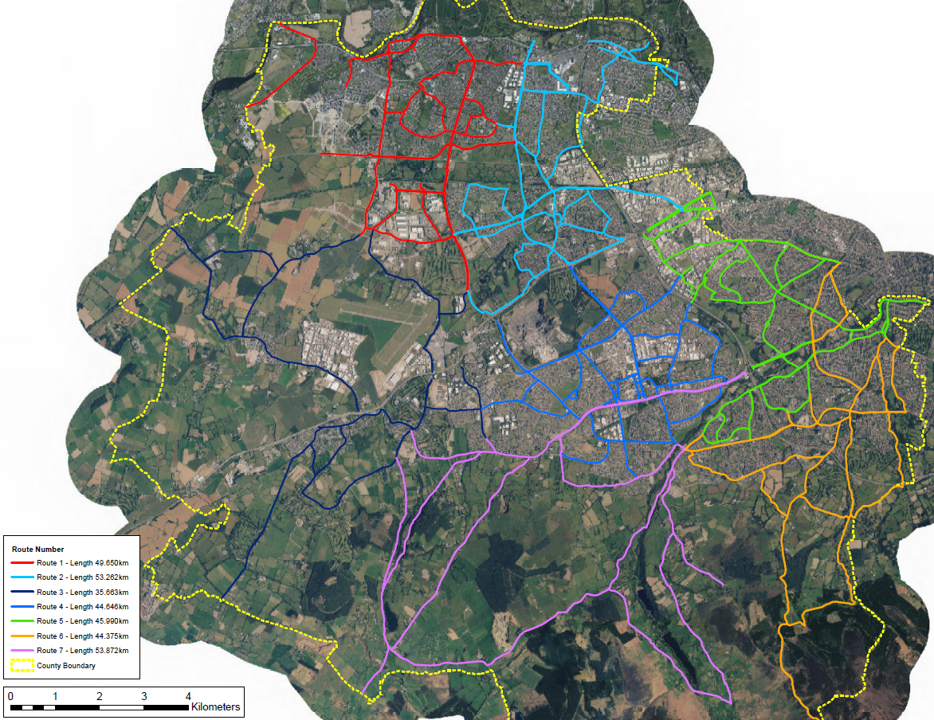

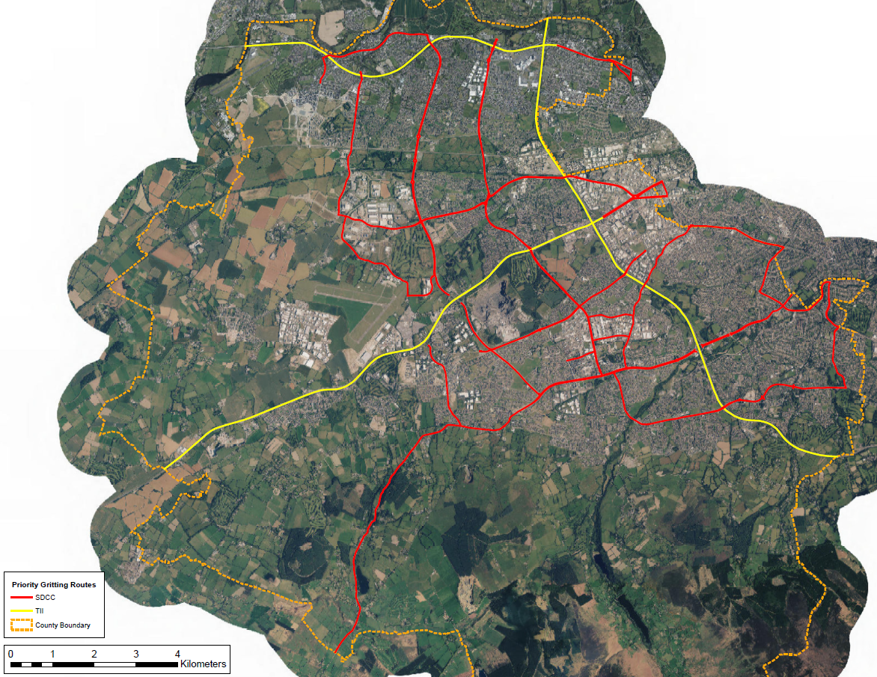

Appendix 2 – Salt Bin Locations
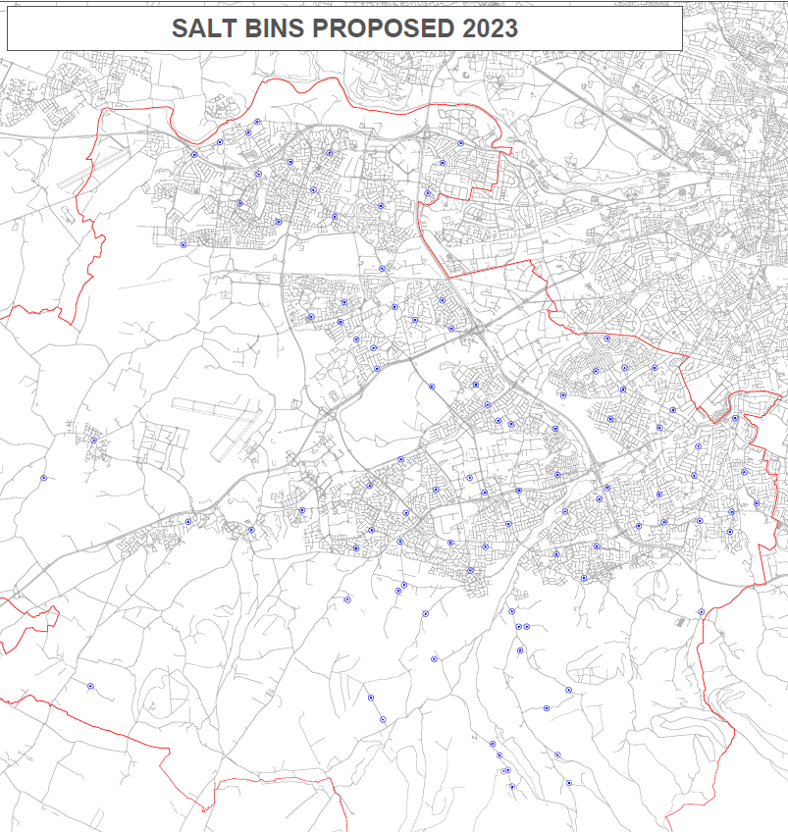

Appendix 3 – Duty Engineer Roster and Rota
 | Duty Engineer | Initials | Email
Duty Engineer 1 | Gary Walsh | GW | garywalsh@sdublincoco.ie
Duty Engineer 2 | Diarmuid Corry | DC | dcorry@sdublincoco.ie
Duty Engineer 3 | Caitriona Lambert | CL | clambert@sdublincoco.ie
Duty Engineer 4 | Lorcan Brennan | LB | lbrennan@sdublincoco.ie
Duty Engineer 5 | John McCormack | JM | jmccormack@sdublincoco.ie

Week  Commencing |  |  | Week  Commencing |  |  | Week  Commencing
16/10/2023 | Duty Engineer 1 |  | 25/12/2023 | Duty Engineer 1 |  | 04/03/2024 | Duty Engineer 1
23/10/2023 | Duty Engineer 2 |  | 01/01/2024 | Duty Engineer 2 |  | 11/03/2024 | Duty Engineer 2
30/10/2023 | Duty Engineer 3 |  | 08/01/2024 | Duty Engineer 3 |  | 18/03/2024 | Duty Engineer 3
06/11/2023 | Duty Engineer 4 |  | 15/01/2024 | Duty Engineer 4 |  | 25/03/2024 | Duty Engineer 4
13/11/2023 | Duty Engineer 5 |  | 22/01/2024 | Duty Engineer 5 |  | 01/04/2024 | Duty Engineer 5
20/11/2023 | Duty Engineer 1 |  | 29/01/2024 | Duty Engineer 1 |  | 08/04/2024 | Duty Engineer 2
27/11/2023 | Duty Engineer 2 |  | 05/02/2024 | Duty Engineer 2 |  | 15/04/2024 | Duty Engineer 3
04/12/2023 | Duty Engineer 3 |  | 12/02/2024 | Duty Engineer 3 |  | 22/04/2024 | Duty Engineer 4
11/12/2023 | Duty Engineer 4 |  | 19/02/2024 | Duty Engineer 4
18/12/2023 | Duty Engineer 5 |  | 26/02/2024 | Duty Engineer 5

