

Hello and Merry Christmas from Lucan Library!
Below are all our upcoming events for December 2025.
Please note:
- All events and activities are free of charge.
- All events are subject to change, but we will try to keep changes to a minimum.
- To register for events via Eventbrite, a valid email address is required.

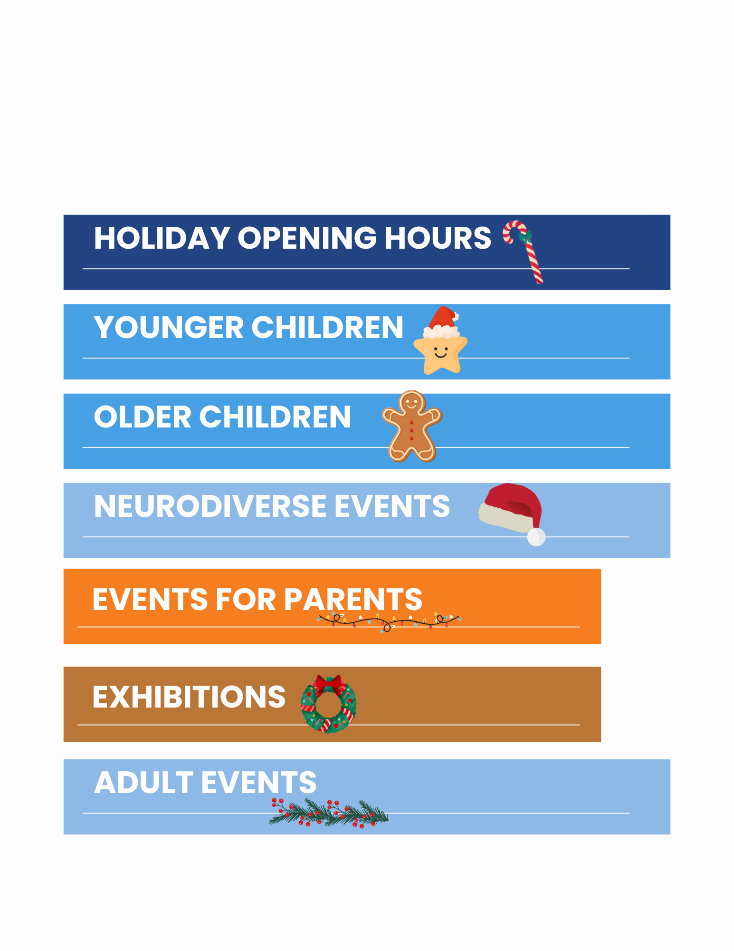
Adult Events in Lucan Library
Regular Events:
No booking is required for the below events - all are welcome to attend!
- Knitting Group - meets every Monday from 10am to 12pm.
- Poets Perch - Tuesday 2nd December at 6.30pm.
- Chess Monthly Meetup - First Monday of the month going forward, 6.30 to 8pm. All levels welcome!
- Lucan Library Creative Writing Group - Thursday 11th December at 10am and 18th December at 10am.
- Classic Film Club - Tuesday 16rd December. Tea & coffee from 5.30pm, film starting at 6pm.
Additional Adult Events
- Table Quiz – Tuesday 2nd December at 2pm.
Booking essential. Staff will be taking bookings from Monday 24th November – ask at the desk to book your place or contact us by phoning (01) 621 6422 or emailing lucanlibrary@sdublincoco.ie.
- The Disconnect Project Talk – Thursday 11th December at 6.45pm.
Join us for an empowering and relatable talk on how adults can take back control from their phone.
Smartphone overuse has become one of the quietest, yet most powerful challenges of modern life. It is impacting how we focus, rest, and connect with others.
Join Eleanor O'Dwyer, founder of The Disconnect Project, for an empowering and relatable talk on how adults can take back control from their phone. Drawing on her own experience of breaking free from smartphone overuse, Eleanor explores how constant scrolling affects our wellbeing and shares simple, evidence-based tools to help you create a healthier relationship with your smartphone.
Booking Essential through Eventbrite/ Lucan Library. Book your place on Eventbrite here from 4/12/2025.
- Wreath Making Workshop – Friday 12th December at 12pm.
Join us for a fun and festive wreath making workshop. All materials are provided.
Booking essential through Eventbrite/ Lucan Library. Book your place on Eventbrite here from 5/12/2025.
- Poet’s Perch Book Launch – Saturday 29th November at 2pm.
Natalie established the Poets’ Perch in December 2023 – a local poetry group who meet in Lucan Library once a month to drink tea, chat, and delight over words. Poets’ Perch is all about creativity, kindness, support, vulnerability, fun, and, most of all, community. Natalie’s vision is to spread her passion and love of words across communities. She is so proud of bringing her dream to life, creating a book of beautiful poetry from beautiful poets. This collection of 39 poems are from people that Natalie has encountered on her journey leading the poetry group.
"Ordinary words from ordinary people describing ordinary things in an extraordinary way. Poetry from the common man and woman. Grab yourself a bun, tea or a coffee and enjoy." - James Mooney, a.k.a. The Wandering Paddy.


Book Clubs:
Enquire at the desk about joining one of our book clubs - new members welcome!
- Monday Lunchtime Book Club – Monday 1st December at 12pm.
- Wednesday Book Club – Wed 17th December at 7pm
- Read and Eat Cook Book Club (new!) – Next meeting January 2026, Thursday 29th at 11.15

Lucan Library is excited to be hosting our annual Christmas Craft Fair on
Saturday 13th of December from 10am - 4pm
Local crafters will be selling plenty of handmade gifts, offering the perfect opportunity to pick up some one-of-a-kind gifts while supporting local small businesses.
There will be fun for all ages, with face painting from 10am-12pm and a magic show from 12.30-1.30pm and festive music with sing-a-longs on the day!
Children's Events in Lucan Library
– Please book events on Lucan Library/ Eventbrite
Events for young children:
- Little Wiggles Discovery Playtime! - Thursday 4th December at 10am. Book your place on Eventbrite here from 27/11/25.
- Reflexology for Babies and Parents - Wednesday 10th December at 10am. Book your place on Eventbrite here from 7/12/2025.
- Storytime - Every Tuesday at 3pm - no booking required, all welcome!

Events for older children:
– Please book events on Lucan Library/ Eventbrite
- Crafts with Elena for ages 6-8 - Tuesday 4th December at 3.30pm. Book your place on Eventbrite here from 27/11/2025
- Crafts with Elena for ages 9-12 - Thursday 11th December at 3.30pm. Book your place on Eventbrite here from 4/12/2025.
- Cool Food School for ages 9-12 - Friday 19th December at 2.30pm. Book your place on Eventbrite here from 12/12/2025.
Neurodiverse Events:
– Please book events on Lucan Library/ Eventbrite
- Sensory Play for Pre-School Children - Wednesday 3rd December at 10am. Book your place on Eventbrite here from 26/11/2025.
Events for Parents:
- Cuidiú Breastfeeding Group - Meets monthly. Next meeting: Friday 19th December at 10am. No booking required, all welcome
Exhibitions:
- Exhibition by Society of Old Lucan - Soldier’s Commemoration exhibition – all month
- Exhibition of artworks by Local Lucan Art Class – all month
- Christmas Exhibition
Other Resources:

- My Open Library
My Open Library is a new service that offers extended library opening hours by allowing access to registered My Open Library members outside of staffed hours.
How does it work?
- You must go through an induction with staff before you can register for MOL.
- Once registered, you can scan your library card at the door to enter the library during My Open Library Hours.
- My Open Library will let you enter the library between 8am and 10pm every day - even bank holidays!
Ask staff at the desk about joining!
Holiday Opening Hours
Lucan Library will be closed for the Christmas Holidays from: Wednesday 24th December to Thursday 1st January, inclusive
Please enquire with staff about My Open Library/ Extended Hours membership

Please contact us if you wish to unsubscribe lucanlibrary@sdublincoco.ie

Follow us on social media!

