

3D Printing Public Usage Policy
SDCC Leabharlanna Libraries service provides public access to a 3D printing service across its library network. This service is offered to encourage borrowers to explore STEAM (Science, Technology, Engineering, Arts and Mathematics) learning opportunities delivered by South Dublin Libraries.
There is no cost to use this service, and it is intended to support creativity, learning, and experimentation in a welcoming public library environment.

1. How to Create Your 3D Project

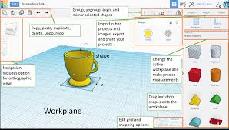
To use the 3D printing service, you must prepare your design in advance and email it to your local South Dublin Library.

Step-by-step guide:
- Choose what you want to print
Decide on a design before visiting the library.
- Download a pre-made design (optional)
  - Visit www.thingiverse.com or www.printables.com
  - Browse thousands of free, pre-designed 3D models
  - Download your chosen design and save it as an .STL or .3MF file
- Create your own design (optional)
  - Visit www.tinkercad.com
  - Use this free, browser-based design tool to create your own model
  - Download and save your finished design as an .STL or .3MF file
- Email your file to your local South Dublin Library.
Library staff will manage the printing process for you.
Please note: Printers are subject to fair use. Prints should be kept to a reasonable size. Library staff are happy to help if you need assistance at any stage.

2. Conditions of Use
Use of the SDCC Leabharlanna Libraries Service 3D printers is subject to the following conditions:
- The 3D printer may only be used for lawful purposes.
- You may not use the 3D printer to create:
  - Weapons, models of weapons, or constituent weapon parts
  - Designs that are obscene, offensive, or inappropriate for a public library environment
  - Designs that are subject to copyright restrictions
- The library reserves the right to refuse any 3D print request at its discretion.
- The service is for educational and hobby purposes only and must not be used for commercial or financial gain.
- A fair usage policy applies:
  - One free 3D print per person, per week.
- The maximum print time for any single design is 7 hours at the library’s discretion during busy periods.
- Exact turnaround times for 3D prints cannot be guaranteed.

3. Printer Access and Technical Limits
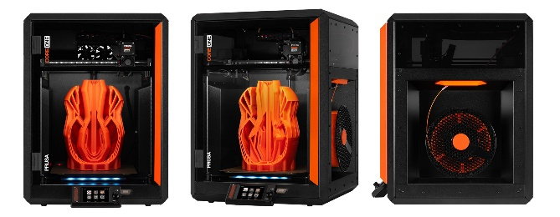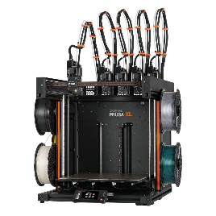

- Only library staff may operate the 3D printers.
- Files will be printed “as is”, without modification. Please check the specification size of the 3D print before sending.
- If supports are required, they will remain attached when you collect your model.
- South Dublin Library Service uses the following printers:
  - PRUSA CORE ONE – available in all library branches
  - PRUSA XL – available in:
    - Ballyroan Library
    - North Clondalkin Library
    - County Library Tallaght

4. Uncollected Items and Display
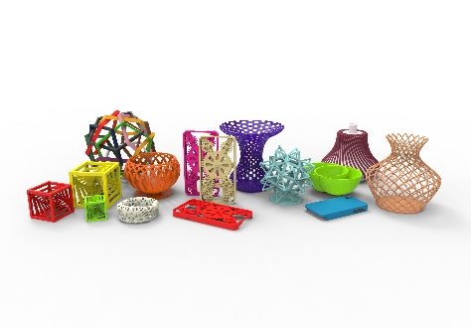

- Items not collected within 7 days become the property of the library.
- Uncollected items may be displayed in the library.
- Designs awaiting collection may also be displayed.
- Images of completed 3D prints may be used by the library for promotional purposes.

5. Final Notes
SDCC Leabharlanna Libraries aims to provide safe, inclusive, and inspiring access to emerging technologies. By using the 3D printing service, borrowers agree to comply with this policy and to respect the shared nature of public library resources.
If you have questions or need help preparing your design, please speak to a member of library staff — we are happy to help.

