Creative Ireland South Dublin Programme
Stimulus Programme

Creative Social Enterprises and Creative Entrepreneurs Award
Awards from €1,000 to €4,000
Budget: €20,000

Creative Ireland is a cultural and creativity programme designed to promote individual, community and national wellbeing. The purpose of this fund is to place Cultural and Creative practitioners in South Dublin County at the centre of economic development and wellbeing.
Applications are now invited for the following awards.

Creative Ireland South Dublin, in partnership with LEO South Dublin, would like to invite proposals from Creative Social Enterprises and Creative Entrepreneurs working in the arts, crafts, design, fashion, film, music, and performing arts.

This funding opportunity aims to support:
- Engagement with new audiences and/or new markets.
- To increase access to local and national platforms for creative social enterprises and creative Entrepreneurs.
- Innovative projects that will complement and augment local events such as the South Dublin Libraries Annual Christmas Craft Fair.
It is open to individuals and organisations based in the county who have not already received funding in 2020 under other strands of the Creative Ireland South Dublin programme.

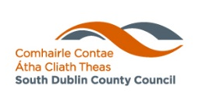
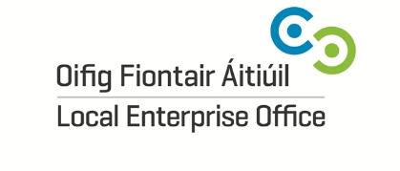
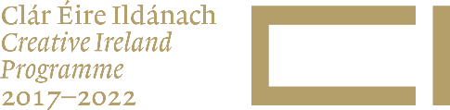

Criteria
- The extent to which the proposal meets the aims of the award
- The quality of the proposal, including clarity of intention; the track record of personnel involved
- The benefit of this award to your practice/ enterprise

Conditions
- Payments will be made on acceptance of the award along with the provision of one high quality image (max. 2MB).
- Recipients will be required to complete an evaluation report and provide an excel report of income and expenditure on completion of the event or project.
- Creative Ireland branding i.e. logo, must be visible on websites, programmes, posters, social media and any other promotional tools used to promote the project or event.
- The following wording must also be used on promotional material and press releases in relation to the event: ‘This (Project name) is supported by the Creative Ireland Programme South Dublin’.
Applications
Application forms and any supporting documents should be submitted as one PDF file.
Supporting material
- A C.V. /biography of key individuals or organisation
- Letter (s) of support/ expression of interest
Queries to: oscannell@sdublincoco.ie
Applications to: jfogarty@sdublincoco.ie
Selection Process
Proposals will be assessed by a selection panel consisting of representatives of the Culture Team and representatives of LEO. Applications may be invited to supply additional information on request by the panel.
The selection panel reserves the right to recommend that no awards are made under this scheme.
Closing Date for Applications: Friday, 25th September 2020 @ 1pm.
Application Form
Creative Social Enterprises and Creative Entrepreneurs Award

1. MAIN GENRE/DISCIPLINE

The purpose of this field is only to identify the main genre that applies to this particular project.
2. ORGANISATION DETAILS

NAME OF APPLICANT ORGANISATION/INDIVIDUAL:
KEY CONTACT:

ORGANISATION PHONE NUMBER: EMAIL ADDRESS OF ORGANISATION:

3. PROJECT DETAILS

TITLE OF INITIATIVE

TARGET AUDIENCE /MARKET AGE RANGE

4. NAME(S) OF KEY PRACTITIONERS INVOLVED:

- DESCRIPTION OF PROPOSED ACTIVITY (Max 1500 CHARACTERS)
- BENEFIT OF THE ACTIVITY TO THE PRACTITIONER/ENTERPRISE
(Max 1500 Characters)
8. KEY DATES / LOCATIONS/ FOR PUBLIC ENGAGEMENT EVENTS IN 2020 /2021

9. PROJECTED NUMBERS OF PARTICIPANTS / AUDIENCES / FOOTFALL
(Both real and/or virtual)

10. PUBLIC RELATIONS AND PROMOTION
Promotion: Please provide an overview of the type of promotion you will use i.e. brochures, posters, advertising, social media etc.

11. PLEASE ENTER THE SOCIAL MEDIA LINKS YOU WILL USE
URL

Social Media Channel

URL

Social Media Channel

Financial details
Project Income 2020 (inc benefit in kind, other grants, fees, box office) | (€)
Total

Project Expenditure 2020 | (€)
Total

Funding requested from Creative Ireland South Dublin 2019 | (€)

I declare that the information supplied in this proposal is accurate and complete.
I understand that all applications and all information provided in respect of the Award Application will be held on file for no longer than 12 months.

Signed: __________ Date: __________

