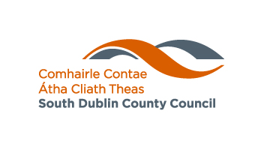

EMERGING ARTIST AWARD 2021

This award is designed to support the practice and/or career development of young artists aged 18 – 25 living in South Dublin County Council’s Administrative Area, in any art form, other than music. *N.B. For music funding, please apply for the Annette Halpin Memorial Award. The maximum award that can be applied for is €2,000.

- If mentoring is being applied for, this should be supported by a letter of agreement from the mentor and details of the exchange that would take place.

CONDITIONS

- Artists must live in South Dublin County Council Administrative Area, it is the responsibility of the applicant to verify which Administrative Area they reside in.
- Funding may be used to support the practice of young artists. It may include mentoring, the purchase of specialised equipment / materials to create new work / travel to events that are useful to the applicant’s practice / attendance at masterclasses / to fund an exhibition / or performance of new work / or to fund research for the making of new work.
- Funding may not be used;
  - For competitions (entry or travel to)
  - This funding will not fund third level undergraduate studies
  - To fund an artist to work with a school or youth service based group. For more information on funding available for this area, please contact the Arts Office.
- Funding provided by South Dublin County Council must be acknowledged in all publicity material associated with the work. South Dublin County Council and NOISE logos are available from the South Dublin County Council Arts Office.
- You may not apply on behalf of someone else.
- Successful applicants will be asked to provide a short, written report describing their experiences and the contribution of the fund to their development.
- Successful applicants will be asked to participate in evaluation of the fund by providing a short, written report describing their experiences and the contribution of the fund to their development.
- Applicants awarded funding must agree to participate in an interview for the NOISE South Dublin website and be open to discussing their experience with other young artists.
- South Dublin County Council reserves the right to publicise the awarding of the fund. Successful applicants may be asked to be available for promotional material.

CLOSING DATE FOR RECEIPT OF COMPLETED APPLICATIONS
7th^{h} May 2021 @ 5pm
For enquiries or further information email cbaker@sdublincoco.ie

