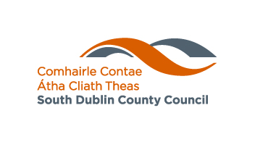

Arts Project Award
Amateur, Voluntary & Community Groups

Five Awards of €1,000 each are now available from South Dublin County Council to Amateur, Voluntary and Community groups. The Awards will primarily grant aid to groups based in the South Dublin County Council’s Administrative Area whose activity may be inside or outside of the county. Also eligible to apply for support under the award scheme are groups whose activity takes place in the South Dublin County Council’s Administrative Area, but are not based in the County.

These Awards may be given to persons or bodies organising an event that in the opinion of the Council would:
- Stimulate public interest in the arts
- Promote the knowledge, appreciation and practice of the arts
- Assist in improving the standards of the arts across the County.

Definition of the arts
"The arts" as defined under the Arts Act of 2003 means any creative or interpretative expression (whether traditional or contemporary) in whatever form, and includes, in particular, visual arts, theatre, literature, music, dance, opera, film, circus and architecture, and includes any medium when used for that purpose.

SELECTION CRITERIA

The selection of the project for South Dublin County Council 2020 Project Award will be based on:

- The extent to which the proposed process shows clear artistic direction
- The quality of the proposal presented with reference to other competing applications

Demonstrable need for financial assistance

GRANT SCHEME CONDITIONS
- The activity or event must begin before the end of 2021.
- Applications can only be considered if submitted prior to the event taking place.
- All commercial activities will be outside the scope of the scheme, (this will not preclude assistance towards the cost of professional assistance e.g. producer, lecturer, orchestra, etc).
- Resources available to the organisers will be taken into consideration.
- Recipients of awards must acknowledge the Council’s assistance in promotional material. The Council’s logo is available on request.
- Consideration will be given as to whether the event would take place regardless of an arts award.
- Awards are not made for Capital expenditure.

Closing Date for Applications: 7th May 2021 at 5pm.

