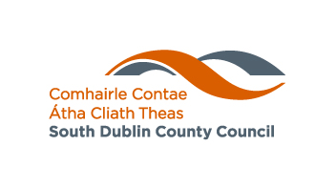

South Dublin County Council
Artists Resilience Awards 2021
Guidelines - How to apply
- Applications are to be made online through https://submit.link/4T

- Applicants will be required to:
1. Give a brief summary of the proposal (Max. 50 words).
- Outline how the award will impact on the Artist (Max. 50 words)
- Provide details of the concept (Max. 500 words)
- Provide a timeline for the project
- Provide a detailed costing of the proposal
- Provide evidence of any agreements in place with funders, organisations and venues which relate to this proposal.
- Provide contact details for two referees.
- Provide a current C.V. (curriculum vitae) of the lead artist and any artist collaborators involved in the proposal
- Provide samples of your work (Max 3 examples)

Assessment Criteria
The selection panel, a panel of peers, will assess proposal based on the following criteria.

- The quality of ideas/proposal presented both on an individual basis and with reference to other competing applications.
- The extent to which the proposed process shows clear artistic direction and vision.
- The impact of the award on the artist
- The viability of the proposal and the ability of the applicant to realise their aspirations within the time and resources available.

Conditions
- Artists must live in the South Dublin County Council Administrative Area. It is the responsibility of the applicant to verify which Administrative Area they reside or work in.
- No email applications should be submitted. All supporting materials should be submitted with the application form and other documentation.
- Funding by South Dublin County Council must be acknowledged on any publicity material relating to the activity supported by the scheme. Logos are available from South Dublin County Council Arts Office.

- Successful applicants will be asked to participate in evaluation of the fund by providing a short, written report on completion of the project. Copies of promotional material must also be submitted to the Arts Office.

- A tax clearance certificate may be required.

- Projects must be completed before December 2021, although artists may be able to extend the timeframe for completion and presentation of the artwork, under exceptional circumstances and with the agreement of the Council.

Queries can be sent to: cbaker@sdublincoco.ie
Answers to queries may be published online for the benefit of all applicants.

Closing Date for receipt of completed applications: Wednesday 28th April @ 4pm

