Individual Artists & Creatives Award 2020
In Collaborative Practice

This Creative Ireland South Dublin initiative seeks to support artists and creatives with a collaborative practice. The successful proposal will have both a developmental aspect for the artist’s creative practice, and a community collaborative element to it. It will engage with one of the cultural/creative/heritage venues or organisations in the county.

There are two strands to the Awards:
- Project Award€10,000
- Development Award €5000

This award is made possible under Pillar Two of the Creative Ireland Programme for 2020 - Enabling Creativity in Every Community.

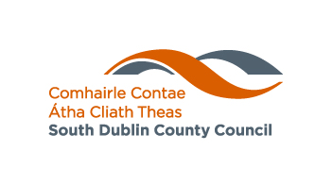
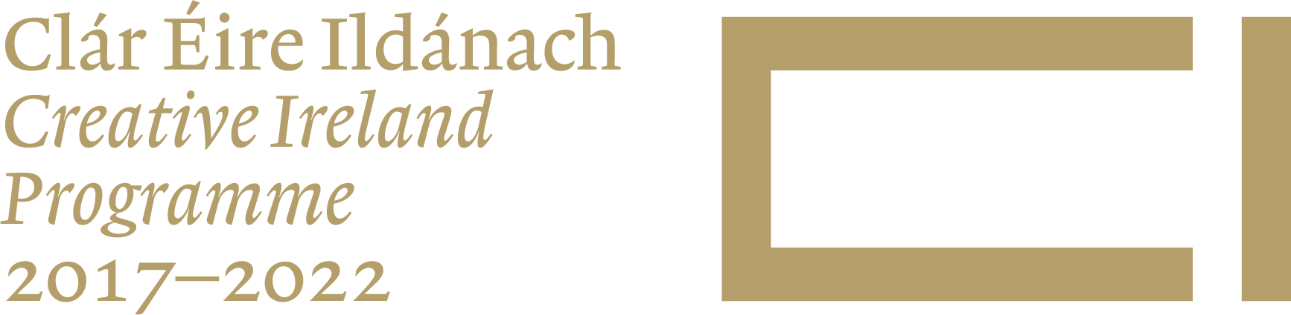

Selection
The selection judges will develop a shortlist of applications that best meet the selection criteria and may request further information to help in the assessment of the shortlisted applications. The selection panel may also decide not to seek further information of shortlisted applicants.

Selection Criteria

- The extent to which the proposed event/project is aligned to the Creative Ireland Programme Pillar - Enabling Creativity in Every Community;
- The extent to which the proposed event/project maximises community and citizen engagement;
- The extent to which the proposed event/ project is ambitious, innovative and fosters creativity;
- The potential scope of the event/project and anticipated target audience;
- The cost of the proposed event/project and any additional supports and funding that may be required or have been confirmed; and
- The feasibility of completion within the current year.
How to apply
- Please submit 1 copy of the attached application form.
- Please give the fullest possible description of the project or proposal (Max. two A4 pages) including a description of how the award will impact on the development of the artist and their practice.
- Provide a timeline for the project/development activity and a detailed costing of your proposal stating any income already confirmed. Please note all costings must be submitted on an excel sheet.

- Applications should provide evidence of any agreements in place with mentors, funders, organisations and venues which relate to this proposal.
- Please include a current C.V. (curriculum vitae).
- Please provide online links to samples of your work.

Conditions
- The community of engagement and any associated event must be within the South Dublin County Council Administrative Area.
- Proposals should include a public event as an outcome of the process.
- Applications will only be accepted by email.

- These awards will not fund third level undergraduate studies.
- Funding by Creative Ireland South Dublin must be acknowledged on any publicity material relating to the activity supported by the scheme. Logos are available from South Dublin County Council Arts Office.

- Successful applicants will be asked to participate in evaluation of the fund by providing a short written report on completion of the project. Copies of promotional material must also be submitted to the Arts Office.

- A tax clearance certificate may be required.

- A Project Report (Template to be provided) must be completed by November 2020. Date to be confirmed.

Applications and all information will be held on file for no longer than 12 months
Completed application forms should be sent to:

oscannell@sdublincoco.ie

Closing Date for receipt of completed applications: Monday 18th February 2020

APPLICATION FORM

Artists & Creatives
Collaborative Practice Award 2020

Name: _______________________________________________________________________

Address: _____________________________________________________________________

_____________________________________________________________________

Telephone: _____________ Mobile: ______________ E-Mail: _________________________

State category of application: Creative Discipline

Amount Requested

Strand a) Max. amount €10,000
Strand b) Max. amount €5,000

Please list supporting material
_______________________________________________________________________________

_______________________________________________________________________________

_______________________________________________________________________________
_______________________________________________________________________________

Referees

Please give the names, addresses and telephone numbers of two people as referees

- _____________________________________________________________________________

_____________________________________________________________________________

- _____________________________________________________________________________

_____________________________________________________________________________

I declare that the information supplied in this proposal is accurate and complete.
I understand that all information provided in respect of the Award Application will be held electronically and it should be noted that the Freedom of Information Act applies to all records held by South Dublin County Council.

Signed: ______________________________________ Date: _________________________

South Dublin County Council
County Hall,
Tallaght,
Dublin 24

Privacy Statement for Economic, Enterprise and Tourism Development Department
Business Unit: Arts Office

Who we are and why do we require your information?
South Dublin County Council seeks to promote the economic, social and cultural development of the County and in doing so contribute significantly to improving the quality of life of the people of South Dublin County.
The delivery of high-quality services, tailored to meet the needs of all our customers, remains one of South Dublin County Council’s core objectives and is included in our Corporate Plan. This quality service includes not only the level and quality of service given to our customers but also the quality of our decision-making processes, the efficiency and effectiveness of our corporate operations, standard of our facilities and our ability to adapt in an ever-changing environment.
To provide the most effective and targeted range of services to meet the needs of the citizens, communities and businesses of South Dublin County we will be required to collect, process and use certain types of information about people and organisations. Depending on the service being sought or provided the information sought may include ‘personal data’ as defined by the Data Protection Acts and by the General Data Protection Regulation (GDPR) and may relate to current, past and future service users; past, current and prospective employees; suppliers; and members of the public who may engage in communications with our staff. In addition, staff may be required, from time to time, to collect, process and use certain types of personal data to comply with regulatory or legislative requirements.

Why does the Council have a privacy statement?
South Dublin County Council has created this privacy statement to demonstrate the Council’s firm commitment to privacy and the security of the personal data you provide to the Council.
South Dublin County Council’s commitment to you is that the personal data you may be required to supply to us is;

- Obtained lawfully, fairly and in a transparent manner
- Obtained and retained for only specified, explicit and legitimate purposes
- Adequate, relevant and limited to what is necessary for the purpose for which it was obtained
- Recorded accurately and, where necessary, updated
- Stored safely and securely
- Kept only for as long as is necessary for the purposes for which it was obtained.
- Kept in a form which permits identification of the data subject
- Processed fairly and in a manner that ensures the appropriate security of the personal data including protection against unauthorised or unlawful processing.

Service referred to in this Privacy Statement
Recording applications to the Councils Bursary and Grant Schemes and informing applicants of the outcome of their application.

Personal data required
Applicants: Name, Address, Phone no, email address
Referees: Name, Address, Phone no, email address
Specific and legitimate purpose for which the personal data is being sought
Applicant: To identify the applicant and the proposal
Referee: To verify the information provided by the applicant

Legal basis under which the information is required to be supplied
There is no legal obligation for somebody to give us their information. However, if they wish to be considered for a grant or award it will be necessary for these details to be provided.
Other organisations/bodies/entities that the Council will be required to share data with, or obtain data from, in order to provide the required service
The Council will not be required to share data with, or obtain data from, other organisations/bodies/entities in order to provide the required service

How your personal data will be kept safe from unauthorised or unlawful processing
Paper documentation will be scanned and disposed of as soon as possible and an electronic version will be stored on SDCC’s secure document storage system

Period for which your personal data will be retained
Data will be held for 12 months.

Contact Details
In order to communicate with you, the Council will ask for your contact details. You do not have to provide all contact details but providing more, such as email, phone, address, makes it easier for the Council to communicate with you.

Your Data Protection Rights
You have the right to request access to personal data held about you, obtain confirmation as to whether data concerning you exists, be informed of the content and source of data and check its accuracy. In addition, if the data held by South Dublin County Council is found to be inaccurate, you have the right to have the data corrected by the Council.
You may request to have information erased, object to direct marketing and to restrict the processing of your information, including automated decision-making.
You have the right to request data portability (transfer) of personal data held electronically by the Council to another data controller where technically feasible.
You may withdraw consent at any time where processing is based entirely on your consent.
Please note that to help protect your privacy the Council will take steps to verify your identity before granting access to personal data.
Data access requests should be made in writing and addressed to the Data Protection Officer, South Dublin County Council, County Hall, Tallaght, Dublin 24.
E-Mail: dataprotection@sdublincoco.ie.
Telephone: 01-4149000.

Right of Complaint to the Data Protection Commission
If you are not satisfied with the outcome of the response you receive in relation to a data access request or are unhappy with the manner of the processing of your data by South Dublin County Council then you are entitled to make a complaint to the Data Protection Commission which may investigate the matter for you.
The Data Protection Commission’s website is www.dataprotection.ie or you can contact the Commission’s Office at:
Phone: 0761104800 or 0578684800
E-mail: info@dataprotection.ie
Postal Address: Data Protection Commission
21 Fitzwilliam Square South
Dublin 2 D02 RD28

