**A Review of Adamstown Strategic Development Zone Planning Scheme, 2014 to reflect the Ministerial Guidelines: ‘*Urban Development and Building Heights Guidelines for Planning Authorities’*, (DoHPLG, 2018)**

Prepared by South Dublin County Council

Land Use, Planning and Transportation Department

April 2020

**Section 1: Introduction**

**Contents**

**Chapter 1.** Background to the Adamstown SDZ Planning Scheme and Implementation to Date Pg 2

* 1. Background and context
  2. Development Areas and Amenity Areas
  3. Building Heights within the existing Planning Scheme
  4. Assessment of Planning Applications
  5. Implementation of the Planning Scheme to date

**Chapter 2**. Recent Relevant Policy, since adoption of the Planning Scheme in 2014 Pg 6

2.1 South Dublin County Development Plan 2016-2022

2.2 Strategic Planning and Relevant Legislative Changes in Recent Years

2.3 Government Guidelines

**Chapter 3.** Review Requirement Pg 13

3.1 Overview of the Independent review by Metropolitan Workshop

3.2 The Review

3.3 Further Considerations for Building Height Review

3.4 Consistency with the Guidelines

**Chapter 4.** Conclusions Pg 20

**Chapter 1**

**Background to the Adamstown SDZ Planning Scheme and Implementation to Date**

Adamstown Strategic Development Zone was designated under Government Order S.I. 272 of 2001, on 1st July 2001. The planning scheme was adopted by the elected members of South Dublin County Council on 7th May 2003 following extensive public consultation and the scheme was approved by An Bord Pleanala on 25th September 2003.

Adamstown Planning Scheme was amended and approved in 2014 and in light of new ministerial guidelines, amendments 1-4 of the Planning Scheme where approved by An Bord Pleanala in 2017.

The Department of Housing, Planning, Community and Local Government has published *Urban Development and Building Heights Guidelines for Planning Authorities (2018)*. Specific Planning Policy Requirements (SPPR’s) for building heights are set out in these guidelines. Based on the requirements as set out in SPPR 3(B) “*In the case of an adopted planning scheme the Development Agency in conjunction with the relevant planning authority (where different) shall, upon the coming into force of these guidelines, undertake a review of the planning scheme, utilising the relevant mechanisms as set out in the Planning and Development Act 2000 (as amended) to ensure that the criteria above are fully reflected in the planning scheme. In particular the Government policy that building heights be generally increased in appropriate urban locations shall be articulated in any amendment(s) to the planning scheme”.*

On the foot of this, a review of Adamstown SDZ Planning Scheme is required to be undertaken to assess its consistency with these Guidelines and to inform whether an amendment to the Planning Scheme is necessary.

Put in Map of Adamstown

* 1. **Background and context**

On 1st July 2001, the Government ordered the designation of 223.5 hectares of privately owned land at Adamstown, as a site for the establishment of a Strategic Development Zone (SDZ) for the purpose of delivering residential development and associated infrastructure and facilities.

South Dublin County Council is the specified Development Agency for the SDZ. South Dublin County Council, as Development Agency, prepared a draft Planning Scheme for the site in 2002. The Scheme was approved by An Bord Pleanála, on appeal, in September 2003.

Development commenced on foot of the approved Planning Scheme in 2004. To date, the Adamstown model has delivered approximately 2,143 homes and significant supporting infrastructure and services, including a railway station, 2 primary schools, a post primary school, crèche, neighbourhood park, local retail services, water and sewerage infrastructure and internal strategic roads and upgrades to adjoining road network. There are a further 624 units currently under construction. Development is currently in Phase 3 of the Planning Scheme.

In 2013, having regard to the challenges presented by the economic crisis and collapse of the residential market, South Dublin County Council initiated a statutory process to amend the 2003 Planning Scheme. This review delivered a policy refocus away from high density apartment-led development, and toward life-cycle housing and associated reduced densities. The review of the Planning Scheme retained the overall principles for a sustainable urban community; with a strong sense of identity that is attractive, safe and secure in a traditional town and village format; and sought to ensure that residential development could be provided at appropriate densities, ably supported by the delivery of all necessary facilities and infrastructure. The amended Planning Scheme was approved by An Bord Pleanála, on appeal, in December 2014.

In 2017, having regard to the Department of Environment, Community and Local Government published guidelines *Sustainable Urban Housing: Design Standards for New Apartments Guidelines for Planning Authoritie*s (2015), amendment numbers 1-4 of the planning scheme were approved by An Bord Pleanála, which served to align the scheme with national guidance in terms of design standards and floor areas.

The planning scheme sets out the specific parameters of built development that is permissible. The total extent of development permissible in Adamstown is listed in Table 2.3 of the Planning Scheme, giving a maximum residential extent of 970,000 sq. metres and 8,905 units, with a maximum non-residential extent of 127,000 sq. metres of commercial development.

**1.2 Development Areas and Amenity Areas**

Eleven distinct Development Areas and four Amenity Areas were designated across the scheme, with each of these development areas prescribed a quantum of residential, commercial and retail uses; and some with educational/civic uses and amenity areas.

Each development area has their own unique character and role, with mixed uses, open space, landmark buildings, flexible perimeter buildings and a high quality public realm. Section 2.3 (viii) sets out the subject of ‘*Building Type and Height’* within the planning scheme.

Section 2.3 ‘*Overall Design of Development*’ sets out the overall pattern of development which is based on a traditional urban town and village format, with lively and interconnecting network of streets, squares and public parks married with interesting buildings providing a mix of residential, commercial, pubic and community uses. Each development area is individual yet complementary to the adjacent development area.

Each amenity area has been positioned in a strategic location, whether running along-side the attendant grounds of Finnstown House and bounding existing protected structures; within a central location within the SDZ, or be it a central boulevard leading from the high density Adamstown Station with its transportations links towards Airlie Park.

**1.3 Building Heights within the Planning Scheme**

Section 2.3 (viii) ‘*Building Type and Height’* sets out the design rationale for building heights within the scheme. Heights within the scheme are based around the area character type, courtyard building, perimeter building heights and landmark building heights. Details of such are set out in Table 2.8 and Table 2.9 within the scheme.

Table 2.8 provides details on Min-Max Building Height by Development Area on such issues as area character type, courtyard building heights and perimeter building heights. The Planning Scheme identifies low, medium and high-density development areas and specific number of storeys for each.

Table 2.9 identifies the Maximum Landmark Building Height by Area Character Type; i.e max 5 storeys for low density, 7 storeys for medium density and 10 storeys for high density areas. Each development area also identifies locations of ‘courtyard’ and ‘perimeter’ buildings and their corresponding heights in relation to the character type.

The design rationale within the scheme also adheres to the principle of sustainable development and compact growth in terms of locating high density development in close proximity to transportation nodes and subsequently, the density reduces as one travel further away from the transport node.

Landmark buildings create a sense of place, urban legibility, visual diversity and are situated at key focal points throughout Adamstown. These locations include the transport interchange, village centres, key street corners or junctions or at the end of strategic vistas, the edges of public squares or parks. The height of landmark buildings is characterised by high architectural quality in terms of innovative design and use of materials. They will be evaluated in terms of townscape analysis, environmental impact and durability and quality of materials.

**1.4 Assessment of Planning Applications**

Height in the SDZ Planning Scheme is addressed in section 2.3 (viii) and development plan guidelines set out in sections 11.2.1, 11.2.7 and 2.2.3 of the South Dublin County Council Development Plan 2016-2022.

Assessment of planning applications are governed under the development management process and under the Planning Scheme requirements.

**1.5 Implementation of the Planning Scheme to Date**

Since November 2016, a number of planning applications have been submitted and decided on by South Dublin County Council. In November 2016, a Community Centre with Sports Hall was permitted (SDZ16A/0001 refers) and has been constructed. In January 2017, permission was granted for the construction of 267 dwelling units in the north western part of the SDZ lands at Tobermaclugg (SDZ16A/0003 refers) and this development is under construction.

In July 2017, planning permission was granted for an All-weather Multi-Purpose Sports Pitch (SDZ17A/0004 refers). In August 2017, 169 dwelling units was granted permission (SDZ17A/0006 refers). In September 2017, permission was granted for Loop Road 1 under (SDZ17A/0007 refers), Loop Road 1 is fully constructed and operational.

The Celbridge link road was granted permission (SDZ17A/0009 refers), this application refers to the Celbridge Link Road within the SDZ lands.

In March 2018, 268 dwelling units were granted permission in Tobermaclugg Village (SDZ18A/0002 refers) and in February 2019 a Local Centre including provision of a supermarket, retail unit/coffee shop was granted in the same development area (SDZ18A/0015 refers).

In April 2018, Tandys Lane Public Park was granted permission (SDZ18A/0003 refers) and in February 2019, Airlie Park which includes provision of all-weather pitches, cricket pitch, basketball, tennis courts, play areas and changing facilities on a 10.95ha site was granted permission (SDZ18A/0014 refers).

In December 2018, permission was granted for the construction of 346 dwelling units at St. Helens (SDZ18A/0011 refers) and development is under construction. Permission was also granted for 237 dwelling units in Airlie Stud Development Area (SDZ18A/0004 refers) and construction has commenced.

In July 2019, permission was also granted for the construction of 163 dwellings in Tubbermaclugg Village Development Area (SDZ19A/0003 refers).

Planning permission has recently been lodged for 237 dwellings on the western part of the SDZ lands at Somerton, under reference SDZ19A/0004, this is currently out on further information request.

Pre-planning discussions are also underway with the relevant landowners for development at Tubber Lane, Tandy’s Lane and Adamstown Station development areas on the SDZ lands. Please see Figure 2 for a graphical representation of this planning activity.

**Get drawing office to provide map of what’s built and what’s left to build.**

**Chapter 2**

**Recent Relevant Policy, since adoption of the Planning Scheme in 2014**

**2.1**

1. *South Dublin County Development Plan 2016-2022*

*2.2.3 Residential Building Height*

‘A policy shift towards more compact and sustainable forms of development over the past two decades has resulted in increased building heights in the County. Varied building heights are supported across residential and mixed use areas in South Dublin County to promote compact urban form, a sense of place, urban legibility and visual diversity’.

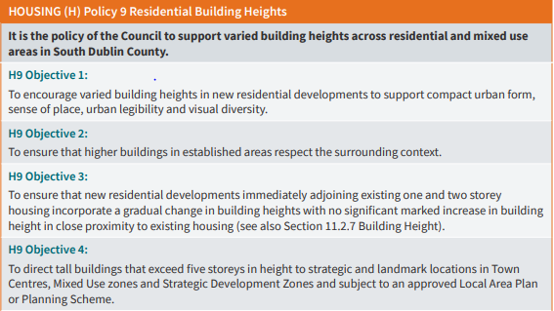

*Section 11.2.7 Building Height*

*‘Varied building heights are supported across residential areas, urban centres and regeneration zones in South Dublin County, subject to appropriate safeguards to protect the amenity of the area.*

*Development proposals that include ‘higher buildings’ that are greater than the prevailing building height in the area should be supported by a strong urban design rationale (as part of a Design Statement) and provide an appropriate series of measures that promote the transition to a higher building.*

*Proposals for higher buildings of over three storeys in residential areas should be accompanied by a site analysis (including character appraisal) and statement that addresses the impact of the development (see also Section 11.2.1 – Design Statements).*

*The appropriate maximum or minimum height of any building will be determined by:*

* *The prevailing building height in the surrounding area.*
* *The proximity of existing housing - new residential development that adjoins existing one and/or two storey housing (backs or sides onto or faces) shall be no more than two storeys in height, unless a separation distance of 35 metres or greater is achieved.*
* *The formation of a cohesive streetscape pattern – including height and scale of the proposed development in relation to width of the street, or area of open space.*
* *The proximity of any Protected Structures, Architectural Conservation Areas and/or other sensitive development.*

*Proposals for ‘tall buildings’, that exceed five storeys will only be considered at areas of strategic planning importance such as key nodes, along the main street network and along principal open spaces in Town Centres, Regeneration zones and Strategic Development Zones, and subject to an approved Local Area Plan or Planning Scheme’.*

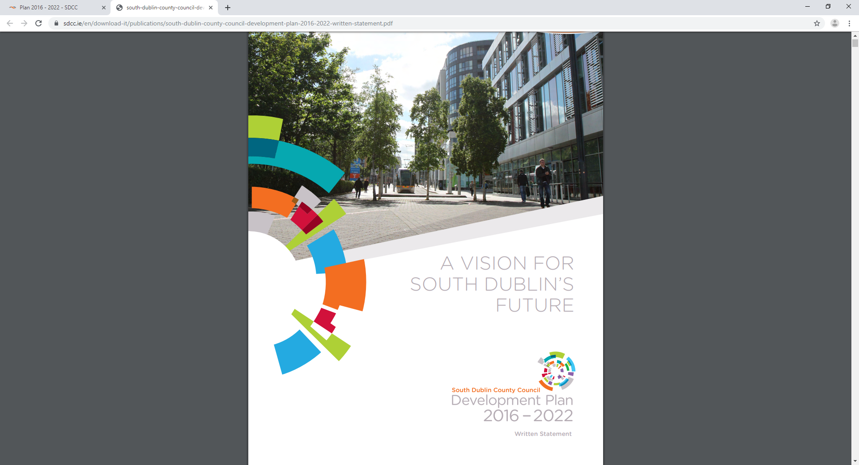

**2.2**

1. *Strategic Planning and relevant Legislative change in recent years*

*Rebuilding Ireland: Action Plan for housing and Homelessness*

In recent years the government have published action plans, guidelines and new legislation to combat the deep recession that Ireland found itself in from 2008 onwards and the lack of housing supply and dramatically increased monthly rents. The ‘Urban Regeneration and Housing Act’ (2015) aimed to help incentivise regeneration and address housing-supply issues though a ‘carrot and stick’ approach. Reduced development contributions were introduced to reduce the cost of built development, and vacant sites levy was introduced (an annual charge) designed to prevent long-term hoarding of vacant land zoned primarily for residential development.

In 2016, the Government published ‘Rebuilding Ireland; Action Plan for Housing and Homelessness’. This included five ‘pillars’ of action, i.e. to address homelessness, accelerate social housing, build more homes, improve the rental sector and utilise existing housing. The mechanisms to achieve the above were set out, with greater detail relating to the newer planning mechanisms.

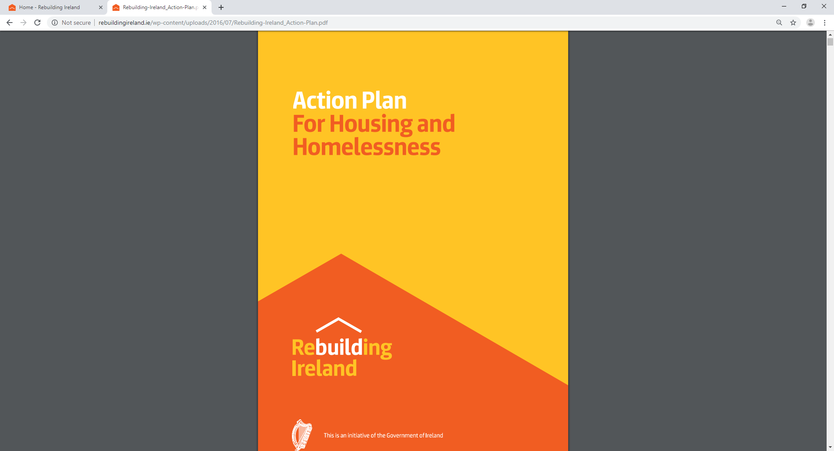

*Transport Strategy for the Greater Dublin Area 2016-2035*

This transport strategy provides a framework for the planning and delivery of transport infrastructure and services for the Greater Dublin Area. Adamstown is a major residential and commercial area located within the GDA and a transport strategy for this area is critical going-forward. The relevant transport objectives for the SDZ area is:

* Corridor C – Maynooth-Leixlip-Lucan to Dublin City Centre. The Kildare Railway Line serves Adamstown and will cater for its future population growth.
* Expansion of the DART Network along the Kildare Line. (Update on this?)
* New LUAS line proposed from central Lucan to the city centre.
* Development of Greenways and enhance cycle provision as per the GDA Cycle Network Plan

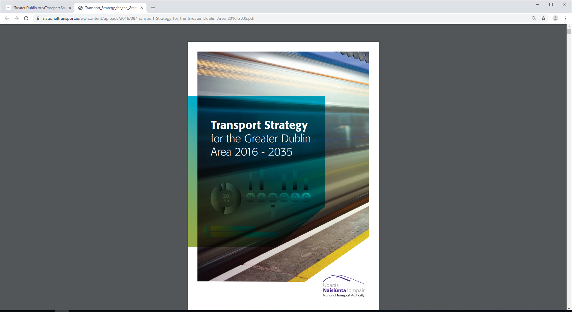

*The National Planning Framework*

In 2018, ‘Project Ireland 2040’ and the ‘National Planning Framework’ (NPF) was published setting out a 20-year strategic framework for balanced regional development. It focuses on long term strategy for development which includes anticipated housing need and required supporting infrastructure.

The NPF identifies a series of National Policy Objectives, Chapter 4, ‘Making Stronger Urban Places’ focuses on improving our urban areas, planning for future urban growth and economic development and regeneration. This chapter discusses matters such as building height and car parking and considers that these matters can be dealt with through high-quality design and alternative solutions which do not compromise public safety or the environment. NPO 13 states that:

“*In urban areas, planning and related standards, including in particular building height and*

*car parking will be based on performance criteria that seek to achieve well-designed high quality*

*outcomes in order to achieve targeted growth. These standards will be subject to a range of*

*tolerance that enables alternative solutions to be proposed to achieve stated outcomes, provided*

*public safety is not compromised and the environment is suitably protected.*”

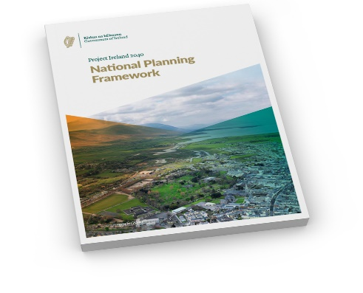

*Regional Spatial and Economic Strategy*

The National Planning Framework guides the newly published Regional Spatial and Economic Strategies (RSES) and the relevant RSES for the Eastern and Midland Region was approved in May 2019. The RSES builds on the foundations of the national policies contained within the NPF and in particular the National Policy Objectives to encourage sustainable development and compact growth.

The RSES contains a *Metropolitan Area Spatial Plan* (MASP) for the sustainable growth of Dublin, which provides a vision for future growth of the area by identifying strategic corridors to achieve compact growth along transport corridors, focusing on large scale strategic residential development and employment opportunities. The development of strategic sites will help meet population targets to provide for consolidated cities and suburbs and preventing unnecessary suburban sprawl.

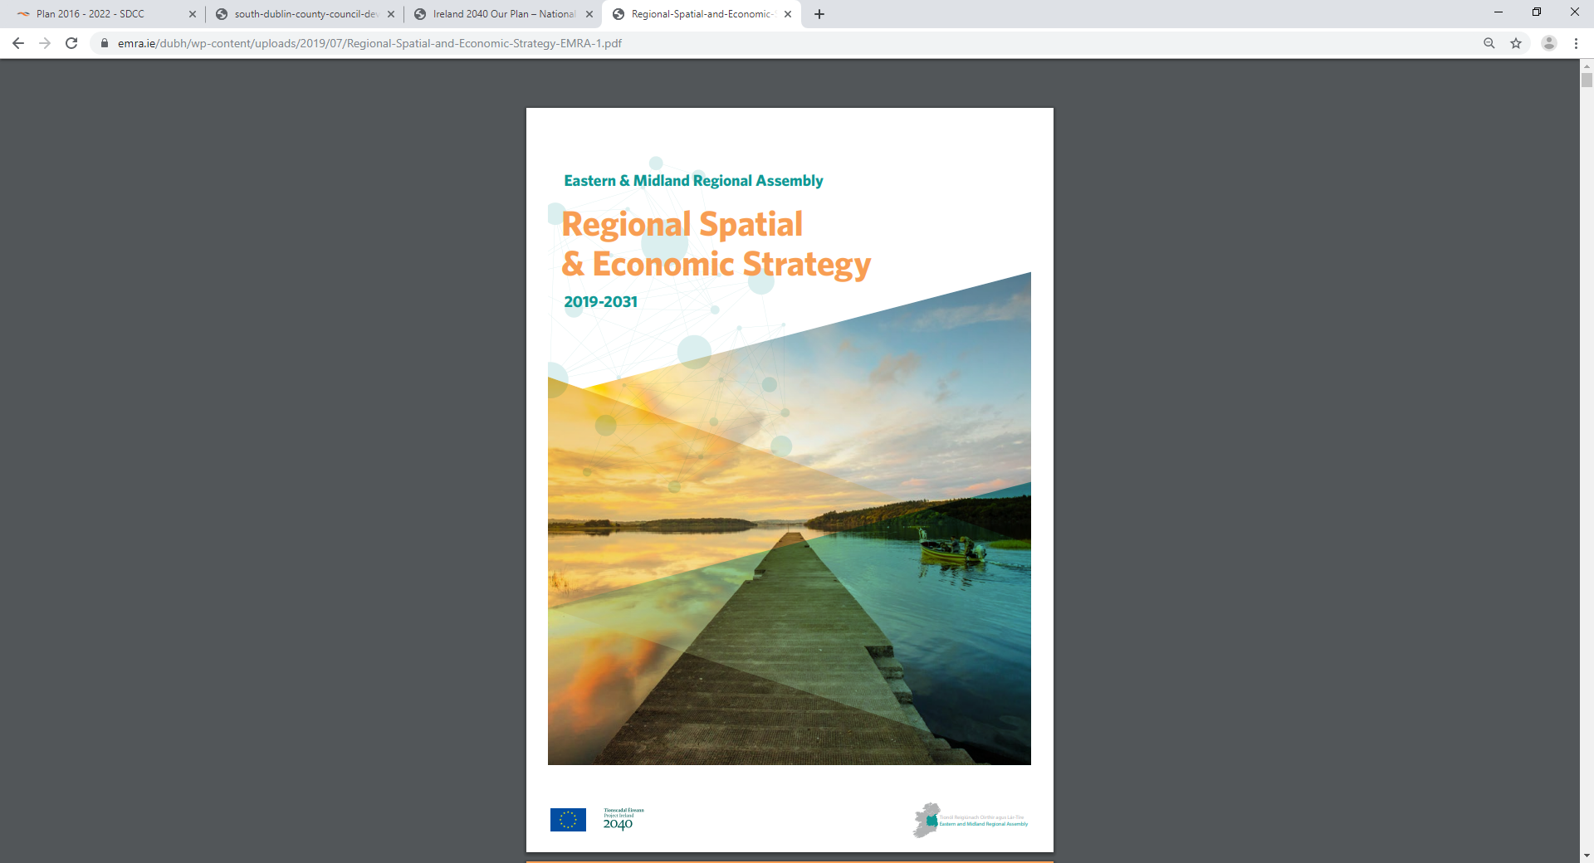

*Climate Action Plan*

‘*Climate Action Plan to Tackle Climate Breakdown’* was published in June 2019, the plan highlights the commitment of the government and public bodies to tackling climate disruption and achieving Irelands decarbonisation goals, central to this is the principles of sustainability and more connected communities. The action plan discusses principles of making growth ‘less transport intensive’ by using key policies such as the successful execution of the National Planning Framework design to promote compact, connected and sustainable living.

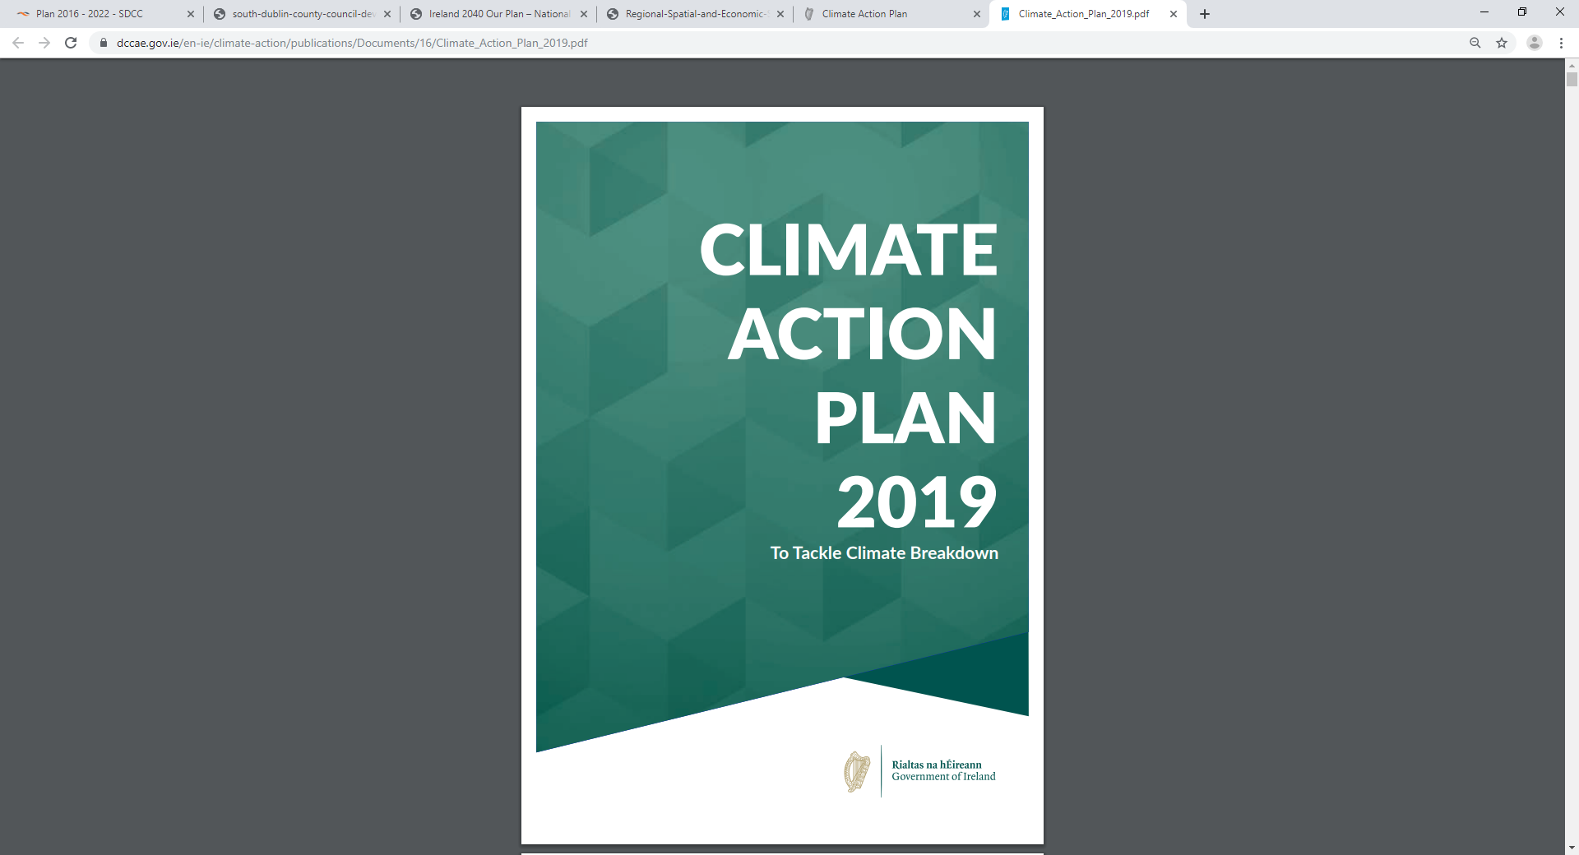

***2.3***

1. *Government Guidelines*

*Urban Development and Building Height Guidelines (2018)*

Urban Development and Building Height guidelines were published in December 2018 under section 28 of the Planning and Development Act 2000 as amended and set of the strategic policy on building heights as set out in the National Planning Framework. These guidelines reiterate the need for sustainable urban communities using national policy for consolidating and strengthening of the existing built up areas and moving away from lower density urban sprawl, in line with the foundations of the NPF and RSES.

The strategic outcomes of the NPF for compact growth, the publication of these national guidelines means that there is significant scope to accommodate the estimated population growth and development needs by building up and consolidating the existing urban areas. The guidelines set out the requirements for development plan, local area plans and SDZ planning scheme to become “more proactive and more flexible in securing compact urban growth through a combination of both facilitating increased densities and build heights, whilst also being mindful of the quality of development and balancing amenity and environmental considerations”.

The guidelines set out Specific Planning Policy Requirement (SPPRs) which must be complied with: *SPPR 1* supports increased building height and density in locations with good transport links. Local authorities are to identify those specific areas in statutory plans.

*SPPR 2* concentrates on ensuring that appropriate mixtures of uses are provided for in statutory plans.

Section 3 of the Guidelines focuses on building height and the Development Management process and implementing national policy that building heights must be increased in appropriate urban locations with good public transport accessibility. The guidelines set out ‘development management criteria’ whereby applicants must demonstrate how developments satisfies criteria such as:

* At the scale of the relevant city/town
* At the scale of the district/neighbourhood/street
* At the scale of the site/building

Specific assessments may also be required to support proposals such as microclimate, biodiversity, aeronautical and environmental assessments.

*SPPR 3* specifically focuses on established Strategic Development Zones (SDZ) Planning Schemes. The relevant section is SPPR 3, Part B, which states:

‘*In the case of an adopted planning scheme the Development Agency in conjunction with the relevant Planning Authority (where different) shall upon the coming into force of these guidelines, undertake a review of the planning scheme, utilising the relevant mechanisms as set out in the Planning and Development Act 2000 (as amended) to ensure that the criteria above are fully reflected in the planning scheme. In particular the Government policy that building heights be generally increased in appropriate locations shall be articulated in any amendment(s) to the planning scheme.’*

*SPPR 4, which relate to Section 3.4 to 3.8 of the Guidelines, focuses on ‘Building Height in suburban/edge locations (City and Towns)’, in this section specific reference is made to Adamstown SDZ, which advocates “where well designed and integrated, also facilitate the development of an attractive street-based traditional town environment with a good sense of enclosure, legible streets, squares and parks and a strong sense of urban neighbourhood, passive surveillance and community”, in the context of providing a variety of building typology and tenure options in providing townhouses (2-3 storeys), duplexes (3-4 storeys) and apartments (4 storey and above).*

The guidelines clearly state *‘*that development should include an effective mix of 2, 3 and 4 storey development which integrates will into existing and historical neighbourhoods and 4 storey or more can be accommodated alongside existing larger buildings, trees parkland, river/sea frontage or along wider streets*’.*

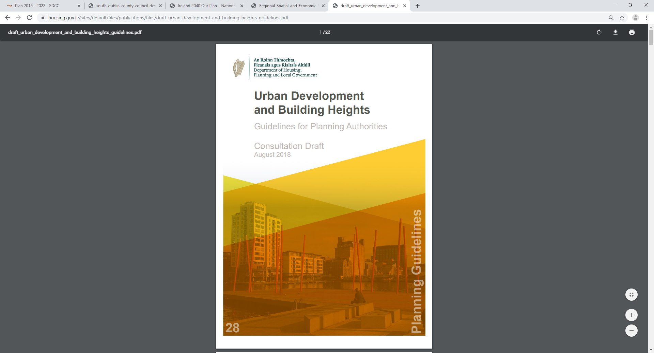

Having regard to the context of the building height guidelines and specifically to SPPR 3(b) above, this review of building heights within Adamstown SDZ is being carried out.

*Sustainable Urban Housing; Design Standards for New Apartments – Guidelines for Planning Authorities (March 2018)*

These guidelines supersede previous statutory guidance on residential development and urban design that pre-date the current planning scheme. These guidelines update the previous guidance in light of greater evidence and knowledge of current and future housing demand in Ireland having regard to the Government’s action ‘Rebuilding Ireland’, ‘Project Ireland 2040’ and the ‘National Planning Framework’.

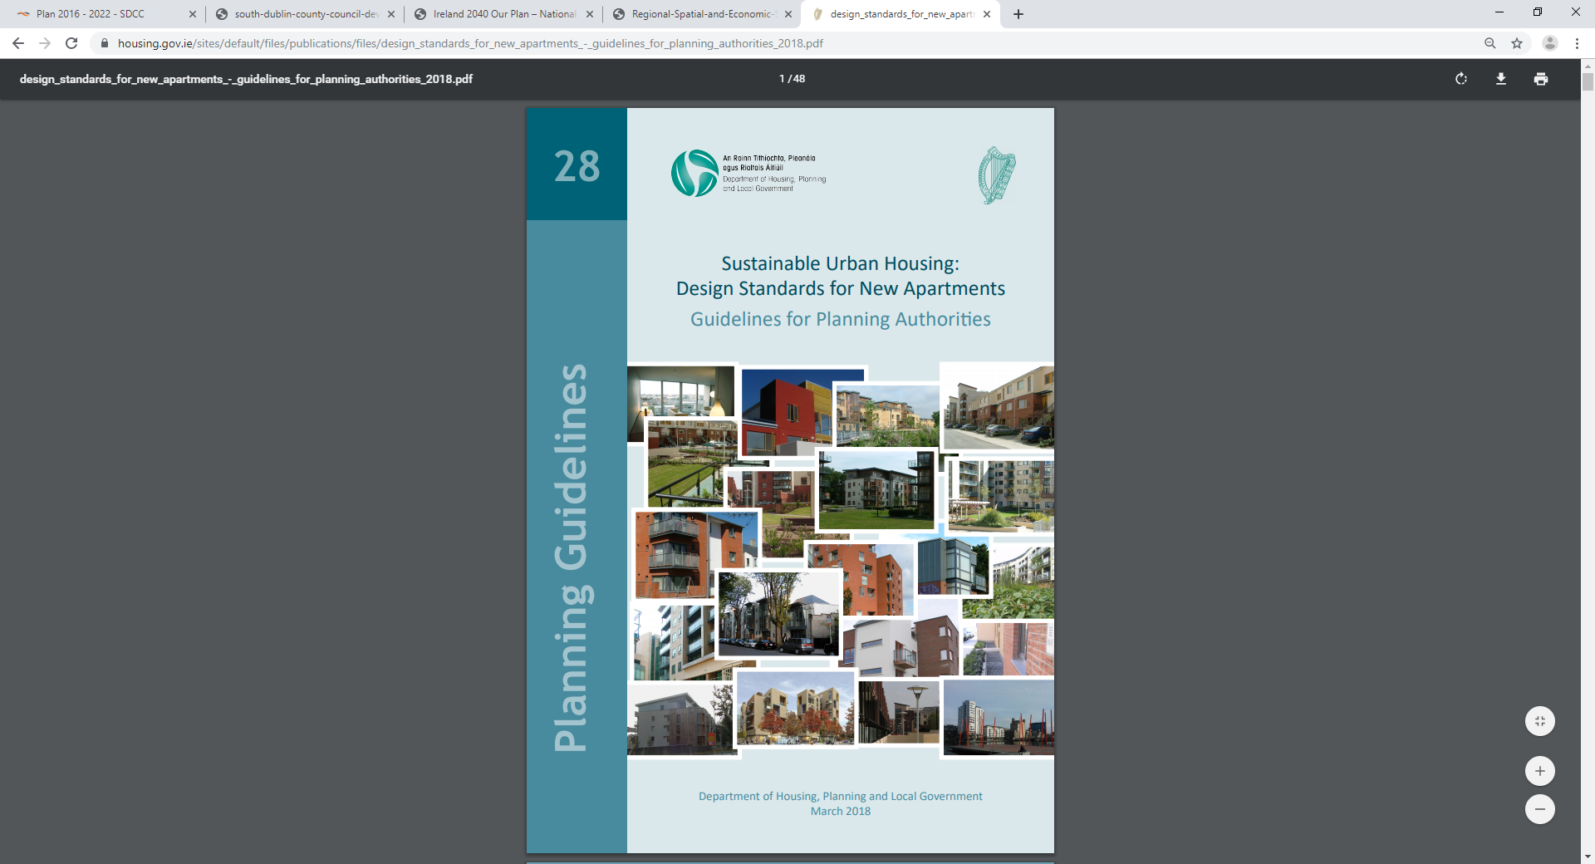

**Chapter 3**

**3.1 Review Requirement**

The overall objective of the Urban Development and Building Height Guidelines is to set out government policy to support increased building height and density in locations with good public transport accessibility, particularly town/city cores, planning authorities are required to explicitly identify areas where increased building height will be actively pursued, and not to provide for blanket numerical limitations on building height. The guidelines identify development management criteria which shall be taken into account when assessing individual applications. Specific Planning Policy Requirement 3(B) requires that a review of all Strategic Development Zones should be carried out to ensure that the new guidelines are fully reflected within the Planning Schemes.

1. *Statutory Legislative Basis*

Under Section 28 (1) of the Planning and Development Act 2000 as amended a planning authority shall have **regard** to Ministerial Guidelines.

Furthermore, Section 28 (1)(1C) of the Planning and Development (Amendment) Act 2018, a planning authority is required by this section –

“without prejudice to the generality of subsection (1), guidelines under that subsection may contain specific planning policy requirements with which planning authorities, regional assemblies and the Board shall, in the performance of their functions, **comply**

Notwithstanding the need to comply with SPPR’s, Planning Schemes must have regard to Section 168 (2)(C) of the Planning and Development Act 2000 (as amended), which sets out the information required to be included as part of a Strategic Development Zone Planning Scheme, including details of the overall design of the proposed development, including maximum heights.

**3.1 Overview of the Independent Review by Metropolitan Workshop**

South Dublin County Council as the Development Agency commissioned Metropolitan Workshop, an independent firm of urban design consultants, to undertake a capacity analysis and provide recommendations on whether additional height could be accommodated within the current Adamstown Planning Scheme, without undermining urban design principles of the Planning Scheme.

This study looked at the Adamstown SDZ in terms of background facts, development area and building heights and summarized the *Urban Development and Building Height Guidelines* and provided details on the impacts this would have on Adamstown SDZ.

A ‘Height Strategy Review’ was undertaken, looking at a series of capacity studies for the undeveloped areas of Adamstown SDZ, namely Aderrig, Adamstown Boulevard and Adamstown Station to determine where increased prescribed heights for these areas may be recommended.

The analysis and conclusions of the capacity studies determined that current height constraints of the Adamstown SDZ Planning Scheme can be developed in-line with the prescribed densities and is in alignment with the aspirations of the *Urban development and Building Height Guidelines 2018*.

The study demonstrates that it is possible to achieve a planning scheme of greater density than is permissible in the current scheme while using the existing building heights. This is particularly true for Adamstown Station where there is potential for a greater density without necessarily altering the current building heights.

The Capacity Analysis Study was used to inform the Council’s own review of building heights within Adamstown SDZ, as required by the guidelines.

**3.2 The Review**

The new guidelines ‘*Urban Development and Building Heights: Guidelines for Planning Authorities*’ set out the government’s current policy regarding building heights and are in alignment with national policies in *Project Ireland 2040* and the *National Planning Framework*.

The emphasis of the guidelines is to require planning authorities to support taller built developments subject to key criteria, taking cognisance of a high standard of urban design, architectural quality and creating positive place-making environments in higher density urban developments.

‘It is therefore critically important that development plans identify and provide policy support for specific geographic locations or precincts where increased building height is not only desirable but a fundamental policy requirement’. (s.2.11)

This review will have an emphasis on Aderrig, Adamstown Boulevard and Adamstown Station Development Areas were no development has taken place to date. The remainder of Adamstown SDZ has either been built-out, is under construction or has live planning permissions in place.

Table 2.9 of the Planning Scheme identifies the Maximum Landmark Building Height by Area Character Type; i.e max 5 storeys for low density, 7 storeys for medium density and 10 storeys for high density areas. Aderrig is characterised as a medium density area and Adamstown Boulevard and Station are both high density development areas with permissible heights of 10 storeys.

The guidelines identify four Specific Planning Policy Requirements (SPPRs) as set out below, which will take precedence over any potential discrepancies with current Strategic Development Zones.

***SPPR 1***

*‘In accordance with Government policy to support increased building height and density in locations with good public transport accessibility, particularly town/ city cores, planning authorities shall explicitly identify, through their statutory plans, areas where increased building height will be actively pursued for both redevelopment, regeneration and infill development to secure the objectives of the National Planning Framework and Regional Spatial and Economic Strategies and shall not provide for blanket numerical limitations on building height’.*

***Comment:***

This SPPR specifically refers to ‘redevelopment, regeneration and infill development’ and is therefore not applicable to Adamstown SDZ, which is a greenfield suburban site on the western fringes of Dublin City.Notwithstanding this, the Adamstown SDZ Planning Scheme does identify areas suitable for increased building height. The matter of increased building height in appropriate locations in the County generally should be addressed in the County Development Plan review and in any future statutory local area plans. However, it is noted, as set out in planning legislation, SDZ’s are required to provide details on maximum building heights within the planning scheme.

***SPPR 2***

*‘In driving general increases in building heights, planning authorities shall also ensure appropriate mixtures of uses, such as housing and commercial or employment development, are provided for in statutory plan policy. Mechanisms such as block delivery sequencing in statutory plans² could be utilised to link the provision of new office, commercial, appropriate retail provision and residential accommodation, thereby enabling urban redevelopment to proceed in a way that comprehensively meets contemporary economic and social needs, such as for housing, offices, social and community infrastructure, including leisure facilities’.*

***Comment:***

The Adamstown SDZ Planning Scheme provides for a wide-ranging increase in building heights compared to the prevailing context and a mix of housing and commercial uses, services and facilities. Development within the Adamstown Planning scheme is subject to a schedule of phasing and implementation which is intended to ensure that appropriate levels of infrastructure, services, facilities and amenities are provide in tandem with residential development. It is considered that the Adamstown SDZ Planning Scheme is broadly consistent with SPPR 2.

***SPPR 3***

*It is a specific planning policy requirement that where;*

*(A) 1. an applicant for planning permission sets out how a development proposal complies with the criteria above; and*

*2. the assessment of the planning authority concurs, taking account of the wider strategic and national policy parameters set out in the National Planning Framework and these guidelines;*

*then the planning authority may approve such development, even where specific objectives of the relevant development plan or local area plan may indicate otherwise.*

*(B) In the case of an adopted planning scheme the Development Agency in conjunction with the relevant planning authority (where different) shall, upon the coming into force of these guidelines, undertake a review of the planning scheme, utilising the relevant mechanisms as set out in the Planning and Development Act 2000 (as amended) to ensure that the criteria above are fully reflected in the planning scheme. In particular the Government policy that building heights be generally increased in appropriate urban locations shall be articulated in any amendment(s) to the planning scheme*

*(C) In respect of planning schemes approved after the coming into force of these guidelines these are not required to be reviewed.*

***Comment:***

SPPR 3(A) refers to development in general, where a planning scheme does not apply andSPPR 3(C) refers to planning schemes approved after the coming into force of the Building Height Guidelines and as such, neither are relevant to Adamstown SDZ Planning Scheme.

SPPR 3(B) is particularly relevant to Adamstown as it requires adopted planning schemes to be reviewed to ensure that the development management criteria in set out in Section 3.2 of the Guidelines are fully reflected and consistent with the Planning Scheme. The formal review of the Adamstown SDZ Planning Scheme now being conducted is as a result if the provisions of this SPPR.

The Development Management Criteria referred to in SPPR 3(B) are set out in Section 3.2 of the Guidelines. These criteria include:

* Proximity to good transport links;
* Character of the area, having regard to key features;
* Contribution to place-making;
* Response to surrounding natural and built environment;
* Use of well-considered design and materials;
* Contribution to improvement of legibility through the site and wider area;
* Contribution to mix of uses and / or building / dwelling typologies;
* Form, massing and height should allow maximum access to natural daylight, ventilation and views and minimise overshadowing and loss of light.

The Adamstown SDZ Planning Scheme development strategy is based on urban design considerations, which include all of the issues covered by the above criteria. The scheme was prepared with regard to best practice in the planning and design of new communities and was designed to be flexible insofar as caps on unit numbers and densities and maximum heights across the scheme. The Metropolitan Workshop study and this review identifies that greater densities and unit numbers can be achieved within the existing building heights provisions, especially in relation to Adamstown Station. Notwithstanding this any higher densities need to take cognisance of amenity, urban form, high quality design, transport capacity and community facilities.

***SPPR 4***

*It is a specific planning policy requirement that in planning the future development of greenfield or edge of city/town locations for housing purposes, planning authorities must secure:*

*1. the minimum densities for such locations set out in the Guidelines issued by the Minister under Section 28 of the Planning and Development Act 2000 (as amended), titled “Sustainable Residential Development in Urban Areas (2007)” or any amending or replacement Guidelines;*

*2. a greater mix of building heights and typologies in planning for the future development of suburban locations; and*

*3. avoid mono-type building typologies (e.g. two storey or own-door houses only), particularly, but not exclusively so in any one development of 100 units or more.*

***Comment***

Section 3.4 – 3.8 of the Guidelines, which include SPPR 4, relate to ‘Building height in suburban/edge locations (City and Towns) and are considered to be of most relevance to Adamstown. It is noted that Adamstown is specifically referenced in Section 3.5 as an exemplar of a medium density development area with good urban form and a good sense of place.

Section 3.4 outlines that newer housing developments in suburban edges of towns and cities are typically 2-3 storey town-houses, duplexes of 3-4 storeys and apartments of 4 storeys upwards. The guidelines go on further to state in section 3.6 that “*development should include an effective mix of 2, 3 and 4 storey development which integrates well into existing and historical neighbourhoods and 4 storeys or more can be accommodated alongside existing larger buildings, trees and parkland, river/sea frontage or along wider streets”.*

In Section 3.7, the guidelines state that “such development patterns are generally appropriate outside city centres and inner suburbs, i.e. the suburban edges of towns and cities, for both infill and greenfield development and should not be subject to specific height restrictions”.

Notwithstanding the foregoing, as highlighted above, under primary legislation, Section 168 (2)(C) of the Planning and Development Act 2000 (as amended) maximum heights within an SDZ Planning Scheme are required to be set out.

Accordingly, it is considered that Adamstown Planning Scheme does not provide for ‘blanket numerical limitations on height’ but rather, provides an effective mix of 2, 3, 4 storeys buildings which increase in height up to 5, 7 and 10 storeys respectively in low, medium and high density development areas. Check.

The requirements of sub-categories 1-3 of SPPR 4 are achieved within the Adamstown Planning Scheme through the following:

1. National guidelines for residential densities (Residential Development in Urban Areas 2007) refer to net residential densities in the general range of 35-50 dwellings per hectare in ‘Outer Suburban / Greenfield Sites’ and recommend increased densities along public transport corridors (within 500 metres walking distance of a bus stop, or within 1km of a light rail stop or rail station) of 50 dwellings per hectare. The Adamstown SDZ planning Scheme allows for a net density range of 47-56 units per hectare across the entire SDZ lands with 75-90 in Adamstown Station development area (close to the train station), reducing to lower densities of 35-50 further from the train station and adjacent to existing housing areas. Proposed Densities have now changed as a result of proposed amendment – insert section in here.
2. The Adamstown SDZ Planning Scheme provides a varied mix of building types and heights throughout the SDZ lands and also within each individual development area, through the building type and height strategy and varying density requirements for each development area. Section 2.3(i) ‘Design Statement’ of the Adamstown Planning Scheme contains the vision and guiding principles for the SDZ lands which are consistent with SPPR 4 (2) and (3).
3. As outlined above, the Adamstown SDZ Planning Scheme provides for a variety of unit typologies and sizes within each development area.

Having regard to the above, it is considered that the existing Adamstown Planning Scheme is consistent with the requirements as set out in SPPR 4 of the guidelines, insofar as the prescribed building heights in the current Adamstown Planning Scheme show a range of 2-6 stories (5 +1 set back), there is flexibility available in terms of the variety of unit typologies and sizes permissible in each of the development areas and varying densities available within the existing planning scheme.

**3.3 Further Considerations of Building Height Review**

*Aviation Safety Height Restrictions*

Adamstown SDZ is in close proximity to two active airfields; Weston Airport and Casement Aerodrome. Weston Airport is located approximately 1.9km north-northwest of Adamstown and consists of one runway. Casement Aerodrome is situated 3.8km south-southeast and has 2 No. runways. Check.

The Irish Aviation Authority (IAA), the relevant authority in relation to airfields in Ireland, have produced guidelines in relation to obstacles which may have an effect on aeronautical navigation. ‘*Guidance Material on Aerodrome Annex 14 Surfaces’* sets out the height restrictions in areas surrounding airfields above which should be free from obstacles.

IAA guidelines designate restricted area in relation to the approach zones at the ends of runways which should form ‘obstacle free zones’ and also set out additional areas of ‘obstacle limitation’ in areas surrounding runways. The guidelines recommend that any object should be lower than the inner and conical surfaces and that objects taller than 30m above local ground level should be lower than the outer surfaces.

Adamstown site falls within the inner surface of Weston Airport and partially within the inner surface of casement aerodrome and according to IAA guidelines:

*“New objects or extensions of existing objects should not be permitted above the conical surface and the inner horizontal surface except when an object would be shielded by an existing immovable object, or after aeronautical study it is determined that the object would not adversely affect the safety or significantly affect the regularity operations of aeroplanes”.*

The elevations of Weston Airport and Casement Aerodromes are +47m and +97m above sea level respectively. This would place the lowest inner surface at +92m above sea level. Adamstown is at approximately +60m above sea level, resulting in a construction limit of 32m in height.

Having regard to the Irish Aviation Authorities guidelines and the elevation above sea-level of Adamstown, the limitation of 32m in height is the equivalent of 10 storeys in building height, and accordingly Adamstown Planning Scheme reflects these aviation height restrictions. Where is above info from?

***Consistency with the Guidelines***

It is considered that the Adamstown SDZ Planning Scheme is consistent with the Building Height Guidelines for the following reasons:

* Adamstown is served by good public transport including the Dublin/Kildare railway line and Adamstown Train Station located to the south of the scheme area.
* The Planning Scheme facilitates increased densities and increased heights compared to the prevailing context. Heights and densities are highest in Adamstown Station and Adamstown Boulevard development areas (check) due to proximity to the transport links and reduce as one move northward towards existing lower density development, using best practice urban design principles.
* The Planning Scheme provides for general building heights of three to five stories across the SDZ lands, with up to 10 storeys in higher density development areas.
* The Planning Scheme provides for an effective mix of 2, 3 and 4 stories buildings and allows for 4 storeys or more in ‘Perimeter Buildings’ and higher ‘Landmark Buildings’ along key thoroughfares, public spaces, important junctions and transport interchanges, which is an urban design approach supported by the *Urban Development and Building Height Guidelines.*
* The variety of building heights within the planning scheme improves legibility through the overall site which enhances the urban quality of the built form and public realm.

**Chapter 4**

**4.1 Conclusion**

South Dublin County Council, as the Development Agency for Adamstown SDZ Planning Scheme 2014, has carried out this review of the Planning Scheme as required under Specific Planning Policy Requirement 3(B) of the Urban Development Building Heights Guidelines (Dec 2018). It is concluded that having regard to:

* The National Planning Framework, the RSES and the Urban Development and Building Heights Guidelines;
* The Adamstown Planning Scheme provides for a wide-ranging increase in building heights within the surrounding urban form context and has been successfully implemented to date to provide a mix of housing, commercial uses and services and social/community facilities as per SPPR 2;
* The need to achieve high quality urban design to form civic spaces and parks, flanked by housing and the provision of a mix of typologies and to avoid a visually oppressive ‘wall of buildings’ especially in higher density development areas;
* The requirement for increased building height in appropriate locations and appropriate densities for outer suburban / greenfield sites with good public transport accessibility;
* The Irish Aviation Authority restrictions on obstacles which may have an effect on aeronautical navigation and restrictive heights;
* The housing crisis and the national policies to achieve well-designed high-quality developments, which encompasses an increase in building height to achieve targeted growth;
* The statutory requirement for a strategic development zone to include maximum building heights as per Section 168(2)(c) of the Planning and Development Act 2000 as amended;
* Adamstown Planning Scheme does not provide for ‘blanket numerical limitations on height’ but rather, provides an effective mix of 2, 3, 4 storeys buildings which increase in height up to 5, 7 and 10 storeys respectively in low, medium and high-density development areas.

This review of the current Adamstown Planning Scheme 2014 does align with the criteria set out in SPPRs 1, 2, 3 and 4 of the Urban Development and Building Height Guidelines (Dec 2018) and that these criteria are fully reflected within the existing Planning Scheme.