Screening Statement for Strategic Environmental Assessment (SEA) under
the Planning and Development Act, 2000 (as amended) for Proposed Amendments to the Adamstown SDZ Planning Scheme, 2014

- Introduction
The Adamstown SDZ Planning Scheme (2014) comprises 223.5 hectares of land located in West Dublin, south of Lucan and the N4 national primary road, and north of the railway line from Dublin to the South and West of Ireland (see Figure 1). The SDZ Planning Scheme divides the plan lands into eleven development areas or ‘tiles’ and sets out parameters for development within each area. The original Adamstown SDZ Planning Scheme (2003) was reviewed and amended in 2014 and at that point, was subject to full Strategic Environmental Assessment.

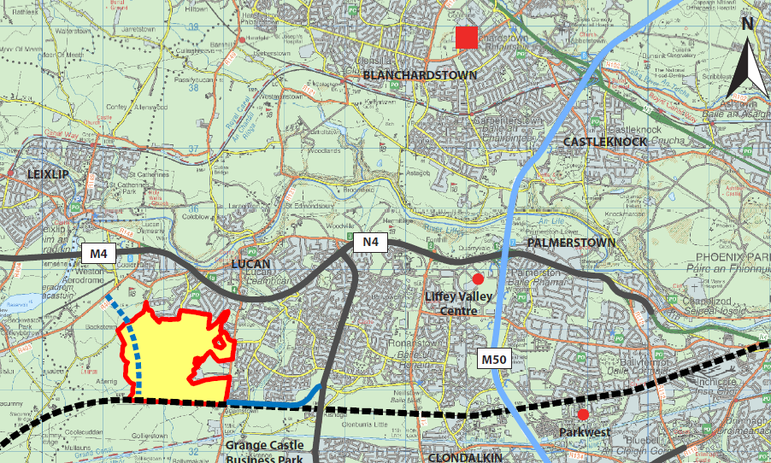
Fig. 1: Adamstown within the wider west Dublin context

- Proposed Amendments
It is now proposed to amend elements of the SDZ Planning Scheme as a result of policy and guidance within the National Planning Framework, 2018 (NPF) and Regional Spatial and Economic Strategy, 2019 (RSES) relating to compact growth and sustainable development; and changes arising from new guidelines including the Sustainable Urban Housing: Design Standards for New Apartments, Guidelines for Planning Authorities, 2018 (the ‘Apartments Guidelines’) and the Urban Development and Building Heights: Guidelines for Planning Authorities, 2018 (the ‘Building Heights Guidelines’).
The three main amendments proposed are as follows:
- An increase in unit numbers, density and residential floor area within the Adamstown Station development area.
- An increase in unit numbers, density and residential floor area and a location-specific increase in building height within the Aderrig development area.
- Relocation of a proposed enterprise centre from the Tobermaclugg Village/Tandy’s Lane Village local centre to the Adamstown Station district centre.
Other minor amendments are also proposed including updated references. Under Section 170A of the Planning and Development Act, 2000 (as amended), amendments to planning schemes must be considered by An Bord Pleanála; in this regard, South Dublin County Council is seeking that the Board considers all of the above amendments as non-material.

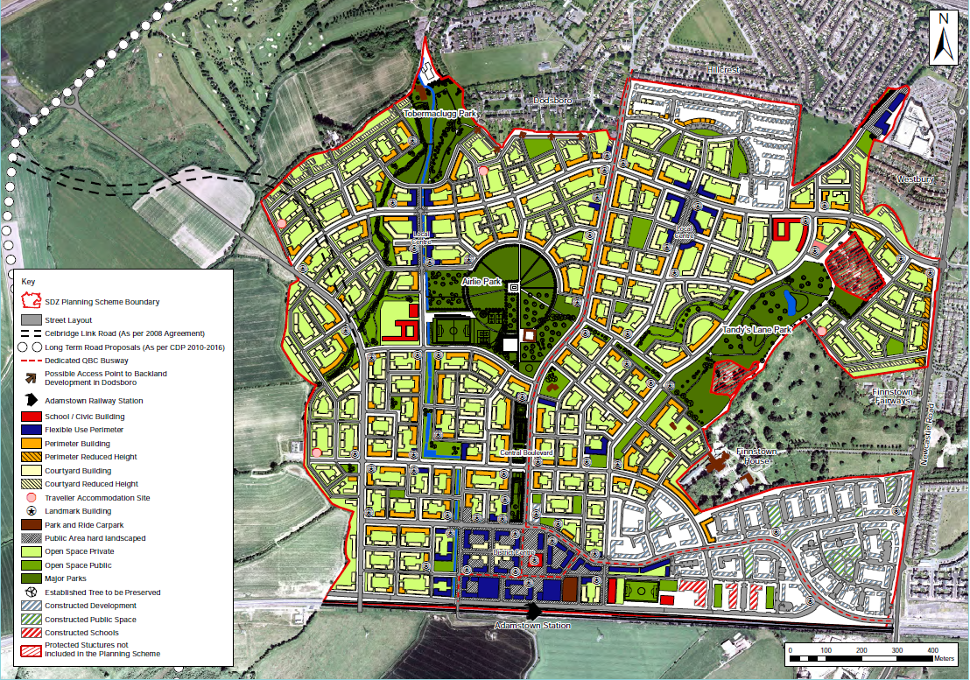
Fig.2: Indicative layout for Adamstown SDZ Planning Scheme, 2014

- Screening for Strategic Environmental Assessment

Screening for Strategic Environmental Assessment (SEA) was carried out by Minogue and Associates Environmental Consultants. The purpose of the SEA Screening report was to screen the proposed amendments to the Adamstown SDZ Planning Scheme to ensure that there are no unexpected or significant environmental effects as a result of the Proposed Amendments. This SEA Screening was carried out in conjunction with a separate screening under Article 6(3) of the EU Habitats Directive prepared by Doherty Environmental which informed the preparation of the SEA Screening Report. The proposed amendments were assessed against the criteria contained in Schedule 2a of the Planning and Development (Strategic Environmental Assessment) Regulations SI 436 of 2004.
The finding of the SEA screening report was that no significant environmental effects are identified for the proposed amendments to the Adamstown SDZ Planning Scheme and that full Strategic Environmental Assessment is not required.
In this regard, the concluding paragraph of section 3.2 of the SEA Screening Report states:
‘The proposed amendments to the Adamstown Planning Scheme seeks to respond to changes in national policy in particular the Regional Spatial Economic Strategy (RSES) for the Eastern and Midland region and the National Planning Framework (NPF). The principal amendments are positive in relation to the promotion of higher densities close to public transport, thus better integrating land use and transport considerations. The relocation of enterprise centre to the Adamstown Station area further supports this approach. The amendment relating to increased height relates to one specific location and again meets compliance with the Height Guidelines. The remaining amendments are minor in nature, and have not been identified as generating strategic environmental effects. As the assessment against the above criteria in the SEA Directive and SI 436 of 2004 (as amended) demonstrate, no significant environmental effects are identified for these proposed amendments to the Adamstown Planning Scheme and therefore are determined not to require full Strategic Environmental Assessment’.

- Conclusion
In accordance with the above, South Dublin County Council therefore conclude that no significant environmental effects are identified for the proposed amendments to the Adamstown SDZ Planning Scheme and that full Strategic Environmental Assessment is not required.

