
Draft

Rathcoole Housing Development

Environmental Impact Assessment Report (EIAR)
Chapter 16: Material Assets (Utilities)

South Dublin County Council (SDCC)

August 2026



Quality information
Prepared by |  | Checked by |  | Verified by |  | Approved by
Ryan Emslie Jonas  Senior Environmental Scientist – Impact Assessments |  | Leticia Braga  Principal Environmental Consultant – Impact Assessments |  | John Halsall  Technical Director – Impact Assessment |  | Richard OCallaghan  Project Director

Revision History
Revision | Revision date | Details | Authorized | Name | Position
R00 | 31/08/2026 | Draft |  | John Halsall | Project Director

Distribution List
# Hard Copies | PDF Required | Association / Company Name
N/A | 1 | South Dublin County Council

Prepared for:
South Dublin County Council (SDCC)

Prepared by:
‌AECOM Ireland Limited
4th Floor
One Burlington Plaza
Burlington Road
Dublin 4
D04 RH96
T +353-1-696-6220

© 2026 AECOM Ireland Limited. All Rights Reserved.
This document has been prepared by AECOM Ireland Limited (“AECOM”) for sole use of our client (the “Client”) in accordance with generally accepted consultancy principles, the budget for fees and the terms of reference agreed between AECOM and the Client. Any information provided by third parties and referred to herein has not been checked or verified by AECOM, unless otherwise expressly stated in the document. No third party may rely upon this document without the prior and express written agreement of AECOM.
Table of Contents
16 Material Assets (Utilities) 16-5
16.1 Introduction 16-5
16.2 Legislation, Policy and Guidance 16-5
16.3 Methodology 16-5
16.3.1 Sources of Information 16-6
16.3.2 Study Area 16-6
16.3.3 Description of Effects 16-7
16.3.4 Sensitivity of Receptors 16-7
16.3.5 Limitations & Assumptions 16-8
16.3.6 Embedded Mitigation Measures & Sustainability Requirements 16-8
16.4 Baseline Environment 16-9
16.4.1 Existing Gas Infrastructure 16-10
16.4.2 Existing Electrical Infrastructure 16-10
16.4.3 Existing Surface Water Drainage 16-10
16.4.4 Existing Foul Water Drainage 16-11
16.4.5 Existing Water Supply 16-12
16.4.6 Existing Telecommunications 16-13
16.5 Potential Impacts 16-13
16.5.1 Construction 16-13
16.5.2 Operation 16-14
16.5.3 Indirect, Secondary and Transboundary Effects 16-15
16.6 Mitigation Measures 16-15
16.6.1 Construction Phase 16-15
16.6.2 Operational Phase 16-16
16.7 Residual Impacts 16-16
16.7.1 Construction Phase 16-16
16.7.2 Operational Phase 16-17
16.8 Cumulative Impacts 16-17
16.8.1 Construction Phase 16-17
16.8.2 Operational Phase 16-17
16.9 Summary 16-17
16.10 References 16-18

Tables
Table 16-3: Sensitivity of Criteria for existing Utilities Infrastructure 16-6

Material Assets (Utilities)

Introduction
This chapter of the EIAR identifies, describes and assesses the likely direct and indirect effects of the Proposed Development on existing material assets (utilities). The Environmental Protection Agency’s (EPA) ‘Guidelines on the information to be contained in Environmental Impact Assessment Reports’ (2022) (hereafter referred to as the ‘EPA Guidelines (2022)’) defines ‘material assets’ as comprising:
- Built services;
- Roads and traffic; and
- Waste management.
For the purpose of this chapter, only the existing utilities (built services) which includes existing electrical infrastructure, gas infrastructure, potable and foul water infrastructure, surface water drainage and telecommunications are assessed. An assessment of roads/traffic and waste management is provided in EIAR Chapters 14 and 17, respectively.

Legislation, Policy and Guidance
The legislation, policies, and guidance applicable to this chapter include:
- ESB (2019) ‘Code of Practice for Avoiding Danger from Overhead Electricity Lines’;
- Health and Safety Authority (2016), Code of Practice for Avoiding Danger from Underground Services;
- Institute of Environmental Management and Assessment (IEMA) (now the Institute of Sustainability and Environmental Professionals (ISEP)) Guidelines (2020) ‘Materials and Waste in Environmental Impact Assessment’ (referred to herein as the IEMA Guidelines, 2020);
- Safety, Health and Welfare at Work (Construction) Regulations 2013 (S.I. No. 291/2013), as amended;
- European Commission (2017), ‘Environmental Impact Assessment of Projects: Guidance on the Preparation of the Environmental Impact Assessment Report’ (Directive 2011/92/EU as amended by 2014/52/EU); and
- Department of Housing, Local Government and Heritage (2024), ‘Sustainable Residential Development and Compact Settlements Guidelines for Planning Authorities’.

Methodology
This section outlines the methodology adopted for the material assets (utilities) assessment which has been conducted in accordance with the EPA Guidelines (2022) to:
- Establishment of the baseline conditions, including identification and assessment of the receiving environment and receptor sensitivity;
- Identification of environmental design measures and mitigation measures that form part of the construction methodology;
- Identification of the potential impacts, and assessment of the magnitude and significance of potential effects;
- Consideration of mitigation measures; and
- Assessment of residual effects, including cumulative effects.
This assessment has been cognisant of the requirements as set by legislation, policy and the guidelines as listed in Section 16.2. These include, amongst others, relevant information on best practice EIA and construction procedures and standards, including guidance on the types of material assets to be considered for EIA, terminology used to describe effects, and the implementation of mitigation measures.
The methodology considers the interaction of the Proposed Development with the surrounding environment and existing developments (namely the Rathcoole village located directly west of the Proposed Development Site, as well as the Saggart village situated directly east of the Site) thereby recognising the need for the coordinated design of utilities/ built services within the Proposed Development.

Sources of Information
This assessment was conducted using a combination of desktop studies from publicly available information, data provided by the Applicant, and relevant information from the EIAR, supplemented by professional judgement.
The following sources of information have informed the determination of the baseline environment in relation to material assets considered under this chapter:
- AECOM (2026) Stage 2 Infrastructure Report (as a supporting technical document in support of the this Proposed Development’s planning application);
- EPA (2025), ‘EPA Maps’;
- OpenStreetMap (OSM) Foundation (2025), ‘Open Infrastructure Map;
- OSi (2025), ‘Discovery Series Maps’; and
- SDCC and ACP’s Planning Portals.

Study Area
The Study Area comprises the area within the Proposed Development Site’s boundary and the directly adjacent surrounding environment (refer to Figure 16-1).
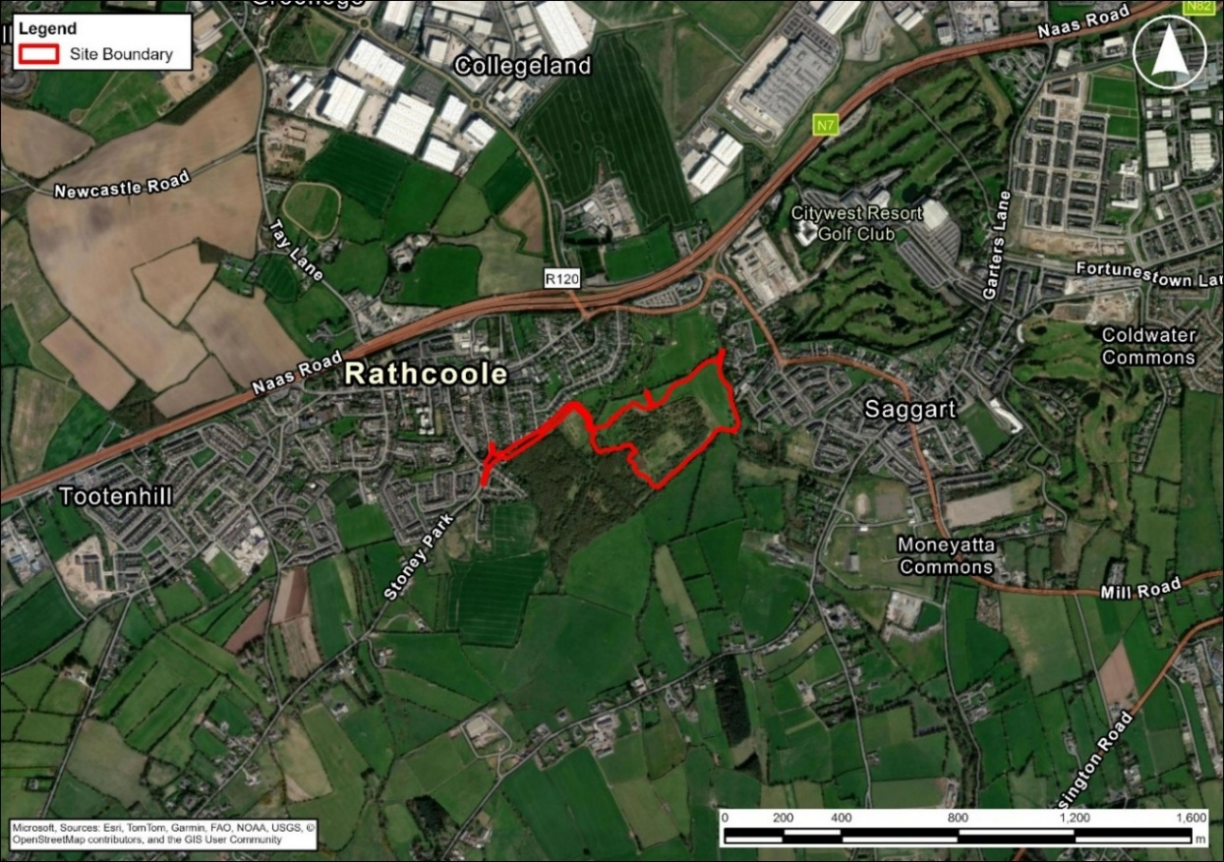
Figure 16-1: Proposed Development Site and Surrounding Environment

Description of Effects
The environmental assessment presented in this chapter identifies and evaluates the likely environmental effects of the Proposed Development on existing material assets (utilities), including, as appropriate, their nature, extent, magnitude, duration, frequency, probability, reversibility and significance.
In identifying and evaluating potentially significant environmental effects on the existing material assets (utilities), regard has been given, where relevant, to the following:
- The magnitude and spatial extent of the effect, including the geographical area and size of the population likely to be affected;
- The nature of the effect;
- The transboundary nature of the effect;
- The intensity and complexity of the effect;
- The probability of the effect;
- The expected onset, duration, frequency and reversibility of the effect;
- The cumulation of the effect with the effects of other existing and/or approved projects; and
- The possibility of effectively avoiding, preventing, reducing or, where appropriate, offsetting the effect.
Descriptors and criteria for defining the magnitude of an impact and significance of effects have been presented in Chapter 1 (Introduction & Methodology) of this EIAR.
The assessment in this chapter has been carried out in accordance with the principles set out in the IEMA Guidelines (2020).

Sensitivity of Receptors
The European Commission (EC) Guidelines (2017) describe ‘sensitivity’ as “the sensitivity of the environmental receptor to change, including its capacity to accommodate the changes the Projects may bring about”. The terminology used to rate and describe the sensitivity of receptors herein is presented in Table 16-3.
Table 16-3: Criteria for Rating Receptor Sensitivity
Sensitivity | Description
High | High importance and rarity, national scale, and limited potential for substitution. High importance for receptors surrounding the Proposed Development.
Medium | High or medium importance and rarity, regional scale, limited potential for substitution. Medium importance for receptors surrounding the Proposed Development.
Low | Low or medium importance and rarity, local scale. Low importance for receptors surrounding the Proposed Development.
Negligible | Very low importance and rarity, local scale. Very low importance for receptors surrounding the Proposed Development.
With regard to water and energy consumption impacts, the IEMA Guidelines (2020) and their approach to assessing the sensitivity of materials has been considered.

Limitations & Assumptions
In preparing this assessment, the following limitations were encountered and assumptions made:
- This assessment relies on professional judgement and evaluates both the potential adverse and positive effects of the Proposed Development on existing and surrounding receptors, considering built services and utilities infrastructure.
- At the time of writing this report, service providers have not been consulted to confirm the presence or absence of local built services and utility infrastructure and connections, or to obtain information on their local arrangements. The assessment is therefore based on information available from sources listed under Section 16.3.1 at the time of application submission. The accuracy of this information regarding the location of built services and utility infrastructure and/ or the overall presence or absence of infrastructure must be verified via ground investigations and consultation with service providers prior to the commencement of any works. This information should not be relied upon for excavations or other activities related to the Proposed Development.
- Estimated energy and water and wastewater consumption figures for the operational phase of the Proposed Development were unavailable at the time of writing this assessment. This poses a limitation to the assessment regarding existing water and wastewater infrastructure within the Study Area. Uisce Éireann (UE) were consulted as part of the EIA scoping consultation in May 2026. UE indicated that Tay Lane Pumping Station, which is currently operating at full capacity, will require upgrades to support future development growth within the Rathcoole area. UE also requested that the location of all existing UE infrastructure within the Site and the surrounding Study Area are clearly identified in all associated engineering and Site layout drawings.

Embedded Mitigation Measures & Sustainability Requirements

Construction Phase
The construction methodology for the Proposed Development is described in Chapter 2: Description of Development. Construction details presented are preliminary and will be further developed by the appointed Contractor prior to commencement of construction, including through preparation of the Contractor’s Construction Environmental Management Plan (CEMP). Measures required to manage potential effects on utilities during construction will be incorporated into the CEMP, as appropriate.
Existing utilities and built services within or in proximity to the Proposed Development will be identified and taken into account during the detailed design and construction planning stages. Where existing services have the potential to be affected by the works, appropriate measures will be developed in consultation with the relevant utility/ service provider, as required, including the protection or diversion of existing services and coordination of proposed utility connections.
Construction works in proximity to existing underground and overhead services will be undertaken in accordance with the requirements of the relevant service providers and applicable health and safety requirements and industry guidance. Appropriate construction methodologies and Safe Systems of Work will be established prior to works affecting existing services.
Where temporary disruption to an existing service is required to facilitate construction, this will be coordinated with the relevant service provider and other relevant authorities, as applicable.
Construction compounds and associated temporary facilities will be provided as described in Chapter 2: Description of Development. Temporary lighting required for construction compounds and working areas will be designed and managed as part of the construction methodology.

Operational Phase
The Proposed Development includes the provision of the utility infrastructure and connections necessary to serve the development, as described in Chapter 2: Description of Development and the Infrastructure Report (AECOM, 2026) accompanying the planning application.
The design of the Proposed Development incorporates measures to improve energy and water efficiency in accordance with the applicable Sustainable Residential Development and Compact Settlements Guidelines for Planning Authorities (dated January 2024) . These measures are taken into account in the assessment of operational effects where they form part of the Proposed Development.

Baseline Environment
The Proposed Development Site and surrounding environment are described in Chapter 1: Introduction and Methodology and Chapter 2: Description of Development. This section describes the existing built services and utilities within and in proximity to the Study Area relevant to this assessment. However, it is also likely that further infrastructure is located within the Study Area. The presence (or absence) of these services will need to be confirmed by site-specific investigations and/or in consultation with service providers.
Further descriptions of existing infrastructure potentially affected by the Proposed Development is presented in the 2026 Infrastructure Report that will accompany the planning application.
Additionally, planning documents associated with the permitted primary school development (SDCC Pl. Ref. SD23A/0336 / ACP Pl. Ref. 321696) which is located within the Study Area , but does not form part of the Proposed Development subject to this EIAR, provides information regarding existing utilities and built services in proximity to the Site.
Considering the information contained within the 2026 Infrastructure Report and the primary school development planning documents, the following existing built services and utilities have been identified within the defined Study Area.

Existing Gas Infrastructure
Within the existing Rathcoole village, a Gas Networks Ireland distribution pipeline runs along Coolamber Drive to the west and outside of the Proposed Development Site’s boundary.

Existing Electrical Infrastructure
Existing electrical infrastructure in proximity to the Site includes:
- An overhead 400 kilovolt (kV) ESB Network powerline situated outside of the Site boundary (to the north);
- 110 kV powerlines approximately 100m south, and outside of the Site boundary which runs parallel direction to the Site’s southern boundary;
- Low voltage powerlines running along Coolamber Road and Coolamber Drive situated within Rathcoole village, which also run parallel to the north-western boundary of the Site where the access road is proposed.

Existing Surface Water Drainage
Based on SDCC drainage records, the following infrastructure exists in the vicinity of the Site (refer to Figure 16-2):
- An existing 1,050mm diameter concrete surface water sewer running east along the roadway at Fitzmaurice Road within Rathcoole village. This is situated to the north and outside of the Site boundary;
- Along the Beechwood Lawns housing estate, to the north-west and outside of the Site boundary, an existing 225mm concrete surface water sewer line runs north-east towards Fitzmaurice Road and west towards Coolamber Drive;
- At Mullaly’s Lane, within Rathcoole village, existing 375mm and 450mm diameter concrete surface water sewers are noted to drain west from the entrance of Site, before connecting into an existing 600mm diameter concrete surface water sewer which continues to drain west along Mulally’s Lane; and
- To the immediate east, and outside of the Site boundary, an existing 225mm diameter concrete surface water sewer is noted running north along Springbank Saggart Road (within Saggart village) before connecting into an existing 225mm diameter concrete surface water sewer, which runs north along Mill Road (also within Saggart village).
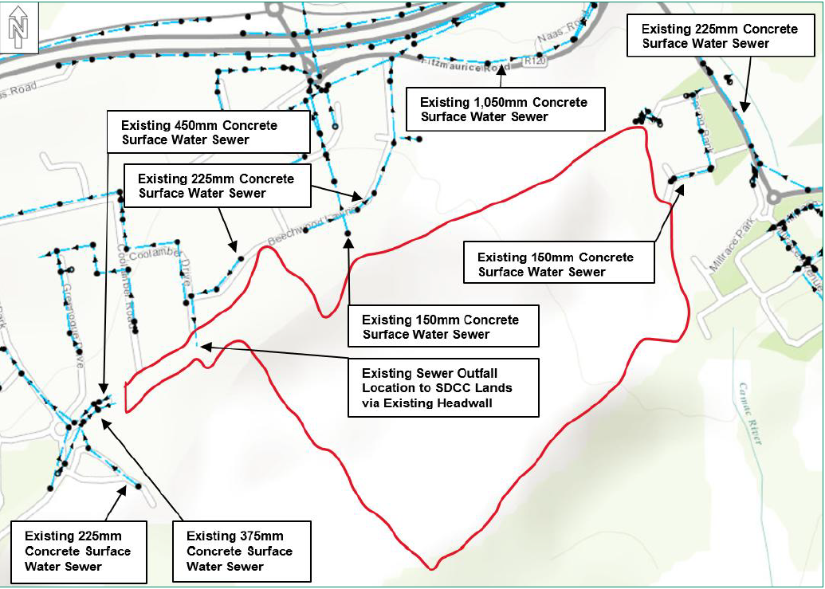
Figure 16-2: Existing Surface Water Drainage Infrastructure in Relation to the Site [RLB to be updated]

Existing Foul Water Drainage
Based on UE drainage records, the following infrastructure exists in the vicinity of the Site (refer to Figure 16-3):
- An existing 150mm diameter foul sewer runs north along Springbank Saggart Road within Saggart village located outside of, and adjacent to the eastern boundary of the Site boundary;
- To the north, and outside of the Site boundary, an existing 225mm diameter foul sewer runs north-east along Beechwood Lawns Road within Rathcoole village;
- An existing 225mm diameter foul sewer running west in Beechwood Lawns Road, located outside of, and north-west of the Site boundary, before running north along Coolamber Drive within Rathcoole village;
- An existing 150mm diameter foul sewer is noted to be running west of, and outside of the Site boundary, along Mulallys Lane within Rathcoole village, before connecting into an existing 225mm diameter concrete foul sewer, which runs north-west along Stoney Lane (also within Rathcoole village).
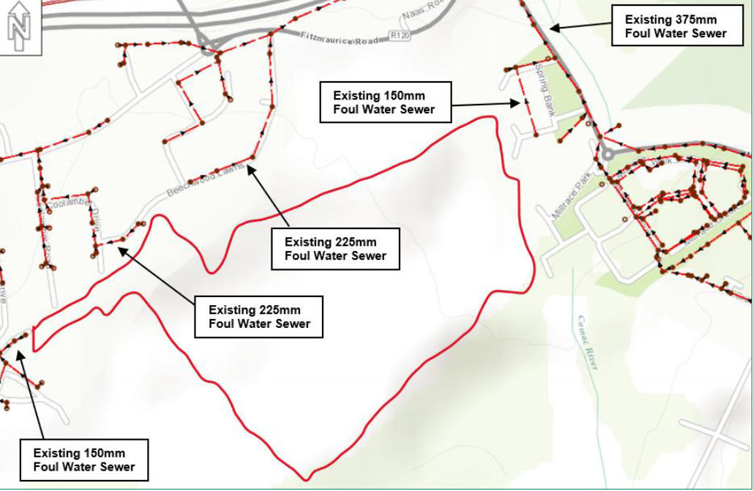
Figure 16-3: Existing Foul Water Drainage Infrastructure in Relation to the Site [RLB to be updated]

Existing Water Supply
Based on UE drainage records, the following infrastructure exists in the vicinity of the Site (refer to Figure 16-4):
- Existing 600mm and 1200mm diameter watermains run along the eastern boundary within the Site boundary;
- An existing 300mm diameter watermain running along the southern boundary within the Site boundary;
- An existing 101.6mm watermain is situated within Coolamber Drive in Rathcoole village, located north-west, and outside of the Site boundary.
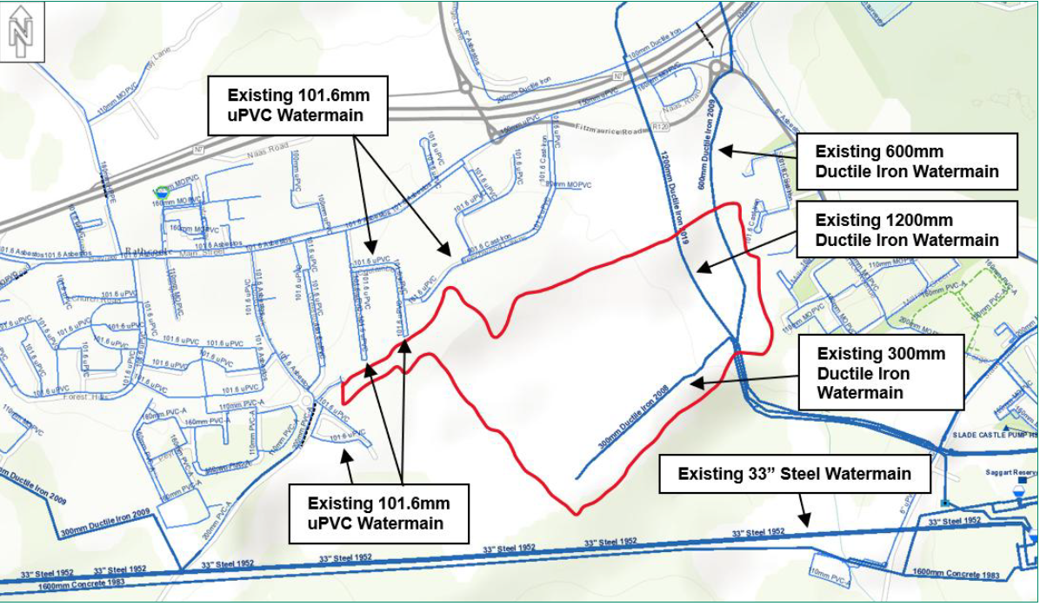
Figure 16-4: Existing Water Infrastructure in Relation to the Site[RLB to be updated]

Existing Telecommunications
Existing telecommunication infrastructure in proximity to the Site includes:
- Local Eir infrastructure located north within a footpath just outside the Site boundary; and
- Virgin Media infrastructure located approximately 100m north and outside the Site boundary.

Potential Impacts

Construction
Taking into account the baseline conditions as detailed in Section 16.4, the Proposed Development’s potential impacts (effectson existing infrastructure during the construction phase would be as detailed in the sections below.

16.5.1.1 Existing Gas Infrastructure
As the existing gas infrastructure is located within Rathcoole village, outside of the Site boundary, the Proposed Development’s potential impact on this receptor is considered to have a Negligible effect.

16.5.1.2 Existing Electrical Infrastructure
As the existing electrical infrastructure is located outside of the Site boundary, the Proposed Development’s potential impact on this receptor is considered to have a Negligible effect. Additionally, the construction phase is not expected to require a large energy supply and therefore the impact on the existing electrical infrastructure within the Study Area is also considered to have a Negligible effect.

16.5.1.3 Existing Surface Water Drainage
As the existing surface water drainage infrastructure is located outside of the Site boundary, the Proposed Development’s potential impact on this receptor is considered to have a Negligible effect.

16.5.1.4 Existing Foul Water Drainage
As the existing foul water drainage infrastructure is located outside of the Site boundary, the Proposed Development’s potential impact on this receptor is considered to have a Negligible effect.

16.5.1.5 Existing Water Supply infrastructure
As existing water infrastructure is located within the Site boundary, the Proposed Development’s potential impact on this receptor is considered to have a temporary adverse effect of Local significance Additionally, the construction phase is not expected to require a large water supply and therefore the impact on the existing water supply within the Study Area, is also considered to have a Negligible effect.

16.5.1.6 Existing Telecommunications
As the existing telecommunication infrastructure is located outside of the Site boundary, the Proposed Development’s potential impact on this receptor is considered to have as a Negligible effect.

Operation
The Proposed Development’s potential impacts (effects) on existing infrastructure during the operational phase are assessed in the sections below.

16.5.2.1 Existing Gas Infrastructure
As the existing gas infrastructure is located within Rathcoole village, outside of the Site boundary, the Proposed Development’s potential impact on this receptor is considered to have a Negligible effect.

16.5.1.2 Existing Electrical Infrastructure
As the Proposed Development will connect to the existing electrical infrastructure which is providing power to the existing Rathcoole and Saggart villages, the potential impact on this receptor may be considered as having a permanent adverse effect of Local significance.

16.5.1.3 Existing Surface Water Drainage
As the Proposed Development will result in increased hardened surfaces which will generate increased surface water runoff, the potential impact on this receptor (especially with consideration to the adjacent Rathcoole and Saggart villages) is considered as having a permanent adverse effect of Local significance.

16.5.1.3 Existing Foul Water Drainage
As the Proposed Development will result in the generation of wastewater, the potential impact on this receptor (considering that UE has confirmed that the existing Tay Lane Pumping Station is running at full capacity and will require an upgrade for future development) is considered to have a permanent adverse effect of Local significance.

16.5.1.4 Existing Water Supply infrastructure
As the Proposed Development will require potable water supply, the potential impact on this receptor (especially with consideration to the adjacent Rathcoole and Saggart villages) is considered to have a permanent adverse effect of Local significance.

16.5.1.5 Existing Telecommunications
As the existing telecommunication infrastructure is located outside of the Site boundary, the Proposed Development’s potential impact on this receptor is considered to have a Negligible effect.

Indirect, Secondary and Transboundary Effects
Indirect and secondary effects are defined in the EPA Guidelines (2022) as effects on the environment which are not a direct result of the Proposed Development and may occur away from the Site or through a more complex pathway.
Potential indirect or secondary effects associated with material assets (utilities), including effects arising from disruption to existing services or additional demand on utility infrastructure, have been considered as part of the construction and operational assessments presented in Sections 16.5.1 and 16.5.2.
Given the nature, scale and location of the Proposed Development, no transboundary effects on material assets (utilities) are anticipated.

Mitigation Measures

Construction Phase
The following best practice measures will be included in the Contractor’s CEMP and implemented during the Proposed Development’s construction phase:
- All proper steps will be taken to minimise any interference with existing gas, electrical, surface water drainage, foul and potable water infrastructure and existing telecommunication infrastructure located within the adjacent existing developments (namely the Rathcoole & Saggart villages);
- Where service diversions and/or infrastructure realignment are required, or where new connections are proposed, the works shall be carried out in accordance with the requirements of the relevant service provider/authority (for example, ESB and UE);
- Prior to the commissioning of the Proposed Development, new connections will be tested by a suitably qualified person using an appropriate methodology approved by the relevant service provider;
- In the event of accidental damage to existing built services or utility infrastructure during construction, works in the immediate vicinity of the affected infrastructure will cease, where necessary, and the relevant service provider and/or authority will be notified. Appropriate measures will be agreed with the relevant service provider and/or authority before works recommence in the affected area;
- Suitable cable- and pipe-locating devices shall be used in conjunction with any available plans and drawings identifying underground built services, in order to determine their position as accurately as possible. These devices will be checked regularly and maintained in good working order;
- Safe digging practices will be undertaken in accordance with the Health and Safety Authority’s ‘Code of Practice for Avoiding Danger from Underground Services’ (2016); and
- Construction staff will be adequately trained and instructed on appropriate work methods, including, where relevant, Safe System of Work Plans (SSWPs). Construction staff responsible for handling locating devices will be required to possess a Construction Skills Certification Scheme (CSCS) card in accordance with the Safety, Health and Welfare at Work (Construction) Regulations 2013.
Where underground built services are identified, their location will be clearly marked using an appropriate method suitable for the ground conditions and maintained for the duration of the relevant works. Markings will be removed, where appropriate, following completion of the works.

Operational Phase
No additional mitigation measures are proposed for the Proposed Development operational phase. The Proposed Development incorporates the utility infrastructure and design measures described in Chapter 2: Description of Development and the accompanying 2026 Infrastructure Report. Routine inspection and maintenance of utility infrastructure will be undertaken in accordance with the requirements of the relevant service providers and applicable operational requirements.

Residual Effects
As it was confirmed that the existing Tay Lane Pumping Station is running at full capacity and will require an upgrade for future development, UE will have to be consulted as part of the planning application process to confirm whether the wastewater generated by the Proposed Development can be accommodated. Residual Effects

Construction Phase
Following implementation of the mitigation measures as identified in this chapter, the risk of accidental damage to, or disruption of, existing built services and utility infrastructure during Proposed Development construction will be reduced. Residual effects on built services and utility infrastructure are assessed as having a temporary adverse effect of Local significance.
Accidental damage to existing adjacent developments (namely Rathcoole and Saggart villages), built services and roads, is unlikely following the implementation of the mitigation measures that the Contractor will be required to adhere to during Proposed Development construction. Nonetheless, the mitigation measures as detailed in Section 16.6.1 are proposed to further reduce the risk of such events and to have in place procedures to deal with such disruptions should they occur, ensuring no significant residual effects result from the proposed works.
Effects relating to water or energy consumption are identified herein as being Not Significant as the Proposed Development construction phase will not require large quantities of water and energy supply. Therefore, the residual effects remain the same as described in Section 16.5.1.

Operational Phase
The Proposed Development’s effects on existing adjacent developments’ built services and utilities have been assessed herein as being Not Significant, provided all recommended mitigations are implemented. Therefore, the residual effects remain the same as described in Section 16.5.2.
During maintenance works, emergency response controls will be implemented to avoid or reduce the unlikely risk of accidental damage to existing built services and utilities, with effects identified as being Not Significant.

Cumulative Impacts

Construction Phase
As noted in Section 16.7, Proposed Development effects on existing adjacent developments’ built services and utilities as a result of construction have been assessed as being Not Significant provided all recommended mitigation measures are implemented. In addition, the Proposed Development will implement standard and best practice mitigation measures to ensure that there are no significant effects on material assets. Consultation with relevant authorities/service providers will be completed ahead of the commencement of the works to identify built services, obtain all relevant permissions/licences, and/or install new connections to services. Therefore, provided that standard best practice control and mitigation measures are implemented, cumulative effects on existing built services during the construction phase of the Proposed Development will be adverse, brief to temporary, and Not Significant.

Operational Phase
As noted in Section 16.7, Proposed Development effects on existing built services as a result of Proposed Development operation have assessed as being Not Significant provided all design mitigation measures are implemented. It is important to note that one of these design mitigation measures would be confirmation from UE that the current Tay Lane Pumping Station will be upgraded to accommodate the future planned developments within the Rathcoole and Saggart Village area.
Adverse cumulative effects on other built services (water, telecommunications, and gas infrastructure, and public lighting) would only occur during maintenance works, when and if these are required within specific areas of the overall Proposed Development at any given time. Taking this into consideration, cumulative effects on existing built services during maintenance works for the Proposed Development will be adverse, brief to temporary, and Not Significant.
During normal operating conditions, cumulative effects will occur on the water and energy supplies as a result of demand from the Proposed Development on adjacent existing developments (namely Rathcoole and Saggart villages). However, taking into consideration the adoption of embedded mitigation measures that form part of the Proposed Development’s sustainability strategy which aims to reduce consumption requirements, no significant effects on built services associated with water and energy supply demands will result from the combination of operational phase impacts from the Proposed Development and adjacent existing developments.

Summary
The assessment of the proposed effects on material assets (existing built services and utilities) as a result of the Proposed Development have been identified as being Not Significant provided all recommended mitigations are implemented.
Mitigation measures for the construction phase would aim to avoid or reduce the potential for adverse effects on existing built services and infrastructure and manage unlikely scenarios such as accidental encounters with underground services which could result in service outages with the potential to disrupt adjacent existing developments (namely the Rathcoole and Saggart villages). These will be incorporated into the Contractor’s CEMP. Similar measures will be followed should maintenance works be required during the Proposed Development operational phase.
There is a potential for cumulative effects on existing built services and infrastructure, in terms of the existing developments adjacent to the Site, however, with the implementation of standard best practice control and mitigation measures, as required during the construction phase, as well as the implementation of building sustainability design policies and requirements during the operational phase, cumulative effects will be Not Significant.

References
EPA (2003) ‘Advice Notes on Current Practice in the Preparation of Environmental Impact Statements’.
EPA (2021) ‘Best Practice Guidelines for the Preparation of Resource & Waste Management Plans for Construction & Demolition Projects’.
ESB (2019) ‘Code of Practice for Avoiding Danger from Overhead Electricity Lines’.
HSA Guidelines (2010) ‘Code of Practice for Avoiding Danger from Underground Services’.
ISEP Guidelines (2020) ‘Materials and Waste in Environmental Impact Assessment’.
Safety, Health and Welfare at Work (Construction) Regulations 2006.


Refer to Section 10.2 of the IEMA Guidelines (2020) (p.30).

