


DRAFT

SDCC Rathcoole Housing Development
Environmental Impact Assessment Report (EIAR)
Chapter 04: Alternatives

South Dublin County Council (SDCC)

August 2026

Quality information
Prepared by |  | Checked by |  | Verified by |  | Approved by
LC  XXX |  | JB  XXX |  | JB  XXX |  | Richard O'Callaghan  Project Director

Revision History
Revision | Revision date | Details | Authorized | Name | Position
0 | 23/06/2026 | Draft | N | Richard O'Callaghan | Project Director
1 | 02/09/2026 | Final | Y | Richard O'Callaghan | Project Director

Distribution List
# Hard Copies | PDF Required | Association / Company Name
0 | 1 | South Dublin County Council

Prepared for:
South Dublin County Council (SDCC)

Prepared by:
‌AECOM Ireland Limited
4th Floor
One Burlington Plaza
Burlington Road
Dublin 4
D04 RH96
T +353-1-696-6220

© 2026 AECOM Ireland Limited. All Rights Reserved.
This document has been prepared by AECOM Ireland Limited (“AECOM”) for sole use of our client (the “Client”) in accordance with generally accepted consultancy principles, the budget for fees and the terms of reference agreed between AECOM and the Client. Any information provided by third parties and referred to herein has not been checked or verified by AECOM, unless otherwise expressly stated in the document. No third party may rely upon this document without the prior and express written agreement of AECOM.
Table of Contents
4 Alternatives 4-1
4.1 Introduction 4-1
4.2 Assessment Methodology 4-1
4.2.1 Types of Alternatives (Environmental Protection Agency) 4-2
4.3 References 4-13
Non-Technical Summary 4-14
Acronyms and Abbreviations 4-15

Figures
Plate 4-1 Zoning at the Site 4-3
Plate 4-2: 2019 Masterplan Site Layout with Zoning Top Left (Source: SDCC) 4-5
Plate 4-3: 2021 Site Layout (Source: Metropolitan Workshop) 4-6
Plate 4-4: Zoning Map SDCCDP 2010-2016 4-7
Plate 4-5: Proposed Development Site Layout Plan (Source: Metropolitan Workshop) 4-8

Tables
Table 4-1: Summary Comparison of the Main Environmental Effects 4-9

Alternatives

Introduction
. This section of the Environmental Impact Assessment Report (EIAR) has been prepared by MacCabe Durney Barnes on behalf of South Dublin County Council. Approval is sought to construct a 130 no. unit residential development, and 2 no. senior and 1 no. junior grass pitches.

Assessment Methodology
Under the EIA Directive, developers are required to consider reasonable alternatives, in terms of project design, technology, location, size and scale. The Directive requires that

‘a description of the reasonable alternatives studied by the developer, which are relevant to the project and its specific characteristics, and an indication of the main reasons for the option chosen, taking into account the effects of the project on the environment.’

The EPA Guidelines further note that a representative range of ‘practical’ alternatives should be considered. It also refers to the Strategic Environmental Assessment (SEA) exercise which accompanies the plan setting out the policy parameters. In this particular instance, reference is made to:
- The SEA of the South Dublin County Development Plan (SDCCDP) 2022-2028.
The SEA for the SDCCDP considered higher level alternatives regarding the location of development for the town. The above SEA was given due consideration during the preparation of this EIAR. The EPA Guidelines also note that different types of alternatives may be considered, namely
- ‘Do-Nothing’ alternative.
- Alternative locations.
- Alternative processes.
- Alternative mitigation measures.
- Alternative layouts and designs.
The EU EIAR Guidance highlights:
‘Identifying and considering Alternatives can provide a concrete opportunity to adjust the Project’s design in order to minimise environmental impacts and, thus, to minimise the Project’s significant effects on the environment. Additionally, the proper identification and consideration of Alternatives from the outset can reduce unnecessary delays in the EIA process, the adoption of the EIA decision, or the implementation of the Project.’

In this sense the consideration of Alternatives can be understood as an iterative process where Environmental characteristics, constraints and opportunities actively provide feedback to the design process (in light of effects of the project on the environment) which is able to evolve and improve as a result.

The EU Guidelines clarify the Developer needs to provide:
- A description of the reasonable Alternatives studied; and
- An indication of the main reasons for selecting the chosen option with regards to their environmental impacts.
The EU Guidelines advise the following in respect of assessing Alternatives (p.54):
“The number of alternatives to be assessed has to be considered together with the type of alternatives, i.e. the ‘Reasonable Alternatives’ referred to by the Directive. ‘Reasonable Alternatives’ must be relevant to the proposed Project and its specific characteristics, and resources should only be spent assessing these Alternatives. In addition, the selection of Alternatives is limited in terms of feasibility. On the one hand, an Alternative should not be ruled out simply because it would cause inconvenience or cost to the Developer. At the same time, if an Alternative is very expensive or technically or legally difficult, it would be unreasonable to consider it to be a feasible Alternative.
…Ultimately, Alternatives have to be able to accomplish the objectives of the Project in a satisfactory manner, and should also be feasible in terms of technical, economic, political and other relevant criteria.”

In this context, ‘Alternative Locations’ is set in the context of a comprehensive SEA integrated with the CDP preparation process (having regard to the SEA). The location of development proposed is predicated on strategic plan preparation and environmental analysis of appropriate locations for development. This is also the case with land ‘uses’; the plan preparation process deemed the subject lands at Rathcoole as appropriate for residential, open space and rural amenity. Uses and location are not considered as standalone alternatives as this has been considered and assessed at a strategic level.

Different alternatives can also be considered at different stages of the process. Decisions have been informed by feasibility and environmental considerations, consultations with South Dublin County Council (SDCC), relevant stakeholders and the feedback of the EIAR team. The main alternatives are presented in the sections hereafter.

The EPA Guidelines state that there is no requirement for a ‘mini EIA’ of all alternatives considered. This section therefore presents the main reasons for selecting the chosen alternative taking into account environmental impacts effect of the project on the environment.

Types of Alternatives (Environmental Protection Agency)

Alternative Uses
The use or development of the subject lands is subject to a range of regulatory controls that influence inter alia future potential function, design and access to the area. The statutory planning framework for this area is the SDCCDP 2022-2028 under which the lands are principally zoned RES-N and OS with a small area of RU zoning to the west. The zoning framework anticipates residential development together with supporting recreational, open space and community infrastructure. The SDCCDP considers a number of ‘permissible in principle’ uses that could be developed on the subject lands. The proposed residential development includes active open space and community facilities in the form of a 3no. GAA pitches, associated pavilion and both formal and informal play areas along with active travel infrastructure.

Having considered the identified need for housing in the Development Plan , the site’s zoning, the patterns of development in the surrounding area of the application site, it is considered that the proposed development puts forward an appropriate balance of development and amenity uses for the site.

‘Do Nothing’ Scenario
This alternative considers that no development occurs of the application lands, meaning they remain used as woodland, scrub and informal pitches (in the short-term). This alternative is considered as ‘Alternative 1’ in the summary table comparing environmental effects.

Environmental Effects of ‘Do Nothing’
The do-nothing scenario would avoid the short-term construction effects associated with the proposed development and would retain the existing natural environment and landscape character of the site. The scenario would also retain existing woodland areas, grassland habitats and the current extent of biodiversity resources on the site. However, the do-nothing scenario would not facilitate delivery of:
- 130 residential units including age-friendly and traveller accommodation units;
- Public and communal open spaces;
- Recreational infrastructure including 3no. GAA pitches, associated pavilion and play areas;
- Active travel connections between Rathcoole Town, the new school and residential units and increased permeability between Rathcoole Park and the surrounding area;
- Landscaping and biodiversity enhancement measures; or
- Housing growth objectives identified for Rathcoole.
The site forms part of lands identified within the SDCCDP 2022-2028 and Settlement Capacity Audit as contributing towards the planned growth of Rathcoole. The NPF Implementation: Housing Growth Requirements Guidelines have significantly increased housing growth requirements for South Dublin County and the delivery of residential development on appropriately zoned lands is an important component of achieving these targets.
SDCC has zoned the lands for residential development (RES-N), open space (OS) and Rural Amenity (RU) and there is an objective for the provision of traveller accommodation units at the site. Directly adjacent the site there is an objective for and approved permission for the provision of a school under CS10 SLO1. This objective also forwards a library, 2 full sized GAA pitches, 1 junior pitch and associated pavilion, access road and open space to be provided in tandem, with new residential development. It is therefore an important consideration that the uses proposed are aligned with those considered by the SDCCDP 2022-2028 and its SEA.
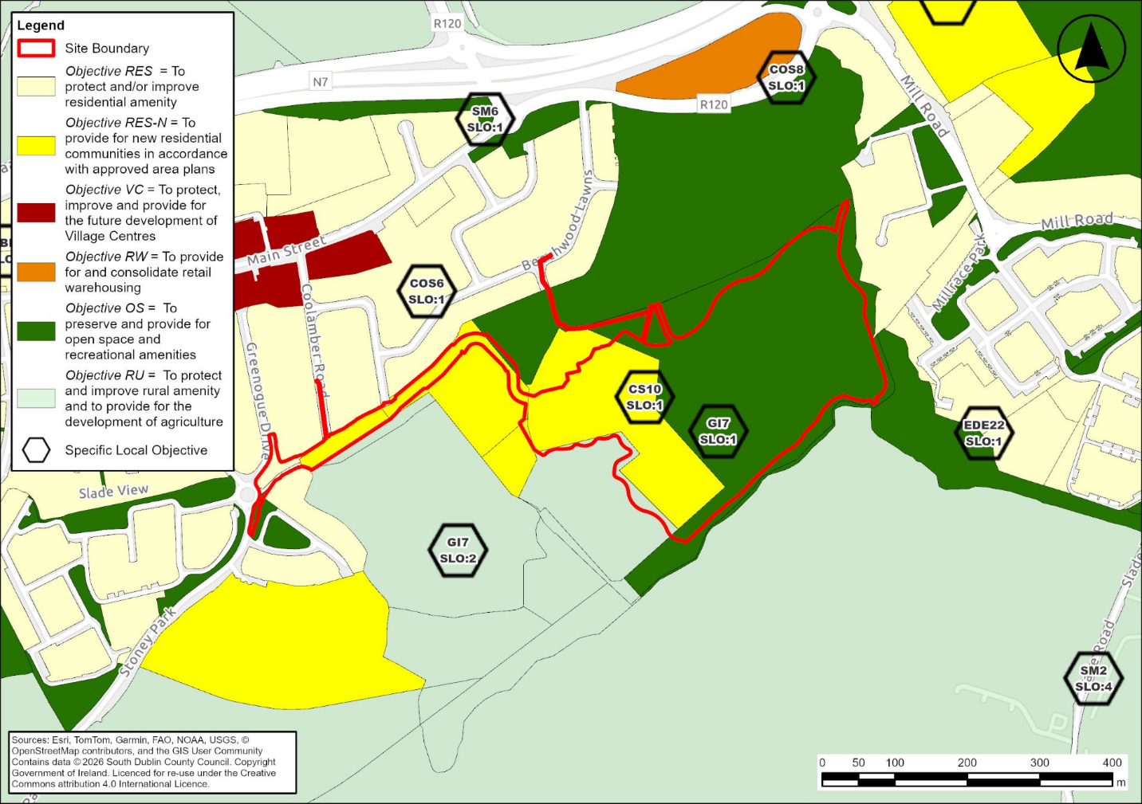
Plate 4-1: Zoning at the Site
Rathcoole is designated as a Self-Sustaining Growth Town in the CDP. The do-nothing scenario is therefore considered to be an inappropriate, unsustainable and constitutes an inefficient use of residentially zoned lands. The future recreational use of the lands and the proposals to develop the proposed pitches and pavilion would not likely occur should the do-nothing alternative be selected.
The do-nothing alternative would obviate any potential short-term construction impacts with associated potential disturbance on local populations. While the do-nothing scenario would retain the existing natural environment, it would represent an inefficient use of zoned and strategically located lands identified for development. Furthermore, opportunities to improve recreational infrastructure, active travel connectivity and biodiversity management would not be realised.
In the long-term, a ‘Do-nothing’ Scenario is not considered realistic or reasonable as the statutory planning objectives to support development in this location remain and if feasible, alternative development proposals for residential development would likely be brought forward in due course. In context of delivering housing for the Dublin Region there would be a failure to address an urgent need for housing as expressed in the NPF.
Overall, while the do-nothing scenario would result in neutral to positive environmental effects in relation to biodiversity and natural habitats, it would result in adverse effects in terms of housing delivery, recreation provision, community infrastructure and achievement of strategic planning objectives.

Alternative Processes
The EPA Guidelines considers that with each design solution, there can be several options as to how an activity can be carried out. Under this alternative, different processes pertaining to the construction phase and the operational phase would be considered.
It is not considered to be a relevant consideration for the development of residential units and active open space. The construction and operation of residential units and active open space comprise generally standard building construction processes. There is also no new, unusual or technically challenging operational techniques required for the operation of the development. As such, there is no specific alternative process, which may be considered.

Alternative Locations
Alternative locations within the overall SDCC lands to the south of Rathcoole have been considered in the selection process. The subject lands have been identified through successive South Dublin County Development Plans as suitable for residential, recreational and community development and form part of the planned growth framework for Rathcoole. The principle of development at this location has therefore already been established through the statutory plan-making process, including SEA undertaken in support of the CDP.
With the exception of the Department of Education lands, site is controlled by South Dublin County Council and the proposed development has been specifically designed in response to the opportunities and constraints associated with these lands, including the approved school development, GAA lands and existing woodland areas.
The purpose of this section is therefore not to identify alternative locations beyond the overall land bank, but rather to examine the reasonable alternatives considered in relation to the layout and design of the proposed development within the subject lands. Accordingly, alternative locations are not considered relevant to the assessment of reasonable alternatives for the proposed development.

Alternative Designs / Layouts
The proposed development is cognisant of and complies with the policies and objectives of the NPF 2025, the Eastern and Midland Regional Spatial and Economic Strategy (EMRA 2019), the relevant ministerial planning guidelines made under section 28 of the Act, the SDCCDP 2022-2028 and proposed Variation No.2.
Alternative layouts and associated distribution of uses have been developed throughout the design process, with a view to minimise impacts on the receiving environment. The alternatives are presented in the following sections.

Alternative 2 – Masterplan 2019
The earliest comprehensive framework prepared for the Rathcoole Lands was the Draft Masterplan presented in 2019. This proposal sought to provide a significant mixed-use extension to the settlement of Rathcoole incorporating residential development, educational facilities, recreational infrastructure and public open space.
The 2019 Masterplan provided for approximately 250 residential units comprising a mix of houses, duplexes and apartments. The residential development was concentrated on the western and southern portions of the site and overall 17.8ha landbank. Of these units, 100 were proposed as social, 100 as affordable and 50 as private.
Lands to the east of the site adjacent Saggart were not included in this proposal. The proposed layout proposed a library and acknowledged the zoned school site to the north. The residential and community elements were additionally supported by and amenity area between the recreational and residential development and a substantial sporting facility comprising three senior GAA pitches, one junior pitch, a pavilion building, maintenance facilities and associated parking. The residential element occupied approximately 6.94 hectares at a density of approximately 36.2 dwellings per hectare with building heights generally ranging from one to four storeys.
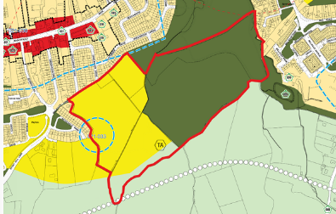
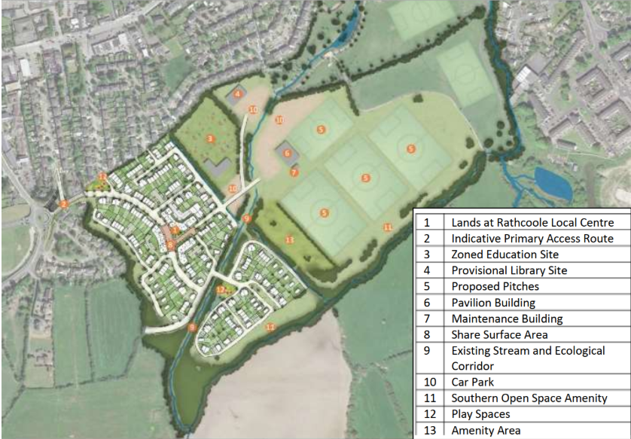
Plate 4-2: 2019 Masterplan Site Layout with Zoning Top Left (Source: SDCC)

Environmental Effects
The 2019 Masterplan would have resulted in a substantially greater level of development across the Rathcoole Lands than that currently proposed. The scheme provided for approximately 250 residential units, extensive associated infrastructure and recreational facilities across the majority of the total landbank. While it sought to integrate housing, education, recreation and community facilities within a comprehensive framework, the scale and extent of development would likely have resulted in a greater loss and fragmentation of existing habitats and natural areas.
The layout extended into areas which were later identified as containing ecological constraints, including Annex I lowland hay meadow and alluvial woodland habitats, woodland areas and important green infrastructure linkages between Rathcoole and Saggart. The extent of development proposed would likely have resulted in a greater reduction in semi-natural habitats and a corresponding reduction in biodiversity value when compared to the current proposal. The provision of three senior GAA pitches, a junior pitch, associated buildings, parking areas and a larger residential development footprint would also have increased the extent of land take, hard surfacing and habitat modification across the site.
From a population and human health perspective, the proposal would have generated significant positive effects through the delivery of a substantial quantum of social, affordable and private housing together with educational, sporting and community infrastructure, including a library. Overall, the 2019 Masterplan would likely have resulted in greater positive effects in terms of housing delivery, recreation and community infrastructure provision. However, these benefits would have been accompanied by greater environmental effects arising from habitat loss, woodland fragmentation, reduced ecological connectivity and increased disturbance of sensitive ecological features.

Alternative 3 – Land Use Concept 2021
In response to Specific Local Objective CS10 SLO1, South Dublin County Council commissioned a detailed review of the lands to investigate alternative land use arrangements informed by ecological survey and flood risk assessment work. This work culminated in the Rathcoole Lands Land Use Concept and Zoning Proposals prepared in December 2021.
Following the consideration of 3 layout options which informed the emerging zoning for the SDCCDP 2022-2028 a preferred emerging option was identified, The 2021 concept represented a significant evolution from the 2019 Masterplan. The updated design included 1.9ha of residential lands to the south of the Coolmine Stream and 1.4ha of residential lands to the north of the Coolmine Stream. The proposed density was c.41 units per ha to include traveller accommodation units. An access corridor from Stoney Hill Road was also included. The proposed school site is to the south of the stream, in between both blocks of residential land.
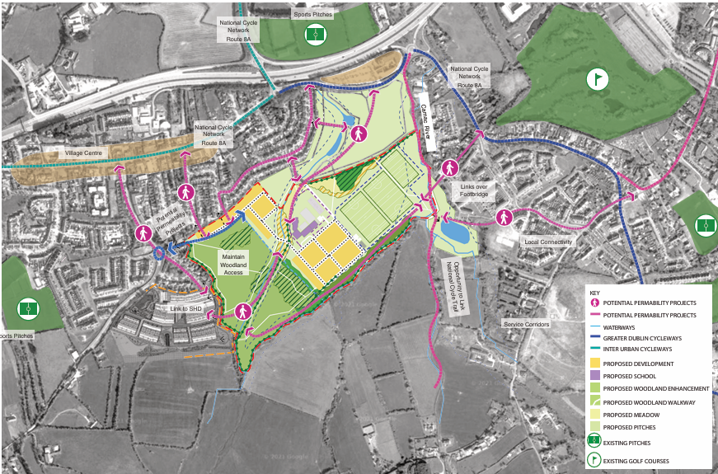
Plate 4-3: 2021 Site Layout (Source: Metropolitan Workshop)

Environmental Effects
The 2021 Land Use Concept represented a significant improvement on the 2019 Masterplan from an ecological perspective and reflected the findings of ecological survey work and flood risk assessment undertaken for the lands. The concept sought to reduce the overall development footprint and provide greater recognition of the environmental constraints present within the site.
The concept provided for residential development on lands both north and south of the Coolmine Stream and designated an area of Annex I lowland hay meadow for the development of the proposed school. The southern residential lands also extended farther to the west into the existing woodland than the current proposal. This area of the site includes Annex I Alluvial Woodland. While this approach facilitated residential development and the delivery of educational infrastructure, residential development would have extended closer to the riparian zone of the Coolmine Stream to the north. As a consequence, there would have been greater interaction with riparian habitats and a greater degree of fragmentation of the site's ecological resources than is proposed under the current application.
The density proposed under the 2021 concept, at approximately 41 units per ha, represented a more efficient use of land than the 2019 Masterplan and aligned more closely with the strategic planning objective of accommodating residential growth balanced with ecological objectives. However, the arrangement of development parcels on both sides of the Coolmine Stream would have reduced opportunities to establish larger and more coherent areas of ecological protection, habitat enhancement and recreational open space while there was some loss of Annex I habitat.
The proposal would have resulted in positive effects through the delivery of housing, educational infrastructure and supporting community facilities. Although this approach provided an improved environmental response compared to the 2019 Masterplan, further work was subsequently undertaken to refine development capacity, reduce impacts on sensitive habitats and align the proposals with the adopted Development Plan objectives.

Alternative 4 – Alternative Access Route
The South Dublin County Development Plan 2010-2016 identified a proposal for a local road forming part of the Southern Relief Road for Rathcoole. This objective was included within Table 2.2.5 (Six-Year Road Objectives) and proposed a route extending from Stony Lane eastwards towards the lands identified for sports and recreational uses. The indicative route traversed agricultural lands to the south of the site and along the southern portion of the subject lands. It would have provided vehicular access to development lands from the south rather than from Greenogue Drive and Coolamber Drive as proposed under the current application.
Under this alternative, the development of the subject lands would have been facilitated through the delivery of the Southern Relief Road corridor and associated access infrastructure. This would have enabled vehicular access to be taken from the south-western portion of the site and would have reduced the requirement for access infrastructure within the northern portion of the lands designated Annex I.
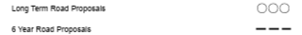
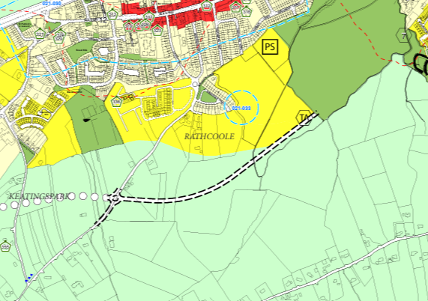
Plate 4-4: Zoning Map SDCCDP 2010-2016

Environmental Effects
The Southern Relief Road option would have required the construction of a new road corridor through largely undeveloped lands south of Rathcoole. While the route had been identified within the SDCCDP as a 6 year road objective, its delivery would have resulted in additional land take, and fragmentation of agricultural lands and natural habitats beyond the boundaries of the current development site.
The provision of a strategic access route through the southern portion of the lands would likely have increased the extent of development within currently undeveloped areas and would have introduced additional traffic infrastructure into the rural landscape south of Rathcoole. The road corridor would also have fragmented ecological linkages and may have resulted in additional impacts on biodiversity and agricultural land resources.
From a transportation perspective, the route may have provided an alternative means of access to future development lands and could have reduced traffic movements on sections of the existing local road network. However, the objective was subsequently omitted from later Development Plans and has not formed part of the planning framework governing the subject lands since adoption of the South Dublin County Development Plan 2016-2022.
Overall, while the Southern Relief Road option would have provided an alternative access strategy for the development of the lands, it would likely have resulted in greater land take and environmental disturbance than the current proposal. Accordingly, the environmental effects of this alternative are considered to be less favourable than those associated with the preferred development option.

Alternative 5 – The Proposed Development
This alternative is in effect the development proposal as described in Chapter 2 of the EIAR. The evolution of the preferred alternative was informed by consultations with the SDCC, relevant stakeholders and further detailed analysis of the characteristics of subject site by the EIAR team and interaction with the design team having regard to the potential environmental impacts of the project.
In summary, the preferred development option comprises the proposed development as described in Chapter 2 of this EIAR. The proposal has evolved through a number of design iterations and strategic land use concepts prepared for the Rathcoole lands since 2019. The final design seeks to balance the delivery of housing, recreational infrastructure, educational facilities, biodiversity protection, woodland management and active travel connectivity having regard to the environmental sensitivities and planning objectives associated with the site.
The proposed development comprises 130 residential units including social, affordable, age friendly housing and traveller accommodation, together with public open space, active travel infrastructure, woodland management and enhancement measures, biodiversity enhancement measures, two senior GAA pitches, one junior GAA pitch and an associated pavilion. The development also facilitates integration with the approved primary school development and wider movement network within Rathcoole.
The proposal has been informed by detailed ecological surveys, flood risk assessment, transportation analysis, engineering design, landscape assessment and planning policy considerations. The final layout seeks to retain and enhance key ecological resources within the site and throughout the wider landbank, including woodland habitats, riparian corridors and areas of Annex I habitat, while facilitating the planned growth of Rathcoole as a Self-Sustaining Growth Town.
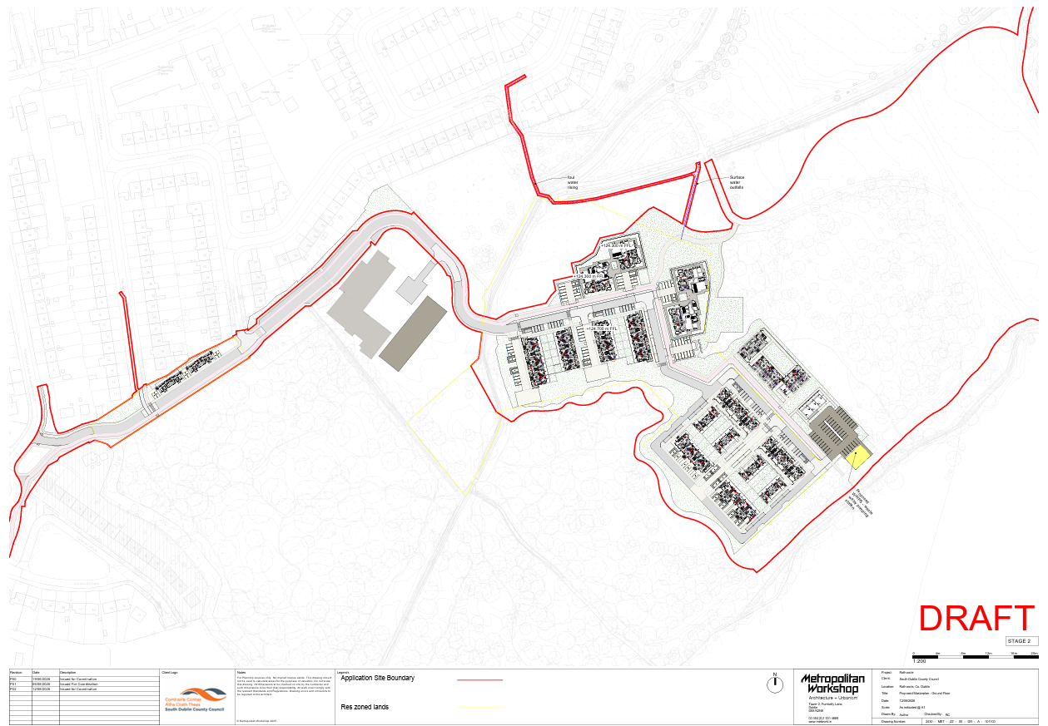
Plate 4-5: Proposed Development Site Layout Plan (Source: Metropolitan Workshop)

Environmental Effects
The preferred development option results in the loss of portions of existing grassland, woodland and other habitats within the site to facilitate residential development, recreational facilities and supporting infrastructure. The development also introduces a permanent change in land use from predominantly undeveloped lands to a combination of residential, recreational and open space uses.
However, the proposal has evolved to respond to the environmental constraints identified throughout the site. Significant areas of woodland, riparian habitat and ecological corridors are retained and incorporated into the design. A bridge across the Coolmine Stream will be introduced to facilitate access to the site, however, the 10m riparian zone will be facilitated throughout the rest of the development and the riparian corridor of the Crockshane (Slade) Stream will be enhanced through appropriate biodiversity enhancement measures.
The proposed development provides a more efficient use of land than the earlier masterplan concepts and supports the strategic planning objectives identified for Rathcoole through the delivery of housing, facilitation of educational infrastructure, along with the provision of recreational. The development contributes to the housing growth requirements identified for South Dublin County.
From a population and human health perspective, the proposal delivers significant positive effects through the provision of housing, pitches and open space, active travel infrastructure and improved access to natural amenities. While some natural areas are developed, the retained woodland and meadow areas continue to provide important ecological and recreational functions.
Overall, the preferred development option is considered to provide the most appropriate balance between housing delivery, recreational provision and environmental protection. The environmental effects of this alternative are therefore considered positive in the long term and represent the optimum outcome when assessed against the reasonable alternatives considered.

Alternative Mitigation Measures
Measures envisaged to avoid, prevent, reduce or, if possible, offset any identified significant adverse effects on the environment are described in the EIAR Report. These measures are commonly referred to as ‘Mitigation Measures’, with the exception of the last action, offsetting, which can be considered to be a Compensation Measure.
When considering Alternatives, such Mitigation Measures might influence how Alternatives are assessed. For example, an Alternative might be considered unfeasible until a Developer factors in a Mitigation or Compensation Measure that reduces the impact of the Alternative. In addition, by considering Mitigation Measures when considering all Alternatives, even feasible Alternatives may benefit from a more environmentally sound Project design, ultimately ensuring a high level of environmental protection.
This EIAR outlines mitigation measures under the topics assessed. These are considered to be appropriate to the location, nature and extent of the proposed development and to its potential impacts. Therefore, no alternative mitigation measures have been considered.

Comparison of Main Environmental Effects
The table below presents a summary comparison of the environmental effects of the alternatives considered. Aside from the 'Do Nothing' scenario, the alternatives represent the evolution and development of scenarios established for the site, and the design alternatives therefore reflect nuanced improvements in layout that constitute relatively discrete changes in environmental terms. The five alternatives are considered as positive, neutral or negative. The classifications set out in this table are relative to the other alternatives and to the long-term objectives for the development of Rathcoole.
Table 4-1: Summary Comparison of the Main Environmental Effects
Topic | Alternative 1 – Do Nothing | Alternative No. 2 – Masterplan 2019 | Alternative 3 – Land Use Concept 2021 | Alternative 4 – Alternative Access Route | Alternative 5 – The Proposed Development
Population and Human Health | Negative | Positive | Positive | Positive | Positive
Biodiversity | Neutral | Negative | Negative | Negative | Negative
Land and Soils | Neutral | Negative | Negative | Negative | Negative
Water | Neutral | Negative | Negative | Negative | Neutral
Air Quality and Climate | Neutral | Neutral | Neutral | Neutral | Neutral
Noise and Vibration | Neutral | Neutral | Neutral | Neutral | Neutral
Landscape and Visual | Neutral | Negative | Neutral | Negative | Neutral
Material Assets – Traffic and Transportation | Negative | Positive | Positive | Positive | Positive
Material Assets - Utilities | Neutral | Neutral | Neutral | Neutral | Neutral
Material Assets - Waste | Neutral | Neutral | Neutral | Neutral | Neutral
Archaeology and Cultural Heritage | Neutral | Neutral | Neutral | Neutral | Neutral
Source: MacCabe Durney Barnes

[HOLD - Amend if alternative 4 removed] [The principal environmental distinction between the alternatives relates to the balance achieved between housing delivery, recreational provision, biodiversity protection and the efficient use of zoned lands.
With reference to Population and Human Health, Alternatives 2, 3, 4 and 5 support the planned growth of Rathcoole through the delivery of housing, recreational facilities, open space and community infrastructure. Alternative 1 does not facilitate the delivery of housing, educational infrastructure, recreational facilities or community benefits on lands specifically identified for growth within Rathcoole.
From a biodiversity perspective, Alternative 1 provides the most favourable outcome through the retention of the majority of existing habitats and ecological resources. Alternative 2 would result in the greatest level of habitat loss and fragmentation due to the scale of development proposed across the site and proximity to watercourses. Alternative 3 represented a significant improvement in environmental performance through a reduced development footprint and greater recognition of ecological constraints. Alternative 4 would require the construction of a road corridor through previously undeveloped lands and would result in additional habitat fragmentation and ecological disturbance. The preferred development option (Alternative 5) seeks to balance development and environmental protection through the retention of significant woodland areas and protection of Annex I habitats (alluvial woodland and lowland hay meadow), enhancement of ecological corridors, management of Annex I Lowland Hay Meadow habitat and the incorporation of biodiversity enhancement and woodland management measures throughout the site.
With regard to noise and air quality impacts, the alternatives are broadly similar in that the principal impacts would arise during the construction phase. Alternative 2 would result in the greatest level of land take and site disturbance, while Alternative 1 would result in negligible amounts. Alternative 5 incorporates Sustainable Drainage Systems (SuDS), riparian protection measures and extensive green infrastructure, thereby reducing potential impacts on water quality and surface water management.
In terms of impacts on water features and quality, the alternatives are differentiated primarily by the extent to which development interacts with the Coolmine Stream, Camac River and Crockshane (Slade) Stream corridors and their associated riparian habitats. Alternative 1 avoids intervention within these watercourses and maintains the existing hydrology and riparian zones. Alternative 2 includes the greatest extent of residential development in proximity to the Coolmine Stream than the subsequent design iterations and would have resulted in increased interaction with the stream corridor and associated habitats. Alternative 3 represents an improvement in this regard but was designed with residential development on both sides of the Coolmine Stream, requiring a bridge crossing to facilitate movement throughout the site. Alternative 4 would have required the construction of a new access route through undeveloped lands in relatively close proximity to the north of the Crockshane (Slade) Stream, increasing the potential for disturbance particularly as the provision of a new vehicular access route is a relatively significant piece of infrastructural development. While all residential development alternatives necessitate a bridge crossing of the Coolmine Stream, the preferred development option (Alternative 5) has evolved to minimise interaction with the water environment and incorporates riparian buffer zones, habitat protection measures, SuDS infrastructure and ecological (including riparian zone) enhancement works. Although the proposed development will introduce new development and infrastructure within the site, it also provides for the long-term protection and enhancement of the Coolmine Stream, Camac River and Crockshane (Slade) Stream corridors, achieving a more balanced outcome between environmental protection and the delivery of housing, recreational facilities and associated infrastructure
In terms of land and soils, the alternatives are mainly distinguished by the extent of development proposed and the associated level of ground disturbance, earthworks and site levelling needed. Alternative 1 avoids any disturbance to existing ground conditions and retains the lands in their current state. Alternative 2 would have resulted in the greatest impact on land and soils due to the extent of residential development proposed together with three senior GAA pitches, one junior pitch, parking, community facilities and supporting infrastructure across a large proportion of the overall landbank. This alternative would have required the greatest level of land modification. Alternative 3 reduced the overall development footprint and therefore the level of land take and earthworks required. However, residential development was still proposed on both sides of the Coolmine Stream. The pitches were located slightly further south than in Alternative 5 in this design iteration covering less ground. Alternative 4 would have introduced additional disturbance through the provision of a new road corridor through previously undeveloped lands, resulting in further excavation and soil disturbance beyond that associated with the residential and recreational elements. The preferred development option (Alternative 5) requires site levelling, earthworks and permanent land take associated with the residential development, GAA pitches, pavilion, bridge crossing and supporting infrastructure. However, the layout has evolved having regard to ecological constraints and topography and generally results in a lower level of land disturbance than the earlier masterplan options while continuing to provide housing and three GAA pitches along with associated infrastructure.
From a landscape and visual perspective, Alternative 1 retains the existing character of the site and therefore performs most favourably. Alternative 2 would have resulted in the greatest visual change due to the scale of residential and recreational development proposed. Alternative 3 reduced this impact, while Alternative 4 would have introduced an additional road corridor through undeveloped lands. Alternative 5 still results in a significant change to the site through the introduction of residential development, recreational facilities and associated infrastructure. However, the proposed development also introduces a coherent urban structure, high-quality residential design, new public open spaces, active recreation facilities and enhanced accessibility. The retention of woodland, open space and riparian corridors further assists in integrating the development into its surroundings. As such, while the existing landscape character will change, a number of these changes may also be considered positive from a visual amenity, placemaking and settlement development perspective.
The alternatives differ significantly in the level of connectivity provided both within the site and to the wider Rathcoole area. Alternative 1 largely retains the existing situation and does not provide any meaningful improvements to pedestrian, cycle or vehicular connections. Alternatives 2 and 3 would have improved access through the lands. Alternative 4 would have created a new connection through the former Southern Relief Road corridor, but this would have relied on significant additional road infrastructure. Alternative 5 provides the strongest connectivity benefits, including links to Rathcoole Park, the approved school development, the proposed recreational facilities and the wider active travel network. Overall, it is considered to provide the most comprehensive and integrated movement network while improving permeability throughout the area.
In terms of utilities and waste, the differences between the alternatives broadly reflect the scale of development proposed. Alternative 2 would generate the greatest demand on utility networks and the largest volume of construction waste, while Alternative 1 would generate little additional demand. Alternatives 3, 4 and 5 fall between these extremes, with the proposed development providing a level of demand consistent with the planned growth of Rathcoole and capable of being accommodated by existing and planned infrastructure.
Potential impacts on archaeology and cultural heritage generally increase in line with the extent of ground disturbance. Alternative 2 would have involved the greatest level of excavation, while Alternative 1 would result in little or no disturbance. The proposed development has been informed by archaeological investigations and any impacts can be appropriately managed through mitigation measures.

Preferred Alternative
With reference to the final layout, the iterative process outlined above, which included alternative site layouts were considered with the objective of producing a new high quality residential development, which has undergone a robust consideration of relevant alternatives having regard to the comparison of environmental effects and meets the requirements of the EIA Directive, based on the multidisciplinary review across all environmental topics.
Alternative 5 represents the preferred development option. The proposed development has evolved through a series of masterplans, land use concepts and design iterations informed its ecology, current planning policy and residential along with community infrastructure requirements. These considerations informed the location and extent of residential development, the arrangement of recreational facilities, the design of access infrastructure and the approach to ecology throughout the site.
The preferred development option therefore represents the most appropriate balance between housing delivery, recreational provision, biodiversity protection, woodland management, active travel connectivity and overall benefit to the community. The iterative design process, informed by environmental assessment and technical input from the multidisciplinary design team, has resulted in a proposal that minimises environmental effects while maximising the social, recreational and community benefits arising from the development of the lands.
In respect of other items it is noted that a sustainable level of density is proposed having regard to the Sustainable residential and Compact Settlement Guidelines for Planning Authorities (2024).
This EIAR describes an iterative process where the environmental assets and sensitivities of the subject lands are considered and assessed as the scheme evolves over time. The EIA process and consultation with Statutory bodies has allowed the creation of greatly improved residential development with reduced environmental impact and a more integrated relationship with the area.

References
Department of Housing, Local Government and Heritage (2025). National Planning Framework.
Department of Housing, Local Government and Heritage (2025). NPF Implementation: Housing Growth Requirements – Guidelines for Planning Authorities.
Eastern and Midland Regional Assembly (2019). Regional Spatial and Economic Strategy 2019–2031.
Environmental Protection Agency (2022). Guidelines on the Information to be Contained in Environmental Impact Assessment Reports.
European Commission (2017). Environmental Impact Assessment of Projects: Guidance on the Preparation of the Environmental Impact Assessment Report.
South Dublin County Council (2022). South Dublin County Development Plan 2022–2028.
South Dublin County Council (2025). Proposed Variation No. 2 to the South Dublin County Development Plan 2022–2028.
South Dublin County Council (2025). Strategic Environmental Assessment of the South Dublin County Development Plan 2022–2028.

Non-Technical Summary
Please note this section will be removed from each individual chapter and inserted the Volume 1 Non-Technical Summary.
The EIAR considered reasonable alternatives to the Proposed Development, including the Do-Nothing scenario, alternative uses and locations, alternative layouts and designs, and alternative access arrangements.

The Do-Nothing scenario would avoid construction effects and retain the existing Site, but the proposed housing, GAA facilities, public open space, active travel links and biodiversity enhancement measures would not be delivered.

Earlier development options included a 2019 Masterplan with a larger development footprint and approximately 250 homes, and a 2021 Land Use Concept which reduced the development area but still had greater interaction with sensitive habitats and the Coolmine Stream. An alternative access via the former Southern Relief Road was also considered but would have required additional road infrastructure through undeveloped lands.

The preferred option is the Proposed Development described in Chapter 2, comprising 130 residential units, two senior GAA pitches, one junior pitch, a pavilion, public open space and active travel infrastructure.

Overall, the preferred option was selected because it provides the most appropriate balance between housing and recreational provision and reducing environmental effects compared with the reasonable alternatives considered.

Acronyms and Abbreviations
Acronym/Abbreviation | Full Text
ACP | An Coimisiún Pleanála
CDP | County Development Plan
EIA | Environmental Impact Assessment
EIAR | Environmental Impact Assessment Report
EMRA | Eastern and Midland Regional Assembly
EPA | Environmental Protection Agency
EU | European Union
GAA | Gaelic Athletic Association
ha | Hectare
MDB | MacCabe Durney Barnes
NPF | National Planning Framework
OS | Open Space and Recreational Amenities Zoning Objective
RES-N | New Residential Zoning Objective
RU | Rural Amenity and Agriculture Zoning Objective
SDCC | South Dublin County Council
SDCCDP | South Dublin County Council Development Plan
SEA | Strategic Environmental Assessment
SLO | Specific Local Objective
SuDS | Sustainable Drainage Systems



European Commission (2017) Environmental Impact Assessment of Projects, Guidance on the preparation of the EIA Report (Directive 2011/92/EU as amended by 2014/52/EU)

