


DRAFT

SDCC Rathcoole Housing Development
Environmental Impact Assessment Report (EIAR)
Chapter 02: Description of Development

South Dublin County Council (SDCC)

August 2026

Quality information
Prepared by |  | Checked by |  | Verified by |  | Approved by
Lara Carey/Jerry Barnes |  | Jerry Barnes |  | Jerry Barnes |  | Richard O'Callaghan  Project Director

Revision History
Revision | Revision date | Details | Authorized | Name | Position
0 | 28/08/2026 | Draft | N | Richard O'Callaghan | Project Director

Distribution List
# Hard Copies | PDF Required | Association / Company Name
0 | 1 | South Dublin County Council

Prepared for:
South Dublin County Council (SDCC)

Prepared by:
‌AECOM Ireland Limited
4th Floor
One Burlington Plaza
Burlington Road
Dublin 4
D04 RH96
T +353-1-696-6220

© 2026 AECOM Ireland Limited. All Rights Reserved.
This document has been prepared by AECOM Ireland Limited (“AECOM”) for sole use of our client (the “Client”) in accordance with generally accepted consultancy principles, the budget for fees and the terms of reference agreed between AECOM and the Client. Any information provided by third parties and referred to herein has not been checked or verified by AECOM, unless otherwise expressly stated in the document. No third party may rely upon this document without the prior and express written agreement of AECOM.
Table of Contents
2 Description of Development 2-1
2.1 Introduction 2-1
2.2 Site Location and Surrounding Area 2-1
2.2.1 Site Location 2-1
2.2.2 Site Context 2-2
2.2.3 Topography, Drainage and Service Infrastructure 2-3
2.3 Detailed Description of Proposed Development 2-3
2.3.1 Public Notice Description 2-3
2.3.2 Residential 2-4
2.3.3 Landscape 2-7
2.3.4 Access 2-9
2.3.5 Services 2-10
2.4 Construction Phase 2-11
2.4.1 Construction Programme 2-11
2.4.2 Construction Compounds 2-12
2.4.3 Construction Methodology 2-12
2.4.4 Environmental Management 2-14
2.5 Operational Phase 2-14
2.5.1 Emergency and Contingency Procedures 2-14
2.6 References 2-14
Non-Technical Summary 2-16
Acronyms and Abbreviations 2-17

Figures
Plate 2-1: Site Location 2-2
Plate 2-2: Zoning at the Site 2-3
Plate 2-3: Site Layout (Source: Metropolitan Workshop) 2-5

Tables
Table 2-1: Residential Typology 2-5

Description of Development

Introduction

This section of the Environmental Impact Assessment Report (EIAR) has been prepared by MacCabe Durney Barnes on behalf of South Dublin County Council. Approval is sought to construct a 130 no. unit residential development, and 2 no. senior and 1 no. junior grass pitches on an application site measuring c.11.3ha.
The EIAR has been prepared to accompany an application for approval to An Coimisiún Pleanála for the aforementioned development works under Section 175 of the Planning & Development Act 2000 as amended.
The EIA Directive requires that an EIAR includes a description of the project comprising information on the site design, size and other relevant features of the project. Recital 22 of the Directive 2014/52/EU requires that

“In order to ensure a high level of protection of the environment and human health, screening procedures and environmental impact assessments should take account of the impact of the whole project in question, including, where relevant, its subsurface and underground, during the construction, operational and, where relevant, demolition phases”.

This chapter satisfies the requirements of the EIA Directive, providing detail on the location, size and characteristics of the proposed project.

Site Location and Surrounding Area

Site Location
The application site consists of a site of c.11.3ha to the south and southeast of Rathcoole Village, County Dublin. Rathcoole Village is located c.15km to the southwest of Dublin City Centre, c.13km northeast of Naas, County Kildare and c.13km to the north of Blessington, County Wicklow. The established settlement largely consists of a traditional development pattern with a central main street which contains local shops and facilities and is surrounded by relatively low-density housing estates.
Rathcoole Village Centre is approximately 2km from the Red Line Luas stop at Saggart which is located at Fortunestown Lane to the east of the Citywest Golf Course. Bus stops serving Kildare, Newbridge and Dublin are located along Main Street, School Road and at the slip road to the north of the N7. The site is well connected to Dublin and Kildare with direct access to the N7 motorway to the north of Rathcoole Village.
The greenfield site is situated adjacent to Rathcoole Park, which extends along its northwestern boundary. Saggart’s western residential estates bound the site to the east and existing residential estates extend along the site’s northern boundary. Those at Beechwood Lawns are separated from the site by the existing Rathcoole Park and approved Department of Education school development (SDCC Ref. SD23A/0336). To the west, Rathcoole Woodlands extends to residential estates proximate Mullally’s Lane Roundabout. Agricultural lands are located to the southwest and south of the site.
Indirect access to the site is currently via Rathcoole Park. Future access is to be provided via a new access road also forming part of this application running eastwards through the approved Department of Education lands from Mullally’s Lane Roundabout, which will include a realignment of Greenogue Drive and the widening of Mullallys’ Lane, which is presently a cul-de-sac. This road will also provide access to the new school. An Irish Water Easement runs along the southeastern extent of the subject lands.
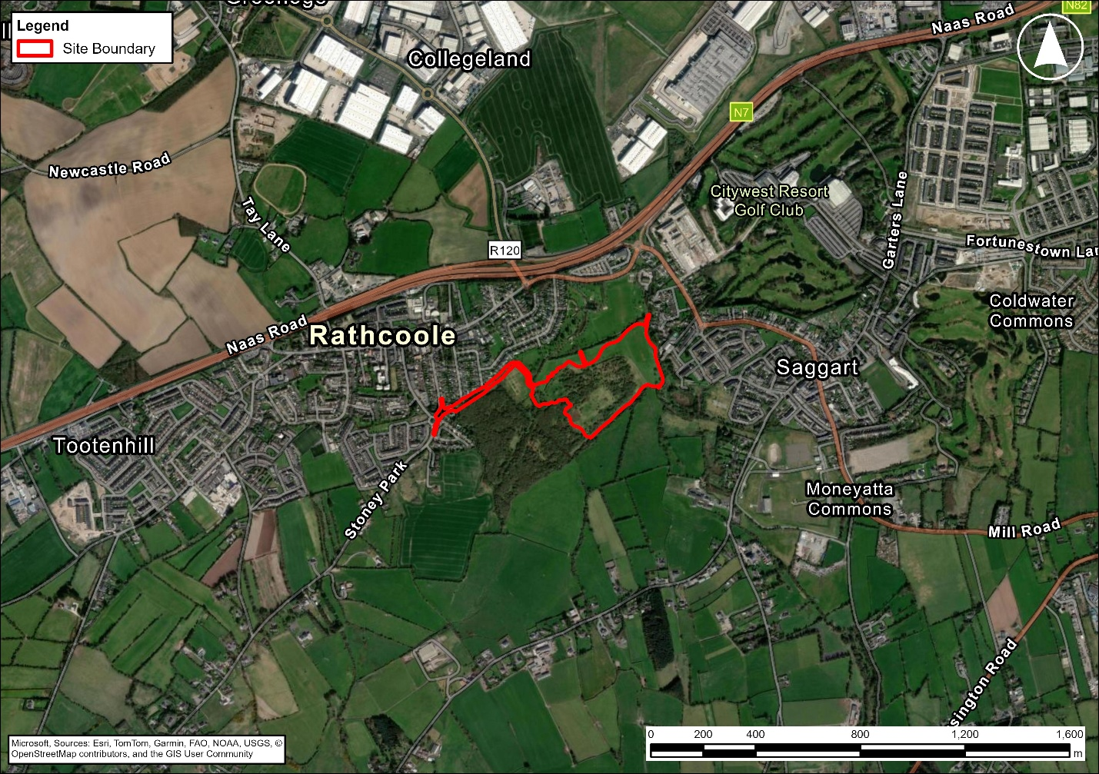
Plate 2-1: Site Location

Site Context
The site is located within the administrative area of South Dublin County Council. Rathcoole Village is a designated ‘Self-Sustaining Growth Town’ within the SDCC Development Plan 2022-2028, which is not considered to be situated within Dublin City and its suburbs. It is however situated within the metropolitan area identified within the Regional Spatial and Economic Strategy Metropolitan Area Strategic Plan (MASP).

The policies and objectives found within the South Dublin County Development Plan 2022-2028 form the relevant plan for the area. The subject site is zoned for New Residential (RES-N), Open Space (OS), and Rural and Agriculture (RU). Rathcoole Village, located to the north of the site, is predominantly zoned Objective RES (Residential). A cluster of existing residential properties is also located to the north-west of the site. A c.5.8 ha site to the east of Stoney Hill Road is zoned Objective RES-N and was recently the subject of a residential development proposal (ACP Ref. 324071), which was refused permission on appeal.

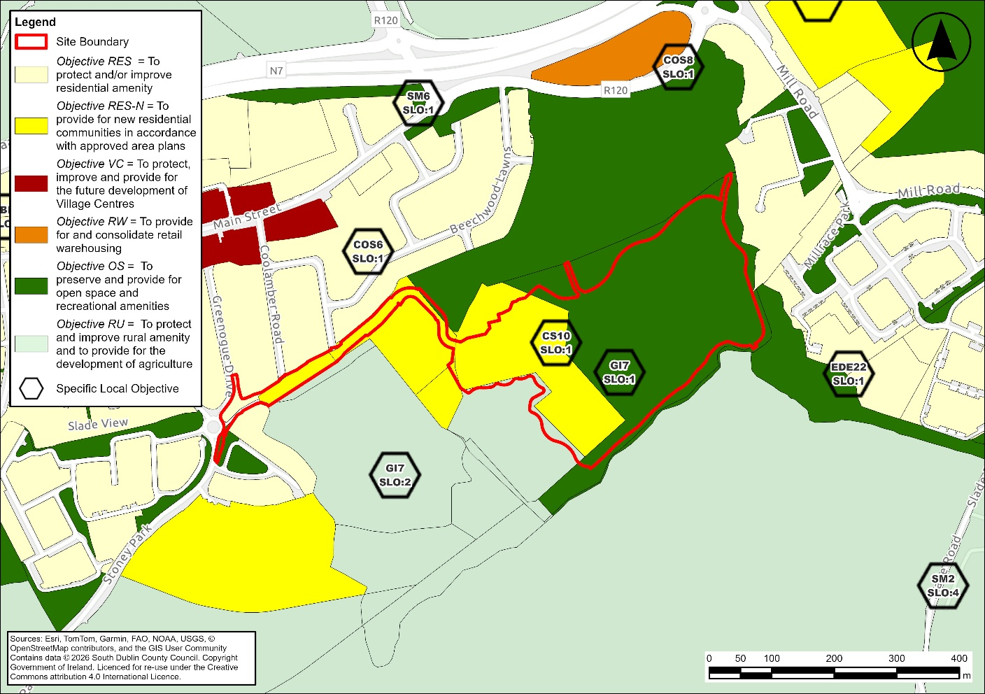
Plate 2-2: Zoning at the Site [HOLD To be updated when final]
Several Specific Local Objectives (SLO) also apply to the site. TA indicates an objective to provide for traveller accommodation at the site. There is an SLO to provide a school (S) on the RES-N zoning. Two local green infrastructure and community objectives additionally apply to the site:

- GI7 SLO1 – maintain the green wildlife corridor between Saggart and Rathcoole and incorporate it into the designs for Rathcoole Park.
- GI7 SLO2 – protect and augment the Alluvial Woodlands within the RU zoning with consideration of linages to proximate amenity areas and provision of sensitive passible amenity uses
- CS10 SLO1 – provide a primary school, library hub, 2 full sized GAA and 1 junior GAA pitch, pavilion, access road and open space.
The site comprises an undeveloped greenfield area which is characterised by a combination of open grassland, scrub, hedgerows and immature woodland. The site boundaries are generally defined by established hedgerows with tree cover concentrated primarily along these hedgerows. The Camac River is situated to the east of the site, the Crockshane (Slade) Stream to the south and the Coolmine Stream bisects the western portion of the site and flows into Rathcoole Park.

Topography, Drainage and Service Infrastructure
Overall gradients at the site are generally graded from southwest to northeast at an average of approximately 1:60. Ground levels ranging from c.126.70mOD at the south to 113.00mOD at the northeast.

There are areas of Flood Zone A and B associated with the riparian corridors of the Coolmine Stream, Camac River and Crockshane Stream in addition to several existing underground watermains present on the site which have associated wayleaves. These include 10m wayleaves (5m either side of the asset) to the watermain that runs parallel with the Crookshane/Slade stream to the south of the site as well as the watermain that runs parallel with the Camac River to the east and 16m wayleaves (8m either side of the asset) to the 2no. watermains that pass through the southern end of the site as well as the remaining watermain which runs north-south through the east of the site and into Rathcoole Park.

Detailed Description of Proposed Development

Public Notice Description
We, South Dublin County Council, intent to apply to An Coimisiún Pleanála for permission for residential and pitch development at this site of 11.3ha to the southeast of Rathcoole Village, County Dublin. The application site is located to the southwest of Rathcoole Park. The River Camac forms the eastern boundary of the site. Part of the approved Department of Education school development (SDCC Ref. SD23A/0336) and Mullally’s Lane forms part of the subject site, with Coolamber Drive, Coolamber Road and Greenogue Drive bounding the site to the north. To the west, Rathcoole Woodlands extends to residential estates proximate Mullally’s Lane Roundabout. Agricultural lands are located to the southwest and south of the site.
The proposed development will consist of:
- 130 residential units including:
  - 43 no. 2 storey houses (39 no. 3 bed and 4 no. 4 bed) provided within 12 no. terraced rows.
  - 16 no. duplex apartments (8 no. 1 bed and 8 no. 3 bed) provided within 2 no. 3 storey blocks.
  - 4 no. age friendly duplex apartments (2 no. 1 bed and 2 no. 2 bed) provided within 1 no. 3 storey block.
  - 7 no. age friendly 1 storey houses and 1 no. age friendly consultation room.
  - 60 no. apartments (17 no. 1 bed and 43 no. 2 bed) provided within 4 no. 4/5 storey blocks.
- ESB substations/switchrooms, lighting, site drainage works, water supply and foul services including pumping station, SuDS features and all ancillary site development works above and below ground.
- Landscaping works to include:
  - 17,911 sqm of public open space with formal and informal play areas.
  - Provision of pedestrian and cycle routes.
  - 1,040 sqm of communal open space, and private open space is provided to serve the proposed residential units.
  - Landscaping including replacement planting, enhancements to riparian corridors and boundary treatments.
- Car and bicycle parking spaces for the residential units are provided as follows:
  - 143 no. car parking spaces (24 no. EV, 4 no. accessible and 15 no. EV/accessible parking spaces).
  - 169 no. residential bicycle parking spaces are proposed.
- A new vehicular entrance, access road and active travel provision including:
  - New pedestrian and cycle access from Mullally’s Lane.
  - Widening of Mullally’s Lane.
  - Provision of a new T-junction and vehicular and pedestrian access from Greenogue Drive.
  - Pedestrian and cycle access from Coolamber Drive.
  - Internal access road connecting the new junction, approved school (Reg. Ref. SD23A/0336) and the residential portion of the site, to include boundary treatment.
  - Pedestrian links to Coolamber Road and Rathcoole Park.
  - Bridge over the Coolmine Stream.
- 2 no. senior GAA grass pitches measuring 20,800 sqm and 1 no. junior grass pitch measuring 6,240 sqm served by:
  - GAA pavilion of 137.26 sqm.
  - 43 no. car parking spaces.
  - 12 no. bicycle parking spaces.
  - Site levelling, reprofiling and drainage works to the pitch area, including reuse of existing topsoil on site and import of sand.

Residential
The proposed development will comprise a residential scheme of 130 no. dwellings arranged across five distinct residential plots. Each plot is defined by its relationship to the surrounding environment and has been designed with regard to the character area in which it is located. The development has been designed having regard to the site's ecological, hydrological and landscape characteristics and will provide a mix of housing typologies, tenures and dwelling sizes intended to support the creation of a balanced and sustainable community.
The residential comprises a combination of houses, duplex units, age-friendly accommodation and apartment units ranging in height from one to five storeys. The overall scheme will deliver 64 no. social housing units and 66 no. affordable purchase units. The residential element be integrated with significant areas of public open space, green infrastructure, recreational facilities and active travel connections. The development has been informed by a landscape-led design approach whereby residential development is arranged around existing landscape features.
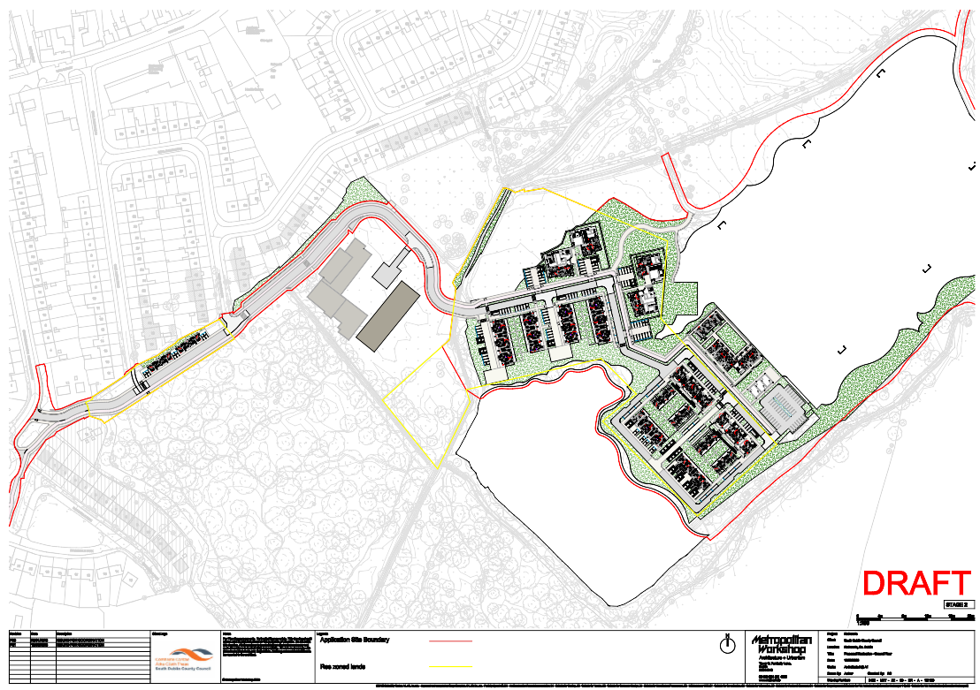
Plate 2-3: Site Layout (Source: Metropolitan Workshop)[HOLD To be updated when final]

Housing Typologies and Unit Mix
The proposed development will provide a diverse range of dwelling types including:
- Traditional two-storey terraced and wide-frontage houses;
- Three-storey duplex/walk-up units;
- Four and five-storey apartment buildings;
- Single-storey age-friendly bungalows;
- Age-friendly duplex accommodation; and
- Traveller Accommodation Units (TAU) integrated within the overall residential offering.
The residential accommodation will comprise that detailed in Table 2-1 below:
Table 2-1: Residential Typology
Unit Type | 1 bed apt | 2 bed apt | 1 bed duplex | 2 bed duplex | 3 bed duplex | 1 bed house | 3-bed house | 4-bed house | Total
No. social units | 9 | 23 | 2 (AF)  4 | 2 (AF) | 4 | 7 (AF) | 1 (UD)  8 | 4 (UD & TAU) | 64
No. afford. units | 8 | 20 | 4 | - | 4 | - | 30 | - | 66
% of mix (overall) | 13.1% | 33.1% | 7.7% | 1.5% | 6.2% | 5.4% | 30% | 3.1% | 100%
Total per type (apartment/ duplex/house) | 60 |  | 20 |  |  | 50 |  |  | 130
% of mix  (per typo) | 46.2% |  | 15.4% |  |  | 38.5% |  |  | -
Source: MacCabe Durney Barnes

The housing mix will include one-, two-, three- and four-bedroom dwellings. The apartment accommodation will primarily comprise one- and two-bedroom units, while the housing component will predominantly consist of three- and four-bedroom family homes. Traveller Accommodation Units and Universal Design Plus (UD+) units will be incorporated within the social housing provision to support inclusive housing delivery across the development.

Plot A – Woodland Edge Housing and Duplexes
Plot A will provide 33 no. residential units comprising a mixture of social and affordable housing. Development within this area will include two-storey terraced housing, three-storey duplex/walk-up accommodation and Traveller Accommodation Units. The houses will be arranged along the woodland edge with gable elevations orientated towards the adjoining landscape, reinforcing visual and physical connections with the surrounding natural environment.
Duplex accommodation will be positioned along the eastern edge of the plot overlooking the proposed GAA facilities and open spaces.

Plot B – Age-Friendly Housing
Plot B will provide 11 no. age-friendly residential units comprising seven single-storey one-bedroom bungalows and four age-friendly duplex units. The development will be arranged around a central communal courtyard designed to promote social interaction, passive surveillance and independent living.
The age-friendly cluster will incorporate shared communal amenity areas and a dedicated consultation/community room to support residents and facilitate community interaction. The layout has been specifically designed to provide accessible and adaptable accommodation in accordance with universal design principles.

Plot C – Villa Apartment and Housing
Plot C will comprise the largest residential component of the development and will provide 82 no. dwellings. The plot will include four apartment buildings ranging in height from four to five storeys together with four terraced rows of two-storey affordable housing units.
The apartment buildings will comprise a mix of one- and two-bedroom units and will be positioned to maximise surveillance of public spaces, provide views over adjoining open spaces and maintain connections between Rathcoole Park and the wider development lands. A shared-surface route and green corridors will extend through the centre of the plot, reinforcing permeability and landscape connectivity.

Plot D – Mullally's Lane Housing
Plot D will comprise four two-storey, three-bedroom affordable housing units located adjacent to the Mullally's Lane entrance. These wide-frontage houses will establish a residential gateway to the development and provide active frontage and passive surveillance over the principal access route. Parking for these dwellings will be accommodated within individual curtilages.

Open Space Provision
The proposed development will be set within an extensive network of public open spaces inclusive of Rathcoole Park, areas dedicated to wildlife inclusive of the proximate Rathcoole Woods; and recreational facilities to include the proposed junior GAA pitch and two senior GAA pitches.
Approximately 17,911 sqm of the area designated for residential uses is proposed as public open space, 1,040 sqm as communal open space, and further private open spaces are provided to serve the houses, duplex and apartment units at the site.
The residential development has been arranged to maximise interaction with these open spaces through active frontages, pedestrian connections and visual links. Green fingers extending through the development will connect residential areas to Rathcoole Park, woodland habitats and recreational facilities while supporting biodiversity and SuDS objectives.

Car Parking
A total of 143 no. car parking spaces will be provided throughout the development (135 no. allocated spaces and 8 no. visitor spaces), equating to an overall parking ratio of approximately 1.1 spaces per dwelling. A total 24 no. EV, 4 no. accessible and 15 no. EV/accessible parking spaces are included within this total. Parking provision has been tailored to the different housing typologies and locations within the development and comprises a combination of in-curtilage parking for houses; landscaped parking courts serving apartment buildings; and on-street parking bays. Parking has been consciously located away from key landscape corridors and woodland edges to draw the landscape into the scheme.

Bicycle Parking
Bicycle parking will comprise a combination of secure resident cycle stores and conveniently located visitor bicycle parking distributed throughout the public realm. 169 no. residential bicycle parking spaces comprising 124 no. spaces for residents and 45 no. visitor parking spaces are proposed
The cycle parking strategy forms part of the wider active travel network and supports sustainable transport objectives by providing direct connections to Rathcoole Village, Rathcoole Park, the proposed school lands, public transport services and future strategic cycle routes.

Refuse Storage
Dedicated refuse storage facilities will be provided throughout the development in accordance with the requirements of the relevant local authority waste management guidelines. Refuse storage areas will be integrated within apartment buildings, while duplex units and houses will accommodate bin storage within private curtilages. Refuse collection arrangements have been incorporated into the layout of each residential plot to ensure efficient operation while minimising visual impact on the public realm.

Accessibility and Universal Design
Universal design principles have informed the development from the outset. The scheme includes 11no. dedicated age-friendly dwellings, 5no. Universal Design Plus (UD+) units, 4no.Traveller Accommodation Units (TAUs) and accessible apartment accommodation integrated throughout the development. Pedestrian routes, open spaces, parking provision and communal facilities will be designed to ensure accessibility for all users regardless of age or mobility.
The residential layout promotes walkability, passive surveillance, social interaction and access to nature, while the provision of a range of dwelling sizes and tenures will support the creation of a diverse and inclusive community.

Landscape
The landscape strategy aims to integrate the proposed residential development with the existing landscape and create a network of attractive and useable open spaces while contributing to local biodiversity. The public green areas are designed as landscape spaces that offer the opportunity for meeting, walking, interaction with nature and formal and informal play. Open space proposals include public open space, communal open space, active open space and management of natural areas to accommodate a range of activities.

The character of the proposed landscape is one of parkland, native woodlands, native hedgerows, formal clipped hedges, and meadow areas. The protection and enhancement of existing landscape features, notably the transitional and Alluvial Woodland, the riparian corridor of the Camac River, Coolmine Stream and Crockshane (Slade) Stream, lowland hay meadows and native hedgerows is an important aspect of the overall strategy, providing a structure for circulation and the connection of proposed open spaces, while continuing to develop green infrastructure links in the area. The long-term development and maintenance of the landscape is an integral part of the design strategy.

Residential
The residential areas within the site are designed as landscape-led neighbourhoods where streets, public open spaces and planting form an integral component of the urban structure. A hierarchy of streets and spaces is proposed, ranging from the primary vehicular street, to local streets and neighbourhood streets. Street tree planting is incorporated at all levels of the road hierarchy to establish a strong landscape framework and reinforce key movement corridors. The tree-lined streets are complemented by shrub planting, ornamental planting beds, native hedgerows and amenity grassland areas, creating a high-quality residential environment while contributing to biodiversity enhancement and climate resilience.

Throughout the site, the streetscape design incorporates Sustainable Urban Drainage Systems (SuDS) such as rain gardens, swales, and permeable paving, contributing to surface water management while enhancing the visual and ecological quality of the streets. Further measures such as detention basins are proposed to be located within public open spaces to the north of the apartment units and age friendly units.

Within the residential portion of the site, it is additionally proposed to enhance the riparian zone of the Coolmine Stream and to enhance planting at the threshold with the transitional woodland to the southwest and Rathcoole Park to the north. Landscape cues such as widened verges, open views, and meadow planting are proposed to create a gradual and biodiversity rich transition into adjoining parkland and woodland. The proposed layout and landscape proposals have been designed to protect and facilitate the maintenance of the area of Annex I lowland hay meadow to the north of the proposed apartment blocks. This area will be sensitively managed through the formalisation of one existing pedestrian route to provide access to Rathcoole Park.

Supporting recreational facilities include a basketball court, calisthenics area, natural play spaces and informal recreation areas distributed throughout the landscape. These are clustered to the north of the apartment blocks, between the age friendly units and apartment blocks and adjacent the boundary with the transitional woodland to the south. These facilities are carefully positioned to maximise accessibility while avoiding conflict with sensitive ecological areas.

Smaller shared spaces, communal courtyards and pocket parks are dotted throughout the development with green fingers integrated into the landscape design. The residential landscape strategy seeks to create an attractive and biodiversity rich environment that promotes active travel, recreational use and passive surveillance while maintaining strong visual connections with the wider parkland and woodland landscape framework. The two northern apartment blocks encroach marginally on the Annex I hay meadow.

Pitches
The proposed development incorporates a significant recreational landscape centred on the provision of both formal and informal sporting facilities. The recreational landscape includes two full-sized GAA grass pitches each measuring 130 m × 80 m and graded to a maximum fall of 1:100, arranged side by side with a 6 m safety margin between them, a junior grass pitch measuring 104 m × 60 m, also graded to a maximum of 1:100. Each pitch is provided with a 5 m runoff safety margin. A graded slope no steeper than 1:3 accommodates the level difference between the two full-size pitches and the junior pitch. Pedestrian access to the pitches is provided by perimeter pathways that link to the wider site circulation network. An associated pavilion (137.26 m²) and car parking (43 spaces) are provided adjacent the residential element of the development to the west of the pitches. A series of grass viewing mounds are proposed to the south and east. The design seeks to integrate the pitches into the surrounding landscape while maintaining public access and sporting requirements.
The development of the pitches will require the clearance of all vegetation within the proposed pitch boundaries. The existing topsoil will be scraped off and stored on site, in a secure location, for reuse. The subsoils will then be regraded and reprofiled to form the new pitch platform, requiring approximately 12,000m³ of material to be moved within the site. The stored topsoil will subsequently be respread and improved through the import of approximately 3,849m³ of sand, which will be used to ameliorate the top 100mm of the soil and sand slits will be installed as secondary drainage at 1m centres across the pitches. These works will create suitable playing surfaces and ensure compliance with relevant sporting standards. The approach has been informed by the site's existing topography and designed to minimise cut and fill requirements and to avoid the export of topsoil from the site. The final layout seeks to balance the provision of strategic recreational infrastructure with the protection of ecological resources and the retention of the site's green infrastructure network.
Each pitch is served by a piped primary drainage system of 150 mm perforated carrier drains and 80 mm perforated lateral, supplemented by secondary drainage in the form of sand slitting at 1 m centres. Collected water is conveyed to a new silt-trap manhole incorporating a flow-control (hydrobrake) unit, which restricts discharge to the greenfield runoff rate for the drained area before outfalling to the Coolmine Stream to the north of the site. The exact outfall location is to be determined and agreed with Inland Fisheries Ireland, and scour protection is to be provided at the outfall to minimise the risk of erosion.
The GAA pitches are designed having regard to the environmental sensitivities present within the site. The layout has evolved through the design process to avoid impacts on areas of Annex I Lowland Hay Meadow where possible while also ensuring that the pitch dimensions and orientation meet the operational requirements of the facility. The pitches are located outside the riparian corridors associated with the Camac River and Crockshane (Slade) Stream, maintaining the ecological and hydrological function of these areas and allowing for their protection and enhancement. The northern portion of the two full sized GAA pitches encroach upon the Annex I hay meadows.

Woodland
Woodland forms one of the defining landscape characteristics of the area to the south west of the site and is a key component of the overall landscape strategy. Existing woodland areas, including designated woodland habitats, riparian vegetation and transitional woodland, are retained and protected as part of the proposed development. A significant area of Annex I alluvial woodland is situated to the west of the site bounding the central residential area and to the south of the access road and units at Mullally’s Lane. A minor area of this woodland overlaps with the proposed vehicular access route and will require removal to facilitate access to the proposed development. This will be adequately mitigated through extensive replacement planting at the site.
A further area of Annex I alluvial woodland and transitional woodland is situated to the west of the central residential area. This portion of the woodland is proposed to be maintained. A woodland edge landscape is proposed at the interface between the residential and woodland area. This transitional landscape provides a sensitive buffer between built development and ecological features while facilitating passive recreation. The woodland edge incorporates native tree planting, meadow grassland, natural play elements, swales and detention basins, creating a graduated transition between urban and natural environments.
Further areas of woodland and vegetation planting are to be enhanced along the riparian corridors to the south and east of the site along with the riparian corridor of the Coolmine Stream which flows from the Alluvial Woodland to the south and through Rathcoole Park. These existing woodland and riparian habitats provide important ecological functions and enhancement of such is considered a central element of the proposed development. These areas form the foundation of a broader green infrastructure network extending throughout the site and linking with surrounding habitats.

Access
The proposed development has been designed to provide a safe and legible network to prioritise walking, cycling and public transport use while ensuring appropriate access for residents, visitors, users of the school, emergency services and servicing vehicles. The site occupies a strategically accessible location adjoining Rathcoole Village, established residential neighbourhoods and the approved primary school (SDCC Ref. SD23A/0336) adjacent the site.

Vehicular Access
The principal vehicular access route to the site is proposed via the provision of a new T-junction from Greenogue Drive to the north of the Mullally’s lane Roundabout. This will involve the removal of the existing Mullally’s Lane vehicular arm and its repurposing as an active travel route. This arrangement minimises impacts on existing infrastructure while providing an efficient and safe access solution for the proposed development.
The vehicular access road will bridge the Coolmine Stream to the south of the school. The bridge has been designed to maintain the continuity of the watercourse while providing access to the site. Emergency, refuse collection and maintenance vehicles will be accommodated throughout the development in accordance with relevant design standards. [PLACEHOLDER - Just to note, we need the bridge design. Not sure if it has been provided yet.]
The internal road network has been designed to provide convenient access to all residential units while maintaining low vehicle speeds through the incorporation of urban street design principles. Shared surface roads are proposed to create multi-functional spaces between the terraced houses and duplex units. Traffic calming measures will be implemented to reduce speeds, and street trees will be incorporated to provide green links and vistas between the road network and adjacent open spaces.

Pedestrian and Cycle Connectivity
A key objective of the development is the creation of a highly permeable and walkable neighbourhood. The proposed layout incorporates a network of footpaths, cycle routes and shared surface areas which connect residential areas with public open spaces, recreational and educational facilities and the surrounding area.
A new active travel route is proposed to replace the existing Mullally’s Lane vehicular arm to the west of the site. A pedestrian and active travel link will be provided from Coolamber Road along with a pedestrian entrance to Coolamber Drive and Rathcoole Park to the south of Beechwood Lawns. Pedestrian footpaths will be provided either side of the road throughout the site, with formal trails to be provided for pedestrian permeability of the public open spaces and green areas surrounding the residential units and pitches.
Pedestrian and cycle connections will link directly with existing routes serving Rathcoole Village, Rathcoole Park, neighbouring residential areas and future educational development lands. The proposed movement framework has been designed to encourage active travel for everyday journeys and to reduce reliance on private car use.

Services
Existing ground levels generally fall from the south-west towards the north-east, with site levels ranging from approximately 126.7mOD to 113.0mOD. Overall gradients across the site generally grade from south-west to north east at an average gradient of circa 1:60. This topography naturally directs surface water drainage towards the northern and eastern portions of the site and this has informed the proposed drainage strategy.

The site is situated within a receiving environment that includes a number of existing watercourses. The Coolmine Stream is located along the northern boundary of the lands, flowing through the residential portion of the site, while the Crockshane (Slade) Stream runs along the southern boundary. The River Camac is located beyond the eastern boundary of the site. These existing hydrological features have been considered in the development of the proposed drainage strategy.

Surface Water
The proposed surface water drainage strategy seeks to replicate natural greenfield drainage conditions and maintain existing overland flow paths, inclusive of open ditches and land drains, where practicable. The proposed development will introduce approximately 23,070sqm of hardstanding area. Approximately 2,070sqm of this area is proposed in the vicinity of the Mullally’s Lane units (Area A) and a further 21,000sqm in the primary residential portion of the site (Area B).

Surface water runoff from these areas will be managed through a dedicated gravity drainage network combined with an integrated SuDS treatment train. Two separate drainage catchments are proposed for the residential portion of the site. Development Area A will discharge to the existing 450mm concrete surface water network at Mullally's Lane which ultimately drains to a 600mm surface water asset, while Development Area B will discharge to the Coolmine Stream following attenuation and treatment. This drain will minorly infringe on the hay meadow to the north of the residential units. Runoff from the adjacent woodlands, located directly southwest of the proposed development and spanning an area of approximately 24,200sqm, is also to be intercepted and attenuated. Surface water drainage from the pitches is additionally proposed to drain to the Coolmine Stream.

The drainage network has been designed to restrict runoff rates to equivalent greenfield discharge rates. The calculated QBAR discharge rates are approximately 0.8 litres per second for Development Area A, 13.5 litres per second for Development Area B and 6.1 litres per second for the woodland area. These rates ensure that post-development runoff will not exceed existing greenfield conditions.

Surface water attenuation requirements have been calculated using recognised hydraulic modelling methodologies. A minimum attenuation storage volume of approximately 129 cubic metres (m3) is required for Development Area A and approximately 1,172m3 for Development Area B. The required attenuation storage volume for the woodland area is calculated as c.113m3. This volume is to be accommodated within Development Area B, resulting in a total required attenuation volume of c.1,285m3 for this area. These storage volumes will be provided through a series of above-ground attenuation features integrated within the landscape design.[PLACEHOLDERS – It must be aligned with the final engineering reports]

This storage will be provided through the use of appropriate SuDS measures to limit runoff rates and mimic greenfield conditions. For Development Area A, a single attenuation basin will be provided with a minimum storage volume of 130 m³. For Development Area B, four attenuation basins will be provided with a combined minimum storage volume of 1,284.84m3.

The proposed drainage network will be designed to accommodate the 1-in-100-year rainfall event with an additional 20% climate change allowance and will be developed in accordance with recognised industry standards and South Dublin County Council requirements.

Sustainable Urban Drainage Systems (SuDS)
A comprehensive SuDS strategy has been developed for the site with the objective of replicating natural drainage processes, reducing runoff rates and improving water quality. Based on the existing site topography, the proposed site layout, and nature of the proposed development, soft SuDS have been prioritised. The proposed SuDS strategy incorporates a range of integrated measures including bioretention rain gardens, vegetated swales, attenuation basins, permeable paving within parking areas, filter drains, tree pits and soft landscaped treatment areas, together with oil interceptors located upstream of discharge points where appropriate. These features will function collectively as a SuDS treatment train, providing interception, filtration, attenuation and controlled discharge of surface water runoff while enhancing biodiversity, visual amenity and overall landscape quality throughout the development.

Foul Water Drainage
Foul wastewater generated by the development will be collected via a dedicated foul sewer network and conveyed to the existing public wastewater infrastructure. Existing foul sewer infrastructure is located within Mullally's Lane, Beechwood Lawns, Springbank, Saggart and Mill Road. Development Area A will connect to the existing foul sewer network at Mullally's Lane (150mm diameter concrete foul sewer), while Development Area B will connect to the existing foul sewer network at Beechwood Lawns (250mm diameter foul sewer). A wastewater pumping station is proposed to the south of the site adjacent the car parking bays for the proposed pitches.

Water Supply
Within the site extents three existing watermains have been identified. One 300mm ductile iron watermain to the south of the site and two, 600mm and 1200mm, ductile iron watermains to the east. existing 101.6mm uPVC watermains are noted to be situated within Coolamber Drive, situated towards the north-western end of the site, before connecting to a 101.6mm watermain running along Main Street. It is proposed to serve Development Area A via a new 100mm diameter watermain connection to the existing 101.6mm uPVC watermain running along Coolamber Road. Water supply to development area B is proposed via a new 100mm diameter watermain connection to the existing 101.6mm uPVC watermain running along Coolamber Drive. These new watermains are to be positioned beneath footpaths along access roads within the site boundary.

Construction Phase
This section describes the construction phase of the proposed development and should be read in conjunction with the Outline Construction and Environmental Management Plan (oCEMP) and outline Construction Traffic Management Plan (oCTMP) submitted with the application. The details set out below are preliminary and are provided for the purposes of the environmental assessment. A refined CEMP will be prepared by the appointed Contractor to implement the mitigation measures set out in the oCEMP, within which these details will be confirmed and updated as required prior to works commencing on site.

Construction Programme
It is envisaged that the construction phase will span approximately two years, from June 2027 to May 2029. On-site construction is expected to begin in January 2028 and to complete in May 2029, with handover expected to be completed in 2030. The construction programme is expected to require up to two years to complete from occupation of the site.
Given the nature of the project and the need for flexibility to respond to external factors the development phases are indicative.

Construction Compounds
The site establishment works will be carried out by the appointed Contractor. The Main Contractor will identify a suitable location, of sufficient size and suitable for the majority of the works, for a site compound upon appointment and will construct the compound as part of the enabling works. The compound may be used as material staging areas, temporary car parking for construction workers, site offices and huts, welfare facilities for workers (including changing rooms and lockers), and/or the storage of plant and equipment. These locations are indicative and may be subject to change as the scheme is built out.
The Main Contractor will propose a designated parking area to cater for the cars and vans of staff in order to minimise disruption to local amenities and parking facilities, and a safe and secure pedestrian walkway will be provided from the car park to the site compound.
Temporary hoarding and fencing will be installed to secure the site and, where required, to minimise nuisance effects such as noise emissions, visual impact and dust. Hoarding will be established around the site construction area, where required, before any significant construction activity takes place in accordance with the required specifications as defined by the Main Contractor.

Working Hours / Periods
For the duration of the construction programme, the working hours will likely be restricted to times as follows, although these are subject to approval:
- Monday to Fridays – 07:00 to 19:00
- Saturday – 08:00 to 17:00
- Sunday and Public Holidays – No activity onsite
Working outside the normal hours would require advance agreement between the Contractor and SDCC. The advanced consent should include what activity is being applied for, how long it will take and what equipment will be used. This should be submitted a minimum of 5 working days in advance of the works taking place. Night-time works are not generally envisaged.

Construction Traffic
All construction activities will be governed by a Traffic Management Plan (TMP) developed by the Main Contractor, the details of which will be agreed with South Dublin County Council’s Roads Department prior to the commencement of the Construction Phase. The principal objective of the TMP is to ensure that the impacts of all building activities generated during the Construction Phase are fully considered and proactively managed and programmed. This plan will contain details of the intended construction practice for the development, including:
- the location of the site and materials compound(s), including area(s) identified for the storage of construction refuse;
- the location of areas for construction site offices and staff facilities;
- details of site security fencing and hoardings;
- details of on-site car parking facilities for site workers during the course of construction;
- details of the timing and routing of construction traffic to and from the construction site and associated directional signage;
- measures to prevent the spillage or deposit of clay, rubble or other debris on the public road network;
- details of appropriate mitigation measures for noise, dust and vibration, and the monitoring of such levels;
- no parking, unloading or blockages on access routes, with any such vehicles immediately requested to move to avoid impeding works; and
- adherence by on-site contractors to the overall traffic management measures for the internal road network, from the preferred construction traffic entrance road to their site.
An oCTMP and oCEMP have been prepared and provide preliminary information regarding the management of construction traffic for the proposed development.

Site Housekeeping
Good housekeeping is an important part of good environmental practice and helps to maintain a more efficient and safer site. The Proposed Development Site should be tidy, secure, and have clear access routes that are well signposted. The appearance of a tidy, well-managed site can reduce the likelihood of theft, vandalism, complaints and/or specific hazards that could affect surrounding area. Good housekeeping will be maintained throughout the construction phase in accordance with the fourth edition of CIRIA’s ‘Environmental good practice on site guide’ (C741).
As outlined in the fourth edition of CIRIA’s ‘Environmental good practice on site guide’ (C741), when considering good housekeeping, the Contractor will implement the following steps:
- Adequately plan the Proposed Development Site with designated areas of materials and waste storage.
- Segregate different types of waste as it is produced and arrange frequent removal.
- Keep the Proposed Development Site tidy and clean.
- Ensure that no wind-blown litter or debris leaves the Proposed Development Site, use covered skips to prevent wind-blown litter.
- Keep hoardings tidy – repair and repaint when necessary, removing any fly posting or graffiti.
- Frequently brush-clean wheel washing facilities and keep haul routes clean from site derived materials.
- Keep roads free from mud by using a road sweeper.
- Ensure site is secure.

Earthworks
Site clearance will require the removal of trees and vegetation across an indicative area of 106,024 m².
Based on the current indicative earthworks modelling, the total quantity of material to be exported off-site is estimated at 65,971 m³, of which 37,083 m³ relates to the residential portion of the site and the remaining 28,888 m³ to the non-residential area, including the pitch area. These quantities exclude the topsoil strip. Topsoil will be scraped and stored on site for reuse across the site, including the pitch area. An indicative c.10,602 m³ of topsoil will be retained and reused on-site.
In respect of the proposed pitches, the existing topsoil will be scraped off and stored on site, in a secure location, for reuse. The subsoils will then be regraded and reprofiled to form the new pitch platform, requiring approximately 12,000 m³ of material to be moved within the site. The stored topsoil will subsequently be respread and improved through the import of approximately 3,849 m³ of sand, which will be used to ameliorate the top 100 mm of the soil, and sand slits will be installed as secondary drainage at 1 m centres across the pitches. This approach has been informed by the site’s existing topography and has been designed to minimise cut and fill requirements and to avoid the export of topsoil from the site.
Imported materials will comprise hardcore fill (indicatively 845 m³ of T1 structural material, 380 m³ of T2 permeable material, 84 m³ of T3 blinding material, 3,014 m³ of Clause 804/808 material and 202 m³ of Breedon gravel), together with an indicative 1,500 m³ of imported subsoil and 3,849 m³ of imported sand. The imported subsoil makes up the shortfall in the approximately 12,000 m³ required to form the pitch platform, as the volume of suitable material generated on site is insufficient to meet this requirement in full. The imported sand will be used for soil amelioration and sand slit drainage to the pitches. [PLACEHOLDERS – quantities need to be confirmed with final engineering reports]
Soil stockpiles, both for re-use on site and for removal off site, will managed appropriately in accordance with the provisions as outlined in the oCEMP. Additional details on the management of stockpiles and procedures to prevent environmental and nuisance issues will be documented in the CEMP, which will be developed by the appointed Contractor in advance of construction works commencing on site.

Construction and Environmental Management Plan
An oCEMP has been prepared by AECOM for South Dublin County Council and has been reviewed by the relevant EIAR consultants. It is submitted as part of the application. The oCEMP outlines the procedures to be followed to ensure the minimal impact of the construction activities on the surrounding environment, inclusive of personnel who may be impacted by the works. The oCEMP should be viewed as an outline plan, with a refined Construction and Environmental Management Plan to be developed by the appointed Contractor prior to works commencing on site, in order to implement the mitigation measures set out in the oCEMP and in the relevant EIAR chapters.

Construction Waste Management Plan
A Construction Waste Management Plan (CWMP) has been prepared as part of the application. The document has been prepared in accordance with best practice guidelines. As a predominantly greenfield site, the proposed development will give rise principally to construction waste, together with excavated material arising from site clearance and earthworks. Given the scale of the development and the volumes of material that will be generated during construction, it is imperative that waste management at the site is tightly controlled and has the least possible impact on the surrounding environment, which comprises established residential neighbourhoods, Rathcoole Park and the adjoining school lands.

The purpose of the CWMP is to ensure that the storage and movement of waste within the development takes place in a manner that complies with relevant legislation and has a minimal impact on nearby residential and amenity areas, and to ensure that, where prevention is not possible, the maximum reuse, recycling and recovery of waste is achieved, with diversion from landfill wherever possible. All construction waste materials will be managed and stored in accordance with the provisions of the CWMP.

As a primary measure, waste generation will be avoided where possible by ensuring that an excess supply of building materials is not delivered to the site and that only the minimum materials required to meet the construction schedule are held on-site. Consistent with the earthworks strategy for the development, clean excavated material will be retained and reused on-site for backfill, regrading and landscaping, thereby minimising both the import and the export of material.

Construction Health and Safety
The main contractor is required to provide a best practice working environment for all employees involved in the construction of the proposed development. This includes a responsibility to take into account all relevant statutory laws and guidelines.
The primary aim of planning for safety on this site is to ensure the safety of people involved in and affected by the development. This includes pedestrians, road users, neighbouring residents, site staff and visitors to the site. All Contractors must progress their works with reasonable skill, care and diligence and must, at all times, proactively manage the works in a manner most likely to ensure the safety, health and welfare of those carrying out the construction works. Contractors are further required to ensure that, as a minimum, all aspects of their works and project facilities comply with legislation, good industry practice and all necessary consents, which will be addressed in.
Health and safety requirements will be further expanded and developed within the Main Contractor's CEMP, which is required to be prepared prior to the commencement of works on site.

Operational Phase
Pursuant to the EIA Directive, an EIAR is required to describe the proposed development, including the processes, activities, materials and natural resources utilised, together with the likely significant effects arising from its construction and operation. The proposed development comprises the provision of 130 residential units, including social, affordable, age-friendly and traveller accommodation, together with associated open space, GAA facilities, active travel infrastructure, a pavilion building, landscaping works, woodland management and enhancement measures, drainage infrastructure and all associated site development works at lands in Rathcoole, Co. Dublin.
The principal direct environmental effects are anticipated to arise during the construction phase as a result of site clearance, earthworks, levelling, bridge construction, utility installation and the construction of residential, recreational and associated infrastructure. Once complete, the operational phase of the development is generally benign in nature and is not expected to give rise to significant adverse effects arising from the use of materials, natural resources, emissions or residues.
The principal operational effects relate to Population and Human Health through the provision of housing, recreational facilities, public open space and active travel infrastructure, together with Landscape and Visual change associated with the introduction of residential development and recreational facilities and Biodiversity on the basis of the change of land use. Operational traffic generated by the development has also been assessed within the EIAR, together with associated noise and air quality considerations.
The proposed development also has the potential to contribute to cumulative, indirect and secondary effects, particularly in combination with other permitted and planned development within Rathcoole and the wider South Dublin area. These interactions have been considered throughout the EIAR. Having regard to the nature of the proposed development, the mitigation measures incorporated into the design and the findings of the assessments undertaken, no significant adverse cumulative, secondary or indirect effects are anticipated.

Emergency and Contingency Procedures
The proposed development comprises residential accommodation, recreational facilities and associated infrastructure and does not include any processes or activities that would be expected to give rise to significant operational environmental risks. Emergency access will be provided throughout the development in accordance with the requirements of the Building Regulations and the recommendations of the emergency services. The internal road network has been designed to facilitate access by emergency vehicles and all residential units and community facilities will be served by the public water supply and drainage networks.
The development will incorporate surface water drainage infrastructure and SuDS measures which will be maintained throughout the lifetime of the development. Utility infrastructure, public lighting, communal areas and recreational facilities will be subject to ongoing management and maintenance as appropriate.
In the event of an incident such as a fire, flooding event, utility outage or accidental damage to infrastructure, standard procedures operated by the emergency services, utility providers and the relevant management entities will apply. Given the nature of the proposed development, no specific emergency or contingency procedures beyond standard operational and maintenance measures are considered necessary.

References
European Union (2014). Directive 2014/52/EU of the European Parliament and of the Council amending Directive 2011/92/EU on the Assessment of the Effects of Certain Public and Private Projects on the Environment.
Government of Ireland (2000, as amended). Planning and Development Act 2000.
South Dublin County Council (2022). South Dublin County Development Plan 2022–2028.
Eastern and Midland Regional Assembly (2019). Regional Spatial and Economic Strategy for the Eastern and Midland Region 2019–2031.
Construction Industry Research and Information Association (CIRIA) (2015). Environmental Good Practice on Site Guide (C741).

Non-Technical Summary
Please note this section will be removed from each individual chapter and inserted the Volume 1 Non-Technical Summary.
The Proposed Development is located on an approximately 11.3 hectare site to the south and southeast of Rathcoole Village, County Dublin. The site is currently largely undeveloped greenfield land and includes grassland, scrub, hedgerows and woodland. Rathcoole Park and existing residential areas are located to the north, with agricultural lands to the south and southwest. The Coolmine Stream, Crockshane (Slade) Stream and River Camac are located within or close to the site.
The Proposed Development will provide 130 new homes, including houses, duplex units, apartments and age-friendly accommodation, ranging from one to five storeys. The scheme will provide 64 social housing units and 66 affordable purchase units, including Traveller Accommodation Units and Universal Design Plus units.
The development will also include two full-size GAA grass pitches and one junior GAA grass pitch, together with a pavilion, associated parking and bicycle spaces. Approximately 17,911 m² of public open space and 1,040 m² of communal open space will also be provided, together with landscaping, play and recreation areas and enhancements to woodland, hedgerows and watercourse corridors.
The main vehicular access will be provided from Greenogue Drive through a new T-junction. The existing Mullally’s Lane vehicular arm will be repurposed as an active travel route, and the new access road will cross the Coolmine Stream by bridge. Pedestrian and cycle routes will connect the development with Rathcoole Village, Rathcoole Park, surrounding residential areas and the adjoining school lands.
Surface water will be managed through Sustainable Urban Drainage Systems (SuDS), including rain gardens, swales, permeable paving and attenuation basins. Surface water from the main residential area and GAA pitches will discharge to the Coolmine Stream following attenuation and treatment. Foul wastewater and water supply will connect to existing public infrastructure.
Construction is expected to take approximately two years and will include site clearance, earthworks, building and road construction, installation of drainage and utilities, landscaping and development of the GAA pitches. Construction activities will be managed through the Construction and Environmental Management Plan and Construction Traffic Management Plan, incorporating the mitigation measures identified in the EIAR.

Acronyms and Abbreviations
Acronym/Abbreviation | Full Text
ACP | An Coimisiún Pleanála
AF | Age Friendly
C&D | Construction and Demolition
oCEMP | Outline Construction Environmental Management Plan
CIRIA | Construction Industry Research and Information Association
EIAR | Environmental Impact Assessment Report
EV | Electric Vehicle
GAA | Gaelic Athletic Association
GI | Green Infrastructure
ha | Hectare
MASP | Metropolitan Area Strategic Plan
MDB | MacCabe Durney Barnes
mOD | Metres Ordnance Datum
NWCPO | National Waste Collection Permit Office
OCEMP | Outline Construction Environmental Management Plan
QBAR | Mean Annual Flood Flow
RES-N | New Residential Zoning Objective
RSES | Regional Spatial and Economic Strategy
SDCC | South Dublin County Council
SLO | Specific Local Objective
SuDS | Sustainable Urban Drainage Systems
TA | Traveller Accommodation
TAU | Traveller Accommodation Unit
TMP | Traffic Management Plan



