


DRAFT

SDCC Rathcoole Housing Development
Environmental Impact Assessment Report (EIAR)
Chapter 01: Introduction & Methodology

South Dublin County Council (SDCC)

August 2026

Quality information
Prepared by |  | Checked by |  | Verified by |  | Approved by
Fiona Ihde  Environmental Consultant – Impact Assessment  Leticia Braga  Principal Environmental Consultant – Impact Assessment |  | Daniel Munro  Senior Environmental Consultant |  | John Hallssal  Technical Director – Impact Assessment |  | Richard O’Callaghan Project Director

Revision History
Revision | Revision date | Details | Authorized | Name | Position
0 | 28/08/2026 | Draft | N | Richard O’Callaghan | Project Director

Distribution List
# Hard Copies | PDF Required | Association / Company Name
0 | 1 | South Dublin County Council

Prepared for:
South Dublin County Council (SDCC)

Prepared by:
‌AECOM Ireland Limited
4th Floor
One Burlington Plaza
Burlington Road
Dublin 4
D04 RH96
T +353-1-696-6220

© 2026 AECOM Ireland Limited. All Rights Reserved.
This document has been prepared by AECOM Ireland Limited (“AECOM”) for sole use of our client (the “Client”) in accordance with generally accepted consultancy principles, the budget for fees and the terms of reference agreed between AECOM and the Client. Any information provided by third parties and referred to herein has not been checked or verified by AECOM, unless otherwise expressly stated in the document. No third party may rely upon this document without the prior and express written agreement of AECOM.
Table of Contents
1 Introduction and Methodology 1-1
1.1 Background 1-1
1.1.1 Purpose of this Report 1-1
1.2 Overview of the Proposed Development 1-1
1.3 Proposed Development Location 1-2
1.4 The Surrounding Location 1-3
1.5 Interaction with Other Projects 1-3
1.6 Legislation, Policy & Guidance 1-4
1.7 Structure of the EIAR 1-4
1.8 Assessment Methodology 1-5
1.8.1 Overall Approach 1-5
1.8.2 Identifying Potentially Significant Environmental Effects 1-7
1.8.3 Assessment Terminology 1-7
1.8.4 Significance Criteria 1-9
1.8.5 Cumulative Effects 1-10
1.8.6 Residual Effects 1-11
1.9 Consultation 1-11
1.10 Difficulties Encountered 1-12
1.11 Expertise of the EIAR Team 1-12
1.12 References 1-15
Non-Technical Summary 1-16
Acronyms and Abbreviations 1-18

Tables
Table 1-1: EIA Team and Authors 1-13

Introduction and Methodology

Background
This Environmental Impact Assessment Report (EIAR) has been prepared by AECOM Ireland Limited (AECOM) on behalf of South Dublin County Council (SDCC), hereafter referred to as ‘the Applicant’. This EIAR accompanies an application for approval for the Proposed Development on lands to the south and southeast of Rathcoole Village, County Dublin. The Proposed Development principally comprises 130 no. residential units, associated access and active travel infrastructure, one junior Gaelic Athletic Association (GAA) pitch, two full-size adult GAA pitches, a pavilion and associated parking, landscaping, green infrastructure and ancillary works. A detailed description of the Proposed Development is provided in Chapter 2: Description of Development.
The overall lands extend to approximately 17.78 ha, within which the application site extends to approximately 11.3 ha. The Proposed Development lies entirely within the administrative area of South Dublin County Council. The Proposed Development will contribute to meeting current and future affordable and social housing needs in Rathcoole and includes affordable purchase and social housing, including age-friendly and Traveller-specific accommodation.

Purpose of this Report
This EIAR has been prepared in accordance with Directive 2011/92/EU on the assessment of the effects of certain public and private projects on the environment, as amended by Directive 2014/52/EU (the EIA Directive), and the relevant provisions of the Planning and Development Act 2000, as amended, and the Planning and Development Regulations 2001, as amended.
The EIAR accompanies an application by South Dublin County Council to An Coimisiún Pleanála (ACP) for approval of the Proposed Development under Section 175 of the Planning and Development Act 2000, as amended. The EIAR provides the environmental information necessary to enable ACP, as competent authority, to undertake the environmental impact assessment of the Proposed Development.
This EIAR presents:
a description of the Proposed Development;
details of the Site and the reasonable alternatives considered;
an assessment of the likely significant environmental effects arising during construction and operation, including maintenance;
an assessment of likely cumulative effects;
measures proposed to avoid, prevent, reduce or, where possible, offset significant adverse effects; and
an assessment of likely residual effects.
The Proposed Development is intended as a permanent development and no decommissioning phase is proposed.
The purpose of this EIAR is to provide ACP, as competent authority, with the information necessary to undertake the environmental impact assessment of the Proposed Development and to inform statutory consultees, interested parties and the general public of the likely significant effects of the Proposed Development on the environment. The EIA Screening and Scoping Report is provided in Appendix 1-4 of EIAR Volume 02.

Overview of the Proposed Development
The Proposed Development will consist of:
- 130 no. residential units, comprising 60 no. apartments, 20 no. duplex units and 50 no. houses (including Traveller Accommodation Units), within buildings ranging from one to five storeys in height, consisting of 64 no. social housing units and 66 no. affordable purchase units;
- A new vehicular entrance and access road from Greenogue Drive, together with active travel provisions, including the repurposing of the existing Mullally's Lane vehicular arm as an active travel route and pedestrian and cycle access from Coolamber Road;
- The development of GAA facilities, including two full-size adult GAA grass pitches, one junior GAA grass pitch and a park pavilion with associated facilities;
- 143 no. car parking spaces to serve the residential units, with an additional 43 no. spaces for the GAA facilities;
- 181 no. bicycle parking spaces, comprising 169 no. spaces serving the residential development and 12 no. spaces serving the GAA facilities;
- Clearance of vegetation to facilitate the development;
- Hard and soft landscaping provisions, including the provision of green infrastructure through a network of green streets, tree-lined avenues and shared-surface spaces;
- Temporary compounds and welfare facilities for the construction phase; and
- All other associated site development works.
Further details of the construction and operational phase activities, elements and requirements of the Proposed Development are provided in Chapter 02: Description of Development of EIAR Volume 01.

Proposed Development Location
The Site comprises greenfield lands located to the south and southeast of Rathcoole Village, adjoining established residential areas. Rathcoole Park lies immediately to the north/northwest and connects directly to the subject lands - Plate 1-1. The overall lands extend to approximately 17.78 ha, comprising lands in the ownership of South Dublin County Council (c.15.93 ha) and the Department of Education (c.1.85 ha). The application site, located within the overall lands, extends to approximately 11.3 ha. An Irish Water easement runs along the southeastern extent of the Site.
The Coolmine Stream traverses the western portion of the Site and flows into Rathcoole Park. The Crockshane (Slade) Stream is located to the south of the Site, while the River Camac is situated to the east. A smaller drainage ditch is also present within the Site.
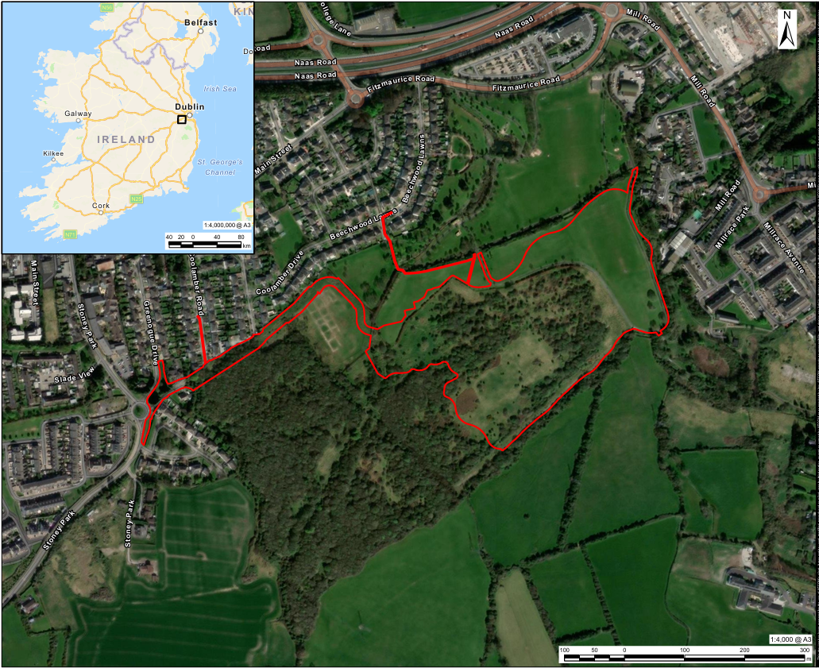
Plate 1-1 Proposed Development Site and Context

The Surrounding Location
The Site is located to the south and southeast of Rathcoole Village, within a transitional area between the existing settlement and the surrounding greenfield lands. Rathcoole Park and established residential areas are located immediately to the north and northwest of the Site. The River Camac is located to the east of the Site, with the village of Saggart located further to the east/southeast. The Crockshane (Slade) Stream and additional greenfield lands are located to the south of the Site.

Interaction with Other Projects
This EIAR takes into account other projects and planning applications within the relevant study area or zone of influence for each environmental factor which may have the potential to interact with the Proposed Development or give rise to cumulative effects. The spatial extent and projects considered are therefore proportionate to the nature of the environmental factor, the potential pathways for effects and the methodology applied within each technical assessment.
Applicable projects and planning applications considered in the assessment of cumulative effects in each technical chapter (Chapters 05 to 16) are presented in Appendix 1-3 Planning Search [PLACEHOLDER – we have to re-run the planning search for the final version of the report]. Where relevant, the technical chapters identify the projects considered and assess the potential for cumulative effects with the Proposed Development. A summary of cumulative effects and interactions is presented in Chapter 18.
The permitted primary school development (SDCC Ref. SD23A/0336 / ACP Ref. 321696) is located within the red line boundary of the planning application but does not form part of the Proposed Development subject to this EIAR. The permitted school development is therefore treated as a separate project for the purposes of the EIA. Where relevant to an environmental factor, its potential cumulative effects in combination with the Proposed Development are considered within the respective technical assessment.
Where elements of the permitted school development have been constructed and form part of the existing environment at the relevant assessment baseline, these are treated as part of the baseline, as appropriate, and clearly identified within the relevant technical chapter. This approach ensures that the treatment of the permitted school development reflects its status at the relevant assessment baseline and avoids duplication between the baseline and cumulative assessment.

Legislation, Policy & Guidance
The EIAR has been prepared having regard to the applicable legislative framework and relevant guidance for Environmental Impact Assessment (EIA). The principal legislation and guidance informing the preparation of the EIAR include:
Legislation:
- Directive 2011/92/EU of the European Parliament and of the Council on the assessment of the effects of certain public and private projects on the environment (the EIA Directive), as amended by Directive 2014/52/EU;
- Planning and Development Act 2000, as amended, insofar as its relevant provisions remain applicable;
- Planning and Development Act 2024, insofar as relevant provisions have commenced and apply to the Proposed Development;
- Planning and Development Regulations 2001, as amended; and
- European Union (Planning and Development) (Environmental Impact Assessment) Regulations 2018 (S.I. No. 296/2018), as amended.
Policy:
- National Planning Framework – First Revision (2025);
- Regional Spatial and Economic Strategy for the Eastern and Midland Region 2019–2031;
- South Dublin County Development Plan 2022–2028.
Guidance:
- Environmental Protection Agency (EPA) (2022), Guidelines on the Information to be Contained in Environmental Impact Assessment Reports (hereafter referred to as the EPA Guidelines (2022));
- European Commission (2017), Environmental Impact Assessment of Projects: Guidance on Scoping (Directive 2011/92/EU as amended by 2014/52/EU);
- European Commission (2017), Environmental Impact Assessment of Projects: Guidance on the Preparation of the Environmental Impact Assessment Report (Directive 2011/92/EU as amended by 2014/52/EU); and
- Department of Housing, Planning and Local Government (2018), Guidelines for Planning Authorities and An Bord Pleanála on carrying out Environmental Impact Assessment.
The legislation, policy and guidance specific to each environmental factor are identified, as appropriate, within the relevant technical assessments presented in Chapters 05 to 16 of this EIAR.

Structure of the EIAR
This EIAR is presented in four volumes:
- Non-Technical Summary (NTS);
- Volume 1: EIAR Chapters;
- Volume 2: Appendices; and
- Volume 3: Figures.
Volume 1 of the EIAR comprises the following chapters:
- Chapter 1: Introduction and Methodology;
- Chapter 2: Description of Development;
- Chapter 3: Need for Development;
- Chapter 4: Alternatives;
- Chapter 5: Population and Human Health;
- Chapter 6: Biodiversity;
- Chapter 7: Land, Soils and Geology;
- Chapter 8: Water and Hydrology;
- Chapter 9: Air Quality;
- Chapter 10: Climate;
- Chapter 11: Noise and Vibration;
- Chapter 12: Landscape and Visual;
- Chapter 13: Archaeology and Cultural Heritage;
- Chapter 14: Material Assets (Traffic);
- Chapter 15: Major Accidents and Disasters;
- Chapter 16: Material Assets (Utilities);
- Chapter 17: Waste;
- Chapter 18: Summary of Cumulative Impacts and Interactions; and
- Chapter 19: Summary of Mitigation and Monitoring.

Assessment Methodology
This section sets out the overarching methodology used to identify, predict and evaluate the likely environmental effects of the Proposed Development on the receiving environment and defines key terms used throughout the EIAR. Environmental factor-specific assessment methodologies, including relevant legislation, policy and guidance, assumptions and limitations, are presented in the respective technical chapters.

Overall Approach
An Environmental Impact Assessment Report (EIAR) provides the information necessary to identify, describe and assess the likely significant effects of a proposed development on the environment. This EIAR has been prepared having regard to the requirements of the EIA Directive and applicable Irish legislation, and in accordance with the overarching approach set out in the EPA Guidelines (2022)
The EIAR provides information regarding:
- the reasonable alternatives considered and the main reasons for the option chosen, taking into account the environmental effects;
- the nature and characteristics of the Proposed Development;
- the receiving environment and baseline environmental conditions relevant to the Proposed Development, including their likely evolution in the absence of the Proposed Development, where relevant;
- the identification, description and assessment of the likely significant effects of the Proposed Development; and
- measures proposed to avoid, prevent, reduce or, where appropriate, offset significant adverse effects on the environment, together with proposed monitoring measures, where relevant.
The EIA process is illustrated in Figure 1-2.
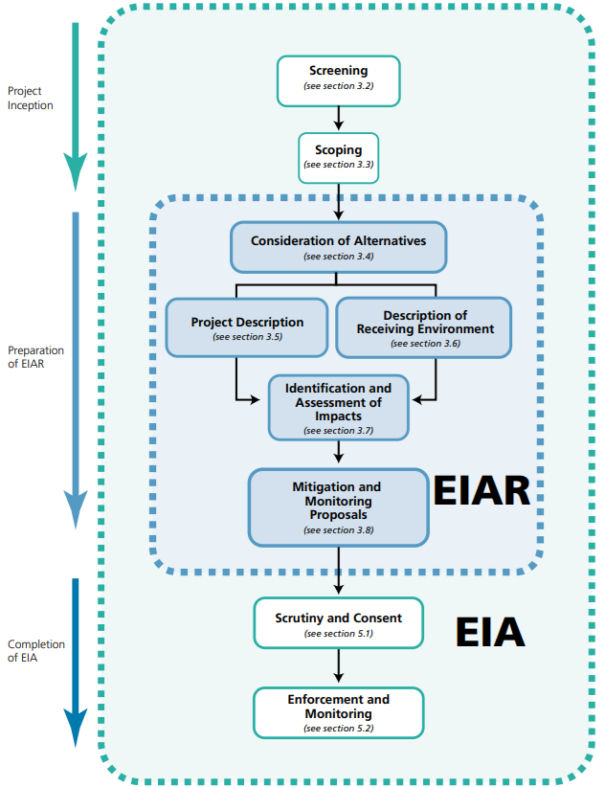
Plate 1-2 The EIA Process
This EIAR identifies, describes and assesses, as appropriate, the direct and indirect, secondary, cumulative, transboundary, short-term, medium-term and long-term, permanent and temporary, positive and negative effects of the Proposed Development. Effects are described using the terminology set out in the EPA Guidelines (2022), including in relation to their quality, significance, extent and context, probability, duration and frequency, as applicable.
In general, the technical chapters for each environmental factor (Chapters 05 to 17) follow the structure set out below:
- Introduction – provides an overview of the environmental factor and matters addressed within the chapter.
- Assessment Methodology – describes the specific approach to the assessment undertaken for the environmental factor, including relevant legislation, policy and guidance, the study area, data sources, assumptions and any limitations to the assessment.
- Environmental Design and Management – describes measures inherent in the design of the Proposed Development and measures forming part of proposed construction environmental management practices. These measures comprise embedded (or primary) mitigation and are taken into account in the assessment of effects.
- Assessment of Effects and Significance – presents the assessment of likely environmental effects, taking account of embedded mitigation, and determines their significance.
- Mitigation and Monitoring – sets out any further measures required to avoid, prevent, reduce or, where appropriate, offset adverse effects identified through the assessment, together with any proposed environmental monitoring.
- Residual Effects and Conclusions – presents the residual effects following implementation of the proposed mitigation measures, identifies any significant residual effects and provides an overall conclusion for the environmental factor.
- Cumulative Effects – presents the assessment of likely cumulative effects arising from the Proposed Development in combination with other relevant existing and/or approved developments, as appropriate to the environmental factor.
Where a technical chapter deviates from this structure for methodological or technical reasons, this is explained within the relevant chapter.

Identifying Potentially Significant Environmental Effects
The environmental assessments presented in this EIAR identify and evaluate the likely environmental effects of the Proposed Development, including, as appropriate, their nature, extent, magnitude, duration, frequency, probability, reversibility and significance.
The approach to determining the significance of effects is set out within each technical chapter, having regard to the characteristics of the relevant environmental factor and applicable topic-specific assessment methodologies and guidance. In identifying and evaluating potentially significant environmental effects, regard has been given, where relevant, to the following characteristics:
- the magnitude and spatial extent of the effect, including the geographical area and size of the population likely to be affected;
- the nature of the effect;
- the transboundary nature of the effect;
- the intensity and complexity of the effect;
- the probability of the effect;
- the expected onset, duration, frequency and reversibility of the effect;
- the cumulation of the effect with the effects of other existing and/or approved projects; and
- the possibility of effectively avoiding, preventing, reducing or, where appropriate, offsetting the effect.

Assessment Terminology
In order to provide a consistent approach across the different technical disciplines, the terminology set out in the EPA Guidelines (2022) is used throughout this EIAR. Where individual environmental topics apply different or additional terminology in accordance with topic-specific guidance, standards or legislative requirements, this is clearly explained in the Assessment Methodology section of the relevant chapter. Each topic chapter provides a reasoned conclusion as to whether the Proposed Development is likely to result in significant environmental effects, both before and, where applicable, following the application of mitigation measures.
To define the quality of effects, the following terminology is used:
- Positive Effects– A change which improves the quality of the environment (for example, by increasing species diversity; or improving the reproductive capacity of an ecosystem, or by removing nuisances or improving amenities).
- Negative Effects– A change which reduces the quality of the environment (for example, lessening species diversity or diminishing the reproductive capacity of an ecosystem; or damaging health or property or by causing nuisance).
- Neutral Effects – No effects or effects that are imperceptible, within normal bounds of variation or within the margin of forecasting error.
Individual technical disciplines may use equivalent topic-specific terminology, such as beneficial and adverse, where required by their applicable guidance.
When addressing the duration of an effect, the following terminology is used:
- Momentary Effects – Effects lasting from seconds to minutes;
- Brief Effects – Effects lasting less than a day;
- Temporary Effects – Effects lasting less than a year;
- Short-term Effects – Effects lasting one to seven years;
- Medium-term Effects – Effects lasting seven to fifteen years;
- Long-term Effects – Effects lasting fifteen to sixty years;
- Permanent Effects – Effects lasting over sixty years;
- Reversible Effects – Effects that can be undone, for example through remediation or restoration; and
- Frequency of Effects – Describes how often the effect will occur (once, rarely, occasionally, frequently, constantly – or hourly, daily, weekly, monthly, annually).
The extent and context of an effect is also described as this can affect the perception of significance. These terms are defined as:
- Extent – Describes the size of the area, the number of sites and the proportion of a population affected by an effect; and
- Context – Describes whether the extent, duration or frequency will conform or contrast with established (baseline) conditions (is it the biggest, longest effect ever?).
The significance of effects is described using the following EPA (2022) terminology:
- Imperceptible – An effect capable of measurement but without significant consequences;
- Not Significant – An effect which causes noticeable changes in the character of the environment but without significant consequences;
- Slight Effects – An effect which causes noticeable changes in the character of the environment without affecting its sensitivities;
- Moderate Effects – An effect that alters the character of the environment in a manner that is consistent with existing and emerging baseline trends;
- Significant Effects – An effect which, by its character, magnitude, duration or intensity alters a sensitive aspect of the environment;
- Very Significant – An effect which, by its character, magnitude, duration or intensity significantly alters most of a sensitive aspect of the environment; and
- Profound Effects – An effect which obliterates sensitive characteristics.
The likelihood of an effect occurring is also considered, where relevant, using the following terminology:
- Likely Effects – The effects caused by the Proposed Development that can reasonably be expected to occur even if all mitigation measures are properly implemented; and
- Unlikely Effects – The effects that can reasonably be expected not to occur if all mitigation measures are properly implemented.
Topic-specific methodologies may apply alternative significance terminology and/or matrices, for example by combining receptor sensitivity with magnitude of change. Where such methodologies are applied, the relevant technical chapter explains how the resulting significance ratings relate to the determination of likely significant effects for EIA purposes.

Significance Criteria
For each technical chapter, the classification and significance of effects have been evaluated with reference to relevant legislation, guidance, standards and accepted assessment criteria, where available. Where effects cannot be quantified, qualitative assessment has been undertaken using professional judgement. Any material assumptions, limitations or uncertainties associated with the assessment are identified within the relevant technical chapter.
For each environmental topic, the assessment considers the characteristics and magnitude of the impact and the sensitivity, importance or value of the resource or receptor, as appropriate, in determining the significance of the resulting effect. Many technical disciplines apply topic-specific methodologies based on relevant legislation, guidance, standards and established practice. These methodologies, including the criteria used to determine significance, are described in the Assessment Methodology section of the relevant technical chapter. Where no topic-specific methodology applies, the general approach described in this chapter is used.
The EPA Guidelines (2022) provide an example of how the significance of an effect may be determined, while recognising that where more specific definitions or methodologies exist for a particular environmental factor or topic, these should be applied in preference to the generalised definitions. The EPA example for determining the significance of an effect is reproduced in Plate 1-3
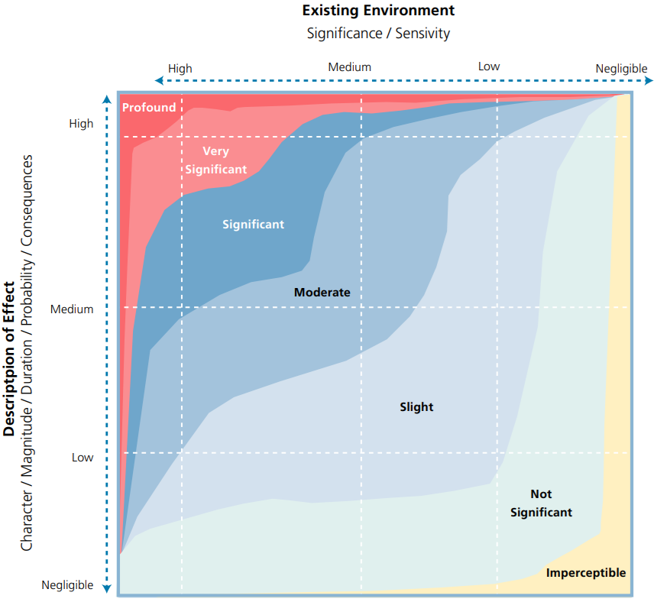
Plate 1-3 Determination of the Significance of an Effect
As illustrated in Plate 1-3, the significance of an environmental effect is generally informed by the relationship between the characteristics and magnitude of the impact and the sensitivity, importance or value of the affected receptor. In general, impacts of greater magnitude and/or those affecting more sensitive or important receptors have greater potential to result in significant environmental effects.
In general, effects classified as “Profound”, “Very Significant”, “Significant” or “Moderate” in accordance with the EPA Guidelines (2022) are considered significant effects for the purposes of EIA, while effects classified as “Slight”, “Not Significant” or “Imperceptible” are generally considered not significant effects. Where a topic-specific assessment methodology applies a different significance scale or threshold, the relevant technical chapter clearly identifies which effects are considered significant for the purposes of EIA.

Cumulative Effects
The EIA Directive states in Annex IV (5) that an EIAR should contain:
“A description of the likely significant effects of the project on the environment resulting from…the cumulation of effects with other existing and/or approved projects, taking into account any existing environmental problems relating to areas of particular environmental importance likely to be affected or the use of natural resources.”
The EIA Directive therefore requires the assessment of likely significant cumulative effects. The EPA Guidelines (2022) describe cumulative effects as “the addition of many minor or insignificant effects, including effects of other projects, to create larger, more significant effects”.
Cumulative effects arising from the Proposed Development in combination with other relevant existing and/or approved projects are assessed, where applicable, within the relevant technical chapters of this EIAR. Appendix 1-3: Planning Search identifies the other projects considered for the purposes of the cumulative assessment. The relevance of individual projects to each environmental factor is determined within the respective technical assessment, having regard to the nature and location of the project, the environmental receptors potentially affected and the potential pathways for cumulative effects.
The permitted primary school development (SDCC Ref. SD23A/0336 / ACP Ref. 321696), located within the wider Site boundary but outside the Proposed Development subject to this EIAR, is treated as a separate project and is considered in the cumulative assessment where relevant to the environmental factor being assessed.
Chapter 18: Summary of Cumulative Impacts and Interactions provides an overall summary of the cumulative effects identified within the technical chapters and considers potential interactions between environmental effects arising from the Proposed Development.
For the purposes of this EIAR, the following terms are used:
Cumulative Effects – Effects resulting from the Proposed Development in combination with effects arising from other relevant existing and/or approved projects, which may result in a greater overall effect on an environmental receptor.
Interaction of Effects – The interaction between two or more environmental effects arising from the Proposed Development, whereby the combined effect on a receptor may differ from the effects considered individually. Where such interactions result in an effect greater than the sum of the individual effects, these may also be described as synergistic effects.

Residual Effects
Residual effects are the environmental effects that remain following the implementation of all applicable mitigation measures. They represent the final predicted effects of the Proposed Development on the receiving environment, taking account of embedded mitigation incorporated into the design of the Proposed Development and any additional mitigation measures identified through the environmental assessment process.
In accordance with the EPA Guidelines (2022), it is recognised that it may not always be possible or practicable to fully avoid or mitigate all adverse environmental effects. The assessment of residual effects therefore identifies the nature, quality, significance, duration and other relevant characteristics of the effects expected to remain following implementation of the proposed mitigation measures.
Each technical chapter clearly identifies the residual effects relevant to that environmental factor and determines their significance in accordance with the methodology set out in this chapter or, where applicable, the relevant topic-specific assessment methodology. Particular attention is given to any significant residual adverse effects, as these represent environmental effects that remain notwithstanding the implementation of the proposed mitigation measures and are therefore relevant to the Competent Authority’s assessment of the Proposed Development.

Consultation
EIA scoping consultation was undertaken in April and May 2026 to inform the scope and preparation of the EIAR. Consultation sought to identify environmental matters requiring consideration in the EIA and to obtain relevant information from consultees to inform the technical assessments.
The consultees contacted, consultation responses received, and details of how the matters raised have been considered and addressed in the preparation of the EIAR are provided in Appendix 1-2 of EIAR Volume 02.
A total of seven consultation responses were received. The principal matters raised are summarised below:
- Geological Survey of Ireland (GSI): GSI shared a recommendation of datasets to be utilised by the technical teams in drafting the EIAR. Datasets include those pertaining to land and soils, water, climate change, cultural heritage, material assets, landscape, natural (geo)hazards and natural heritage.
- Uisce Éireann (UE) (formerly Irish Water): UE shared a letter denoting aspects of water and wastewater services that should be addressed in the scope of the EIAR and in the planning proposals, including Tay Lane Pumping Station, which is currently operating at capacity and will require upgrade projects to support future development growth in the Rathcoole area. UE requested that the location of all existing UE infrastructure within the site and the adjoining wider site area is clearly identified in all associated engineering and site layout drawings. UE also requires that the engineering and site layout drawings demonstrate the required separation distances to public water services infrastructure can be achieved, in accordance with UE Standards, Codes and Practices.
- Transport Infrastructure Ireland (TII): TII recommends that a Traffic and Transport Assessment (TTA) is carried out in accordance with relevant guidelines, including TII’s Traffic and Transport Assessment Guidelines (TII Publication No. PE-PDV-02045), subject to meeting the appropriate thresholds and criteria. The TTA would note traffic volumes and traffic routes to/from the Site, with reference to the impacts on the national road network and junctions of lower category roads with national roads. The designers and assessors are asked to consult TII Publications to determine whether a Road Safety Audit is required. TII advises that consultations should be had with the relevant Local Authority/National Roads Design Office (RDO) with regard to locations of existing and future national road schemes.
- Department of Transport: The Department for Transport notes that the inclusion of Active Travel infrastructure is welcome in the Proposed Development’s design. In addition to this, the provision of safe, secure bicycle parking is critical, and therefore it is important that the proposed design includes secure bike parking spaces for future residents.
- Butterfly Conservation Ireland (BCI): BCI’s consultation response focused on the importance of the species and habitats onsite and in the wider surrounding area, three of which are listed on Annex I of the E. U. Habitats Directive. BCI suggest that SDCC designate a nature reserve under Section 15 of the Wildlife Act 1976, which they recommend as a suitable action in alignment with SDCC’s Biodiversity Action Plan 2026-2031.
- Inland Fisheries Ireland (IFI): IFI recommends that a full-time, suitably experienced, and qualified ecological clerk of works is appointed prior to the commencement of construction, to ensure the implementation and compliance with all agreed measures to protect the environment. IFI indicates that the presence of water bodies within the site boundary poses a significant risk to the receiving aquatic environment, with the importance of appropriate construction environmental management procedures and practical mitigation measures being implemented.
- Development Applications Unit/ National Parks and Wildlife Service (NPWS): The Department advises that an Archaeological Impact Assessment is scoped into the proposed EIA process, and should be carried out by a suitably qualified Consultant Archaeologist. They recommend that the methodology should incorporate desk-based research, site inspections, and consultation with the public and relevant stakeholders.

Difficulties Encountered
No unusual or significant technical difficulties were encountered in the preparation of this EIAR. Where information was unavailable or subject to uncertainty, reasonable assumptions have been made based on the information available at the time of assessment and professional judgement.
Any topic-specific limitations, data gaps, uncertainties or assumptions that are material to the assessment are identified in the subsections of each chapters 05 to 17 Limitations and Assumptions of the relevant technical chapter, together with an explanation, where relevant, of how these have been taken into account in the assessment of likely significant environmental effects.

Expertise of the EIAR Team
This EIAR has been compiled by AECOM; assessment and reporting were provided by competent experts from AECOM and MacCabe Durney Barnes (MDB). The authors of the chapters comprising Volume 01 of the EIAR and their qualifications are listed in Appendix 1.1 of EIAR Volume 02.
The authors of the chapters comprising Volume 01 of the EIAR are identified in the introduction to each chapter also listed in Table 1.1.
Table 1-1: EIA Team and Authors
EIAR Chapter | Author
Project Director | Richard O’Callaghan, BSc, BL, MSCSI, MRICS - 31 years QS experience
Project Manager | Roisin Connolly, BA(Hons) Barch, pDip Part III. - 9 years experience
EIAR Manager | Aldona Binchy, Eng MSc, PISEP - 20 years’ experience
EIAR Coordinator | Leticia Braga, PhD, MSc, BSc (hons), PGeo - 16 years’ experience
EIAR Lead Verifier | John Halsall, MSc (Merit), BSc (Hons), CEnv – 25 years’ experience
Chapter 01: Introduction and Methodology | Leticia Braga, as above
Chapter 02: Description of Development | Jerry Barnes, BA, MPhil, MSc, MA, MIPI, MRTPI – 35 years’ experience  Lara Carey, BA, pMSC - 2 years' experience
Chapter 03: Need for Development | Jerry Barnes, as above  Lara Carey, as above
Chapter 04: Alternatives | Jerry Barnes, as above  Lara Carey, as above
Chapter 05: Population and Human Health | Jerry Barnes, as above  Lara Carey, as above
Chapter 06: Biodiversity | Paul Lynas, BSc (Hons), MRes Environmental Biology, CEnv (Society for Environment), MCIEEM – over 20 years’ experience
 | Jenny Hunter, BSc (Hons), MSc, MCIEEM, MRSB (Royal Society of Biology), over 13 years of experience
 | Seánin Munglani née Maxwell, BSc (Hons), MSc, ACIEEM, over six years of experience
Chapter 07: Land, Soils and Geology | Kevin Forde, BSc (Hons), Dip Comp Sci, MSc Hydrogeology – over 30 years’ experience  Hollie Whelan, BA, MSc, 2 years’ experience
Chapter 08: Water and Hydrology | Lauren Kellett, BSc, MSc – 4 years’ experience  Aline Moreau, MSc, MSE – 5 years’ experience  Tim Jones, PhD, BSc – 6 years’ experience academia and 9.5 years’ experience consultancy  Jenny Rush BA, MSc, PDip – 22+ years’ experience
Chapter 09: Air Quality | Anna Savage MIAQM, MIEnvSci, Csci – 25 years’ experience  Rachel Perryman, CSci, MSc, BSc (Hons) – 17 years’ experience  Matt Smith, BSc, AMIEnvSc – 2 years’ experience
Chapter 10: Climate | Jarrad Fisher, BSc (hons), BA, PISEP, REnvP – 3 years’ experience  Hannah Willert, BSc – 2 years’ experience
Chapter 11: Noise and Vibration | Chris Skinner MSci, MA, MIOA – 26 years’ experience  Alex Young, MSc, CEng, MIOA – 11 years’ experience  Patrick Wood, BEng, Meng, MIOA – 4 years’ experience  Aisha Teffah, BSc (Hons), TechIOA – 3 years’ experience
Chapter 12: Landscape and Visual | Joerg Schulze, Dipl.- Ing. (FH) LA, MILI – 21 years’ experience  Jimmy Lu, BA, MSc – 10 years’ experience
Chapter 13: Archaeology and Cultural Heritage | Luke McParland, BSc, 2 years’ experience  David Kilner, BA (Hons), MSc, 22 years’ experience
Chapter 14: Material Assets (Traffic) | Michael Bell, BSc (Hons), CTPP, FCIHT, MCMI, MTPS – 26 years’ experience  Claire McComish, BSc (Hons), MCIHT, MTPS – 18 years’ experience  Katherine Stevenson, MPlan – 6 months’ experience
Chapter 15: Major Accidents and Disasters | Jason Ferns, BEng, MSc, PhD – 4.5 years’ experience  Elisa Uginet, MEng AMIES, 7 years’ experience  Angela Graham, BSc (Hons), MSc, MCIWM, MCRM, MIIRSM – 30 years’ experience
Chapter 16: Material Assets (Utilities) | Ryan Jonas, BSc, MSc – 20 years’ experience.  Kate Flood BSc (Hons), Marine Biology, 15 years
Chapter 17: Waste | Caroline Braithwaite, BSc (Hons), PISEP, MCIWM, CRWM  Lucy Hill, BSc (Hons) MSc CRWM CEnV MCIWM 19 years
Chapter 18: Summary of Cumulative Impacts and Interactions | Noxolo Zondi, BSocSc (Hons) Public Policy, BSocSc (Geo. Env. Management), EAP – 11 years’ experience
Chapter 19: Summary of Mitigation and Monitoring | Noxolo Zondi, as above
Geographic Information System (GIS) Figures | Jordan Barr, BSc (Hons), MSc – 9 years’ experience

References
Department of Housing, Planning and Local Government (2018). Guidelines for Planning Authorities and An Bord Pleanála on Carrying out Environmental Impact Assessment.

Eastern and Midland Regional Assembly (2019). Regional Spatial and Economic Strategy 2019–2031.

Environmental Protection Agency (EPA) (2022). Guidelines on the Information to be Contained in Environmental Impact Assessment Reports.

European Commission (2017a). Environmental Impact Assessment of Projects: Guidance on Scoping (Directive 2011/92/EU as amended by 2014/52/EU).

European Commission (2017b). Environmental Impact Assessment of Projects: Guidance on the Preparation of the Environmental Impact Assessment Report (Directive 2011/92/EU as amended by 2014/52/EU).

Government of Ireland (2025). National Planning Framework – First Revision.

South Dublin County Council (2022). South Dublin County Development Plan 2022–2028.

Legislation

Directive 2011/92/EU of the European Parliament and of the Council on the assessment of the effects of certain public and private projects on the environment, as amended by Directive 2014/52/EU.

European Union (Planning and Development) (Environmental Impact Assessment) Regulations 2018 (S.I. No. 296/2018), as amended.

Planning and Development Act 2000, as amended.

Planning and Development Act 2024, as amended and insofar as relevant provisions have commenced and apply to the Proposed Development.

Planning and Development Regulations 2001, as amended.

Non-Technical Summary
This Non-Technical Summary (NTS) provides a summary of the Environmental Impact Assessment Report (EIAR) prepared by AECOM Ireland Limited on behalf of South Dublin County Council for the Proposed Development on lands to the south and southeast of Rathcoole Village, County Dublin.

The Proposed Development will provide 130 new homes, comprising 60 apartments, 20 duplex units and 50 houses. Of these, 64 will be social housing units and 66 will be affordable purchase units. The development will also include age-friendly and Traveller-specific accommodation.

In addition to the new homes, the Proposed Development will include two full-size adult GAA grass pitches, one junior GAA grass pitch, a park pavilion and associated facilities, new roads, pedestrian and cycle routes, car and bicycle parking, landscaping and green infrastructure, drainage and utilities, and other associated works. Vehicular access will be provided from Greenogue Drive. The existing Mullally's Lane vehicular arm will be repurposed as an active travel route, with pedestrian and cycle access also provided from Coolamber Road.

The application site covers approximately 11.3 hectares within wider lands of approximately 17.78 hectares. The Site is mainly greenfield land located to the south and southeast of Rathcoole Village. Rathcoole Park and existing residential areas are located to the north and northwest, Saggart is located further to the east and southeast, and agricultural and other greenfield lands are located to the south. Several watercourses are located within or close to the Site, including the Coolmine Stream, Crockshane (Slade) Stream and River Camac.

A separate primary school development has already been permitted within the wider planning application boundary. The school does not form part of the Proposed Development assessed in this EIAR. However, it has been considered where it could combine with the Proposed Development to affect the environment.

An Environmental Impact Assessment Report (EIAR) provides information about how a proposed development could affect the environment. The EIAR has been submitted to An Coimisiún Pleanála (ACP) to assist it in assessing the environmental effects of the Proposed Development as part of its decision on the application.

The EIAR considers both the construction and operation of the Proposed Development. It considers potential effects on people and human health, biodiversity, land and soils, water, air quality, climate, noise and vibration, landscape and views, archaeology and cultural heritage, traffic, utilities, and the risk of major accidents and disasters. Waste was scoped out of detailed environmental assessment; however, information on the management of construction and operational waste is also provided in the EIAR and supporting waste management plans.

For each environmental topic, specialists considered the existing environment, the changes that could result from the Proposed Development and whether these changes could have significant environmental effects. The assessments also consider measures already included in the design and identify additional measures where necessary to avoid or reduce adverse effects. The effects expected to remain after these measures are implemented are also identified.

The EIAR also considers whether effects from the Proposed Development could combine with effects from other existing or approved developments. The developments considered vary between environmental topics depending on the type of effect being assessed and how far that effect could reasonably extend. This includes the permitted primary school development within the wider planning application boundary, where relevant.

Consultation was undertaken in April and May 2026 to help identify environmental matters that should be considered in the EIAR. Seven responses were received from public bodies and other organisations. Matters raised included water and wastewater infrastructure, traffic and transport, walking and cycling facilities, biodiversity and habitats, protection of watercourses and archaeological heritage. These matters were provided to the relevant specialists and taken into account in preparing the EIAR, where applicable.

The EIAR has been prepared in accordance with the relevant Irish and European environmental assessment requirements and guidance, including the Environmental Protection Agency's 2022 guidelines for EIARs. It was prepared and reviewed by a team of suitably qualified and experienced environmental professionals from AECOM Ireland Limited and MacCabe Durney Barnes.

No unusual or significant technical difficulties were encountered in preparing the EIAR. Where information was unavailable or uncertain, reasonable assumptions and professional judgement were used. Any important limitations or assumptions are explained in the relevant environmental chapters.

The Proposed Development is intended to be permanent and there are currently no plans to decommission it.

Acronyms and Abbreviations
This will be removed to a combined table at the start of the EIAR document.
Acronym/Abbreviation | Full Text
ACP | An Coimisiún Pleanála
AECOM | AECOM Ireland Limited
BCI | Butterfly Conservation Ireland
CEnv | Chartered Environmentalist
EIA | Environmental Impact Assessment
EIAR | Environmental Impact Assessment Report
EPA | Environmental Protection Agency
EU | European Union
GAA | Gaelic Athletic Association
GIS | Geographic Information System
GSI | Geological Survey of Ireland
IFI | Inland Fisheries Ireland
MDB | MacCabe Durney Barnes
NPWS | National Parks and Wildlife Service
NTS | Non-Technical Summary
SDCC | South Dublin County Council
TII | Transport Infrastructure Ireland
TTA | Traffic and Transport Assessment
UE | Uisce Éireann



EPA Guidelines (2022) Figure 2.1.
EPA Guidelines (2022) Figure 3.4.

