**Remote Working Survey Report**

**March 2021**

**Contents**

1. Background 3

2. Remote Working Survey findings 5

2.1 Respondents profile 6

2.2 Current remote working arrangements 9

2.3 Advantages and disadvantages of current remote working arrangement 11

2.4 Organisational supports for remote working teams 15

2.5 Preferred options for future remote working arrangements 18

2.6 Structure and implementation of any future remote working policy…………… .22

3. How SDCC Staff Survey findings compare to a national comparative survey… .23

4. Key findings and recommendations………………………………………… ..24

**1. Background**

COVID-19 provided for an unplanned global scale experiment necessitating remote working for significant periods of time during the past year. For SDCC staff, this has meant a fundamental change in work practices and the greater use of technologies to enable us to continue to deliver essential services to all our citizens.

In June 2020, staff were asked to complete a remote working survey to capture the collective learning and insight gained during this time. This was following a period when remote working was necessitated due to level five restrictions of the COVID-19 pandemic when government advice was to work from home where possible’. It is noted that the nature of some of our services are front facing and did not lend themselves fully to remote working and some staff continued to attend their work locations. The move to full remote working in March 2020 represented a transformational change in work practices and was compounded initially for some staff by lack of availability of childcare and school closures and for most others various societal restrictions restricting movement. However, these restrictions were reduced as society partially re-opened including schools and childcare. Staff have continued to work remotely to varying degrees throughout the course of the year.

The first survey in June 2020 asked staff what they considered to be the business tasks that could be completed fully, remotely, partially or that required a physical presence in the office environment. This survey also examined the various remote working arrangements which prevailed when restrictions were eased, and staff had returned to an office environment in a safe, socially distanced manner. This information was gathered to review and refine existing business processes to meet the challenges of remote service delivery, improve work practices, and to consider possible digitisation of some tasks to allow for remote delivery.

Following on from this in March 2021, the Chief Executive had again sought the views of all staff on their experience and insight of remote working during various levels of restrictions which has operated for almost one year. The purpose of this Remote Working Survey is to capture the collective learnings made while remote working during COVID-19 from the perspective of staff to future proof policies for new work arrangements, to better inform our Business Continuity Plans and to be factored into future workforce planning requirements.

In this survey, Respondents were asked to provide a snapshot of their current working arrangements, pre COVID-19 transport to work and broadband availability to facilitate remote working. They were also asked if there was sufficient support from their line manager and that they are aware of the supports to ensure health and wellbeing being provided by SDCC. Line managers were asked if there are specific challenges to managing their teams remotely.

Respondents were also asked to reflect upon what they personally understand to be the advantages and disadvantages of remote working and ultimately if remote working arrangements were available options, would they wish to avail of this. They were also requested to advise on what they deem to be important factors to be considered in devising any future Remote Working Policy for SDCC.

The results of this survey should be considered in the overall context that level five restrictions are prevailing where staff may be working remotely to a greater extent than in previous months. Also, general COVID-19 fatigue regarding overall lifestyle restrictions may compound dissatisfaction with remote working. Despite this, this information will provide valuable insight into devising a relevant policy for future remote working arrangements and the factors to be considered and addressed to make this effective in the long term for both staff and the organisation.

**2. Remote Working Survey findings**

This Remote Working survey was conducted through on-line questionnaire over the period of 23 February 2021 through to 14 March 2021. The survey was open to all staff of South Dublin County Council. The survey received 651 responses with 570 of those fully complete. This is broken down by directorate as follows:

|  |  |  |  |
| --- | --- | --- | --- |
|  | **Respondents to survey** | **Total in work area** | **% of the work area answered** |
| **HSCD** | 138 | 209 | 66 |
| **CPCM** | 87 | 127 | 69 |
| **LUPT** | 102 | 175 | 58 |
| **EWCC** | 125 | 372 | 34 |
| **EETD** | 82 | 144 | 57 |
| **Finance** | 44 | 58 | 76 |
| **ICT** | 24 | 26 | 92 |
| **Architects** | 24 | 29 | 83 |
| **Law** | 14 | 21 | 67 |

Most responses were completed by clerical, administrative, professional, and technical grades (88%). There was also a small number of returns by operational and depot-based staff (12%). Seventy-six percent (76%) of all respondents are based in County Hall with the remaining (24%) spread between the Clondalkin Area Office, Library Services and Depots.

The highest number of responses returned by each Directorate are as follows:

* Housing, Social and Community Development (HSCD) (21.5%), followed by
* Environment, Water and Climate Change (EWCC) (19%)
* Land Use, Planning and Transportation (LUPT) (16%)
* Corporate Performance and Change Management (CPCM) (13.5%)

**2.1 Respondents profile**

The majority of staff (70%) of staff who completed this survey are from Administrative / Clerical Grade 3 to Grade 7 inclusive. Only 4% of respondents are Senior Management, however this represents 87% of the total people employed at this level. Middle Management (Grades 6s and 7s which) represented 23% of all respondents, and 4.6% of respondents from Library Services. These responses are broadly reflective of the proportions of staff employed in each cohort.

Due to the specialist and diverse roles represented across the organisation, 3.72% of all respondents are categorised as ‘other’. This category includes respondents from the following grades / roles, Cleaner, Community Centre Employee, Facilities Supervisor, Ganger, Gardener, General Operative, Housing Inspectors, School Warden, Traffic Warden, Outreach Worker and Water and Drainage Inspectors.

|  |
| --- |
|  |

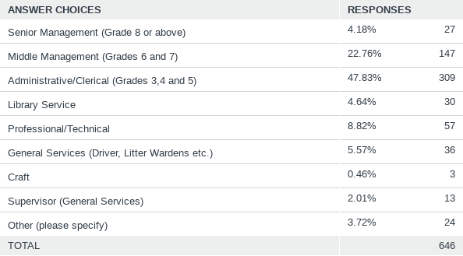

**Age profile of respondents**

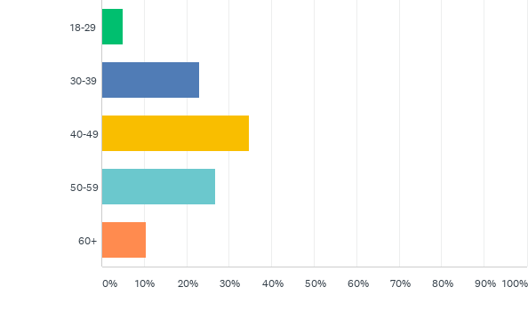

The majority of respondents (35%) who completed were in age bracket of 40 - 49 years of age, which is reflective of the organisation’s age profile, with next highest age bracket being 50 - 59 years of age (27%). Only 5% of those who responded were from younger members of staff in the 18 to 29 years of age bracket.

**Where do you live?**

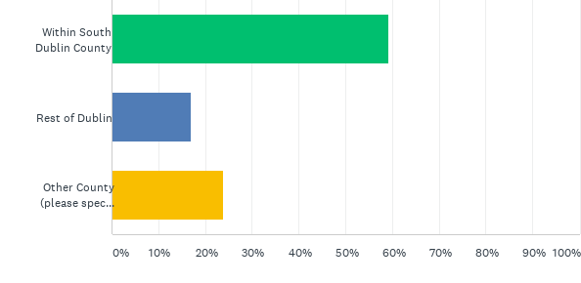

Most staff (76%) live in either the South Dublin County area or in Dublin County. Twenty-four percent (24%) of all other respondents are residing in another county and commuting for work purposes.

**How did you get to work pre COVID-19?**

Pre COVID-19 almost 80% of all respondents travelled to work in a private motor car. The remaining 20% of respondents opted for more sustainable modes of transport including travel by public transport, walking, cycling or carpooling arrangements.

**Staff commute:**

The majority of respondents live in South Dublin County (59%) or the greater Dublin area (17%). Ten percent (10%) are commuting from the neighbouring county of Kildare. The balance of staff (14%) are commuting further distances including from Carlow, Meath, Westmeath, Longford, Laois and Tipperary.

**How good is your broadband?**

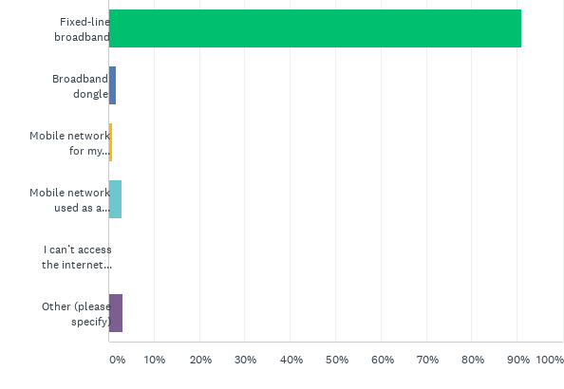

A huge number of respondents (over 91%) reported that they have fixed line broadband at home facilitating their ability to work remotely. Almost 4% of respondents make use of their smartphone or mobile network used as a hotspot for work purposes and 1.69% of staff have broadband dongles. Only 0.31% of all respondents reported that they are unable to access the internet or SDCC networks.

**2.2 Current remote working arrangements**

Regarding current working arrangements, there is a high percentage across all office-based grades who are currently remote working in some capacity across the organisation. However, it must be recognised that this survey is taken when Level 5 -COVID-19 restrictions are prevailing.

Of those currently engaged in remote working this is further broken down to specific work patterns, with staff based at home either:

* full time;
* full time and attending the office as required;
* three / four days per week; or
* working remotely for one / two days per week due to the nature of their work.

Most respondents are remote working for most of the working week. However, these current working arrangements are reflective of the prevailing Level five restrictions and represent an increased incidence of remote working.

The remote work pattern is detailed by grade in the table below.

**2.3 Advantages and disadvantages of current remote working arrangements**

When surveyed on the current benefits of remote working, the overwhelming positive reason given was the absence of any commute to work (80%). Other shared benefits include savings made in the associated costs of office-based working (lunch and / or travel) (56%), greater flexibility (48%), having more time with family (42%) and being able to work without distractions (52%).

Efficiencies in work practices and feeling better at their job were benefits listed by some staff but were not particularly identifiable as benefits of new work patterns.

A very small number of staff (6%) felt there were no benefits to remote working.

Of all groups analysed, library staff reported the least benefits across all those listed – which is consistent with their role as front facing staff and perhaps the overall suitability of the Library service to be fully delivered remotely.

Overall, disadvantages were reported as being far less significant than the overall perceived benefits. The most common disadvantages were reported as feelings of isolation (average of 39%) and missing friends (average 36%) which underlies the intangible benefits of social networks at work to some respondent’s personal sense of wellbeing and purpose. There was some commonality where staff reported the lack of access to office-based knowledge or files as a disadvantage (25%). There appears to be little adverse effect on motivation with only 8% of staff noting that their motivation has suffered.

As with the current advantages, all disadvantages are more evident across in the respondents based in the library service.

**Other benefits and drawbacks:**

A free text space was included in this survey for respondents to further examine the benefits or drawbacks of remote working arrangements. Several common themes emerged among staff on both sides of the issues.

**Additional benefits:**

* Time normally taken up with a commute is now used for exercise, hobbies, or other domestic purposes. Some staff feel that this has led to more enhanced personal productivity and better concentration.
* Working from home has meant that some respondents are less reliant on childcare services – needing to make collections for schools / crèches / childminder at certain times and so on, which is a significant benefit for them.
* Reduced stress levels and better work life balance. The overall satisfaction rating with work life for the organisation is rated at over seven.
* There is a significant recognition that Line Managers are communicating and meeting frequently with their teams albeit for the most part through Teams. Respondents are for the most part fully aware of the positive supports offered by SDCC to support mental health and wellbeing.

**Drawbacks:**

* High incidence of feelings of isolation among staff in full time remote working patterns.
* Communication issues either among teams or from senior management. This ranged from what is perceived by some as ‘too many unnecessary meetings’ to a lack of communication and limited interaction with colleagues possibly exacerbating feelings of isolation.
* No suitable workspace.
* Less likely to take coffee or lunch breaks while remote working.
* Issues with connectivity with Citrix / Microsoft Teams or disruptions to home Wi-Fi can sometimes impact on their work.
* Lack of access to office hardware – printer, copier, scanning equipment in a remote working environment.
* Perceived pressure to be always ‘switched on’ at laptops, uninterrupted from 9am - 5pm.
* Increase in unnecessary Microsoft Teams meetings where the office environment lends itself to more informal interaction and discussions.
* Additional costs in the home (light, heat, and Wi-Fi).
* Ad hoc working discussions or ‘brainstorming’ that result in a new approach to problem solving have disappeared.
* No real networking opportunities for staff.
* Front facing staff have found that it is just not possible to help some people on a remote basis, this is particularly evident for customer care staff and library staff. Also, for some grades home visits forms the basis of their work and this cannot be replicated through the use of either Microsoft Teams or other virtual meeting place.

**2.4 Organisational supports for remote working teams**

**Communications with line manager:**

In terms of support structures for staff who are remote working, 82% of staff report regular contact with line managers. Seventy-three percent (73%) of respondents reported that they feel they are as effective working remotely, with only 9% of respondents reporting that they feel less motivated when working remotely. Interestingly, only 9.68% of respondents think their team works better remotely.

**Challenges for line managers:**

There are some concerns around the challenges of managing teams remotely with over a quarter of respondents at middle management level (Grade six and seven) and again by Senior Managers (48%) identifying this as an issue. Through the free text extraction from the survey it is clear there were some respondents who felt that the productivity of all members of the team were not equal. This idea is further supported in that over 50% of staff feel that some form of productivity measurement should be introduced as part of any remote working scheme. Remote working lends itself to more task driven and result orientated work rather than time spent at a computer.

**Effectiveness and productivity:**

When respondents surveyed their assessment of their own perceived effectiveness, on the positive side 64% of staff either agreed or strongly agreed that they were as effective at their job while working remotely. Twenty-six percent (26%) of staff felt they were more productive when remote working. Almost 50% respondents reported that are fewer distractions and get more work done.

On the negative side, 10% of respondents stated they feel more distracted at home, 18% feel they work better in an office environment and 30% stated they have less access to corporate knowledge or files. The comments in the free text included that some respondents felt the need to be always on 9am to 5pm and were not availing of lunches or breaks as required. This may be attributed to the perception of increased productivity.

While 31% of respondents advised that they felt better at their job working remotely, only 8% stated that their team works better remotely. This would indicate that remote working positively impacts on individual job satisfaction but does not appear to translate into enhanced overall team performance.

**Organisational wellbeing supports**

It is evident that a significant number of respondents (40%) are experiencing feelings of isolation from their work colleagues and 19.3% of respondents felt disconnected from SDCC even one year hence from the initial lockdown in March 2020. Forty-four percent (44%) of respondents cited missing their friends as one of the main disadvantages to remote working. It remains difficult to electronically replicate the fabric of social networks or the benefits of tacit knowledge sharing. The missing of friendship in the workplace and social interaction are cited as the main disadvantage to remote working and the diminution of this negatively impacting on personal wellbeing and sense of organisational cohesion.

Access to remote wellbeing supports were also rated highly in terms of awareness and accessibility with 67% strongly agreeing or agreeing with this statement.

**Work satisfaction rating**

Respondents were also asked to score on a scale of 0 (being not at all satisfied) to 10 (completely satisfied) how satisfied they are with their working life. Respondents overall scored a satisfaction level of over seven which is a positive result. Respondents in free text cite reduced stress levels and better able to manage childcare arrangements.

This is perhaps reflective of respondent’s sense of greater flexibility on how they manage their time (49%) with enhanced work life experienced by (44%) who report having more time for themselves and family. However, this must be balanced by several staff feeling unable to avail of lunches or breaks and feeling they have to be constantly switched on.

**2.5 Preferred options for future remote working arrangements**

If staff were offered the opportunity to work remotely on a 20% basis, approximately 77% of all staff surveyed would like to avail of this option. Only 5% of all respondents said they would not be interested and 8% were unsure of this as an option.

In terms of the breakdown across the grade structure, all except library staff were very much in favour to a proposed 20% model remote working arrangement if made available.

The preference for a 20% remote working is balanced across the organisation with all departments showing the same trends across all grades, with between 70 - 80% of all surveyed in favour of this model. Again, this is not reflected in Economic, Enterprise and Tourism Development (EETD) as the Libraries Service is within this function.

**Preference for more than 20% remote working**

When a more than 20% model of remote working was surveyed, the average in favour drops to approximately 64% of all respondents. Thirteen percent (13%) of those surveyed would not seek to work more than 20% remotely with the balance either undecided or did not provide answer.

The anticipated benefits of a possible Remote Working Scheme from the point of view of those surveyed is below. This mirrors the current experience of respondents, with the absence of a commute and a better work life balance identified as the most significant benefits. It is worth noting that there is a reasonably low (10%) percentage of staff that feel that their team operates better in a remote work setting and also that a sense of trust from line managers is also on the lower side (20%).

When surveyed on the anticipated drawbacks of remote working, feelings of isolation and dislike of mixing the home and work environment are among the highest on the negative side. Difficulty in managing teams and a lack of shared purpose were also identified as issues. Overall, the perceived drawbacks of a remote working pattern are less absolute than the benefits.

**2.6 Structure and implementation of any future Remote Working Policy**

In terms of the structure of any Remote Working Policy the main concerns of staff are outlined below:

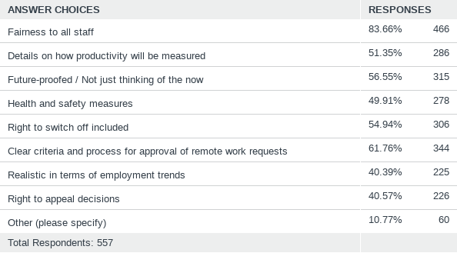

The top five concerns identified by the majority of staff in all cases starts with the chief concern (84% of staff) that any scheme implemented should above all other factors be fair to all applicants, and secondly (62% of respondents) have clear criteria and processes for approval of remote working requests developed. The third top issue, identified by 57% of respondents, is that a Remote Working Policy would be future proofed and not based on the current pandemic experience, and also that the right to disconnect (55% of respondents) would feature in the practice of remote working. Finally, the fifth issue identified (51% of respondents) was the need to consider how productivity is measured in the remote working context.

All responses will help to inform the development of the Remote Working Policy for the organisation.

**3. How SDCC compares to national comparators**

The Whitaker Institute based in NUI Galway [1] carried out a remote working survey in April 2020 and a follow up survey in October of 2020. Of over 7,000 survey participants in the April 2020 survey, 83% expressed a desire to continue in some form of remote working post COVID-19, rising to 94% of over 5,000 participants in the follow up October 2020 survey.

The survey carried out in April 2020 identified the top three advantages to remote working as **(1)** No commute **(2)** Savings **(3)** Greater flexibility in time management.

The top three disadvantages identified were **(1)** Inability to switch off **(2)** Adverse effects on team communications **(3)** No suitable workspace.

In the October 2020 follow up survey, the advantages remained unchanged, however the disadvantages identified were **(1)** Feelings of isolation **(2)** Motivational issues and **(3)** No suitable workspace.

The findings of this survey in terms of the desirability of some form of remote working options being made available to staff of South Dublin County Council are consistent with the findings of the Whitaker Institute surveys on remote working.

The advantages and disadvantages identified are also consistent with the SDCC survey – particularly those of the October 2020 follow up. However, it must be considered that the change in the nature of the disadvantages is likely to do with the timings of the survey and a general level of fatigue with COVID-19 restrictions. For example, the reported feelings of isolation are perhaps most likely compounded by the wider issue of COVID-19 restrictions rather than a direct consequence solely attributed to remote working.

**4. Key findings and recommendations**

The information borne out of this remote working survey provides for an overwhelming preference across most respondents for the development and implementation of a Remote Working Policy in South Dublin County Council. The statistics (77%) support a hybrid approach to remote working with the ideal being that most staff could apply to work remotely subject to business requirements for a proportion of the working week for up to 20%.

A further 65% of respondents have indicated that they would favour the option of working remotely for more than 20% of the working week. In both instances, respondents have stated that any future policy must be a fair process, with clear approval criteria with future proofing for business requirements.

Some respondents stated that they felt isolated from colleagues. Teams meetings do not always address this issue in the same way as impromptu meetings on site or facilitate the building of social networks across the organisation. These findings show the intrinsic value of working relationships, social networks, team working, the importance of knowledge sharing and information is better facilitated in an office environment. Encouragingly, the majority of staff continued to be motivated about work while 9% of staff felt less motivated when remote working. A model that enables the full team to be onsite at regular intervals could make a hybrid model of remote working more advantageous for the organisation.

A hybrid model of remote working could help to counteract the significant disadvantages identified around issues of respondents missing their friends or feeling isolated from their team and colleagues. This would also address the disadvantages experienced by some respondents where (30%) of staff felt that had less access to knowledge or files while working remotely and (18.02%) stated that they felt better in an office environment.

Consideration should be given to front facing work areas such as Library Services which are not necessarily suited to remote service delivery to examine if feasible to refine some business processes to allow for a more limited form of remote service delivery.

With regards to line management and the provision of staff wellbeing supports, SDCC has responded well to the ongoing needs of staff. The management of staff remote working provided specific challenges for Line Managers at grade six and seven and Grade eight. Some responses from this survey suggest that it would be beneficial for a training module specifically tailored to concerns around remote working to be made available to staff covering areas such as those identified below:

* Supervision and management of remote working teams.
* Self-management while remote working.
* Online meeting management and etiquette.

The main perceived advantage of remote working is reduced commuting time which, may be offset by Government policy for the development of remote working hubs. It is noted that 59% of all respondents reside within South Dublin County or an overall 76% of respondents reside in the greater Dublin area inclusive of all respondents residing in South Dublin. Government policy on the provision of remote working hubs may provide opportunities for those with longer distance commutes to work in closer proximity to home. These may be considered a viable option in the small number of cases where staff do not have fixed line broadband at home.

From a business continuity perspective, the overall findings of this survey indicate that the majority of staff are positively engaging with new technologies and remote working arrangements. It is evident that the preferred hybrid model of remote working as advocated by the majority of respondents, will allow staff to continue to enjoy the quality of working life benefits but will also be enhanced by the social and wellbeing benefits derived from physically working in an office location or work environment. However, the negative impact on teamwork, the additional challenges to managers in supervising staff and the need for clear measurement of productivity when managing work done remotely will also have to be addressed considered by the organisation.

The Council is actively involved in the development of guidance on the provision of a Remote Working Policy for the sector by the LGMA. The views of staff as expressed here and in any subsequent staff engagement provide valuable insight and will be taken on board in the development and implementation of the remote working policy for this organisation.

The Human Resources Department will develop training modules to assist staff and line managers with managing work remotely. These modules will include some of the areas identified in this survey by respondents as particularly relevant such as managing teams remotely as well as self-care while managing remotely

SDCC will continue to support the continued health and wellbeing of all staff and will continue to provide regular online wellness webinars and supports to address topical issues particularly around issues of managing personal wellbeing and building resilience.

Managers should continue to meet and engage with their teams regularly to counteract any potential feelings of isolation experienced by staff. A concerted effort should be made by line managers to more frequently engage with staff who may have to fully remote work for a prolonged period.

HR will continue to update staff of the progress and development of the future development of a future Staff Remote Working Policy.

Thank you to all respondents for taking the time to complete the SDCC Staff Remote Working survey.

1. [Remote Working in Ireland - Whitaker Institute for Innovation and Societal Change | NUI Galway](http://whitakerinstitute.ie/project/remote-working-during-covid-19-irelands-national-survey/)