12 December 2013

Circular Fin 6/2013

County Manager
cc. Head of Finance
South Dublin County Council

LGF General Purpose Grant Allocations 2014

A Chara,

I am directed by the Minister for the Environment, Community and Local Government to inform you that the provisional General Purpose Grant allocation from the Local Government Fund for South Dublin for the year 2014 is €923,906.

Local Authority Funding model
The local government funding model has changed considerably in 2014. Under the Finance (Local Property Tax) Act 2012, commencing in 2014 the Minister for Finance will pay into the Local Government Fund an amount equivalent to the Local Property Tax paid into the Central Fund during that year; this revenue has been allocated to local authorities from the Fund. In addition, the establishment of Irish Water and its financial relationship with the local government sector has a considerable impact on local authority financing.

The Government has indicated an intention to move to 80% retention of all Local Property Tax receipts within the local authority area where the Tax is raised. The establishment of Irish Water presents local government with significant organisational and financial challenges in 2014. Service provision responsibilities will shift from the local authorities to Irish Water, infrastructure will be transferred, financing arrangements will alter and local authorities will operate on behalf of Irish Water under Service Level Agreements. In this context, it was decided as part of Budget 2014 to defer defining a certain proportion of the proceeds of the Local Property Tax to be retained in each local authority until 2015.

The General Purpose Grant allocation to your local authority reflects the water costs being removed from local authorities through the establishment of Irish Water in 2014 including costs covered under SLAs and costs to be met directly by Irish Water.

Non-Principal Private Residence Charge
As announced in the context of Budget 2013, the Non-Principal Private Residence Charge will cease in 2013. This has been taken into account in framing General Purpose Grant allocations for 2014. The necessary legislative provision will be made shortly which will provide for continued local authority collection of outstanding NPPRs and arrears from the period 2009 to 2013.

Rates and local charges
The General-Purpose Grant allocation continues to provide a very significant contribution towards the current expenditure needs of your authority for 2014. As part of a range of measures to aid economic recovery, the Minister is clear on the need for continued reductions in commercial rates over the coming years and again requests that local authorities exercise restraint or, where possible, reduce commercial rates and local charges for 2014, in order to support competitiveness in the economy, nationally and locally, and to protect the interests of communities. Local authorities have responded positively to previous requests in this area and, in light of the current, challenging environment for business, it is strongly urged that, at a minimum, restraint be continued.

GGB and Budgetary Control
The Departments of the Environment, Community and Local Government and Public Expenditure and Reform are committed to ensuring that the local government sector continues to be managed in balance over the medium term and, in particular, that General Government Balance (GGB) neutrality is achieved in 2014. This requires that local authorities strictly adhere to the stipulations of Circulars LGF 03/09 and 03/10 in terms of ensuring balanced revenue and capital accounts in 2014. Authorities should be aware that both Departments will be closely monitoring individual local authority quarterly GGB and financial returns in 2014. Adopted 2014 Budgets should be framed on the most highly prudential basis possible and provide for dealing with any contingencies that may arise in the year.
Mise, le meas,

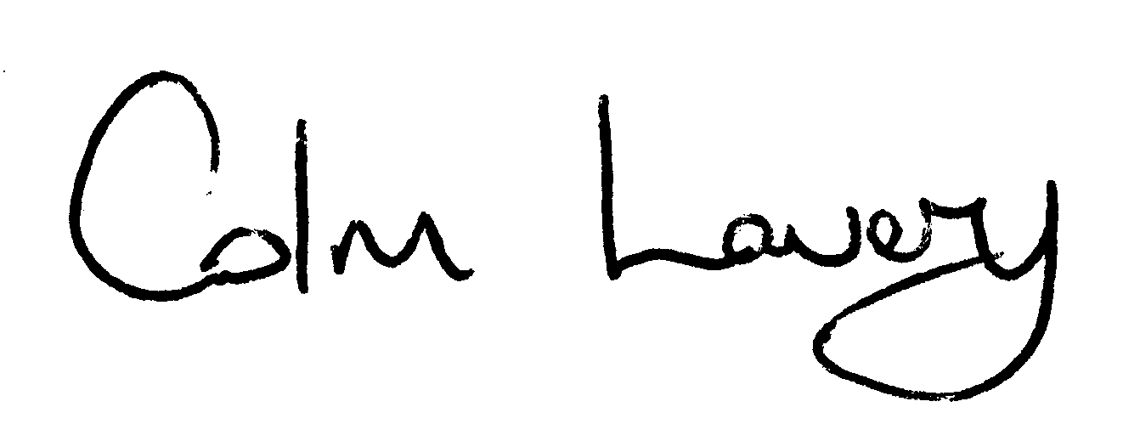
_____________________
Colm Lavery
Principal
Local Government Finance

