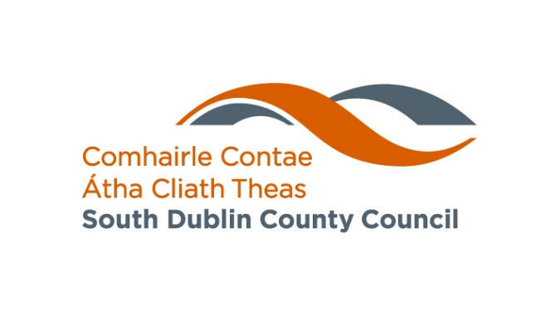

Fresh Start Principle

A ‘Fresh Start’ principle applies for applications to State affordable housing schemes. This means that the following categories of persons may be eligible to apply for an affordable home:

- Applicant(s) that previously purchased or built a residential property but is divorced and has left the property and divested themselves of their interest in the property may be eligible to apply.

Examples of documentary evidence will be:
• separation agreement
• court order
• affidavit from a Solicitor confirming the separation or divorce.

- Applicant(s) that previously purchased or built a residential property but has been divested of this through insolvency or bankruptcy proceedings, may be eligible to apply.

Examples of documentary evidence will be:
• Solicitors Letter confirming the applicant has exited insolvency or bankruptcy and that any previously purchased home has been sold or they have fully divested of that home as result of such process.

- Applicant(s) that previously owned, was beneficially entitled to, or have an interest in a dwelling in the state and that this dwelling, because of its size, is not suited to the current accommodation needs of the applicant’s household i.e., house overcrowded, may be eligible to apply.

