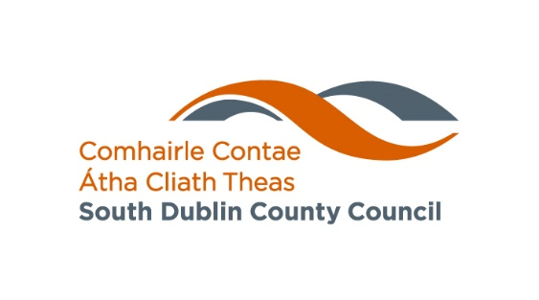

Affordable Housing Purchase Scheme – Glossary of Terms

Affordable Dwelling Contribution
This is the amount paid by South Dublin County Council towards your purchase of an affordable dwelling. This refers to the monetary amount paid, whereas the equity share refers to this amount as a percentage of the Market Value.

Affordable Dwelling Purchase Arrangement (ADPA)
This is the legal contract you will enter into with South Dublin County Council if your application is successful and you are approved to purchase an affordable dwelling. This sets out, among other legal arrangements, the details of the Affordable Dwelling Contribution made by the Council, a valuation mechanism, and procedures for making redemption payments.

Affordable Purchase Price
This is the price you will pay after South Dublin County Council’s Affordable Dwelling Contribution is subtracted from the Market Value. This will be calculated using your income, savings and the terms and conditions of the Affordable Housing Scheme you are applying for.

Scheme of Priority
In cases where the number of applications exceeds the number of available dwellings, the Scheme of Priority outlines the rules South Dublin County Council uses to decide which applicants will be offered dwellings. This may include factors such as household size, residency in the local authority’s area, or an allocation based on the order the applications are received.

Approval in Principle
An Approval in Principle takes the form of a letter from a lender indicating the amount you are eligible to borrow for a mortgage.

Equity Share
This is the percentage of the market value that South Dublin County Council will contribute to the purchase of an affordable dwelling. This will be at least 5% of the market value. This entitles the Council to the same percentage in value of a future sale of the property subject to terms and conditions. It does not establish the Council as a co-owner of the property.

First Time Buyer
A First Time Buyer is someone who has never previously purchased or built a dwelling in the state for their occupation or owns or is entitled to a stake in a dwelling.

Fresh Start Principle
The Fresh Start Principle enables you to apply for an affordable dwelling if you previously owned a home but no longer do. This applies if you have sold or been divested of your interest in a home through insolvency or bankruptcy proceedings, or as part of separation or divorce arrangements.
Local Authority Home Loan
The Local Authority Home Loan is a mortgage offered by a local authority. If you have been unable to get a mortgage from a bank you may be able to use a Local Authority Home Loan (LAHL) to purchase your property, subject to the terms and conditions of the LAHL.

Redemption Payments
These are payments made to South Dublin County Council to reduce their Equity Share and increase your ownership share. These can be made at any time subject to a minimum amount of €10,000 and to the Long-Stop Date.

Long-Stop Date
This is the date after which South Dublin County Council may request full repayment of its Equity Share in the property if it has not previously been paid down through redemption payments. It is set at 40 years after the date of purchase.

Market Value
This is the price that the affordable dwelling might reasonably be expected to be sold for on the open market. The market value will be initially set by South Dublin County Council. This will be equal to the affordable purchase price that you pay, plus the affordable dwelling contribution made by the Council.

Realisation Notice/Realisation Event
There are certain conditions under which South Dublin County Council will request that their equity share in the property be redeemed. This is called a Realisation Event and you will be notified as such by a Realisation Notice. The most typical case is when a property is sold and a percentage of the sale price equivalent to the percentage equity share must be paid to the Council. Other circumstances when this may occur include but are not limited to bankruptcy, the property being subject to a Compulsory Purchase Order, or abandonment of the property, or in the event of the death of the homeowner(s)

Valuation Mechanism
The market value of your home may vary over time, and the valuation mechanism is the process that will be used to reassess the market value of your home. This will be outlined in your Affordable Dwelling Purchase Arrangement.

