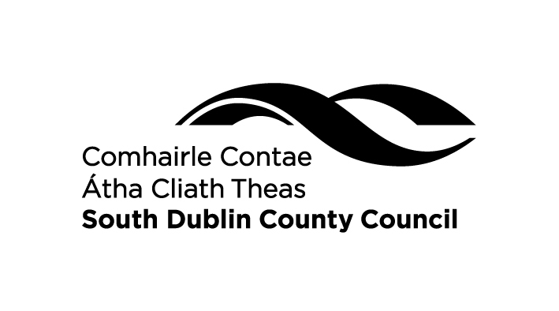
Application Form
Anti Litter & Anti Graffiti Awareness Initiatives Grant 2021

About the Fund
Anti-Litter and Anti-Graffiti-Awareness Initiatives should seek to promote public awareness and education in relation to litter and/or graffiti. This Grant Scheme has a particular focus on voluntary initiatives by community and environmental groups, and on involving schools and young people in anti-litter and anti- graffiti action.

ONLY APPLICATIONS WITH EDUCATION & AWARENESS DIMENSIONS WILL BE CONSIDERED FOR FUNDING.

Typically Suitable Projects
  - Adopt a road, adopt a bring bank, community clean ups or similar initiatives, (e.g. adopt a section of road, designated bring banks or housing estates kept litter free by local community groups, South Dublin County Council will provide bags and collect waste following a clean up).
  - Plays, puppet shows, interactive workshops, story telling, talks, art projects mainly aimed at schools (e.g. Rubbish Pirates with Waterford Youth Arts, Environmental Story Teller, ‘The Story of the Rubbish Monster’ – play and puppet show).
3. Anti litter and anti graffiti awareness competitions - design a poster competition.

Project Title: _______________________________________________________
Group/Organisation: ________________________________________________
Target Audience: ___________________________________________________
Target Location: ____________________________________________________
Project Duration: ____________________________________________________
Project Description (Please submit additional information on a separate page if necessary)
________________________________________________________________________________________________________________________________________________________________________________________________________________________________________________________________________________________
_____________________________________________________________________________________________________________________________________________________________________________________________________________________
How would this project benefit your local community?
__________________________________________________________________________________________________________________________________________________________________________________________________________________________________________________________________________________________________________________________________________________________________________________________________________________________________________
What are the expected outcomes of the project?
____________________________________________________________________________________________________________________________________________________________________________________________________________________________________________________________________________________________________________________________________________________________

Funding Required
COSTS | AMOUNT

TOTAL

Note: Expenditure on Capital items will not be provided
e.g. signage, bins, etc see conditions below.
SOURCES OF FUNDING | AMOUNT
Funding From Anti Litter Awareness Grant
Applicant Contribution
Other Sources if any e.g. Business sponsorship

Applicant Details
Name: __________________________________________________________
Address: __________________________________________________________
Phone Number: _____________________________________
Email Address: __________________________________
Signed ____________________________________
Date ______________________________________

RETURN COMPLETED APPLICATIONS TO:
Environmental Awareness Section, Environmental Services, South Dublin County Council, County Hall, Town Centre, Tallaght, Dublin 24 or by email envawareness@sdublincoco.ie by 5pm on Fri 10th Sept 2021. Phone 01 4149000 www.sdcc.ie
Conditions of Funding
- Projects/activities should seek to promote greater public awareness and education in relation to litter and/or graffiti, and should, as far as possible, have a particular focus on involving schools and young people and on voluntary initiatives by community and environmental groups.
- Grants should be used, where possible, to leverage local business co-funding of anti-litter and/or anti-graffiti education/awareness measures.
- Grant aid for expenditure on capital items will not be provided, e.g. Signage, Bins, Machinery Hire, Lawnmowers, Shovels, Litter Pickers, Bags, Gloves etc.
- Projects in receipt of monies under the Local Agenda 21 Environment Partnership Fund are excluded for grant purposes.
- If this application for funding is successful, the applicant will be required to submit a brief Completion Report to the Local Authority on the achievements of the project .
- Funding must be used for the project submitted and cannot be transferred to another project.
If any applicant is found to have contravened one or more of the above stipulations; that person, group or organisation, must refund the grant and may lose all current and future rights to apply for funding under the scheme.

