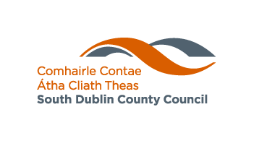
Environment, Water & Climate Change Department

ANTI-LITTER AND ANTI-GRAFFITI AWARENESS GRANT SCHEME 2024
South Dublin County Council is now accepting applications for funding of projects which qualify as Anti-Litter and Anti-Graffiti Awareness Initiatives. Applications should seek to promote public awareness and education in relation to litter and/or graffiti.

This Grant Scheme has a particular focus on voluntary initiatives by community and environmental groups, and on involving schools and young people in anti-litter and anti-graffiti awareness actions.

ONLY APPLICATIONS WITH EDUCATION & AWARENESS DIMENSIONS WILL BE CONSIDERED FOR FUNDING.

How to Apply
Further information and an application form can be obtained online at www.sdcc.ie or from the Environmental Awareness Section, South Dublin County Council, County Hall, Town Centre, Tallaght, Dublin 24.
Phone 01 4149000, email: envawareness@sdublincoco.ie

Applications must be made to South Dublin County Council no later than5pm Friday 7th June 2024.

Late applications will not be accepted.
Web: www.sdcc.ie

