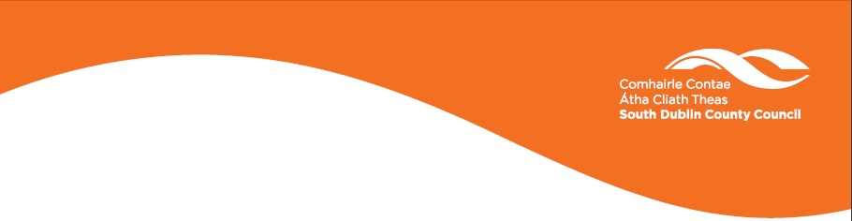

SOUTH DUBLIN COUNTY ENVIRONMENTAL POSTER COMPETITION 2021

Design an Anti-Litter or Anti-Dog Fouling Poster & Slogan for South Dublin County

Three posters will be chosen and professionally printed and distributed to the winning schools in the County.
There are 3 categories
Ages 4 – 8
Ages 9 – 12
Ages 13-18

Posters should be A3 size and the slogan on the poster must be in English and Irish.

All Entries must be accompanied by the following details:

School/ Club Name ……………………………………………………………….

School/ Club Address ………………………………………………………........

Class/ Group Name ……………………………………………………………….

Teacher/ Leader Name ……………………………………………………………

Contact Number …………………………………………………………………

Contact Email Address …………………………………………………………

Childs Name …………………………………………………………………

Closing date for entries is 2pm Friday 5th February 2021.
All entries must be sent in picture format ONLY with the application form to:
envawareness@sdublincoco.ie

Entry forms can be downloaded on www.sdcc.ie .

Background Information
This competition encourages children of all ages to take a stand on issues that may affect their local area and to express themselves artistically.
Let’s get the message out there – Keep South Dublin County Clean.
www.sdcc.ie - Printed on recycled paper

