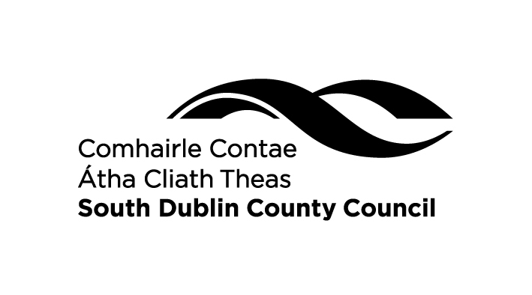
CHRISTMAS DECORATION COMPETITION 2019
Official Entry Form
Reuse household recyclables to make Christmas Decorations...
egg boxes, old CD’s, yogurt tubs, cereal boxes, lollipop sticks, broken toys, old socks, & your imagination!
Win some great prizes and treats!

Closing date for receipt of entries is
Friday 6th December 2019 by 5 pm.

Please complete the application form

Name ___________________________________________________

Age (please tick) Under 9 Over 9

Address ___________________________________________________

___________________________________________________

Telephone Number ___________________________________________________

Name of Decoration ___________________________________________________
(Not Necessary)

Detailed description of decoration, including all the materials used

Mark your name, age category and school somewhere on the decoration if possible. Submit your Decoration along with this official entry form to Environment Awareness Section, Environment Services, South Dublin County Council, County Hall, Tallaght, Dublin 24. Telephone (01) 4149000.

Any entries not collected by 3rd January 2019 will be recycled.

