South Dublin County
Joint Policing Committee
Annual Report 2017

Agreed by South Dublin County Joint Policing Committee on 25th May 2018

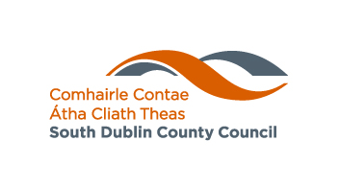

Contents
No. | Item | Page
1 | Introduction | 3
2 | Structure | 4
3 | Strategic Plan | 6
4 | Demographics | 10
5 | Advice/Recommendations | 13
6 | Local Policing Fora and Public Meetings | 16
7 | Attendance Record | 19

South Dublin County Joint Policing Committee
Annual Report 2017

1. Introduction

The South Dublin County Joint Policing Committee was established on the 26th October 2007. The Committee continues to provide a forum for representatives from An Garda Síochána, South Dublin County Council, Oireachtas members and Community representatives, to make an important contribution to addressing issues relating to crime locally, to get together in a regular and structured way, to consult with each other and to discuss and make recommendations on matters affecting the policing of South Dublin County.

The JPC is a partnership, co-operative in nature and operating with the minimum of formality to identify, raise awareness of and find solutions to issues impacting on, or causing concerns for the local community.

South Dublin Joint Policing Committee continues to be a partnership between an Garda Síochána, South Dublin County Council and the residents of South Dublin County. Members of the Joint Policing Committee work together to help prevent crime and solve neighbourhood problems by:
- Encouraging active citizen involvement in policing efforts.
- Focusing on issues of ongoing public concern.
- Providing continuity of service to the community
- Ensuring active involvement by the relevant staff in problem-solving
- Initiate creative responses to neighbourhood problems.
- Developing the capacity of residents and affording them the opportunity to speak and act effectively on their own behalf
- Strengthening and building groups and organizations so residents can advocate for their own interests.
- The work of the LPF Management Committees and LPF Public Meetings convened by the four Local Policing Fora and their role and reporting relationship to the JPC increases community involvement and trust in the work of the committee.
2. Structure

2.1 Membership of the JPC
In 2015 the Public Participation Network (PPN), Drug & Alcohol Task Forces and the Garda Diversion Programme were asked to nominate representatives to the JPC. The following diagram illustrates the current membership of the JPC.

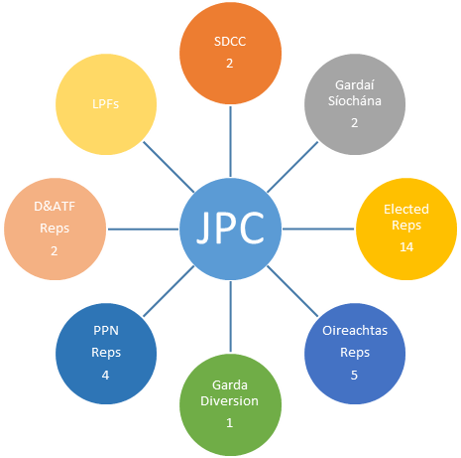

2.2 Garda Síochána Districts
South Dublin County JPC is covered by two Garda Regions:
- Dublin Metropolitan Region South
- Dublin Metropolitan Region West

The Regions are split into Districts and Sub Districts:

Sub District | District | Superintendent | Divisional HQ | Chief Superintendent
Clondalkin | Clondalkin | Brendan Connolly | Blanchardstown | Lorraine Wheatley
Rathcoole | Clondalkin | Brendan Connolly | Blanchardstown | Lorraine Wheatley
Ballyfermot | Clondalkin | Brendan Connolly | Blanchardstown | Lorraine Wheatley
Ronanstown | Lucan | John Gordon | Blanchardstown | Lorraine Wheatley
Lucan | Lucan | John Gordon | Blanchardstown | Lorraine Wheatley
Rathfarnham | Tallaght | Ian Lackey | Crumlin | Kevin Gralton
Tallaght | Tallaght | Ian Lackey | Crumlin | Kevin Gralton
Crumlin | Crumlin | Michael Cryan | Crumlin | Kevin Gralton
Terenure | Terenure | Pat Conlon | Crumlin | Kevin Gralton

The following map sets out the five Garda Districts that cover South Dublin County, note some Districts cut across the County boundary.

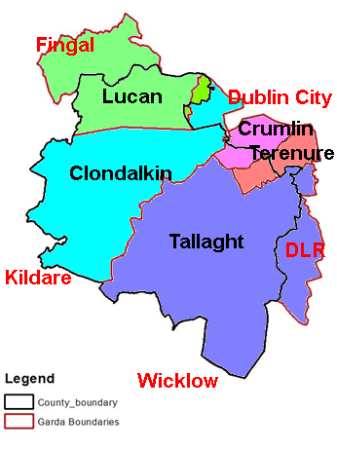

2.2.1 Garda Síochána Sub-districts

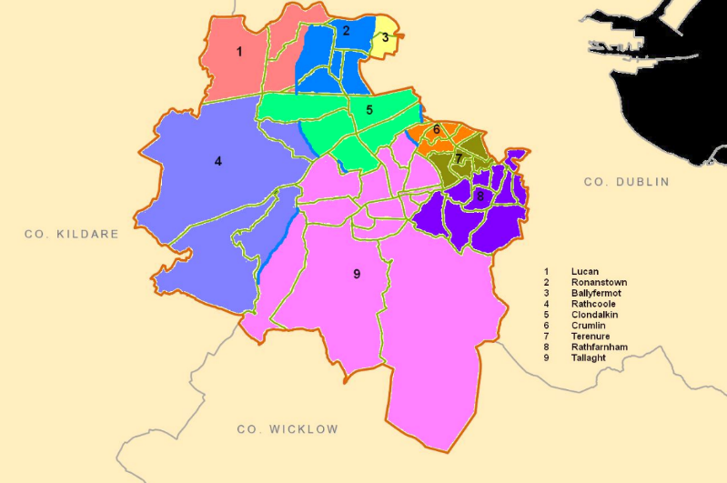

3 Strategic Plan

3.1 In 2017 at the JPC meeting held on the 24th November 2017 the Strategic Plan for 2016-2022 was agreed.

3.2 The Plan links to other plans and strategies by:

3.2.1 The Links to the following plans have been considered
- An Garda Síochána Annual Policing Plan
- South Dublin County Local Economic & Community Plan (LECP) 2016-2021
3.2.2 Other Plans considered were:
- A Safer Community: South Dublin County Council Road Safety Plan 2016-2020 (published August 2016 yet to be considered by the JPC)
- Clondalkin Drug and Alcohol Task Force Plan
- Tallaght Drug and Alcohol Task Force Plan
3.2.3 It should be noted that the current National Drugs Strategy comes to an end in December 2016 and work is underway to develop a New National Drugs Strategy for the period from 2017 onwards. Clondalkin Drugs and Alcohol Task Force are in the process of preparing a tender brief for the development of a new three year Local Drugs Strategy and a Local Alcohol Strategy 2017 – 2020 which will be finalised in 2017.

3.2.4 A “Framework Policy for Local and Community Development in Ireland was approved by Government in December 2015 and is an overarching high level vision for the State’s engagement with the local and community development sectors. JPCs are identified within the following objectives as having a role:
- Objective 2: Working with partners:
  - pursue an integrated “whole government” approach at central and local levels
- Objective 3: Planning for Local and Community Development:
  - Support an integrated, coherent approach through the County Local Economic and Community Plan that is adaptable to changing needs and which clearly identify the outcomes they aim to achieve
  - Ensure priorities, as set out in the relevant Local Economic and Community Plan for expenditure at local level across all community and local development programmes are based on appropriate needs analysis and matched to available resources
- Objective 4 :Delivery
  - Through the County Local Economic and Community Plan. Deliver an integrated approach to economic development and community development at local level within the local authority area
  - Through the County Local Economic and Community Plan, manage the delivery of interventions that provide positive action programmes targeting those groups that are most marginalised, and support them to become involved in issues and concerns affecting themselves and their communities

3.2.5 A Memorandum of Understanding between the JPC and the Local Community Development Committee was drafted in 2017 to be agreed at the first JPC meeting in 2018.

3.3 The JPC Six Year Strategic Plan is as follows:

JPC Six Year Strategic Plan Strategic Objectives | Summary of strategy to be pursued in relation to each objective | Lead /agency key partners/ Name of JPC subcommittee where relevant | Anticipated outcomes
High Priority Objectives
Drugs | Develop through the Drug subcommittee | Drug subcommittee | Ongoing
Parks | Deter crime and anti- social behaviour in public parks | - JPC  - SDCC  - Gardaí | Ongoing
LPFs | Support the work of the local policing fora in the County | - SDCC  - Gardaí  - JPC  - LPFs | Ongoing
Strategic Objectives | Summary of strategy to be pursued | Lead /agency key partners | Anticipated outcomes
CCTV | Community Based CCTV: To support the following Community CCTV schemes:  - Jobstown  - Fettercairn  - Brookfield  - Killinarden  - North Clondalkin | - Gardaí  - SDCC | Ongoing
Community Safety:  To promote positive crime prevention and community safety initiatives | Information: To develop and produce information on community safety initiatives/projects through the media and the JPC web page of South Dublin County Council web site | - JPC Executive (Supported by SDCC) | Ongoing
 | Events: To plan for events attracting large crowds and ensure they are a safe and enjoyable experience. To build on the good working relationship between the Gardaí, South Dublin County Council, the Community and other stakeholders co-ordinating events | - SDCC  - Gardaí  - Public Transport providers  - Local Communities  - Local Businesses | Ongoing
 | Road safety: To consider elements within the SDCC Road Safety Plan 2016-2020 | - SDCC  - Gardaí
 | Older People: Support South Dublin County as an Age Friendly County which is a safe place for older people and continue to work on any safety issues identified by the Age Friendly Alliance. To work with the Network and any other partners on the proposed Text Alert Scheme | - SDCC  - Gardaí  - Age Friendly Network | Ongoing
Consultation & Involvement:  To improve the process of engagement and interaction between local community reps. An Garda Síochána, Elected Representatives, South Dublin County Council, Local Drug & Alcohol Task Forces on matters concerning community safety. | Local Policing Forums: Support the work of the local policing fora in the County by:  - Each local policing forums will report to each JPC meeting  - Consider recommendations of the Local Policing Forums  - Support for public and other meetings organised by the Local Policing Forums | - SDCC  - Gardaí  - JPC  - LPFs | Ongoing
 | Young People: Continue consultation with young people through Comhairle na nÓg and other services. Support the Comhairle na nÓg charter to prevent Cyber Bullying | - Comhairle na Nog  - Gardaí  - JPC  - SDCC | Ongoing
Crime:  To support actions that address crime and the fear of crime | Parks: Deter crime and anti- social behaviour in public parks (See Appendix 4) through the implementation of the recommendations included in “Reclaiming our Parks.” Reports to be prepared for each JPC meeting | - JPC  - SDCC  - Gardaí | Ongoing
 | Drugs: Support the work of the Drug Sub-committee of the JPC (See Appendix 3) to agree its Terms of Reference and Action Plan and if appropriate support any recommendations identified | - JPC Drug Sub-committee  - JPC  - Gardaí  - SDCC  - Local Drug & Alcohol Task Forces | December 2017
Integration | Integration Strategy: Support the implementation of the South Dublin County Integration Strategy and work on any actions identified that can improve the quality of life and safety of residents in the County | - SDCC  - Gardaí  - Community | Begin middle 2014
Pro-social initiatives:  To provide continued support for Pro-social initiatives in the County and to support inter agency projects | To develop a close liaison between the JPC, its members and inter agency projects in the County, To support pro-social projects by improved coordination between Gardaí, SDCC and Community Representatives | - JPC  - Children & Young People’s Services Committee (CYPSC),  - Childhood Development Initiative (CDI) Safety Initiative,  - Local Partnerships  - Community/Voluntary Sector  - Local Drug & Alcohol Task Forces  - FAI (Football night leagues) | Ongoing
Restorative Justice: | Support the recommendations contained in the National Commission on Restorative Justice by strengthening relations with the Restorative Justice Service in Tallaght and continue to promote restorative practice in the Community. Consider services which will look at tackling anti-social behaviour using restorative practices. Continue to support the work of Restorative Practice promoters where necessary | - Gardaí  - SDCC  - Restorative Justice and Practice Programmes  - Community Mediation  - Community Groups  - CDI | Ongoing

4 Demographics

4.1 Population (2016 Census)

4.1.1 The 2016 Census statistics for population have been released.
The population of the state has risen from 4,588,252 in 2011 to 4,757976 in 2016 an increase of 169,724 and a 3.7% increase and the population of South Dublin County has risen from 265,205 in 2011 to 278,749 in 2016 an increase of 13,544 and a 5.1% increase

4.1.2 The following table gives an estimate of the change in population relating to Garda sub districts (Note some of the EDs are divided between two sub districts)

Garda Sub District | Pop 2011 | Pop 2016 | Males 2016 | Females 2016 | Change 2011-16 | % Change 2011-16
State | 4,588,252 | 4,757,976 | 2,352,240 | 2,405,736 | 169,724 | 3.7
Leinster | 2,504,814 | 2,630,720 | 1295533 | 1,335,187 | 125,906 | 5
Ballyfermot | 11,216 | 11,130 | 5,377 | 5,753 | -86 | -1
Clondalkin | 33,882 | 35,556 | 17,526 | 18,030 | 1,674 | 5
Crumlin | 11,089 | 11,197 | 5,338 | 5,859 | 108 | 1
Lucan | 44,487 | 47,800 | 23,628 | 24,172 | 3,313 | 7
Rathcoole | 11,549 | 13,891 | 6,970 | 6,921 | 2,342 | 20
Rathfarnham | 50,959 | 52,263 | 25,270 | 26,993 | 1,304 | 3
Ronanstown | 12,914 | 12,944 | 6,232 | 6,712 | 30 | 0
Tallaght | 75,206 | 80,022 | 39,150 | 40,872 | 4,816 | 6
Terenure | 13,903 | 13,946 | 6,784 | 7,162 | 43 | 0
South Dublin | 265,205 | 278,749 | 136,275 | 142,474 | 13,544 | 5.1%

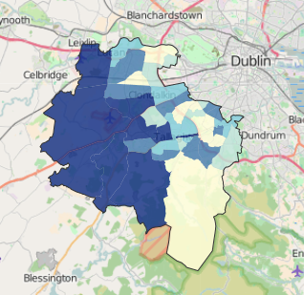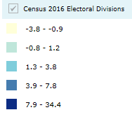

4.1.3 The greatest percentage population increase EDs are as follows:
ED | Garda Sub District | Percentage Population Change (2011-2016)
027 Saggart | Rathcoole/Tallaght | 34
039 Tallaght-Springfield | Tallaght | 21
001 Ballinascorney | Tallaght | 16
021 Rathcoole | Rathcoole | 16
018 Newcastle | Rathcoole | 14
017 Lucan-St. Helen's | Lucan | 10
030 Tallaght-Fettercairn | Tallaght | 9
010 Clondalkin Village | Clondalkin | 8
015 Lucan-Esker | Lucan/Ronanstown | 8

4.1.4 The greatest percentage population decrease EDs are as follows:
ED | Garda Sub District | Percentage Population Change (2011-2016)
044 Templeogue-Orwell | Terenure | -4
034 Tallaght-Kilnamanagh | Tallaght/Crumlin | -3
041 Templeogue-Cypress | Terenure | -3
045 Templeogue-Osprey | Terenure | -3
002 Ballyboden | Rathfarnham | -2
005 Clondalkin-Cappaghmore | Ronanstown | -2
013 Firhouse-Knocklyon | Rathfarnham | -2
049 Terenure-St. James | Crumlin | -2
003 Bohernabreena | Tallaght | -1
020 Palmerston West | Ballyfermot/Ronanstown | -1

4.2 Deprivation (2011 Census)

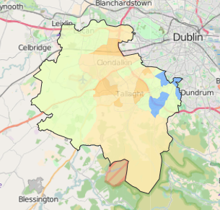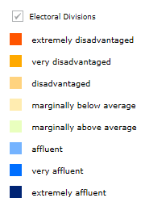

4.2.1 The disadvantaged EDs are as follows:

ED | Garda Sub District | Relative Deprivation Score (2011)
033 Tallaght-Killinardan | Tallaght | -19
009 Clondalkin-Rowlagh | Ronanstown | -17
028 Tallaght-Avonbeg, | Tallaght | -17
005 Clondalkin-Cappaghmore | Ronanstown | -15
030 Tallaght-Fettercairn | Tallaght | -14
049 Terenure-St. James | Crumlin | -13
008 Clondalkin-Moorfield | Ronanstown | -11
037 Tallaght-Millbrook | Tallaght | -11
040 Tallaght-Tymon | Tallaght | -11

4.2.2 The affluent EDs are as follows:

ED | Garda Sub District | Relative Deprivation Score (2011)
024 Rathfarnham-Hermitage | Rathfarnham | 15
026 Rathfarnham Village | Rathfarnham | 14
042 Templeogue-Kimmage Manor | Terenure | 14
012 Firhouse-Ballycullen | Rathfarnham | 13
046 Templeogue Village | Terenure | 12
002 Ballyboden | Rathfarnham | 11

5 Advice/Recommendations

5.1 The JPC has discussed many different issues at their meetings and in 2017 these included:

January | May
- Purple Flag initiative  - Joy riding  - Community Gardaí  - Neighbourhood watch  - Horses  - Scramblers  - JPCs & local authorities; consequences of recreational drug use  - Road Safety | - Scramblers  - Neighbourhood Watch  - SDCC Home Security Scheme  - Annual Report 2016  - Community Based CCTV Scheme  - Code of Ethics for Garda Síochána  - New Local Policing Forums  - South Dublin County Community Safety Booklet 2017
September | November
- JPC Strategic Plan 2016-22  - Halloween  - Drug subcommittee  - Future Local Policing Forums | - Criminal Assets Bureau  - Domestic Violence  - Seniors alert scheme  - Rathcoole Garda Subdistrict staffing  - JPC Strategic Plan 2016-22  - CCTV  - Halloween

In South Dublin County, the Gardaí and the Local Authority have a good working relationship. Contact is made both at Senior Level, through the JPC and other inter-agency committees and also at operational level with the Community and Housing Departments and the Community and Juvenile Liaison Sections of the Gardaí. Crime Prevention and Traffic problems/blackspots were examples of issues discussed at JPC meetings.

5.2 Drugs

5.2.1 Following repeated reports from members of the JPC and recommendations from the South Dublin County Community Platform and more recently the Public Participation Network, the JPC set up a Drug Intimidation Subcommittee to consider this topic. Both the Gardaí and Local Authority officials are very involved together with members of the Drug & Alcohol Task Forces. Two Seminars on the issue were held; in 2011 (Community Platform) and 2012 (JPC), there was a poster campaign started in 2013 that continued into 2014. In 2016 a further Seminar to review progress on the issue was held. At this seminar a number of suggestions were made including:
- The need for “mini CABs” to address the wealth generated by drug suppliers
- That the impact of poverty and unemployment within disadvantaged and Traveller communities is linked to the problem of drug misuse and then drug related intimidation
- That the impact of intimidation on people’s mental health be recognised and that GPs have a role to play here
- That there is a need to address the “normalisation” of drugs where recreational drug use has a huge impact on communities
- That mothers/women are often the victims of intimidation and that drug related intimidation has similarities to the impact of domestic violence

5.2.1 Following the seminar in May 2016 at the JPC meeting held on the 25th November 2016 it was agreed to form a Drug Subcommittee which comprises the following and met a number of times in 2017:

Name |  | 20  01  17 | 10  03  17 | 05  05  17 | 06  06  17 | 23  06  17 | 22  08  17 | 24  10  17 | 14  11  17
Cllr Paul Gogarty | Councillor | P | P | P | P | P | P | P | P
Cllr Cathal King | Councillor
Cllr Liona O’Toole | Councillor | P | A | P | A | A | A | A | A
Gemma Carton | Garda Diversion | P | P | P | P | P | A | P | A
Ann Corrigan | PPN | P | P | P | P | P | P | P | A
Tara Deacy | PPN | P | P | P | P | P | P | P | P
Noreen Byrne | North Clondalkin LPF | P | P | P | A | A | A | P | A
Grace Hill | Tallaght D&ATF | D | P | P | P | P | P | D | A
Vacant | Clondalkin D&ATF
Insp. Lennie Brennan | Clondalkin Garda | P | P |  | D |  | P | A | P
Insp. Ray Blake | Tallaght Garda | D | A |  |  |  |  |  | P
In attendance
Andy Lane | SDCC | P | P | P | P | P | P | P | P
Noel Fitzgerald | Facilitator | - | - | P | P | P | - | - | -
Brian Roberts | Garda Síochána | - | - | - | - | - | - | - | P

5.3 Age Friendly County
There are currently a wide range of projects and initiatives in place which help to improve community safety and reduce levels of fear. These have included attendance by Gardaí at post offices on Friday and visibility at places of worship and community meetings. The Gardaí are also committed to raising awareness with young people of the impacts of antisocial behaviour on older neighbours. Crime Prevention Officers from an Garda Síochána continue to meet regularly with older persons groups throughout the County. The JPC supported the initiative to have a Home Security Lock Scheme which fitted over 500 locks for older people in 2016 which was repeated in 2017.

5.4 Integration Strategy
An integration strategy was prepared for South Dublin County. The JPC continues to support the implementation of the community safety actions contained in the strategy.

5.5 Safety in Parks
The Joint Policing Committee set up a Parks Working Group in November 2009 to look at safety in public parks. This group provided a comprehensive report to the Joint Policing Committee which listed 52 recommendations. Following consideration of the report, the JPC set up a small working group to monitor progress on the implementation of the recommendations; this involves both the Gardaí and the Local Authority. In 2016 the JPC agreed that the work of this group should now be considered by the JPC and the Parks Working Group has now finished its work.

5.6 CCTV
The Joint Policing Committee considers that CCTV is an important tool in combating crime and anti-social behaviour. The Community CCTV schemes in Tallaght and Clondalkin are now monitored 24/7 in Tallaght and Ronanstown Garda Stations. Both the County Council and the Gardaí are working closely together to ensure that the CCTV schemes in this County are successful in terms of safety, prevention and intervention. In 2017 the Community Based CCTV initiative was relaunched with funding of €40,000 and this was considered by the JPC to be insufficient to support the installation and maintenance of CCTV schemes. Options for CCTV schemes have been brought to the JPC by individual Management Companies seeking support.

5.7 Halloween 2017
An interagency approach which included the Council, Gardaí, Fire Brigade and Dublin Bus continued to promote a Safe Halloween through radio, school visits, and the early collection of bonfire material and co-operation from local communities.

5.8 Late Night Leagues
The late night leagues continue to be successful throughout the County with new venues and age groups added in 2014. The initiative is based around the concept of using football as a tool for social inclusion and learning, divert youths from Crime and anti-social behaviour and encouraging at risk young people to participate in meaningful activities, thus reducing anti-social behaviour

6 Local Policing Fora and Public Meetings

6.1 South Dublin County Joint Policing Committee set up three Local Policing Fora which are located in Tallaght, Clondalkin and North Clondalkin. In addition South Dublin County covers part of the D12 Local Policing Forum. Public meetings are organised by the Local Policing Fora and supported by the Joint Policing Committee. Each Local Policing Fora is made up of representatives of the Local Authority, Garda Síochána, Elected Representatives, Local Drugs Task Force and local residents. The relevant Superintendents/Chief Superintendents with Inspectors and Community Garda attend these meetings together with senior managers from the Housing and Community Department of Dublin County Council. This commitment by the most senior Gardaí and Local Authority officials has been recognised by the Local Policing Fora members and the local community. This also allows the most senior staff in both organisations to hear the difficulties, fears and concerns first hand from residents. The Local Policing Fora also allow for input and discussion with other local safety initiatives such as the Dublin Bus/LUAS Fora.

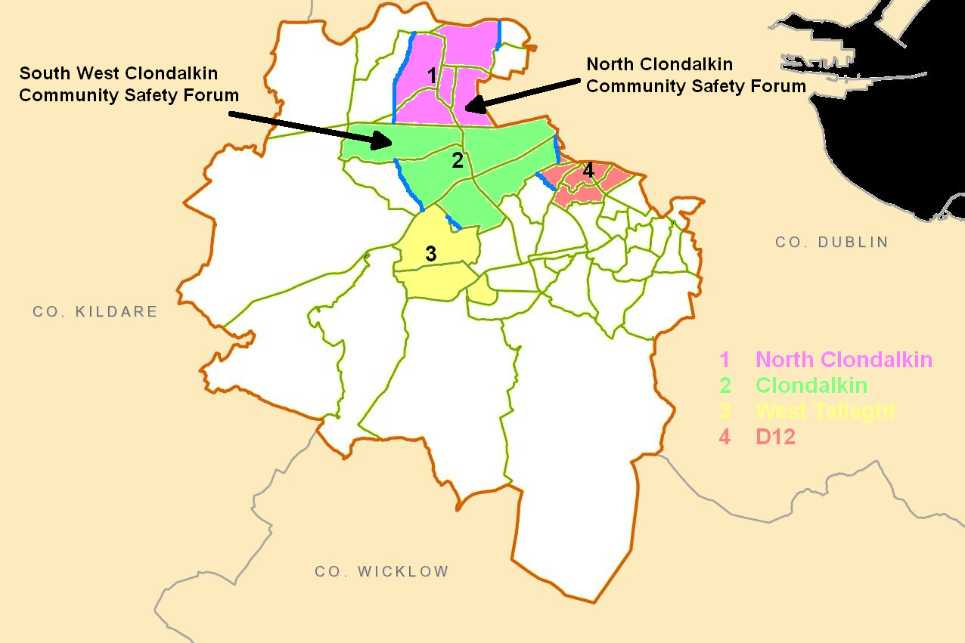

LPF Management Committees met regularly throughout 2017 and public meetings were held in all areas. Reports from the public and management meetings have been presented to all meetings of the JPC in 2017.

6.2 The following issues have been raised in 2017 at public meetings and again at Local Policing Fora management meetings in the four areas:

D12 | Tallaght
Dublin City Council Health & Safety Parks Committee  - Drug Debt intimidation  - Bicycle thieves  - Gangland activity  - Relationship between LPF and Drug & Alcohol Task Force  - Stolen bikes  - Text alerts see garda.ie website  - Rapid build housing  - The impact of gangland feuding  - Community policing  - Drug searches and drug trends  - Bike Crime and Prevention  - Crime statistics and trends  - D12 D&ATF presentation on alcohol  - Licensing of premises  - Anti-social behaviour  - Impact of gangland feud | - Burglaries  - Alcohol and drug use  - Housing sub-letting by Council tenants  - Litter / dumping  - Community Garda numbers in West Tallaght  - Gangs, intimidation and anti-social behaviour  - Estate Management Project workers  - Public Meeting
Clondalkin | North Clondalkin Lucan, Palmerstown
Home security pilot scheme  Neighbourhood Watch schemes  Burglaries  Public meeting on 18th February 2016  Drugs and criminal gangs  Reporting crime  Dublin Bus  St Cuthbert’s Park  - Trees and pruning schedule  - Ramps  - Critical response to incidents  - Anti-racism sticker Campaign  - Kingswood policing area  Business Watch  - Quality of Life Survey  - Community response initiative  - Racism and the need for hate crime legislation  - Scramblers  - Halloween  - Resurfacing to Monastery Road  - School Wardens  - Trees, hedges and undergrowth  - Newlands cross flyover | - Parking at schools and ASB specific to local School  - M50 grid lock  - Trimming of trees  - Bus shelter on Neilstown Road  - Laneway at Rowlagh shops  - Intimidation and begging at shops  - Parking in disabled bays at shops  - Quad Bikes & scramblers  - Burglaries  - Traffic, and traffic lights sequencing  - Bogus charity collectors  - Social media  - Community Safety Forum  - Drug dealing  - Offensive graffiti  - Cars being vandalised  - Houses being egged  - Traffic congestion  - Dumping of rubbish on public land and in local parks  - Pedestrian and vehicular access at Rossecourt  - CCTV – Netwatch  - Public Policing Meeting  - Halloween

6.3 LPF Relationship with the JPC

The Local Policing Fora provide a report to each meeting of the Joint Policing Committee and the agenda allows for consideration and discussion on the items raised.

The following chart shows the relationship between the LPFs and the JPC. Two areas South West Clondalkin and North Clondalkin have Community Safety Forums covering part of the LPF area. The Community Safety Forums have representatives on the LPF Management Committees to ensure a flow of information.

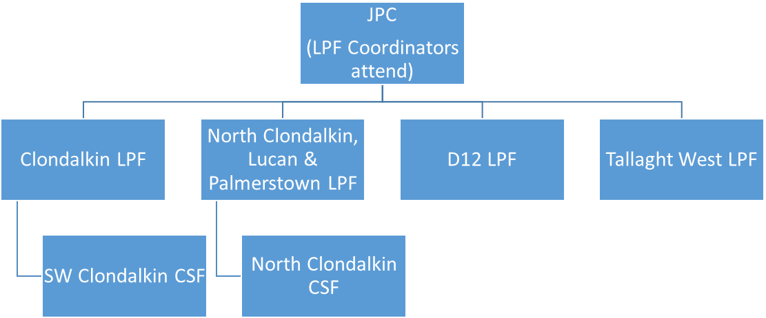

6.4 JPC & LPF Meetings 2017

 |  | Jan | Feb | Mar | Apr | May | Jun | Jul | Aug | Sep | Oct | Nov | Dec
JPC |  | 27 |  |  |  | 26 |  |  |  | 22 |  | 24
JPC Drug Sub Committee. |  | 20 |  | 10 |  | 05 | 06  23 |  | 22 |  | 24 | 14
Clondalkin LPF Man. Committee. |  |  | 16 |  |  | 25 |  |  |  | 14
Clondalkin LPF Public Meeting |  |  | 23 |  |  |  |  |  |  |  | 19
D12 LPF Man Committee. |  |  | 14 | 29 |  | 17 |  | 04 |  | 19 | 12 | 28
D12 LPF Public Meeting |  |  |  | 29 |  |  |  | 04 |  | 19 |  | 28
N Clondalkin LPF Man. Committee. |  | 26 |  | 09 |  | 11 | 08 | 13 |  | 14 | 12 |  | 07
N Clondalkin LPF Public Meeting |  |  |  |  |  |  |  |  |  |  |  | 09
W Tallaght LPF Man. Committee. |  | 17 | 28 |  | 11 |  |  |  |  | 19 | 17 |  | 05
W Tallaght LPF Public Meeting |  |  |  | 14 |  |  |  |  |  |  | 10
Total | Year 37 | 3 | 4 | 4 | 1 | 4 | 1 | 3 | 0 | 6 | 5 | 4 | 2

7 Attendance Record

The following chart sets out the attendance record for JPC meetings held in 2017

Name | 27  01  17 | 26  05  17 | 22  09  17 | 24  11  17
Cllr. Nicky Coules | P |  | - | -
Cllr. Paula Donovan | P | P | A | A
Cllr Mick Duff | - | - | - | P
Cllr. Louise Dunne | P | P | A
Cllr. Kenneth Egan | P |  | P
Cllr. Brendan Ferron |  | P | P
Cllr. Paul Foley | P | P | P
Cllr. Paul Gogarty (Mayor) | P | P | P | P
Cllr Emma Hendrick | - | - | - | P
Cllr Jonathan Graham |  |  | - | -
Cllr. Pamela Kearns | P | A |  | -
Cllr. Cathal King | P | P | P | P
Cllr. Brian Lawlor |  | - | - | -
Cllr. Kieran Mahon
Cllr. Ed. O’Brien | P |  | P | P
Cllr. Deirdre O’Donovan (Chair) | P | P | P | P
Cllr. Liona O’Toole | P | P | P | P
Cllr Mark Ward | - | - | P | P
Cllr. Guss O’Connell (Mayor) | P | P | - | -
Sean Crowe T.D. | P | P
John Curran T.D. | P | P | P | P
John Lahart T.D. | P | P | P
Billy Coman (SDCC) | P | D | P | P
Chief Superintendent Orla McPartlin | P | P | P | -
Chief Superintendent Kevin Gralton | - | - | - | P
Chief Superintendent Lorraine Wheatley | D | P | P | P
Ann Corrigan (PPN) | P | P | P | A
Tara Deasy (PPN) | P | P | P | P
Enda Creegan (PPN) | - | - | - | P
Jim Lawlor (PPN) | P |  | P | -
Michael Noonan (PPN) | P | P | P | P
Eamon Dolan (D&ATF) | A | P
Ray McGrath (D&ATF)
Gemma Carton (Garda Diversion) | P | P |  | P
Total | 23 | 19 | 18 | 16

P- Present
D- Deputy attended
- Apologies given
- Not or no longer a member of the JPC

