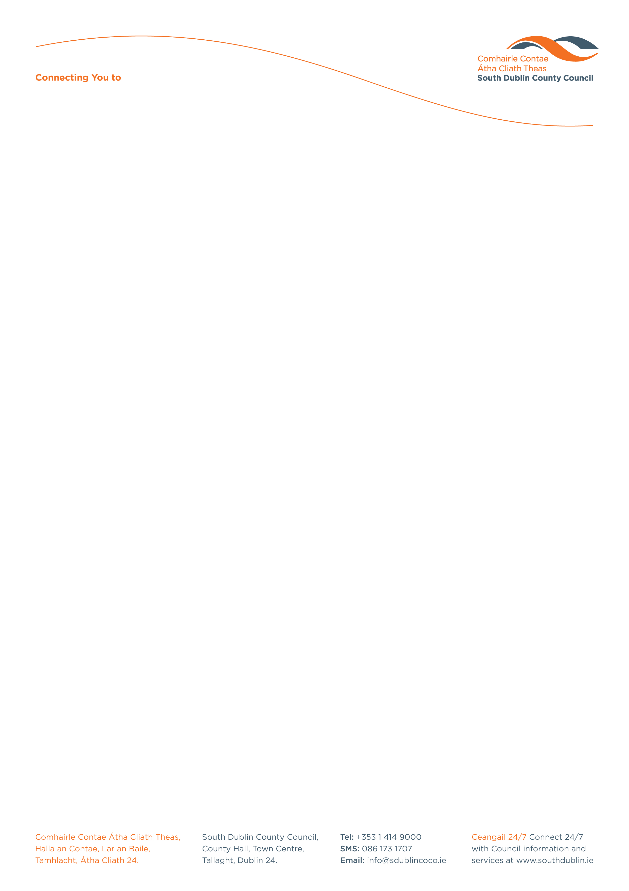

Information on Deputation meetings

- A Deputation meeting is an opportunity for a Residents Association / Community Group to directly discuss specific issues of local concern to them with both Council Officials and Elected Members.

- South Dublin County Council’s Housing, Social & Community Development department organises
Deputation Meetings for Residents’ Associations / Community Groups during the months listed below:

Meeting Date | Apply by
25th January 2023 | 28th December 2022
22nd February 2023 | 25th January 2023
22nd March 2023 | 22nd February 2023
26th April 2023 | 29th March 2023
24th May 2023 | 26th April 2023
27th September 2023 | 30th August 2023
25th October 2023 | 27th September 2023
22nd November 2023 | 25th October 2023

- Deputation meetings are hosted via Microsoft Teams.

- The Deputation group may consist of up to 5 persons.

- The duration of the Deputation meeting is no more than 45 minutes.

- Any group wishing to avail of a Deputation meeting will be required to register their groups
details with the PPN (Public Participation Network) @ www.sdcppn.ie

- The group should also complete an application form. The agenda should include specific items, issues and specific locations (maximum 100 words per item)

- Late application forms will not be accepted under any circumstances.

- Any group wishing to make a visual presentation must forward the completed presentation with their application.

- No Group can be received for Deputation within 6 months of their previous Deputation.

The completed application and registration forms can be forwarded by email to housingadmin@SDUBLINCOCO.ie

Alternatively, the forms may be forwarded by post to:

Housing, Social and Community Development (Admin office)
Housing Department,
South Dublin County Council,
County Hall, Tallaght,
Dublin 24

Housing, Social & Community Development
Phone: 01 4149 270
Fax: 01 4149 306

Agenda

The agenda may contain a maximum of 5 items and written notification of the subject matter should be received in the Housing, Social & Community Development department at least 28 days before the date of the Deputation meeting.

The following items are considered as not being appropriate to be discussed at Deputations meetings:

- Areas that have not been taken in charge by South Dublin County Council.
- Planning files – both where decision is due and decision is made.
- Planning Developments in progress.
- Planning Enforcement cases.
- Traffic issues where a decision has already been made and notified to Elected Members through Traffic Management Meeting.
- General issues of traffic congestion (local issues of concern around schools may be considered subject to verification from relevant department).
- Items relative to published Works Programmes.
- Part 8 applications under the Planning & Development Regulations 2001-2016.
- Sports Capital Grant Programme applications.
- Enforcement actions under the Environment, Water and Climate Change Department.
- Commercially sensitive information.

(It is helpful if the group submits some background information with regard to each of the Agenda items. Applications should include specific items, issues and locations. - maximum 100 words per item)

Minutes

It should be noted that Deputation reports are a summary of the main points and not a verbatim report of every individual’s contribution. The main purpose of the report is to record commitments made by Council Officials and any follow-on actions to be taken by the officials.

The agenda and reports of Deputation meetings are made available on South Dublin County Council’s website www.sdcc.ie and located under Community Services Department / Deputations.

Staff in the following of South Dublin County Council’s Housing, Social & Community Development department are available to advise Residents Associations / Community Groups on the procedure for seeking Deputation Meetings.

Contact details are as follows:

HSCD Department: housingadmin@SDUBLINCOCO.ie
Website: www.sdcc.ie

