

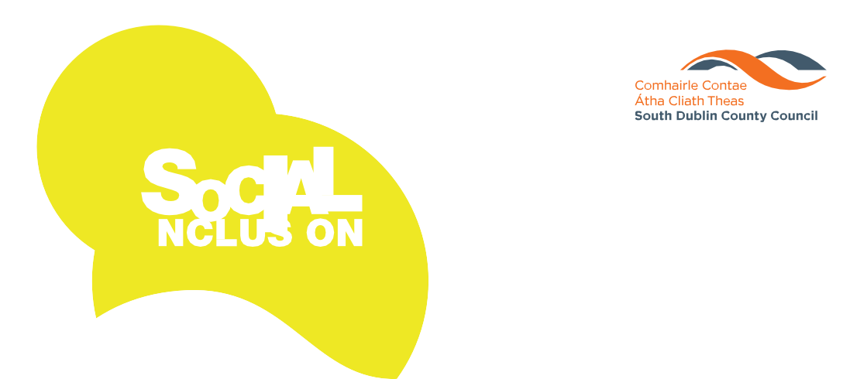

**Festival 2019**

**15 - 24**

**NOVEMBER**

Visit our website at [**www.sdcc.ie**](http://www.sdcc.ie/) **sdublincoco SouthDublinCountyCouncil**



*Act of Kindness*

**Individual and Group Entries are accepted in the following categories:**



*1*

# *Category*

**Draw a picture showing an act of kindness**

*Category 2*



**Write a short story or poem explaining a time you showed an act of kindness**

Please use this page for **Category 1** or **Category 2**





ENTRY FORM

## Name:

**Age on the 1st September 2019: Home Address:**

**Contact number for Guardian:**

**School:**

**Class Year:**

**Teachers Name, contact number & email:**

**This competition is open to all young people in Primary School.**

**Entries to be submitted to** The Social Inclusion Unit, Community Services Department, South Dublin County Council, County Hall, Tallaght, Dublin 24

**If further information is required please contact:**

Social Inclusion Unit

**Tel:** 01 414 9270

**Email:** [socialinclusionunit@sdublincoco.ie](mailto:socialinclusionunit@sdublincoco.ie)

Please tick box to confirm you have read and agreed with the Privacy Statement attached. If this box is not ticked we will not be able to accept your application.

### Latest Date for Completion of Entries is Thursday 31 October 2019

Visit our website at [**www.sdcc.ie**](http://www.sdcc.ie/) **sdublincoco**



### SouthDublinCountyCouncil