**Summer is Sizzling in South Dublin!**

**June 1st to 17th 2022**

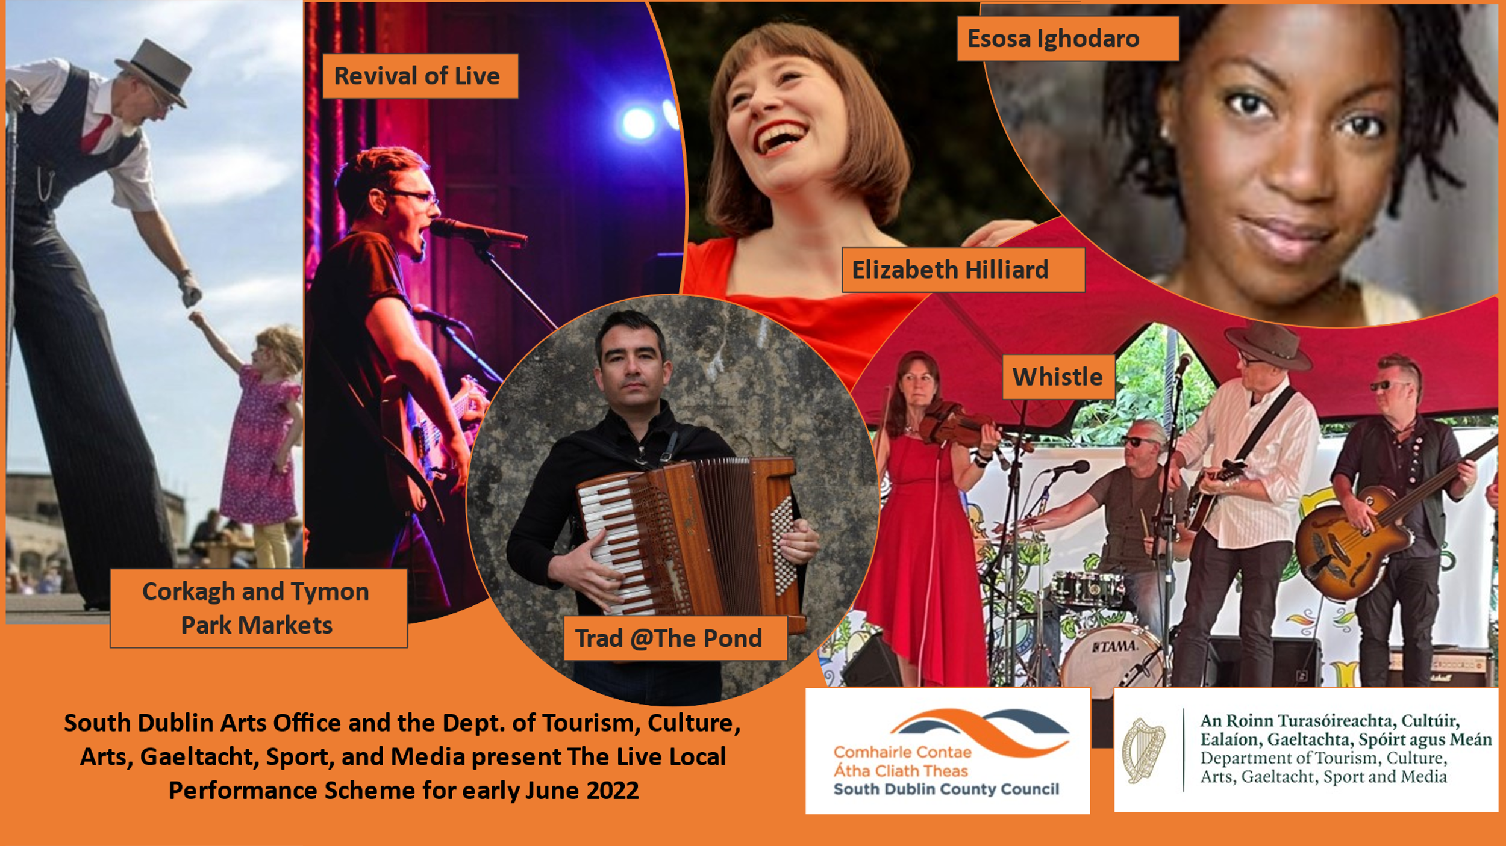

An eclectic mix of live performance will take place early June, supported by South Dublin Arts Office and the Dept. of Tourism, Culture, Arts, Gaeltacht, Sport, and Media through their Live Local Performance Scheme.

Trad, Classical, Jazz, Bluegrass and Country Music performances have South Dublin Sizzling! Showcasing professional and emerging artists from across the region, there are events to suit all tastes and whet all appetites.

|  |  |  |  |  |
| --- | --- | --- | --- | --- |
| **Date** | **Event** | **Venue** | **Booking Details** | **Time** |
| Fri 3rd | **The Full Shillin**  Trad music, old & new | Lisheen Nursing Home | Private Event - By invitation only |  |
| Sat 4th | **Urban Picnic Market**  Family Fun & Entertainment | Corkagh Park | Public Event | 11am-5pm |
| Sat 4th | **Elizabeth Hilliard**  Soprano performing work by Debussy, Poulenc, and Ravel | Rathfarnham Parish Church | Booking Essential  <https://www.eventbrite.co.uk> | 1.15-2.15pm |
| Sun 5th | **Revival of Live**  Opera, Jazz & World Music - Live music from South Dublin County Performers Network | Rathfarnham Castle Grounds | https://www.artscope.ie/revival-of-live/ | 2-5pm - Free |
| Mon 6th | **Revival of Live**  Trad@The Pond – Live Music from South Dublin County Performers Network | Rathfarnham Castle Grounds | https://www.artscope.ie/revival-of-live/ | 2-5pm - Free |
| Thurs 9th | **Noise Music Presents**  Ais, Muttonhead, Julia Louise KnifeFist, Baliboc, Pius, Celaviedmai and Smiley Emmanuel (Hip-Hop, House & Techno) | Rua Red | [noisemusicsouthdublin@gmail.com](mailto:noisemusicsouthdublin@gmail.com) | 7pm – Tickets €5 |
| Fri 10th | **Summer Music Trail**  Live Folk Music | North Clondalkin Library | Public Event | 10am & 11.30 am - Free |
| Fri 10th | **Ruaille Buaille**  Children’s Music Festival | Griffeen Park, Lucan | Public Event | 4pm & 6pm  Free |
| Fri 10th | **Revival of Live Festival**  An eclectic mix of live Trad, Jazz, and World Music | Griffeen Park, Lucan | <https://www.artscope.ie/revival-of-live/> | 7.30pm - Tickets €5 |
| Fri 10th | **Sub Sounds Music** **Collective**  Original music from local performers Amy Naessens and Ciara Dalton | Áras Chrónáin | Áras Chrónáin or eventbrite.ie/ | 8pm - Tickets €5 |
| Sat 11th | **Urban Picnic Market**  With live family entertainment all day | Corkagh Park | Public Event | 11am-5pm |
| Sat 11th | **Food & Craft Market**  With O’Hanlon’s Stage School, Magic Shows, and music from Neighbourhood Rock | Tymon Park | Public Event | 11am-4pm |
| Sat 11th | **Ruaille Buaille**  Children’s Music Festival – Full day of live entertainment | Griffeen Park, Lucan | Public Event | 10am – 4pm |
| Sat 11th | **Revival of Live Festival**  Featuring Trad and World Music from Claire Sherry, Tony Byrne, Simon Morgan, Richie Buckley, Martin Tourish with special guest Cathy Jordan. | Griffeen Park, Lucan | www.artscope.ie/revival-of-live/#Revival-of-Live-Lucan-Festival | 7.30pm Tickets €5 |
| Sat 11th | **Whistle**  Country & Bluegrass, with special guests Shared Spirit | Áras Chrónáin | <https://www.eventbrite.com/e/339164148097> | 7.30pm - Tickets €10 |
| Sun 12th | **Revival of Live Festival** – **The Dublin Song Live**  Featuring Paul Kelly, Ciara-Lee Jenkinson, Mary Byrne, Oleg Ponomarev, Lou Van Laake, Jay Rankin, Richie Buckley, Esosa Ighodaro and many more… | Griffeen Park, Lucan | www.artscope.ie/revival-of-live/#Revival-of-Live-Lucan-Festival | 12 noon Tickets €5 |
| Tue 14th | **The Full Shillin**  Trad music old and new | Lucan Lodge | Private Event - By Invitation only |  |
| Fri 17th | **Summer Music Trail**  Live Folk Music | Tallaght Library | Public Event | 10am & 11.30am - Free |
| Fri 17th | **The Full Shillin**  Trad Music old and new | Sally Park | Private Event - By Invitation only |  |
| Fri 17th | **Donal Kirk Band**  Blues Music | Áras Chrónáin | https://araschronain.ie/en/product-category/tickets/ | 6.30pm - Tickets €5 |
| Fri 17th | **Celtic Passage Music**  Frontline Workers Concert  Suggested donation of €10 for Ukraine Appeal | Tallaght Hospital Chapel | Frontline Workers Concert | 1-2pm |
| Fri 17th | **Celtic Passage Music**  Patients and Family Concert  Suggested donation of €10 for Ukraine Appeal | Tallaght Hospital Chapel | Concert for Patients and their families | 3-4pm |
| Fri 17th | **Troubadour at The Speakeasy**  Singer Songwriters | Áras Chrónáin | https://araschronain.ie/en/product-category/tickets/ | 8.30pm - Free (Booking Essential) |