Inclusive Playspaces In South Dublin County

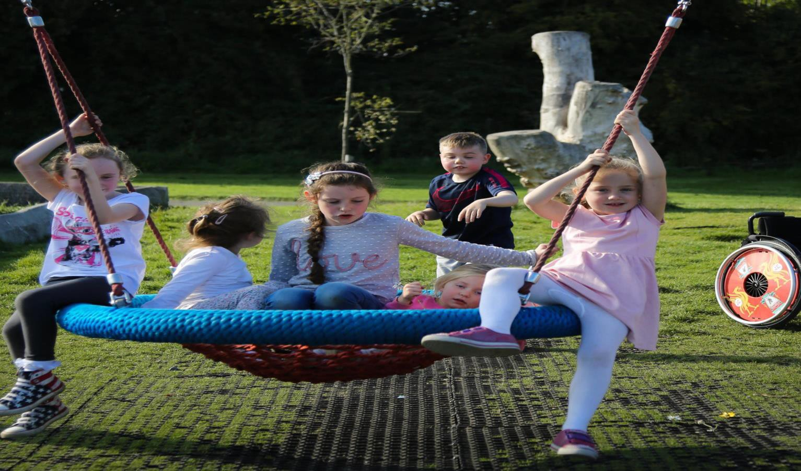

SDCC take a universal design approach to playground provision where we consider disability to be part of everyday life. We build playgrounds and playspaces in the assumption that they are places for everyone to play together. This contrasts to special needs provision such as wheelchair only swings which must be fenced off from other children and where the play happens separately.

# Playground Designed from a Universal Design Approach

Universal design places human diversity at the heart of the design process so that buildings and environments can be designed to meet the needs of all users. It therefore covers all persons regardless of their age or size and those who have any particular physical, sensory, mental health or intellectual ability or disability. It is about achieving good design so that people can access, use and understand the environment to the greatest extent and in the most independent and natural manner possible, without the need for adaptations or specialised solutions.

# Effective means of improving accessibility in playgrounds

A key issue with accessibility of play areas is providing a firm access from car parks to the play areas. Within play areas it is important to provide a firm access between play items. A self-closing gate is essential; it should be at least 800mm wide to facilitate easy access for people using wheelchairs and motorised scooters, and parents or carers pushing prams and pushchairs, including double buggies. Gate latches should be easy for children to use.

SDCC use the 7 principles of Universal Design from the Centre of Excellence in Universal Design when considering the design of playspaces.

Principles of Universal Design

|  |  |
| --- | --- |
| Principle | Built Environment Example |
| 1. Equitable Use: How well does the building, place or project appear to be fully usable, and appealing to a wide range of diverse users with differing ages and personal capabilities? | Is there the same means of use for all users whenever possible, avoiding segregation – for example play equipment that everyone regardless of age, size, ability or disability  can use with ease? |
| 2. Flexibility in Use: How well does the design readily adapt or offer multiple methods of use to enable a wide range of individual preferences and abilities? | Does the Playground provide choice in methods of use, for example play equipment and the surrounding spaces designed to accommodate children of different heights, those with mobility difficulties, those who lip-read & those  with visual difficulties? |
| 3. Simple and Intuitive Use: How well does the design make it simple for diverse users to understand the important features of the  building, place or project? | For example, is it easy to use the Playground & the play equipment for the first time? |
| 4. Perceptible Information: (Sensory abilities, e.g. vision, hearing, touch). How well does the design offer multiple use options for people, especially those with sensory limitations at any age and including the use of specialty equipment or  strategies? | For example, does the use of colour and materials provide visual contrast and/or tactile information to allow all children & adults regardless of age, size, ability or disability to navigate the Playground with  ease? |
| 5. Tolerance for Error: (Features that promote safe use and reduce risk). How well does the design prompt or assist the user to minimize  hazards and the adverse consequences of accidental or unintentional interactions? | For example, is the play equipment designed with easy access, well-designed handrails and good use of materials, finishes and colours? |
| 6. Low Physical Effort: How well does the design enable all users, including those with limited strength and stamina, to have a comfortable and  effective user experience? | For example, is the various play equipment provided easy to use for all children & adults regardless of age, size, ability or  disability? |
| 7. Size and Space for Approach and Use: (Efficient access and use for all user sizes) How well does the design enable users of diverse size, (including people who may use specialty equipment) to use the building, place or project? | For example, are the spaces in the Playground designed with sufficient dimensions to allow all children & adults regardless of age, size, ability or disability to circulate and use the Playground with ease? |

# Who are we catering for when we consider Universal Design?

Only a small percentage of children with a disability are wheelchair users. However, by ensuring proper access for these children we are also making play areas easier to use and therefore more likely to be used by a wider range of people.

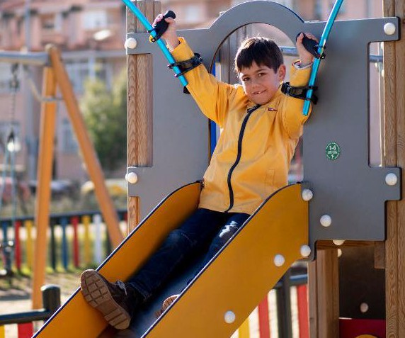

It is also not just children who we must cater for. It may be the parent or carer who uses a wheelchair or it could be an elderly person with reduced mobility or a person pushing a buggy that benefits from better access.

Designing for one group can result in solutions that address the needs of many others. For example:

* level entry (Step-free) entrances facilitate not just wheelchair users but also people with buggies; people with suitcases or shopping trolleys; people using walking or mobility aids; and people with visual difficulties
* clear, well-placed signage that uses recognised symbols or pictograms helps people with reading or cognitive difficulties, and those whose first language is neither English nor Irish

We must also be aware that physical disabilities make up a small proportion of children with a disability. There are also many children with sensory, mental health or intellectual ability or disability.

When considering the accessibility of playspaces we should not concentrate solely on equipment. We must ensure that the overall experience of play is to the forefront. Play meets various psychological, developmental and social needs. It can be a very personal experience for children but there is also a strong communal element to it and a child should feel part of a wider society while playing rather than excluded from it or having play highlight differences. To achieve this we should look at where play happens, what needs it meets and concentrate on universal design rather than special needs.

We should consider the environments for play and shared play experiences as much as the play equipment.

# What Play Equipment to Choose? -

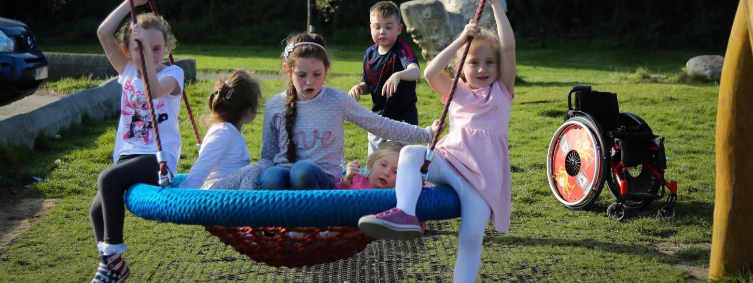Where equipment is provided in playgrounds SDCC look for accessible and Inclusive items Basket swings

•Basket swings allow for children to use the equipment in the same way as their siblings, friends and neighbours and are universally popular with children of all ages. Wetpour surfacing, safagrass matting and engineered woodchip surfacing are all approved for safety and accessibility

Wheelchair Accessible trampolines

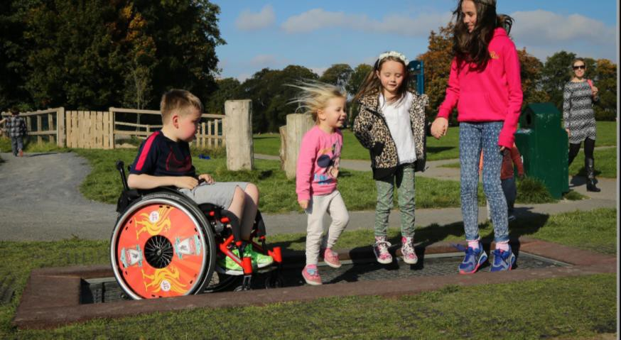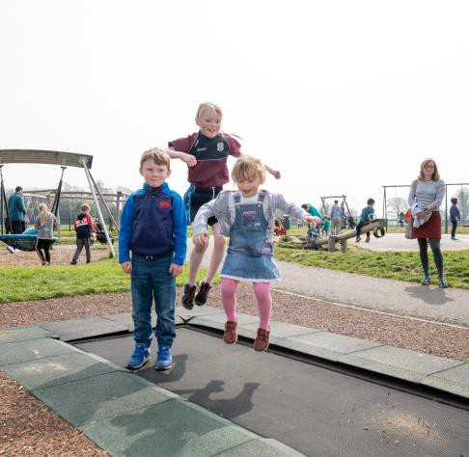

These are universally accessible and very popular with all children. There are various designs available for motorised and non-motorised wheelchairs.

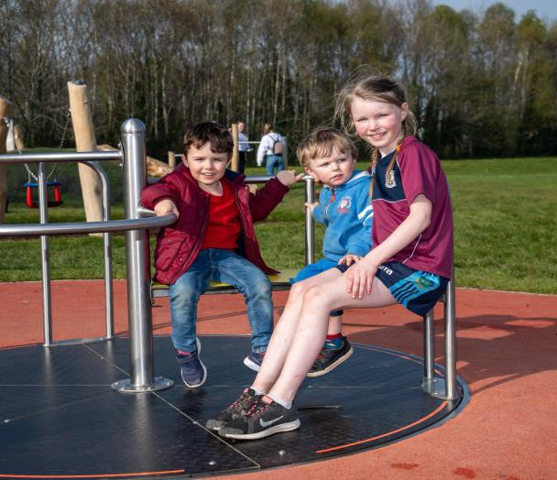Roundabouts

# Wheelchair accessible roundabouts allow children of different abilities to all play together and use the equipment in the same way. Great for group play and social interaction.

Many are designed requiring low physical effort allowing children of different abilities to push the roundabout rather than just being pushed as this is also an important part of play.

Swing Seats

SDCC provide a wide range of swing seats in playgrounds across the county. It can also be important to consider the length of the chain as some children love the sensation of long swinging motion. Lower swings have reduced play value. These seats designed for children requiring additional support seem to be popular with all children.

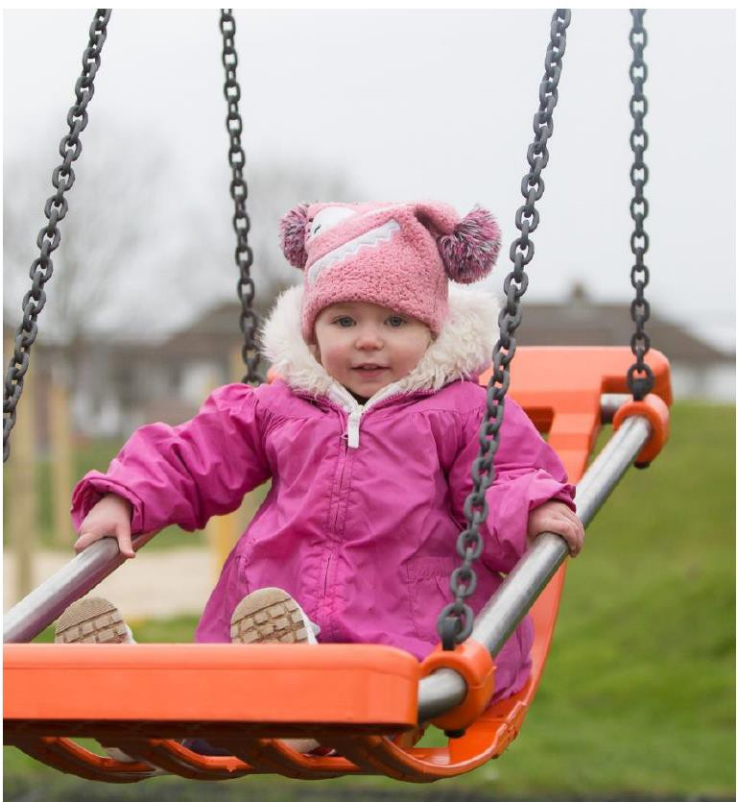

Slides

Double width Slides-allow parent/carer/sibling to go down the slide with the child who may be unable to use the slide alone or may require more space-also allow children to climb back up the slide or use it for free play. Both stepped and ramped access are ideally provided

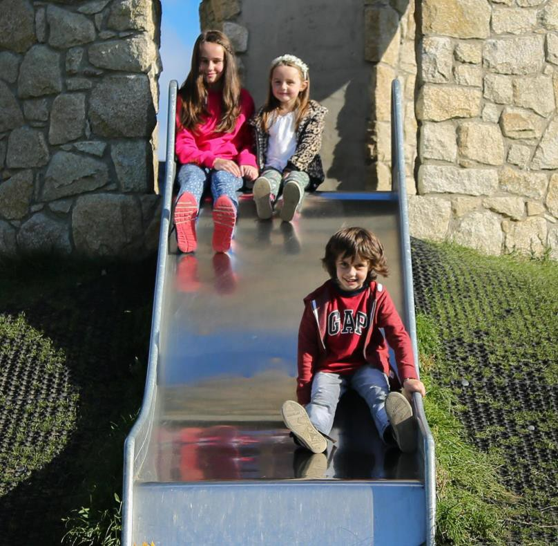

Spinning Disks- bowls-saucers

[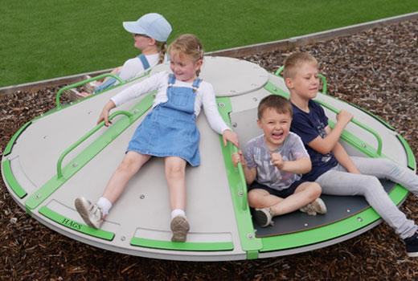](https://www.google.ie/url?sa=i&url=https%3A%2F%2Fhags.co.uk%2Fen-gb%2Fspinr2-inclusive-roundabout&psig=AOvVaw1ERrZM1nnhBLOvedp62qiM&ust=1627735222579000&source=images&cd=vfe&ved=0CAoQjRxqFwoTCJD5_6_oivICFQAAAAAdAAAAABAQ)

These come in many different designs. The spinning helps children of all abilities to develop their balance and are particularly enjoyed by children in need of certain sensory experiences. While some children may need to be assisted into the equipment it is enjoyed in the same way by all children

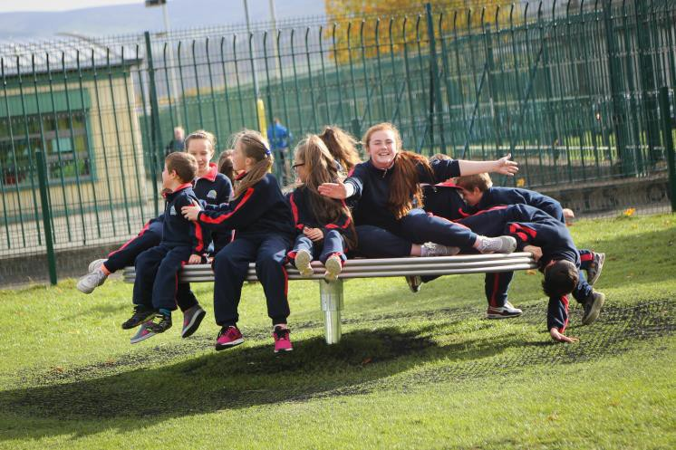

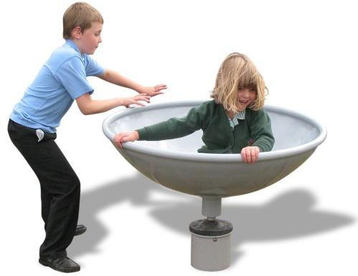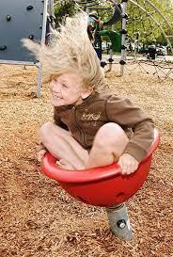

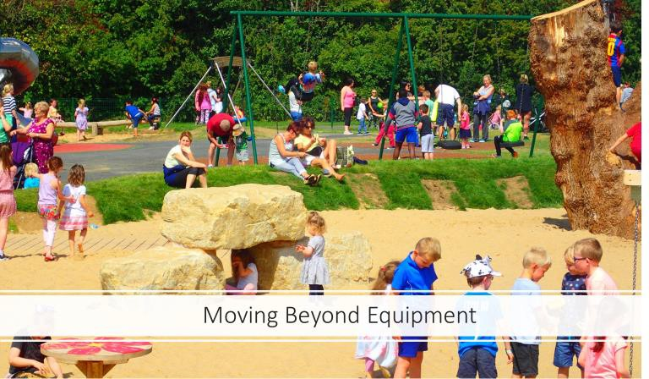

As the important role of play in children’s lives is better understood there has been a move towards providing more natural play and unstructured play experiences for children and the focus has moved away from concentrating on equipment to meet play needs towards looking at play environments.

During the consultations on playspaces in communities all across the county SDCC staff spoke to thousands of people about play. Only a handful of these conversations related to wheelchair accessibility.

BY far our greatest number of conversations around disability or accessibility was in relation to children with autism.

Everyone recognised the benefits of play for children with autism but a major fear from parents was around how their children's behaviour was perceived by others. They pointed to so many rules of the playground which their children may break and the reaction of other children and parents.

These conversations with parents had a big impact on our design considerations and layouts.

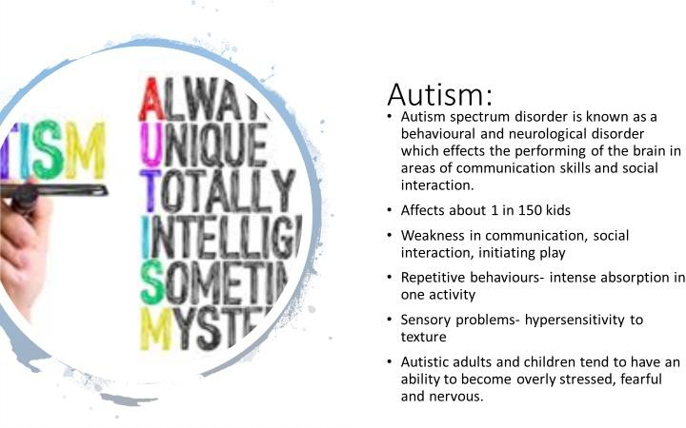

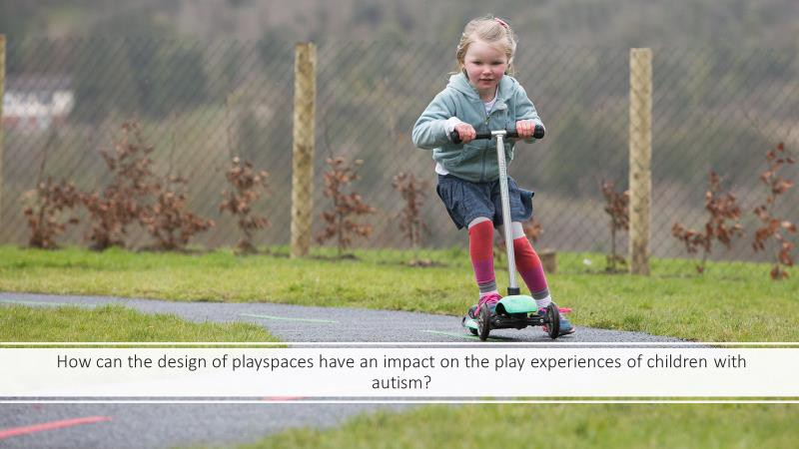

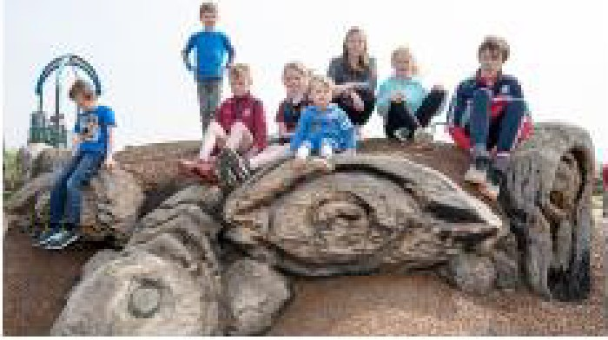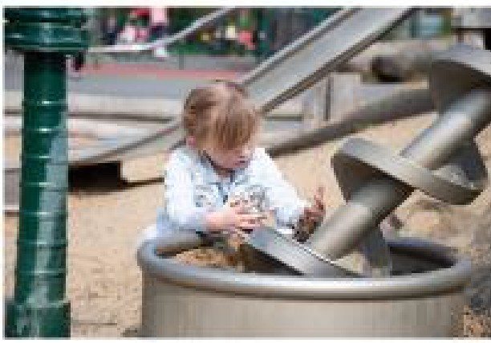11mp,ortant Req1uirements for

**children·with ASD**

* **Contact with Nature** provfdes huge benefltsto children with Autism
* The **rules** of a playground rnay **exclude** some children so we should try to remove as many as possible. Parents worry about howtheirchildsbehaviourrnary be perceived **if** they break these rules/conventions.Th,e less rules and more free play the better.
* 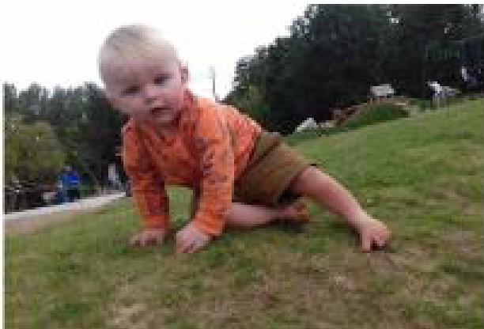Certain children will really desire to play in full **sunshine** or may need to be total **shade**

Children may need hidden places to retire to out of the full glare of observers.

* Children rnay require **quiet spaces** with little activfty to reduce their stresslevels
* Children rnay **require sensory rich environments** and sensory stimulation

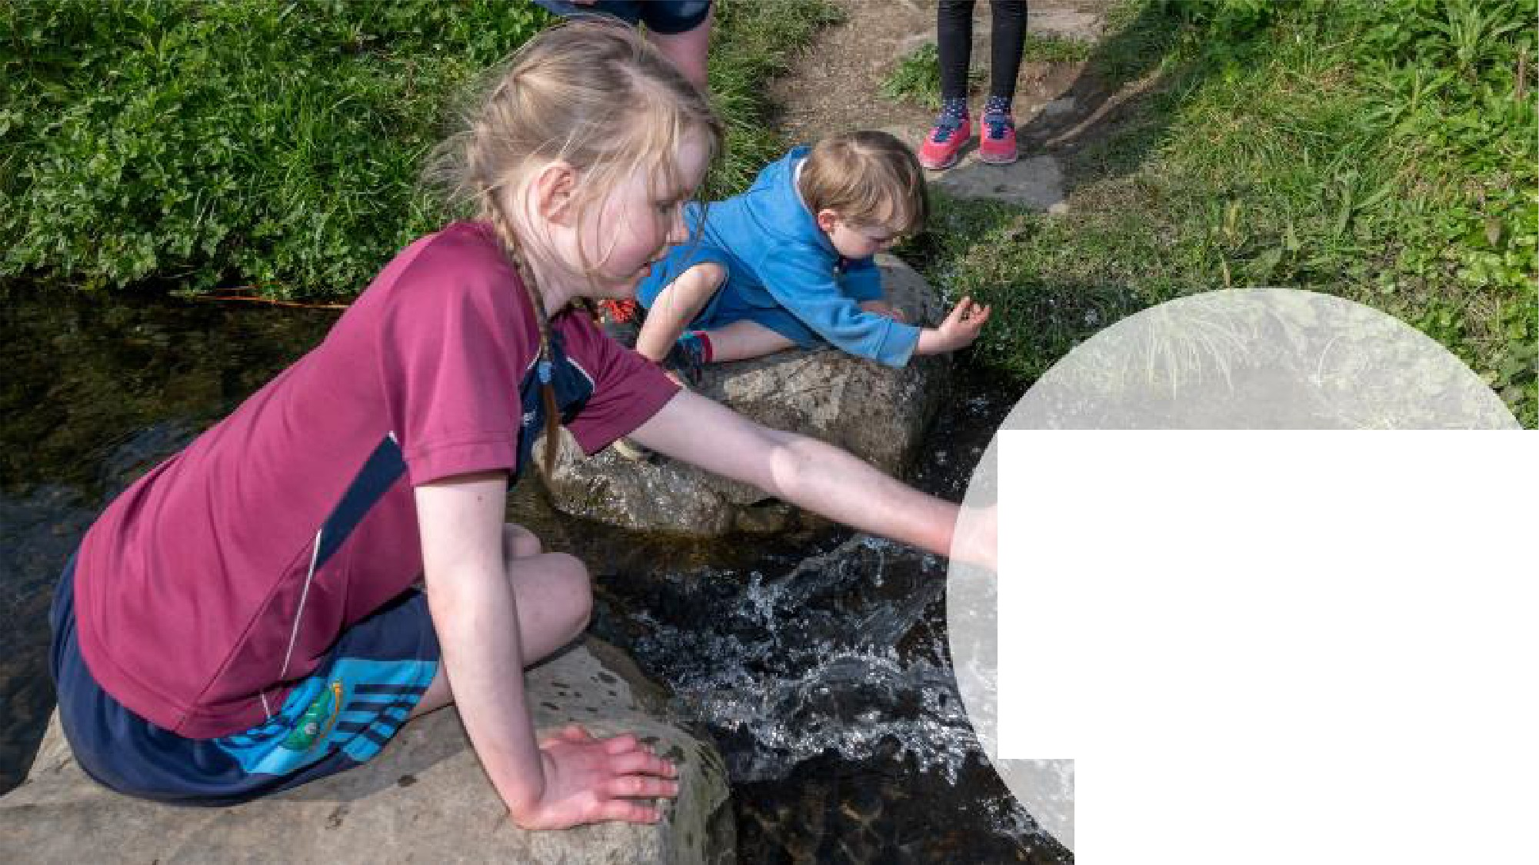

Examples of accessible play in South Dublin

Stepping stones -Tymon Park- close up cont.act wftl'I nature rn a sensory ricl'I environment

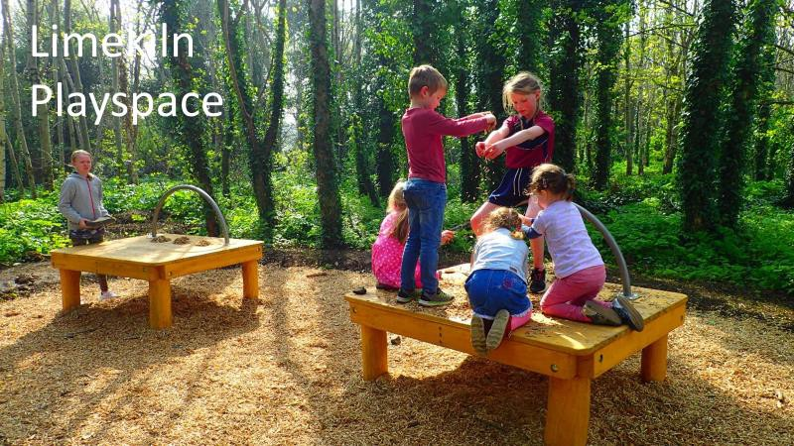

Children with autism benefit greatly from time spent in natural surroundings. It increases creativity and

language development. Simple props for play such as these tables set in a woodland at Tymon Limekiln have become restaurants, theatres, schools, hospitals, morgues, fire stations, busses, and a wide array of other

amazing things. These games are beneficial to children with language difficulties. Less rules and more in the imagination space

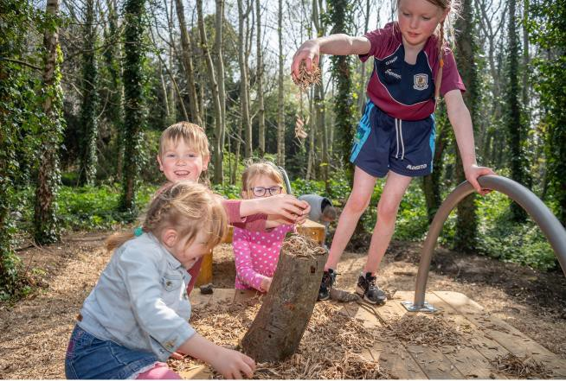

Here a group of children are “cooking a ham”. The game engaged children, boys and girls of different ages, unknown to one another in imaginative play. This type of play helps with language development and communication skills. There are no game rules or conventions, and children can learn to express themselves freely in such environments. This is not possible on equipment such as swings, slides or springers where children rarely engage with one another.

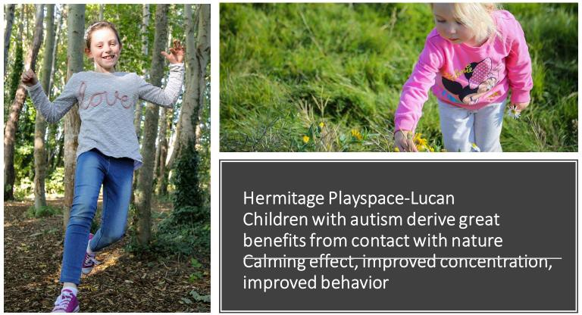

These children deserve to have their needs met in our playspaces so it is therefore important that play isn’t fenced in too much and free play and interaction with nature is valued as an integral part of play experiences.

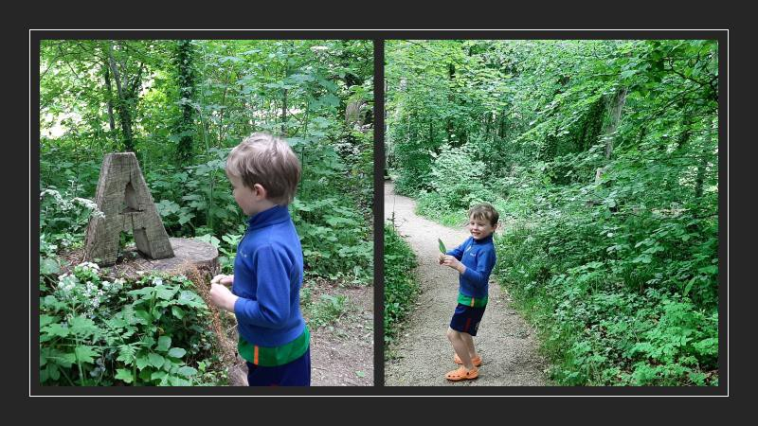

Corkagh Playground- woodland trail. Nature provides a wide variety of experiences. Children can escape from the noise, enjoy the shade, be more hidden and enjoy the calming effects of nature. Having such

spaces can be the difference between allowing a playground visit to continue or having to take a child home when regulating behaviour becomes difficult.

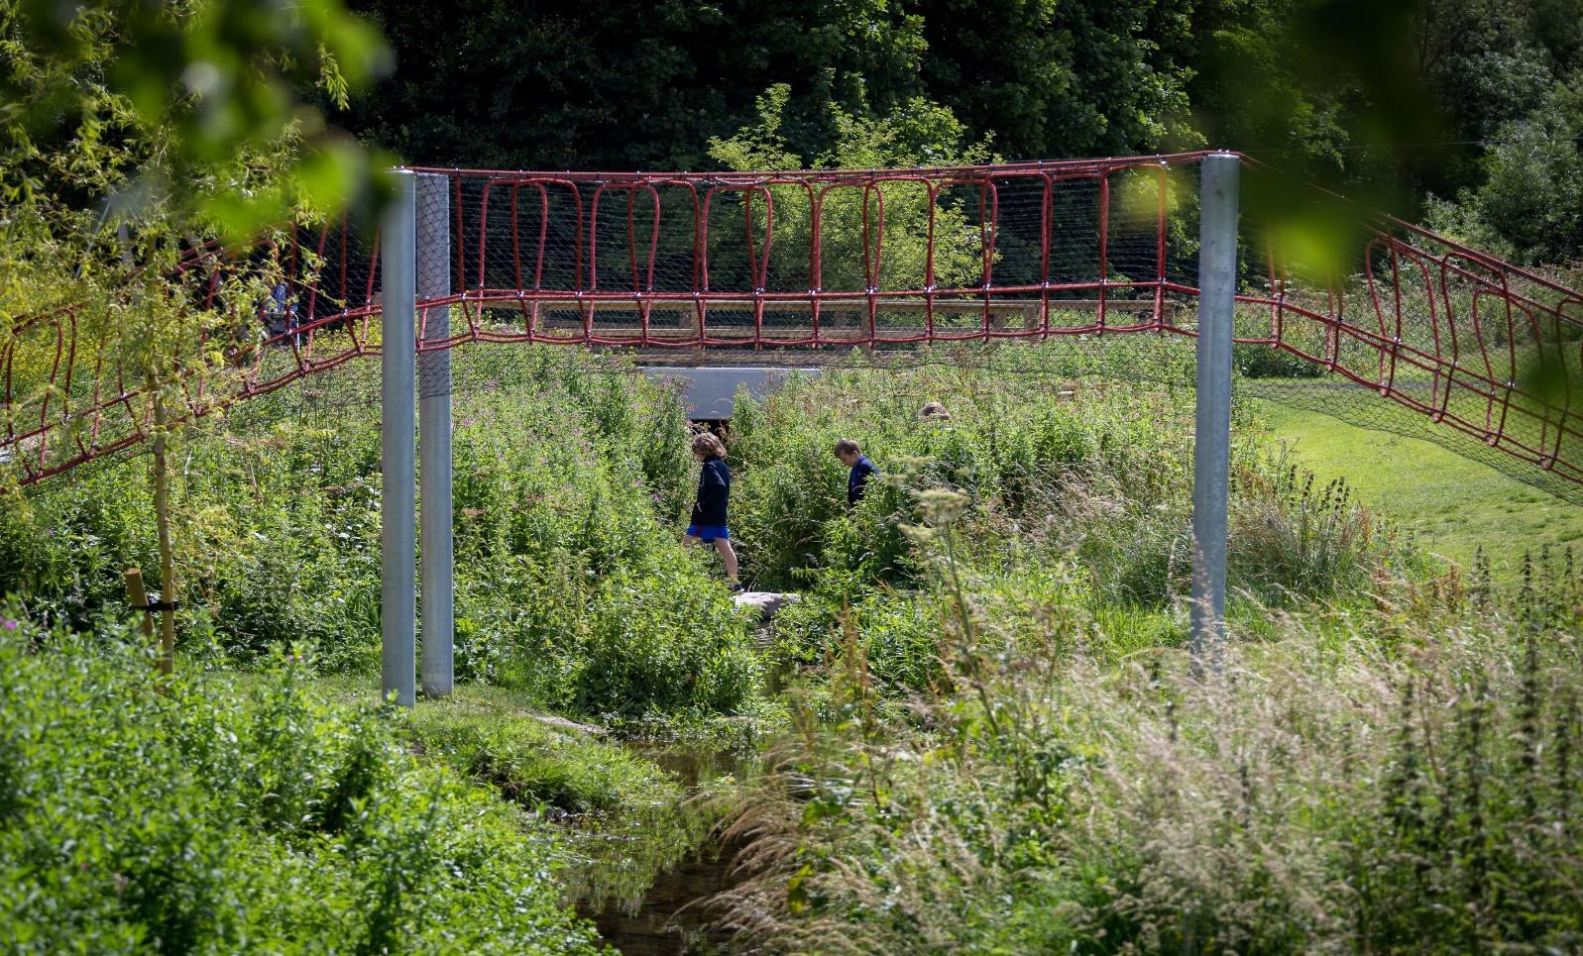

Tymon Park.

Nature is by its design is messy. Children do not need it tidied up. By presenting playspaces like this we are also sending out the message that it is ok to play in natural places.

There are less conventions on how children play making it much easier for children with ASD. Less rules and more free play make it a less stressful place. It also creates a more relaxing slower paced experience which can be very beneficial and making it easier to regulate behaviour.

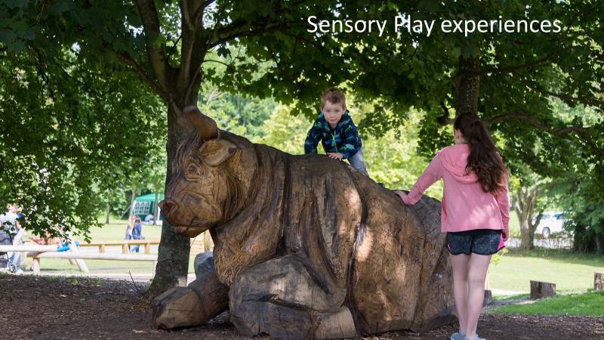

This bull is positioned in a shady area of the playspace. As well as being important for imaginative play many children and adults really enjoy siting for long periods on the bull and enjoy the sensory experience of

feeling the carved oak.

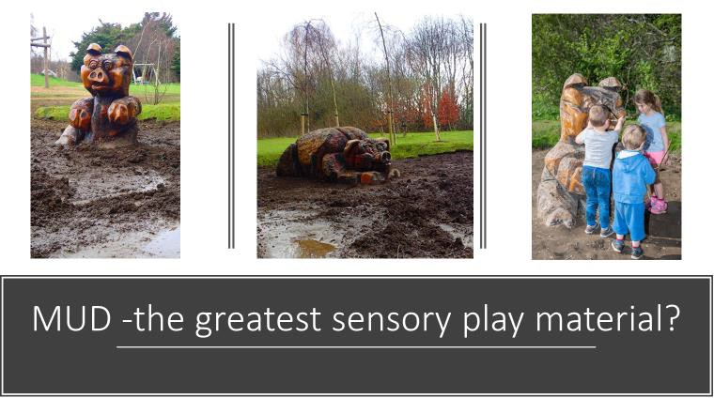

Pig Sty Mud Play Area designed by St Josephs Special Needs School beside Tymon Park in Tallaght. It features a family of pigs basking in the mud. Playground users can observe or jump right in. There has been a huge amount of research on the value of mud for sensory play. Virtually all children are naturally drawn to it.

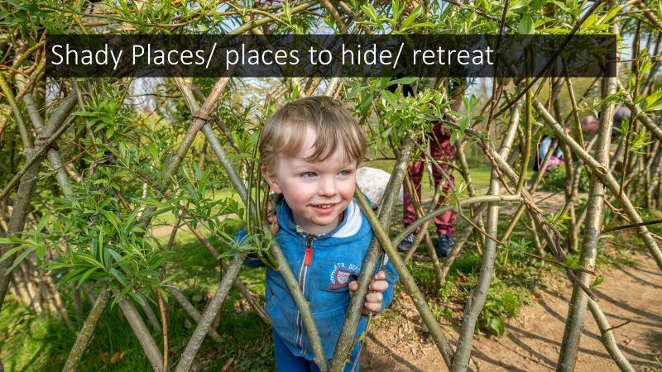

Children can find playspaces stressful so it helps if there are places to retreat to. Standing with your back to a fence is far more stressful than retreating to a willow dome or a behind a bamboo screen. As well as

imagination play they encourage movement and provide shady places favoured by many children.

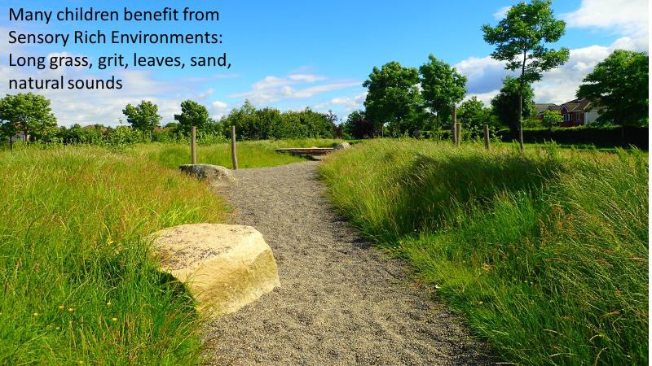

Griffeen Avenue

This is not a very well used play area as we were very restricted in the number of play features we could install due to local fears. It is however, a quiet place of high biodiversity where children can interact with nature. We have families who have reported that it is a really important place for their children. Pulling the seed heads from grass, dragging one’s feet in the grit, rolling on hills and being introspective or lost in deep play can be as important as play involving lots of movement and particularly so for many children with ASD.

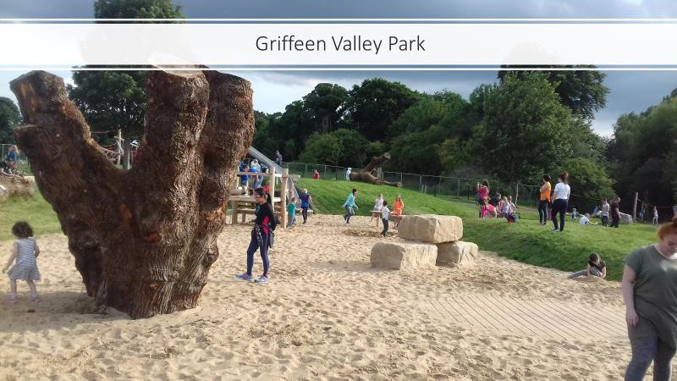

Here the main activity area is surrounded by mounding. Many children with ASD have difficultly communicating with or playing with other children. This mounding allows children to sit back and observe the play from a comfortable distance and then decide when they are comfortable joining in. The space we allow can be as important as the stuff in the space. Also, by taking the emphasis off the equipment and

making it more about the play environment the experience improves for children and parents.

Where we do this, we also find parents are also more likely to be relaxed (than when sitting on a playground bench) and visits to play areas last much longer.

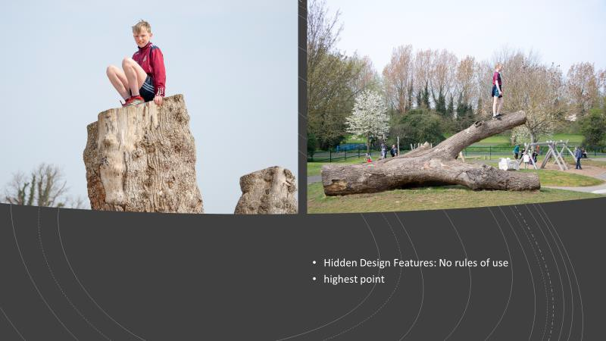

Many children with ASD will seek out experiences such as standing at the highest point of a playground. Where this is the top of a slide it can be problematic as this can block others from using the slide. Where the highest point is a boulder of tree trunk then the issue does not arise.

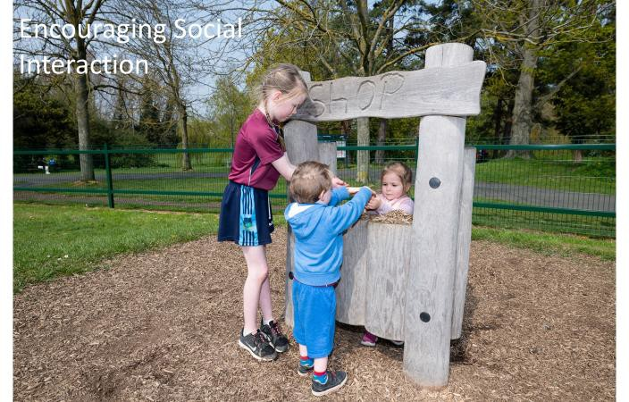

Shop Front at Griffeen Valley Park Playground

Interactions such as the one pictured here can place without any language. This can be where the children are small or shy or speak different languages or are non verbal. The exchanges are easily understood

without language and are an opportunity for social interaction for children who otherwise may find playing together very difficult or impossible.

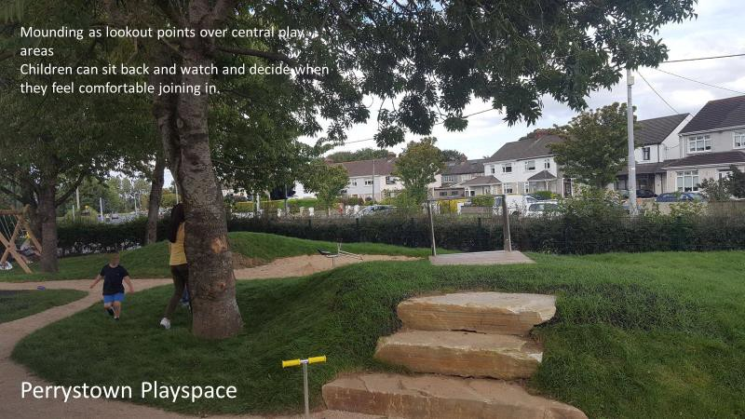

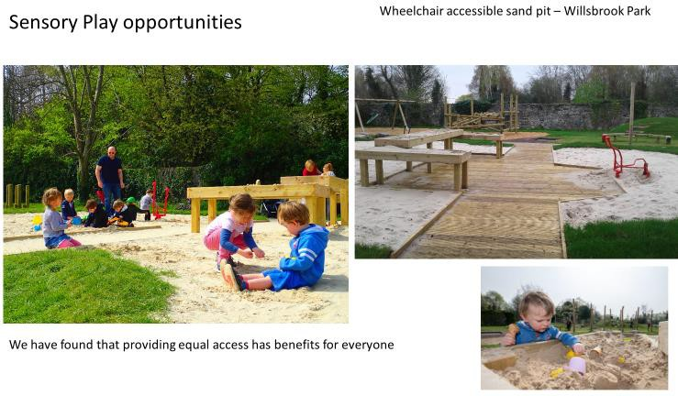

Willsbrook Park- Lucan

The decking allows wheelchair users access to the sand play area. There are raised tables allowing all users to play with the sand. There is also an accessible sand digger that can be operated from a wheelchair.

In this play area we have found that the use of the sand pit has gone mainly from sunny days to being a year round experience. Small children love sand play but may not be allowed to walk into the sand when it is wet. The decking and tables have made it useable year-round for everyone. We have a similar set up in Waterstown Park.

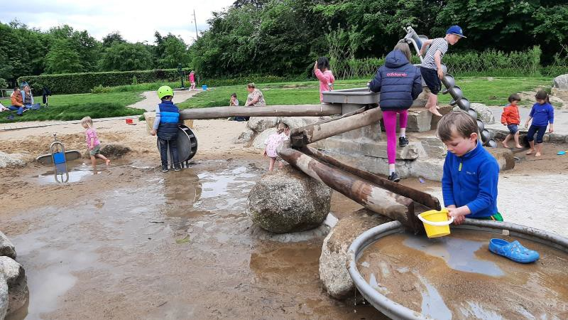

Corkagh Park Playground

The wheelchair accessible sand and water play area in Corkagh Playground is unique in Ireland. It offers constructive play, sensory play and encourages group play, cooperation, and social interaction.

Sand and water create sensory rich experiences which are important to younger children, but wheelchair users are often excluded from these areas. Here wheelchair users can access the entire area along with their friends/siblings. It is a good example of inclusive design.

There are no rules to be observed and the various actions required to get the water flowing encourage co- operation and communication between all children. Equally a child would feel comfortable playing alone or alongside other children.

Favourite free play experiences such as mixing water and sand/dirt and jumping in puddles is allowed and encouraged. The area has been designed with splash pools (puddles) and is suitable for play in bare feet.

Most children seek out these sensory experiences but are often discouraged from doing so by adults who don’t understand the benefits of free play or the sensory stimulation it provides. When provided in a play environment children are much more likely to be allowed to engage in these activities.

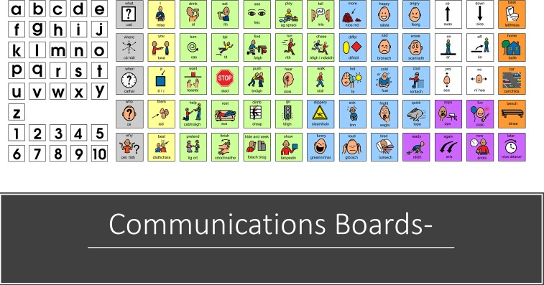

The use of these boards is very new to Ireland and SDCC have yet to understand how beneficial or otherwise they can be. The board above, installed on a pilot basis in Corkagh Playground, has the potential to assist

children with language difficulties.

Many children with ASD can become overwhelmed and unable to communicate in certain situations. Play and time outside are very important for regulating behaviour so it is very difficult for children and parents when play has to be cut short due to the child becoming overwhelmed.

The idea is that these boards can be used as an aide to parents/carers to communicate with and reassure a child. This reassurance can allow playground visits to be extended and for greater enjoyment of playground visits.

Despite a social media campaign and contacting many organisations we did not get any feedback from the public about the boards however they have started conversations about the hidden disabilities that many children have and the various needs of children. SDCC staff have also regularly observed children and

parents using the boards as part of play. They are in 13 playgrounds and are likely to be rolled out to all play areas.

END.