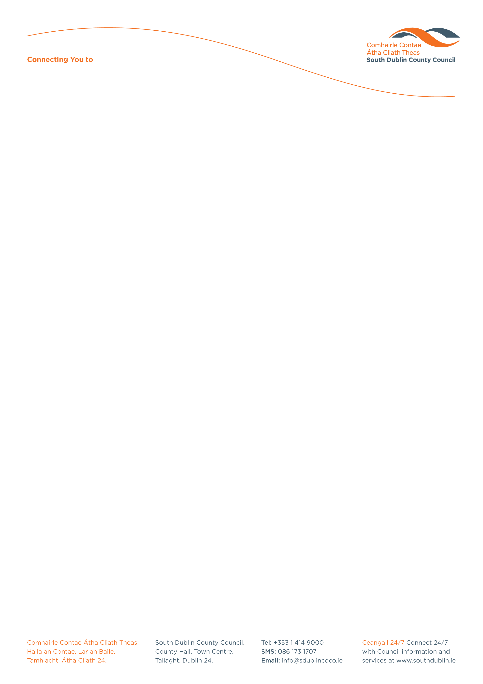
Adult’s Competition for European Week Against Racism 2019

To mark European Week Against Racism 16th March – 24th March 2019
the Social Inclusion Unit, Community Services Department, South Dublin County Council will hold a competition to combat racism and to celebrate the variety of cultures and people living in Ireland today.

Name: _____________________________________________________________

Address: ___________________________________________________________

Contact No.: ________________________________________________________

Email: _____________________________________________________________

Name of School (if applicable): __________________________________________

Class Year (if applicable): ______________________________________________

Teacher’s Name (if applicable): __________________________________________

Teacher’s Contact No (if applicable): ______________________________________

Teacher’s Email address (if applicable): ___________________________________

Title of Entry: _________________________________________________________

Anybody can participate in European Week against Racism by conveying their personal message against racism through any of the following:
Poetry, prose, art, photography….. (Maximum: Poetry 30 lines, Prose: 750 words)

LOTS OF PRIZES TO BE WON!

PLEASE RETURN FULLY COMPLETED FORM & ENTRY TO:
Adrienne Moloney or Donna O’ Reilly
Social Inclusion Unit, Community Services Department,
South Dublin County Council, County Hall,
Tallaght, Dublin 24.

Tel: 01 414 9270/ 086 779 3429/ 086 185 0656
Email: socialinclusionunit@sdublincoco.ie

Latest date for completion of entries is TUESDAY 5TH MARCH 2019

Please tick box to confirm you read and agreed with the Privacy Statement attached. If this box is not ticked and application form is not fully completed we will not be able to accept your entry.

Community Services

