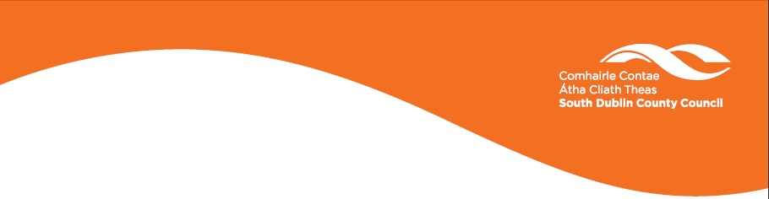

SOUTH DUBLIN COUNTY ENVIRONMENTAL POSTER COMPETITION 2018 - 2019

Design an Environmental themed Poster & Slogan for South Dublin County
The theme of your poster should be chosen from one of the following topics:
Anti-Litter
Water Conservation
Energy Conservation
Waste Prevention
Three posters will be chosen and printed for distribution to all schools and libraries in the County.
There are 3 categories
- Ages 4 – 8
- Ages 9 – 12
- Ages 13-18
Posters should be A3 size and the slogan on the poster must be in English and Irish.
All Entries must be accompanied by the following details:

School/ Club Name ……………………………………………………………….

School/ Club Address ………………………………………………………........

Class/ Group Name ……………………………………………………………….

Teacher/ Leader Name ……………………………………………………………

Contact Number …………………………………………………………………

Contact Email Address …………………………………………………………

Childs Name …………………………………………………………………

Please tick this box if you DO want your poster returned after the competition

Any uncollected entries will be recycled one month after the awards ceremony due to space restrictions.

Please send entries to:

Environmental Awareness Section
South Dublin County Council
County Hall
Tallaght
Dublin 24
Telephone: 01 - 414 9000

Closing Date:
Closing date for entries is 2pm Friday 8th February 2019.
Entry forms can be downloaded on www.sdcc.ie . Judging and the prize ceremony will take place in March 2019.

Background Information
South Dublin County Environmental Poster Competition is in its 15th year. The competition encourages children of all ages to learn about environmental issues and to express themselves artistically through various media such as artwork, projects or multimedia presentation.
Winning posters will be displayed in schools, libraries, community centres and other public buildings all around South Dublin County.
Let’s get the message out there – Keep South Dublin County Clean.
www.sdcc.ie
Printed on recycled paper

