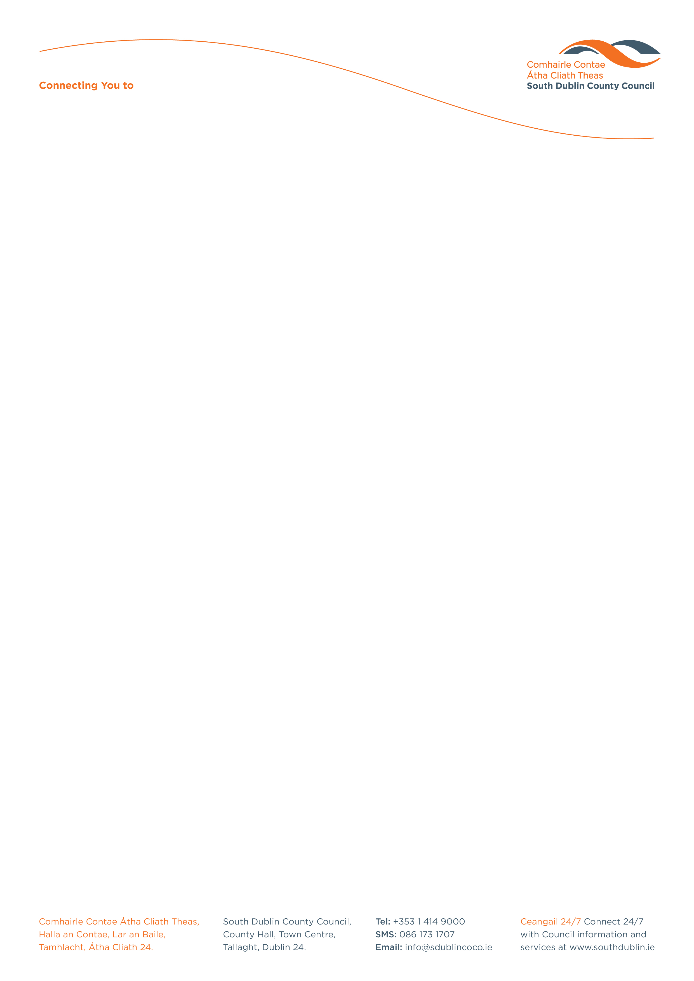

Secondary School Competition for European Action Week Against Racism 2020

To mark European Action Week Against Racism 14th March – 22nd March 2020
the Social Inclusion Unit, Community Services Department, South Dublin County Council will hold a competition to combat racism and to celebrate the variety of cultures and people living in Ireland today.

Name: _____________________________________________________________

Address: ___________________________________________________________

Contact No.: ________________________________________________________

Email: _____________________________________________________________

Name of School: _____________________________________________________

Class Year: _________________________________________________________

Teacher’s Name: ____________________________________________________

Teacher’s Contact No: ________________________________________________

Teacher’s Email address: ______________________________________________

Title of Entry: _________________________________________________________

Anybody can participate in European Action Week against Racism by conveying their personal message against racism.

Prize will be a contribution of €1,000 towards school equipment or a team building trip!

PLEASE RETURN FULLY COMPLETED FORM & ENTRY TO:
Social Inclusion Unit, Community Services Department,
South Dublin County Council, County Hall,
Tallaght, Dublin 24.

Tel: 01 414 9270
Email: socialinclusionunit@sdublincoco.ie

Latest date for completion of entries is Wednesday 11th March 2020

Please tick box to confirm you read and agreed with the Privacy Statement attached. If this box is not ticked and application form is not fully completed we will not be able to accept your entry.

Community Services

