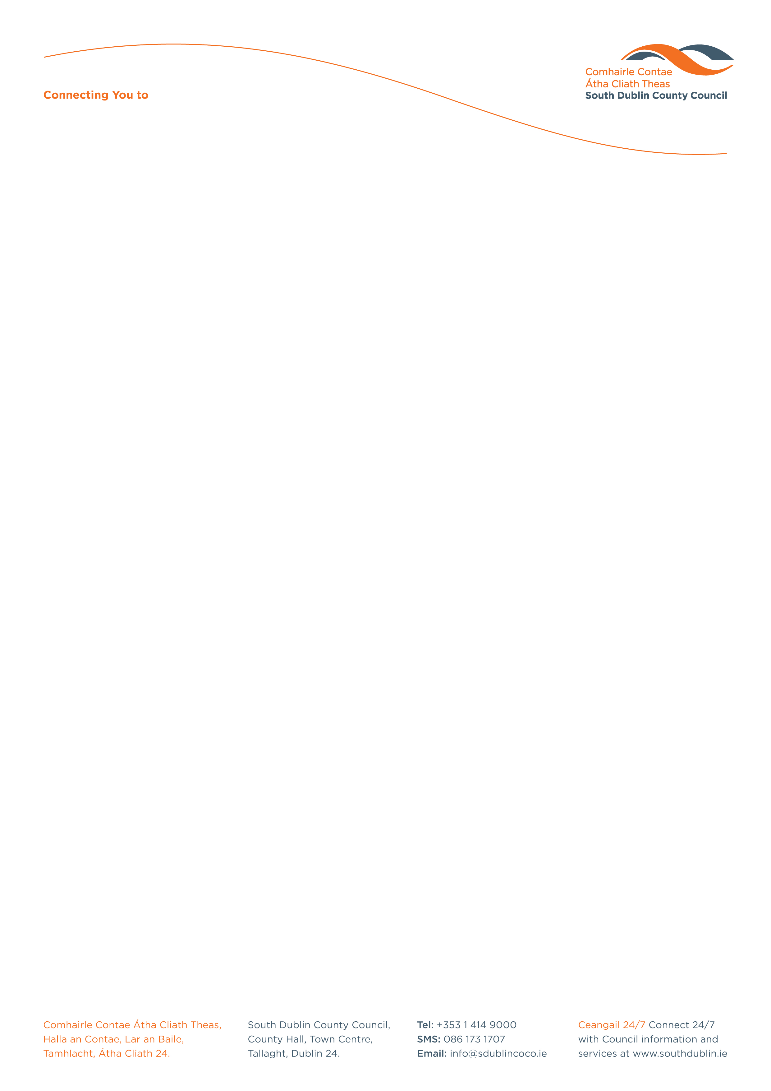

Primary School Competition for European Week against Racism 2020

To mark European Week against Racism 14th March – 22nd March 2020 the Social Inclusion Unit, Community Services Department, South Dublin County Council will hold a competition to combat racism and to celebrate the variety of cultures and people living in Ireland today.

Name: _________________________________________________________________

Home Address: __________________________________________________________

_______________________________________________________________________

Age on the 1st September 2019: _____________________________________________

Name of School: __________________________________________________________

Class Year: ______________________________________________________________

Teacher’s Name: __________________________________________________________

Teacher’s Contact No: ______________________________________________________

Teacher’s Email address: ____________________________________________________

This competition is open to all primary school children. Individual and/or class entries are acceptable.

LOTS OF PRIZES TO BE WON!

PLEASE RETURN FULLY COMPLETED FORM & ENTRY TO:
Social Inclusion Unit, Community Services Department,
South Dublin County Council, County Hall,
Tallaght, Dublin 24.

Tel: 01 414 9270
Email: socialinclusionunit@sdublincoco.ie

Latest date for completion of entries is Wednesday 11th March 2020

Please tick box to confirm you read and agreed with the Privacy Statement attached. If this box is not ticked and application form is not fully completed we will not be able to accept your entry.

Community Services

