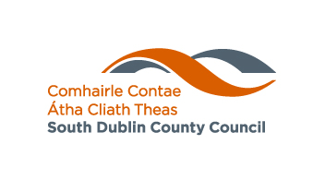 |  | 

South Dublin County Council (SDCC)

Carbon Monoxide Scheme 2019/2020

Installed by South Dublin County Partnership

Closing date Thursday 16th January 2020 at 4pm or until quota is reached

Carbon Monoxide (also known as CO) is a colourless, odourless poisonous gas and is a common yet preventable cause of death from poisoning worldwide.  Carbon Monoxide has no smell, taste or colour. This is why it is sometimes called the "Silent Killer".  When inhaled, it prevents blood from absorbing oxygen.  It can be produced by any fuel when burned – coal, turf, oil, gas, wood. | Carbon Monoxide Alarms:  South Dublin County Council is running their scheme to provide carbon monoxide alarms free to residents in SDCC administrative area providing they meet certain criteria. South Dublin County Council will arrange to have the required number of alarms fitted in selected properties from 2020 onwards.  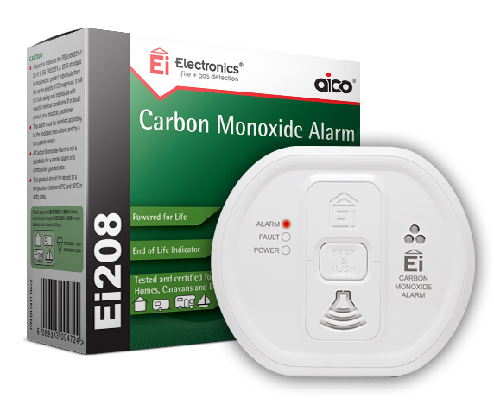
Who can apply:
This scheme is specifically for residents of SDCC area aged 55 plus. The scheme is also available to residents who are under the age of 55 if they are living alone or deemed vulnerable for the purpose of this scheme. Applicants must be living in privately owned accommodation in SDCC administrative area. This scheme is not open to people living in rented accommodation (private or social).

Carbon Monoxide alarms can be used as a backup to provide a warning to householders in the event of a dangerous build-up of CO. Remember that Carbon Monoxide alarms are no substitute for regular inspection and maintenance of appliances, vents, flues and chimneys.

How do I apply:
Please apply using the attached form or by visiting our website at www.sdcc.ie

Completed forms can be submitted any of the following ways:
- Online at www.sdcc.ie
NOTE - you should receive a confirmation email to confirm that your online application has been received. If you do not receive this confirmation, it means that your application has not been received and it should be re-submitted.
- by email to comdevof@sdublincoco.ie
- by post to Community Services Department, South Dublin County Council, County Hall, Tallaght, Dublin 24, D24 YNNS

You must include your contact phone number.

There are a limited number of alarms available. These alarms will be allocated on a first come first served basis. A list of successful applicants will be submitted to South Dublin County Partnership. They will contact you to make arrangements to fit the alarms if your application is deemed suitable. NOTE: Alarms need to be fitted and not just supplied.

South Dublin County Council or South Dublin County Partnership cannot accept any liability for damage to your property during this fitting process.

For any queries you can contact the above email address or telephone 01-4149270

Approximate timeframe for the scheme:
- Scheme open for applications – 28th November 2019
- Scheme to close - Thursday 16th January 2020 at 4pm. Scheme may close early if quota is reached.
- Contact details provided to South Dublin County Partnership - end January 2020
- Installation to commence – February 2020
- Installation to be completed - end June 2020

South Dublin County Council reserves the right to stop or amend this scheme at any time.

South Dublin County Council
Carbon Monoxide Scheme 2019

First name: __________________________ Last name: __________________________

House number/House Name: _______________________________________________

Street name: _____________________________________________________________

Address 2: ______________________________________________________________

Town: ___________________________________ County: ________________________

Eircode (online at https://www.eircode.ie/): _____________

Telephone Number(s)*: ___________________________________________________

Email Address (Block Capitals): _____________________________________________

* Telephone number(s) must be provided

Please tick the boxes that best describe you:
Over 55 □

Live alone □

Under 55 and Live alone □

Vulnerable (please specify below) □

_________________________________________________________________________

_________________________________________________________________________

Accommodation Type/Housing Tenure:
You must tick this box to verify that you live in privately owned accommodation (NOTE: applicants in rented accommodation (private, social or voluntary are not eligible for the scheme) □

Property Type – tick all that apply:
House | □ | Apartment | □
Single Storey | □ | Two Storey | □
Detached | □ | Semi-detached | □

Declaration
I declare that the information supplied in this form is accurate and complete. I understand that all information provided in respect of this application will be held electronically and will be made available to South Dublin County Partnership as appropriate.

It should be noted that the Freedom of Information Act 2014, and the Data Protection Acts 1988-2018 applies to all records held by South Dublin County Council. I have read the privacy statement which was provided to me in connection with this scheme.

I have read the timeframe for the installation of the scheme and I am aware that I may not receive my alarm until June 2020.

Signed: _______________________________________ Date: __________________

