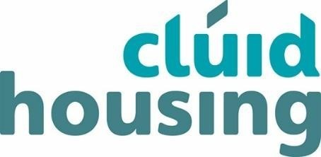

**Temporary Closure of Seán Walsh Park Carpark and Bottle Bank.**

**Dear All,**

**To facilitate upgrade works to the Carpark and the green area North of the Whitestown Way Stream, public access to the carpark will be closed from 8.00AM Monday 16th January 2023.**

**The bottle bank located within this area of the park will also be temporarily removed for the duration of these works. The nearest bottle bank locations to Sean Walsh Park are located at The Square Shopping Centre Tallaght (1.4km), South Dublin County Council HQ (1.7km), Tallaght Leisure Centre (1.7km), Killinarden Heights SDCC Housing Maintenance (2.0km) and Ahearne’s Public House Car Park (2.0km).**

**Full access to the Seán Walsh Park Carpark and the surrounding upgraded landscaped areas will again be available to the public at the end of November 2023.**

**We thank you in advance for your co-operation and apologise for any inconvenience caused whilst we undertake these works to improve this public amenity.**