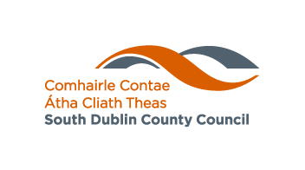

**Expression of Interest Form**

**Accelerated Measures in Response to**

**COVID-19**

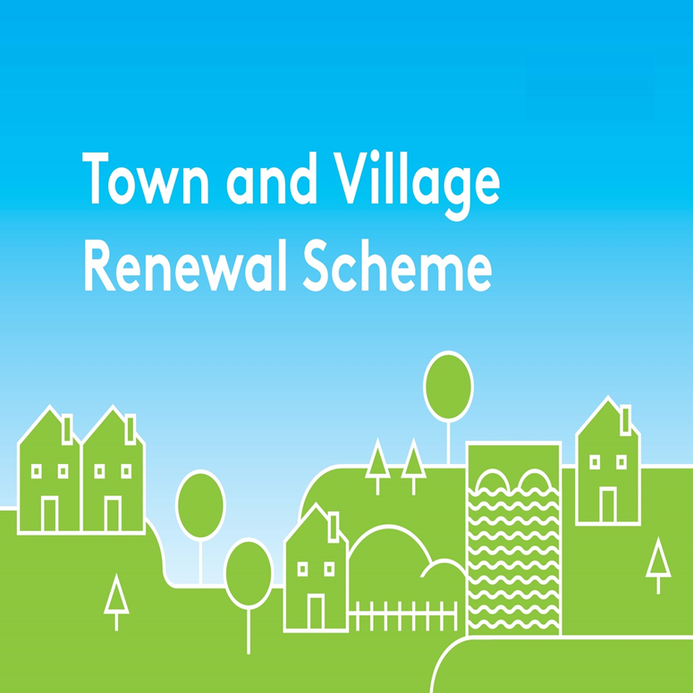

**Expression of Interest Form**

**Accelerated Measure in Response to**

**COVID-19**

**Please indicate which round of funding is being applied for:**

* **Round 1 Expression of Interest Deadline: Friday 26th June**
* **Round 2 Expression of Interest Deadline: Friday 17th July**

**Town/Village covered**:

**Postal Address of project:**

**Amount of Grant Funding Requested**

**Contact Name (Local Authority):**

**Contact email address:**

**Contact Telephone Office:**

**PROJECT DETAILS:**

1. **Brief description of project (max 30 words) :**
2. **Project Proposal (Max 300 words) :**

**3. Who will be implementing the project?**

1. **Brief explanation as to how this project will assist businesses/communities of the town/village to adapt to the specific challenges posed by COVID-19 (e.g. social distancing) and increase footfall/economic activity in the short-term:**

**5. When will work on the project commence and how long will the proposed work take to complete?**

**Proposed commencement date:**

**Proposed completion date:**

**The number of weeks it will take to complete this project:**

DECLARATION

|  |
| --- |
| I hereby confirm that I have read and understand this document. I request that consideration be given in support of the project as outlined above.  Signature: __________________________________________  Position: ____________________________________________  Date: _______________________________________________ |

**Completed Expression of Interest forms are to be submitted by e-mail only to:**

[**comdevof@SDUBLINCOCO.ie**](mailto:comdevof@SDUBLINCOCO.ie)

**please state “2020 Accelerated Measures” in the email subject line.**