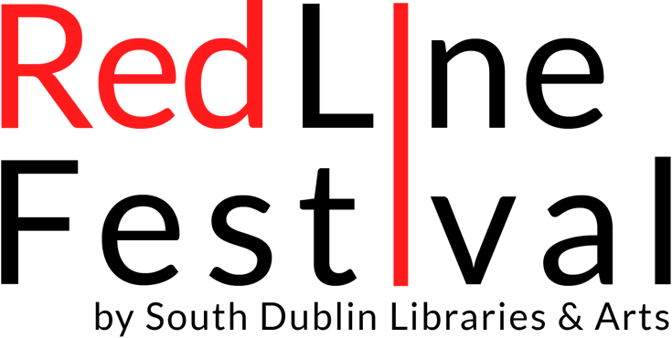

Red Line Festival Poetry Competition Rules:
• The winners of this competition will receive the following prizes: 1st Place €300, 2nd Place €200 and 3rd Place €100
• A maximum number of 2 poems per person may be submitted.
• Poems should be in English and be a maximum of 40 lines (not including the title and spaces between stanzas).
• There is no theme - your poem(s) may be on any subject of your choosing
• Each entered poem, including its title, should be typed single-spaced in a standard 12 point font on one side of a single A4 sheet. No fancy/coloured/oversized fonts or images please!
• All entrants must be 16 years of age or over.
• The competition is open to anyone living on the island of Ireland.
• Closing date for entries is Monday 12th September 2022. No entries will be accepted after this date.
• Poems must be the original work of the entrant and must not have been published either in print or on a website, not be currently submitted or accepted for future publication. They must not previously have been awarded a prize in another competition.
• Entrants must not have published a full collection of poems at the time of entry. Entrants who have published a chapbook/pamphlet are permitted to enter.
• Please complete the entry form (available to download from www.redlinefestival.ie) and send it along with your poem/s via email to: poetrycompetition@sdublincoco.ie. Both poems should be attached in one word document that should include a short biographical note.
The Closing Date for receipt of ALL entries is: Monday 12th September 2022.
• Please retain a copy of your work, as entries cannot be returned.
• Poems cannot be altered or changed after they have been entered.
• Poems are judged anonymously. The entrant’s identity must not appear alongside the poems.
• The adjudicator’s verdict is final and no correspondence shall be entered into regarding individual competition entries. Shortlisted entrants only will be notified. The shortlist will be announced on Monday 3rd October 2022.
• Winners will be announced at an event during the Red Line Festival in October 2022 where they will be invited to read their winning poems. (Travel to the event will be at the entrant's own expense.)
• Copyright stays with the author but Red Line Festival reserves the right to publish winning and shortlisted poems on its website and/or in print.
• No employee of South Dublin Libraries may enter the competition.

