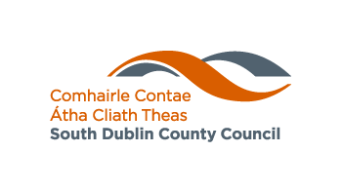

**Environmental Services Department**

**ANTI-LITTER AND ANTI-GRAFFITI AWARENESS GRANT SCHEME 2016**

South Dublin County Council is now accepting applications for funding of projects which qualify as Anti-Litter and Anti-Graffiti Awareness Initiatives. Anti-Litter and Anti-Graffiti Awareness Initiatives should seek to promote public awareness and education in relation to litter and/or graffiti. This Grant Scheme has a particular focus on voluntary initiatives by community and environmental groups, and on involving schools and young people in anti-litter and anti-graffiti awareness actions.

**ONLY APPLICATIONS WITH EDUCATION & AWARENESS DIMENSIONS WILL BE CONSIDERED FOR FUNDING.**

**How to Apply**

Further information and an application form can be obtained online at www.sdcc.ie or from the Environmental Awareness Section, South Dublin County Council, County Hall, Tallaght, Dublin 24,

Phone 01 4149000,

Email info@sdublincoco.ie

Applications must be made to the Environmental Awareness Section, South Dublin County Council by **5pm on Wednesday 16th March 2016** at the latest.

**Protect your Environment -**

**Tabhair Aire don Timpeallacht**

**Web: www.sdcc.ie**