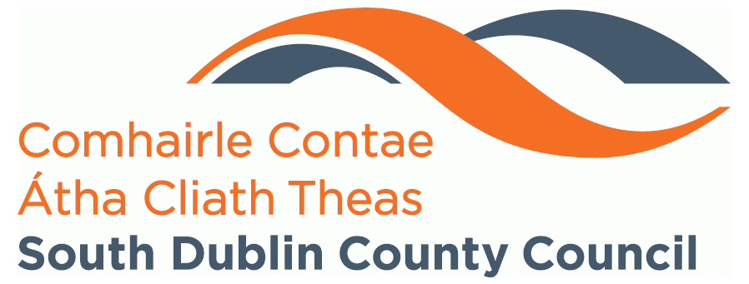

SOUTH DUBLIN COUNTY COUNCIL
LOCAL CLIMATE GRANT 2021 APPLICATION FORM

*When completing this application form, please read the accompanying NOTES and ASSESSMENT CRITERIA (at the end of this form) to ensure that your project is suitable for grant funding, and that the necessary requirements are being met. It should be noted that this form and any subsequent correspondence may be subject to release under the Freedom of Information Act and under the European Communities (Access to Information on the Environment) Regulations 2007-2018.

1. Applicant Details

Organisation Name (as per Tax Clearance Certificate or Tax Reference Number):

Project Co-ordinator: Contact Number:

Address:

Email Address:

Estimated Project End Date

2. Project Title

3. Project Summary
Please give a brief outline of your project (200 word max)

4. How will this project develop a more sustainable local community
150 word max

5. Assessment Criteria
Please describe briefly how your proposed project meets the following criteria. These criteria will be used to assess proposed projects and to make decisions regarding funding. The full set of assessment criteria is described at the back of the form.
(150 words max for each box)

5.1 Positive Impacts on Climate and/or Biodiversity

5.2 Awareness Raising Potential

5.3 Partnership Arrangements including community partners involved with this project e.g. Tidy Towns groups, schools, local environmental groups etc.

5.4 Feasibility of Project Targets

6. How your project will be funded?

Sources of Funding | Amount
Amount Sought from this Scheme | €
Applicant Contribution | €
Other Funding Sources (please list): | €
 | €
 | €
Total Funding: | €
If your project is workshop based, please outline the unit cost of each workshop including materials, preparation etc. | €

7. Summary of Project Costs

Please itemise all costs in relation to the delivery of your project.
What we will not fund:
- Projects are not eligible for funding if already received via another grant scheme e.g. Anti-Litter & Anti-Graffiti Grant Scheme etc.
- Initiatives that can be funded through other SDCC schemes such Social Credits Scheme will not be funded through this grant. For more information on the Social Credits Scheme please contact us directly.
- Purchase or hire of equipment/machinery such as lawnmowers, strimmers, wheelbarrows, diggers etc.
- Treats for clean ups

Cost Item | Amount
 | €
 | €
 | €
 | €
 | €
Total Costs | €

8. Applicant’s Authorisation for Assessment, Audit and Data Retention

- All particulars as entered above, and any supplementary materials supplied in support of this application, are correct as of the date of this signature.
- I acknowledge that my application form will be assessed based on the attached criteria and understand that it may or may not receive a funding allocation.
- I acknowledge that my application form will be held by South Dublin County Council in line with appropriate data retention policies and GDPR.
- To ensure appropriate governance, I acknowledge that my application may be subject to audit.

Signed:____________________ ______ Date:_______________________

Note to Applicants – How your grant application is assessed

The following assessment criteria will be used to rank eligible proposals. Decisions on funding will be based on this ranking.

- Climate Change and Biodiversity
Projects which have a meaningful climate or biodiversity focus will receive a higher rating but only where they promote good environmental practice and provide practical solutions to these issues.

- Awareness raising potential
Will your project raise environmental awareness in your local community? Is it educational, with a focus on national environmental concerns? Proposals are more likely to be given a higher rating where environmental awareness is brought to a wider audience.

- Partnership arrangements
Does your proposed project involve working closely and in partnership with local authorities, local business, NGOs, and other local interests? How will you ensure a high level of interest and involvement with the project? Projects with strong partnership arrangements and local involvement will be given a higher rating.

- Feasibility of project targets
Are the project targets feasible and how will the project be managed to achieve those targets? Have similar projects been undertaken in the past and have they been successful? Proposals demonstrating good management to achieve feasible objectives will be given a higher rating.

Note to Applicants – Additional Information including Data Protection

This grant is funded by South Dublin County Council. We take our role in Data Protection seriously. Therefore, any personal information you provide will not be shared with any third party.

Your application form will be retained on file (print/electronic) in compliance with the Council’s data retention policy and GDPR.

General Note to Applicants

- Tax Clearance / Tax Reference Number: Applicants should be advised that approval of funding will be conditional on tax clearance / tax reference requirements being met.

- Approved projects receive two equal payments, one at the beginning of the project and the remainder once the completion report has been submitted. South Dublin County Council may engage with the successful applicant throughout the implementation of the project.

- Projects are not eligible for funding if already received via another grant scheme e.g. Anti-Litter & Anti-Graffiti Grant Scheme etc.

- Initiatives that can be funded through other SDCC schemes such Social Credits Scheme will not be funded through this grant. For more information on the SCS please contact us directly.

- Applicants must ensure that relevant projects are carried out in accordance with all Child Protection Policies and Procedures currently in place in each local authority. Applicants may be subject to Garda vetting procedures – South Dublin County Council will discuss this with you.

- Commercial/business projects / for profit projects are not eligible for funding.

- Completed application forms should be returned to the relevant local authority by 5pm on 19th November 2021 at the latest. Submission of applications by email only.

