 |  | 

South Dublin County Council (SDCC)

Home Security Locks Scheme 2018

Installed by Crothers Security

Closing date 30th April 2018

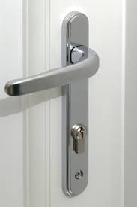
Does your external doors have a Euro Profile Cylinder? If so, you are invited to apply to have your existing European Profile Lock replaced with a high security cylinder lock free of charge through SDCC.

If you have previously availed of this scheme in 2016/2017 you may be eligible to have an additional door lock replaced.

Who can apply:
This scheme is specifically for residents of SDCC aged 55 plus. It is also available to any residents who may be vulnerable or living alone. Applicants must be living in privately owned accommodation. This scheme is not open to people living in rented accommodation (private or social). Only one lock will be available per household.

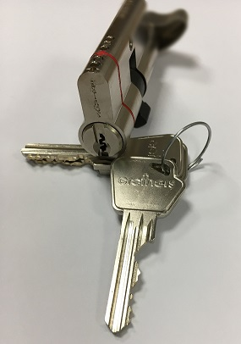
What are the benefits of high security cylinder locks:
The locks that will be installed under this scheme make it virtually impossible for an intruder to bypass.

Locks are:
- Anti-Snap
- Anti-drill
- Anti-pick
- Anti-bump

How do I apply:
Please apply using the attached form or online at www.sdcc.ie

Completed forms can be submitted any of the following ways:
- Online at www.sdcc.ie
NOTE - you should receive a confirmation email to confirm that your online application has been received. If you do not receive this confirmation, it means that your application has not been received and it should be re-submitted.
- by email to comdevof@sdublincoco.ie
- by post to Community Services Department, South Dublin County Council, County Hall, Tallaght, Dublin 24, D24 YNNS

You must include your Eircode and a contact phone number.

There is a limited number of locks available. These locks will be allocated on a first come first served basis. A list of successful applicants will be submitted to Crothers Security. They will contact you to make arrangements to fit the lock if your application is deemed suitable. Not all doors are suitable for replacement locks.

Crothers Security will have the final say on whether a lock can be replaced or not. We may replace one lock per household for front, back, side, porch or patio doors etc if they are suitable.

SDCC or Crothers Security cannot accept any liability for damage to any doors during this replacement process. Any issues with the lock mechanism will be highlighted at the time and while the cylinders replaced will be covered by a 12 month warranty* by Crothers Security this does not include the handle or lock mechanism.

For any queries you can contact the above email address of telephone 01-4149270

SDCC reserve the right to stop this scheme at any time.
*subject to the terms & conditions of Crothers Security

South Dublin County Council
Home Security Scheme Application Form – 2018

First name: __________________________ Last name: __________________________

House number/House Name: _______________________________________________

Street name: _____________________________________________________________

Address 2: ______________________________________________________________

Town: ___________________________________ County: ________________________

Eircode (online at https://www.eircode.ie/) – MUST BE COMPLETED *: _____________

Telephone Number(s)*: ___________________________________________________

Email Address (Block Capitals): _____________________________________________

* Telephone number(s) and Eircode must be provided)

Please tick the boxes that best describe you:
Over 55 □
Live alone □

Accommodation Type:
You must tick this box to verify that you live in privately owned accommodation (NOTE: rented accommodation (private or social) are not eligible for scheme) □

Door Type:
UPVC door □
Aluminium door □
Munster Joinery (timber) door □
Unsure □

Declaration
I declare that the information supplied in this form is accurate and complete. I understand that all information provided in respect of this application will be held electronically and will be made available to Crothers Security as appropriate.

I understand the terms and conditions in relation to Crothers Security 12 month warranty for the locks.

I understand that not all locks are suitable for replacement. I understand that the final decision on whether or not a lock can be replaced will be taken by Crothers Security.

It should be noted that the Freedom of Information Act applies to all records held by South Dublin County Council.

Signed: _______________________________________ Date: __________________

