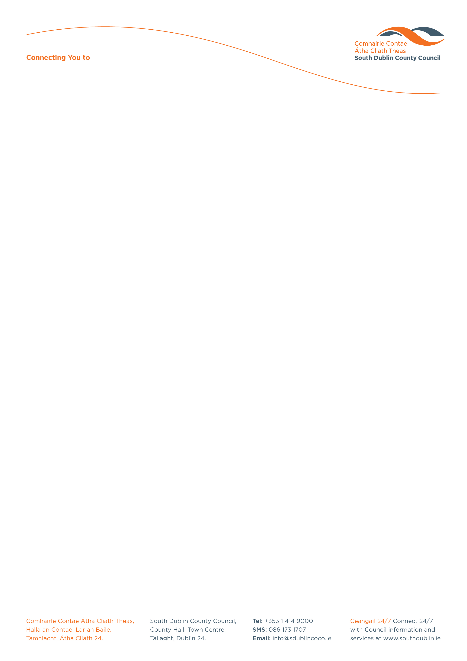

Library and Arts Services

South Dublin County

Amateur, Voluntary & Community Arts Grant

APPLICATION FORM

Name of Organisation or Society: ___________________________________________________________

Contact Name: __________________________________________________________________________

Contact Address: _________________________________________________________________________

_______________________________________________________________________________________

E-mail address:______________________________________________________________

Telephone: (H) _________________(W) _____________ Mobile: ______________________

State category of application:

Amateur ________Voluntary________Community________

State activity to be funded:

Training__Event Subsidy____Professional support___Materials___Project Completion________

State category of art form below:

Dance____Music____Literature____Visual Art____Photography____Choral____Drama____Other____

Provide details of activity for which you are seeking grant assistance, including date or period of activity. Please state, if relevant, to what extent the activity is professionally assisted (eg. name actor/director/artists involved in the activity). Please give the fullest information possible of the activity and your group — maximum 500 words or use an additional page, if necessary.

Give detailed costing of your proposal. Please state all income (grants, sponsorship, tickets) excluding possible grant from South Dublin County Council (continue on separate page if necessary).

Cost of Activity: Income:
________________________________ _________________________________
________________________________ _________________________________
________________________________ _________________________________
___________________________ ____ _________________________________
___________________________ ____ _________________________________
___________________________ ____ _________________________________

Total ____________________________ Total ____________________________________

State amount of grant sought (up to €650) :

_______________________

Please list accompanying material enclosed with application:

_________________________________________________________________________________

_________________________________________________________________________________

Return of enclosed material (please tick as appropriate).
I do not wish to have material returned I wish to collect the material ___
I enclose stamped addressed envelope/stamps/money order to the value of postage____

• Please include a statement indicating the organisation’s present financial situation.
• A statement of actual Income & Expenditure must be submitted after an event or performance. Successful Arts Grant payment will only be made subsequent to the provision of actual Income & Expenditure.

Signed: __________________________________________Chairperson/Secretary/Treasurer (delete as appropriate)

DECLARATION
I declare that the information supplied in this proposal is accurate and complete.
I understand that all information provided in respect of the Grant Application will be held electronically and may be made available to other South Dublin County Council Departments as appropriate. It should be noted that the Freedom of Information Act applies to all records held by South Dublin County Council. (The application must be signed either by the Chairperson, Secretary or Treasurer of the organisation making the submission).

Name: (please print) ________________________ ________ Date: ___________________

Applications are accepted on an ongoing basis (subject to availability of resources)

Completed application forms should be sent to: Siobhan Nolan, Arts Office, South Dublin County Council, Library Headquarters, Unit 1, The Square Industrial Complex, Tallaght, Dublin 24. YXW3 Tel: (01) 4597834 email: siobhannolan@sdublincoco.ie

Arts Act Grants

South Dublin County Council allocates grants under Section 6 of the Arts Act 2003. These grants may be given to persons or bodies organising an event that in the opinion of the Council would:

- Stimulate public interest in the arts
- Promote the knowledge, appreciation and practice of the arts
- Assist in improving the standards of the arts across the County.

Definition of the arts
"The arts" as defined under the Arts Act of 2003 means any creative or interpretative expression (whether traditional or contemporary) in whatever form, and includes, in particular, visual arts, theatre, literature, music, dance, opera, film, circus and architecture, and includes any medium when used for that purpose.

Grant Scheme Conditions

- The scheme will primarily grant aid groups based and performing in the County but also performing at events outside the County. Groups performing in, but not based, in the County will also be eligible to apply for support under the Scheme.

- You may not apply for activities undertaken for charity fundraising purposes or for primarily profit-making purposes

- All commercial activities will be outside the scope of the scheme, (this will not preclude grant aid towards the cost of professional assistance e.g. producer, lecturer, orchestra, etc).

- Regard will be had to the resources available to the organisers in determining the amount of grant.

- Applications for grants must be submitted at least eight weeks prior to the date of the event or performance, as recommendations are made at monthly County Council meetings.

- Applications can only be considered if submitted prior to the event taking place.

- Recipients of grants must acknowledge the Council’s assistance in programmes or other promotional material, and forward a copy of this before payment is made. The Council’s logo is available on request.

- Where the grant supports the publication of material, this material may not be used for any other purpose, other than that stated in the application form, and in particular may not be used to endorse any other activity without South Dublin County Council’s prior consent.

- Consideration will be given as to whether the event would take place regardless of an arts grant.
- Awards are not made for Capital expenditure.

PLEASE NOTE
Applications and all related information will be held on file for no longer than 12 months.

Further information is available from the Arts Office at South Dublin County Council, County Hall, Tallaght, Dublin 24. Tel: 4597834 email: oscannell@sdublincoco.ie

