Screening Statement for Appropriate Assessment (AA) of Proposed Amendments to the Adamstown SDZ Planning Scheme, 2014

- Introduction
The Adamstown SDZ Planning Scheme (2014) comprises 223.5 hectares of land located in West Dublin, south of Lucan and the N4 national primary road, and north of the railway line from Dublin to the South and West of Ireland (see Figure 1). The SDZ Planning Scheme divides the plan lands into eleven development areas or ‘tiles’ and sets out parameters for development within each area.

The original Adamstown SDZ Planning Scheme (2003) was reviewed and amended in 2014 and at that point, it was determined that an Appropriate Assessment of the Planning Scheme and Draft Amendments was not required having regard to:
- The AA Screening Report (October 2013) and Addendum to the Screening Report (January 2014);
- The characteristics of the Planning Scheme;
- The objectives of the Plan to protect Natura 2000 sites and biodiversity;
- The Strategic Environmental Assessment Environmental Report prepared; and
- The consultations with the Prescribed Bodies.

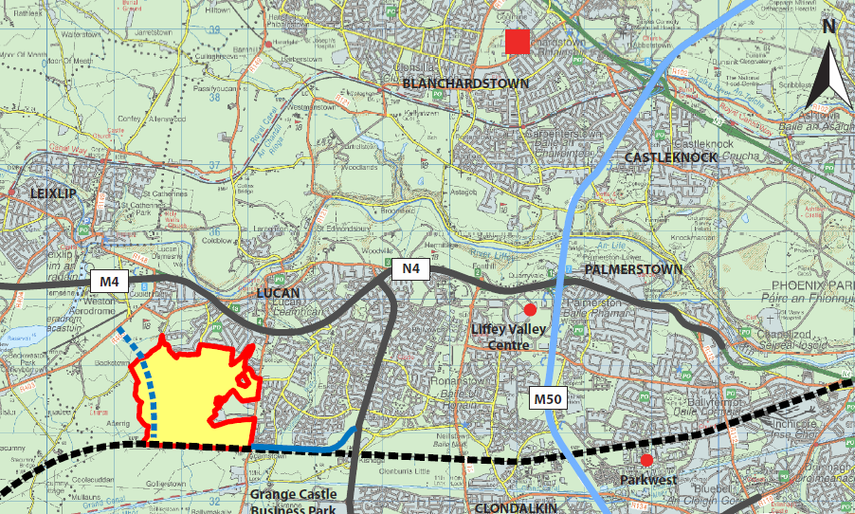
Fig. 1: Adamstown within the wider west Dublin context

- Proposed Amendments
It is now proposed to amend elements of the SDZ Planning Scheme as a result of policy and guidance within the National Planning Framework, 2018 (NPF) and Regional Spatial and Economic Strategy, 2019 (RSES) relating to compact growth and sustainable development; and changes arising from new guidelines including the Sustainable Urban Housing: Design Standards for New Apartments, Guidelines for Planning Authorities, 2018 (the ‘Apartments Guidelines’) and the Urban Development and Building Heights: Guidelines for Planning Authorities, 2018 (the ‘Building Heights Guidelines’).
The three main amendments proposed are as follows:
- An increase in unit numbers, density and residential floor area within the Adamstown Station development area.
- An increase in unit numbers, density and residential floor area and a location-specific one-storey increase in building height within the Aderrig development area.
- Relocation of a proposed enterprise centre from the Tobermaclugg Village/Tandy’s Lane Village local centre to the Adamstown Station district centre.
Other minor amendments are also proposed including updated references. Under Section 170A of the Planning and Development Act, 2000 (as amended), amendments to planning schemes must be considered by An Bord Pleanála; in this regard, South Dublin County Council is seeking that the Board considers all of the above amendments as non-material.

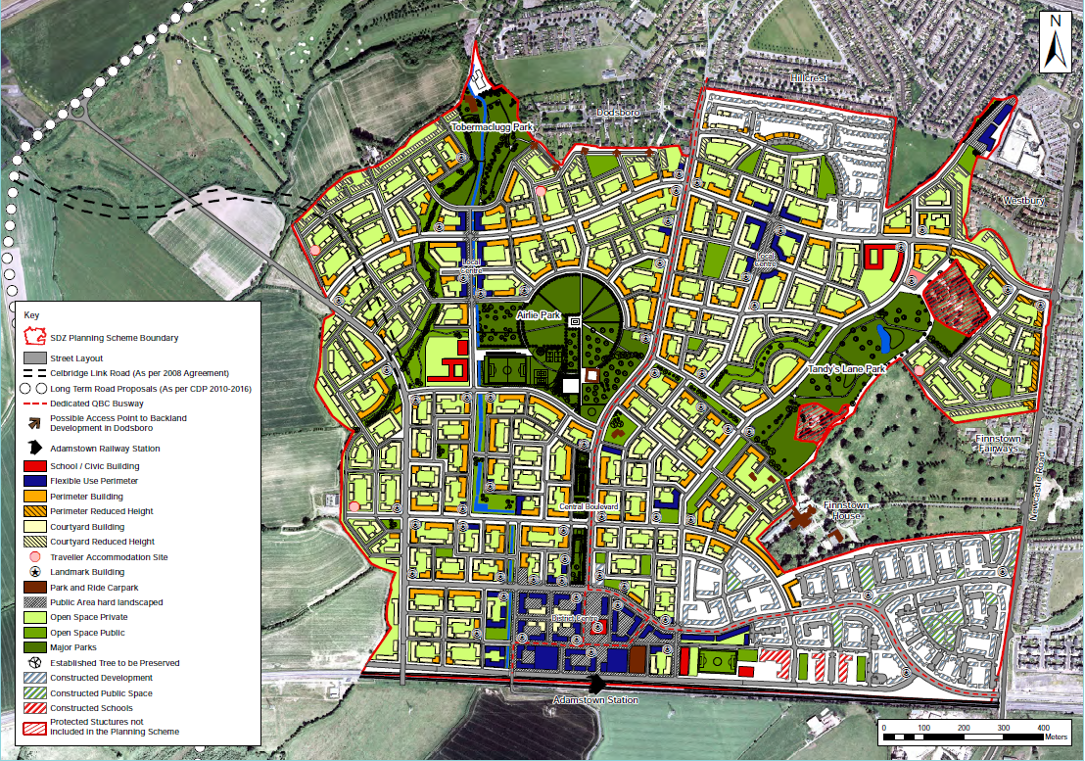
Fig.2: Indicative layout for Adamstown SDZ Planning Scheme, 2014
- Screening for Appropriate Assessment

Screening for Appropriate Assessment (AA) was carried out by Doherty Environmental Consultants under Article 6(3) of the EU Habitats Directive. (This, in turn, informed the preparation of a separate Strategic Environmental Assessment (SEA) Screening Report by Minogue and Associates Environmental Consultants).
The AA Screening report identified that three European Sites occur within the zone of influence of the proposed amendments within Adamstown, by virtue of the presence of a hydrological pathway – these are North Dublin Bay SAC; South Dublin Bay River Tolka Estuary SPA; and North BullI Island SPA.
The AA Screening Conclusion states:
‘This Screening Report for Appropriate Assessment has found that development within the SDZ lands will not present a risk of negatively affecting water quality at Dublin Bay in the vicinity of the three European Sites and will not have the potential to influence the status of wetland qualifying habitats of the SAC and the wetland habitats of the SPA upon which special conservation interest bird species rely.’
The Screening Conclusion continues:
‘In light of the findings of this report it is the considered view of the authors of this Screening Report for Appropriate Assessment that it can be concluded by South Dublin County Council that the proposed amendment to the SDZ is not likely, alone or in-combination with other plans or projects, to have a significant effect on any European Sites in view of their Conservation Objectives and on the basis of best scientific evidence and there is no reasonable scientific doubt as to that conclusion.’

- Conclusion
In accordance with the above, South Dublin County Council therefore conclude that the proposed amendments to the SDZ are not likely, alone or in-combination with other plans or projects, to have a significant effect on any European Sites in view of their Conservation Objectives.

