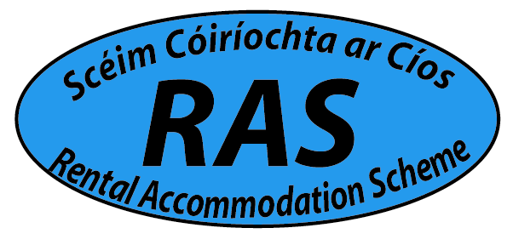

Rental Accommodation Scheme - Landlord Application Form

Contact Details of Landlord

Name: ________________________________________________________________________________

Address: _________________________________________________________________

Telephone: Home: ________________ Mobile: ______________________________

Email: ____________________________________________________________________

Landlord PPS No: _________________________________________________________

Are you resident in Ireland? Yes ⁭ No ⁭
(For non resident landlords, 20% tax will have to be deducted from your monthly rent and be paid to the Revenue Commissioners on your behalf.)

Are you the sole owner of the property? Yes ⁭ No ⁭

If NO please give name and PPS of Co-Owner

Name: ________________________________________________________________________________

Landlord PPS No: _________________________________________________________

Documents required to be submitted – after property passes an Environmental Health inspection

- Copy of Tax Clearance Certificate, for all owners - (for further information check www.revenue.ie )
- Copy of the current insurance certificate for the property
- Copy of BER Certificate (Building Energy Rating Certificate) - (for further information check www.seai.ie)
- Proof of ownership of the property - (please refer to your solicitor or the Land Registry at www.landdirect.ie)
- Proof of payment for Annual Management Fees if applicable.
- Proof of Registration with the RTB ( for further information check www.rtb.ie)

Property Details

Address: ______________________________________________________________

Description: House Bungalow Dormer Apartment

Apartment; Ground Floor Apartment; 1st Floor or Above Detached

Semi Detached End Terrace Mid Terrace Front Garden Back Garden

No. of Bedrooms ________ No. of Bathrooms ________ Kitchen ________ Utility room ______

Dining Room ________ Living Room ________ Type of Heating _________________________

Garage ________ Garden Shed ________ Parking Spaces ________ Lift Access ____________

How much Rent do you charge per Calendar Month? ______________________________________

Is your property built above a Commercial Unit? Yes ⁭ No ⁭

- Please note the property must comply with the Housing (Standards for Rented Houses) Regulations 2017 and South Dublin County Council requirements before the property is accepted onto the Scheme.

- An inspector will make contact with the landlord within three weeks to organise a viewing of the property.

- Please note that South Dublin County Council is not liable for any costs incurred in the upgrading of the property or any costs in relation to the sourcing of the documents listed on the previous page

Other Information

Are your current Tenants in receipt of Supplementary Welfare Allowance? Yes ⁭ No ⁭

If yes, please give details as follows;

Tenant Name: _________________________________________________________________________________

Telephone Numbers: Home: ________________ Mobile: ___________________________________

Tenant PPS No: ___________________ Tenancy Start Date: ________________________________

