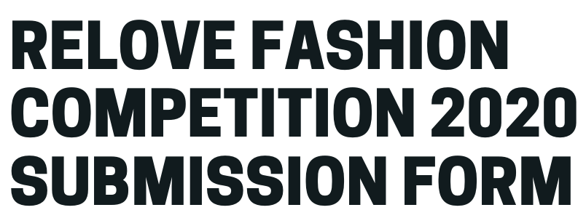

Student Name/s: ______________________________
School Name: _________________________________

Maximum of 250 words per answer
- How did you source your materials/clothing?
__________________________________________________________________________________________________________________________________________________________________________________________________________________________________________________________________________________________________________________________________________________________________________________________________________________________________________________________________________________________
- What are your materials/clothing made from?
__________________________________________________________________________________________________________________________________________________________________________________________________________________________________________________________________________________________________________________________________________________________________________________________________________________________________________________________________________________________
- What is the environmental impact of these types of fabric?
__________________________________________________________________________________________________________________________________________________________________________________________________________________________________________________________________________________________________________________________________________________________________________________________________________________________________________________________________________________________
- What recycling/upcycling options are there for these types of materials/clothing?
__________________________________________________________________________________________________________________________________________________________________________________________________________________________________________________________________________________________________________________________________________________________________________________________________________________________________________________________________________________________

- What are your views on why it is important to make fashion more sustainable, taking account of the impacts of textile production and manufacturing?
__________________________________________________________________________________________________________________________________________________________________________________________________________________________________________________________________________________________________________________________________________________________________________________________________________________________________________________________________________________________

- How do you think this can be achieved?
__________________________________________________________________________________________________________________________________________________________________________________________________________________________________________________________________________________________________________________________________________________________________________________________________________________________________________________________________________________________

Email your entry before 5pm on 30/10/2020 to:
envawareness@sdublincoco.ie

Your information will be stored in line with your Local Authority’s GDPR policy, please refer to their website if you would like further details.

